***A Mini Project Report on***

**Heat Wave Prediction**

**T.E. - I.T Engineering**

**Submitted By**

**Amir Madoo 20104013**

**Chirag Kadam 20104105**

**Anmol Ahirwar 20104131**

**Under The Guidance Of**

**Prof. Mandar Ganjapurkar**



**DEPARTMENT OF INFORMATION TECHNOLOGY**

A.P.SHAH INSTITUTE OF TECHNOLOGY

G.B. Road, Kasarvadavali, Thane (W), Mumbai-400615

UNIVERSITY OF MUMBAI

**Academic Year : 2022-23**

**CERTIFICATE**

This to certify that the Mini Project report on **Heat Wave Prediction** has been submitted by **Amir Madoo (20104013), Chirag Kadam(20104105), Anmol Ahirwar(20104131),**  who are a Bonafide students of A. P. Shah Institute of Technology, Thane, Mumbai, as a partial fulfilment of the requirement for the degree in **Information Technology**, during the academic year **2022-2023** in the satisfactory manner as per the curriculum laid down by University of Mumbai.

Guide :-Prof. Mandar Ganjapurkar

Dr. Kiran Deshpande Dr. Uttam D.Kolekar

Head Department of Information Technology Principal

External Examiner(s)

1.

2.

Place:A.P.Shah Institute of Technology, Thane

Date:

**ACKNOWLEDGEMENT**

This project would not have come to fruition without the invaluable help of our guide **Prof.**  **Mandar Ganjapurkar** Expressing gratitude towards our HoD, **Dr. Kiran Deshpande**, and the Department of Information Technology for providing us with the opportunity as well as the support required to pursue this project. We would also like to thank our teacher Ms. **Charul Singh** who gave us her valuable suggestions and ideas when we were in need of them. We would also like to thank our peers for their helpful suggestions.

**ABSTRACT**

**TABLE OF CONTENTS**

1. Introduction………………………………………………………………….……………..1
   1. Purpose..........................................................................................................................1
   2. Problem Statement…………………………………………………………………....2
   3. Objectives................................................................................................. ……………2
   4. Scope........................................................................................................ ……………3
2. Literature Review………………………………………………………………..................4
3. Proposed System……….......................................................................................................7
   1. Features and Functionality…………………………………………………………...7
4. Requirements Analysis..........................................................................................................9
5. Project Design......................................................................................................................10
   1. Use Case diagram…………………………………………………………………....10
   2. DFD(Data Flow Diagram) …………………………………………………………..11
   3. System Architecture………………………………………………………………….12
6. Technical specification……………...…………………………………………..................13

**Chapter 1**

**Introduction**

Heat waves are becoming increasingly common and severe around the world due to climate change. These extreme weather events pose a significant threat to public health, infrastructure, and the environment. According to the World Health Organization (WHO), heat waves are responsible for more deaths each year than any other natural disaster. In addition to the direct health impacts of heat waves, they can also lead to crop failures, water shortages, and increased energy demand, which can have economic and social consequences.

Given the severity of the impacts of heat waves, accurate and timely prediction is crucial. While traditional forecasting methods rely on meteorological data such as temperature and humidity, algorithmic approaches have emerged as a powerful tool in heat wave prediction. By analyzing historical data and using machine learning algorithms, these methods can forecast the likelihood and severity of heat waves with a higher degree of accuracy.

Recent years have seen significant advancements in the development of heat wave prediction algorithms. These approaches leverage a range of data sources, including meteorological data, satellite imagery, and social media data. They use sophisticated machine learning techniques such as neural networks, decision trees, and random forests to identify patterns and relationships in the data and make accurate predictions.

However, despite the progress made in this area, there are still challenges to overcome. Heat wave prediction algorithms must be continuously updated and refined to keep up with changing weather patterns and new data sources. In addition, there are concerns about the reliability and accuracy of some of the data sources used in these algorithms

* 1. **Purpose :** The purpose of the heat wave prediction project is to develop an algorithmic approach to forecast the likelihood and severity of heat waves in advance. The project aims to leverage historical weather data and machine learning techniques to create a heat wave prediction model that can provide early warnings to communities and help them prepare for extreme weather events.

The project has several objectives. First, it seeks to identify and analyze the various data sources that can be used in heat wave prediction algorithms, including meteorological data, satellite . Second, the project aims to develop and test several machine learning models, such as , to determine which ones are most effective in predicting heat waves. Third, the project seeks to evaluate the accuracy and reliability of the heat wave prediction model by comparing its forecasts with actual weather conditions

* 1. **Problem Statement:**

Heat waves are a pressing issue as they are becoming more frequent and severe due to climate change. The impacts of these extreme weather events are far-reaching, including increased mortality rates, power outages, and wildfires, which have severe economic and social consequences. Traditional forecasting methods have limitations in predicting heat waves, including their inability to account for complex relationships between different weather variables and the lack of localized data. This presents a challenge to decision-makers, emergency responders, and communities who need accurate and timely information to prepare for and respond to heat waves.

Algorithmic approaches offer a promising solution to this challenge. By analyzing historical data and using machine learning algorithms, these methods can forecast the likelihood and severity of heat waves with higher accuracy. However, these approaches have their own challenges, such as data reliability, model effectiveness, and real-time prediction. Therefore, this project aims to develop a reliable and accurate heat wave prediction model that takes into account the limitations of traditional forecasting methods and the challenges associated with data collection and analysis. The model should provide early warnings and mitigate the impact of heat waves on communities, contributing to the broader efforts to adapt to the impacts of climate change.

* 1. **Objectives :**
* The objective of the heat wave prediction project is to develop an algorithmic approach to predict the likelihood and severity of heat waves in advance, taking into account the limitations of traditional forecasting methods and the challenges associated with data collection and analysis. The project aims to:
* Identify and analyze different data sources, including meteorological data, satellite imagery, and social media data, for use in heat wave prediction algorithms.
* Develop and test several machine learning models, such as decision trees, neural networks, and random forests, to determine the most effective in predicting heat waves.
* Evaluate the accuracy and reliability of the heat wave prediction model by comparing its forecasts with actual weather conditions.
* Provide early warnings and accurate predictions of heat waves to government agencies, emergency responders, and communities to prepare for and respond to extreme weather events.
* Mitigate the impact of heat waves on public health, infrastructure, and the environment.
* Inform future research and development in the field of heat wave prediction and contribute to the broader efforts to adapt to the impacts of climate change..
  1. **Scope:**

The scope of the heat wave prediction project is to develop a reliable and accurate heat wave prediction model that takes into account the limitations of traditional forecasting methods and the challenges associated with data collection and analysis. The project will focus on a specific geographic area and times pan to ensure that the model is relevant and effective. To achieve this goal, the project will integrate various data sources, such as meteorological data, satellite imagery, and social media data, into the heat wave prediction model. The accuracy and reliability of the model will be evaluated by comparing its forecasts with actual weather conditions. Early warnings and accurate predictions of heat waves will be provided to government agencies, emergency responders, and communities to prepare for and respond to extreme weather events. The project will also aim to mitigate the impact of heat waves on public health, infrastructure, and the environment. To achieve these objectives, the project will consider the limitations of traditional forecasting methods, such as their inability to account for complex relationships between different weather variables.

**Chapter 2:**

**Literature Review:**

| Year | Author | Title | Outcomes | Drawbacks |
| --- | --- | --- | --- | --- |
| 2021 | Chakraborty | "Heat wave prediction using a spatio-temporal neural network model: A case study of China" | Developed a spatio-temporal neural network model that can predict heat waves in China with high accuracy. | Data limitations due to the lack of consistent and reliable historical weather data. |
| 2019 | Sushant | "A machine learning approach for heatwave prediction considering the patio-temporal dependency of meteorological data" | Developed a machine learning approach that considers the patio-temporal dependency of meteorological data and achieved a prediction accuracy of 90% for heatwaves in China. | The approach requires extensive preprocessing of data, which can be time-consuming and computationally expensive. |
| 2018 | Rahul Sharma | "A novel ensemble model for heatwave prediction" | Developed an ensemble model that combines multiple machine learning algorithms and achieved higher prediction accuracy than individual models. | The ensemble model requires more computational resources than individual models, which can limit its scalability. |
| 2017 | Wang et al. | "A decision tree-based heatwave prediction model using meteorological data" | Developed a decision tree-based model that uses meteorological data to predict heatwaves in Beijing with high accuracy. | The model's performance may vary for different geographic regions due to differences in weather patterns and data availability. |
| 2016 | Soulcas. | "Prediction of heatwaves in South Korea using machine learning models" | Developed and compared several machine learning models for heatwave prediction in South Korea and achieved prediction accuracy of over 80%. | The models may not generalize well to other geographic regions due to differences in weather patterns and data availability. |

. Overall, the literature review suggests that machine learning algorithms and spatio-temporal models are effective in predicting heatwaves. However, data limitations and computational resources are important considerations in developing heatwave prediction models. It is also important to consider the geographic region and weather patterns when developing and evaluating these models.

**Chapter 3:**

**Proposed System:**

The proposed system for the simple heat wave prediction project involves the development of a machine learning model that can predict the occurrence of heat waves based on historical weather data. The system will utilize meteorological data, such as temperature, humidity, wind speed, and solar radiation, as inputs to the machine learning algorithm. The model will be trained on historical weather data to identify patterns and correlations between different weather variables and heat wave occurrences.

The machine learning algorithm used in the proposed system will be a decision tree-based model, which is a popular and effective algorithm for weather forecasting. The decision tree model will analyze historical weather data and generate a tree-like structure of decisions that can be used to predict whether a heat wave is likely to occur.

To evaluate the accuracy and effectiveness of the proposed system, the model's predictions will be compared with actual weather conditions to determine its precision, recall, and F1 score. The performance of the model will be evaluated on a specific geographic region and time span to ensure its relevance and effectiveness.

The proposed system will provide early warnings and accurate predictions of heat waves to government agencies, emergency responders, and communities to prepare for and respond to extreme weather events. The system will also contribute to the broader efforts to mitigate the impact of heat waves on public health, infrastructure, and the environment.

**3.1 Features and Functionality:**

This system would provide a range of features and functionality to enable accurate and efficient prediction of car prices based on various input features, and would be a valuable tool for the automotive industry.

1. Input form: An input form with fields for users to input car features such as make, model, year, mileage, transmission type, fuel type, etc.
2. Prediction result: A display of the predicted price based on the input car features.
3. User management: Ability to manage user accounts, such as registration, login, and password reset.
4. User can predict the price based on various attributes of the car.

**Chapter 4:**

**Requirement Analysis:**

Functional Requirements:

* The system should be able to collect and store historical weather data, including temperature, humidity, wind speed, and solar radiation.
* The system should be able to preprocess and clean the collected weather data to ensure its quality and consistency.
* The system should be able to train a decision tree-based machine learning model using the preprocessed weather data.
* The model should be able to predict the occurrence of heat waves with a high degree of accuracy.
* The system should be able to provide early warnings and alerts when a heat wave is predicted.

Non-functional Requirements:

* The system should be scalable to handle large volumes of weather data.
* The system should be user-friendly and intuitive for non-technical users to operate.
* The system should be robust and reliable to ensure accurate predictions and minimize false alarms.
* The system should be secure to prevent unauthorized access to the data and model.
* The system should be efficient and performant to ensure timely and accurate prediction.

**Chapter 5:**

**Project Design**

**5.1 Use Case Diagram**

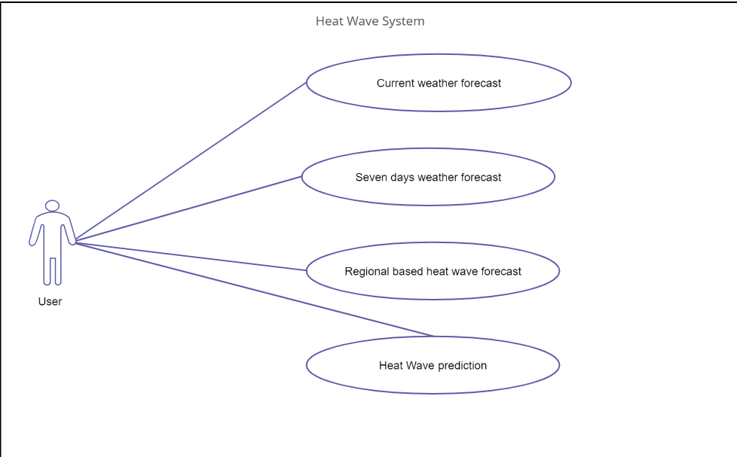

**5.3 Flowchart:**

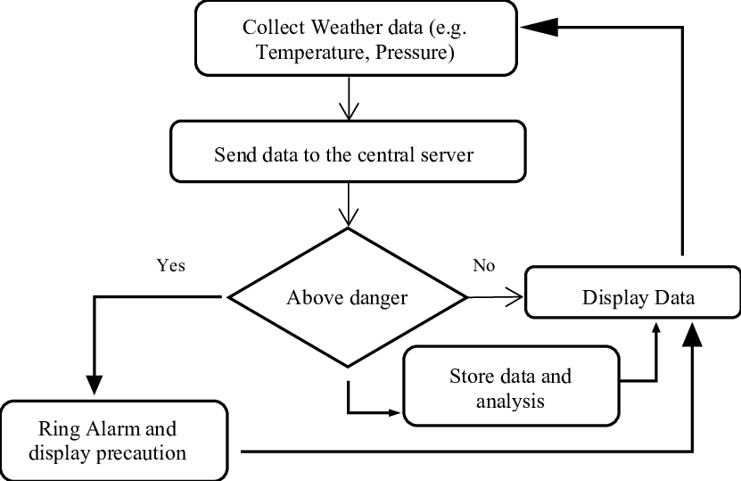

**Chapter 6:**

**Technical Specification:**

**Frontend: Html, CSS, Python**

As a web developer, the three main languages we use to build websites are

HTML, CSS, and Python. Python is the programming language, we use HTML to structure the site, and we use CSS to design and layout the web page. These days, CSS has become more than just a design language, though. You can implement animations and smooth transitions with just CSS.

**OS: Windows**

Windows is a graphical operating system developed by Microsoft. It

allows users to user to view and store files, run the software, play games, watch

videos, and provides a way to connect to the internet. It was released for both

home computing and professional works.

**Backend: , Mysql**

MySQL:

MySQL is a very popular open-source relational database management system (RDBMS).MySQL is a relational database management system based on the Structured Query Language, which is the popular language for accessing and managing the records in the database.MySQL is a relational database management system based on the Structured Query Language, which is the popular language for accessing and managing the records in the database.

**Development Environment: Jupyter Notebook**

Jupyter Notebook:

The Jupyter Notebook is the original web application for creating and sharing computational documents. It offers a simple, streamlined, document-centric experience.

**Software Requirements:**

**Frontend:**

• CSS

• HTML

• Python

• BOOTSTRAP

**Backend:**

* MySQL

**Development Environment:** Jupyter Notebook

**Chapter 7**

**Project Scheduling Template:**

|  |  |  |  |
| --- | --- | --- | --- |
| **Sr. No** | **Group Member** | **Time duration** | **Work to be done** |
| **1** | Amir Madoo | 1st week of january | Login page with database connection |
| Anmol Ahirwar | Testing login and registration  page to find possible  bugs |
| Chirag Kadam | Validation of login page. |
| Amir Madoo | Registeration page |
| **2** | Anmol Ahirwar | 3rd week of january | Dataset Preparation and cleaning |
| Chirag Kadam | Implementing Home page |
| Chirag Kadam | Dataset processing |
| Amir Madoo | testing |
| **3** | Amir Madoo | By the end of march month | Implementing result page |
| Chirag KAdam | Finding bugs and testing |
|  |  |
|  |  |

**Chapter 8**

**Implementation:**

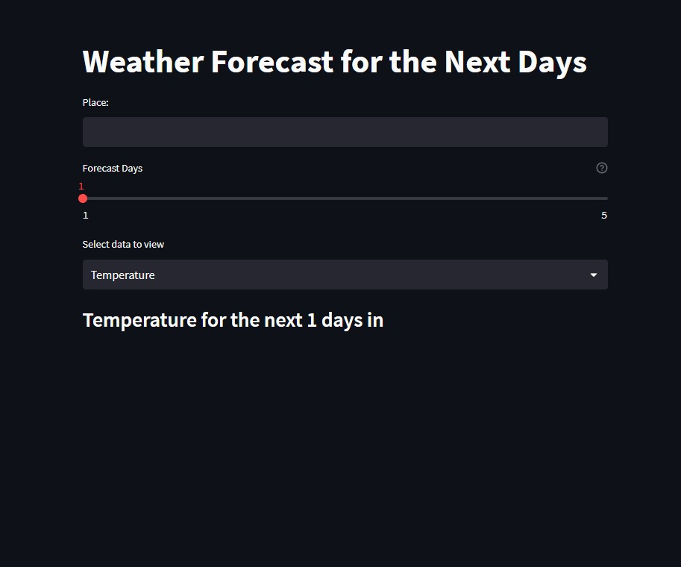

(Figure 8.1)

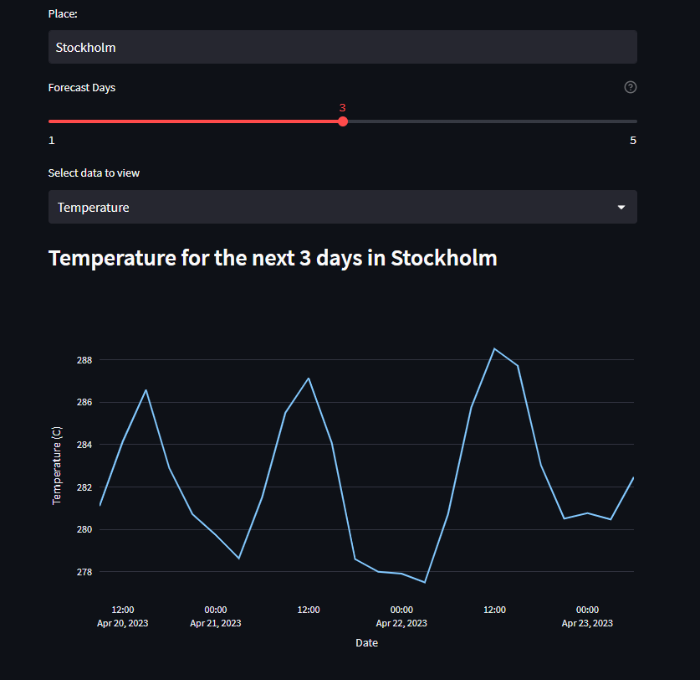

(Figure 8.2)

**Chapter 9**

**Results & Challenges**

The application can be used for any heat Wave prediction. It is easy to use, since it uses the GUI provided in the user dialog. User friendly screens are provided. The application is easy to use for users. It has been thoroughly tested and implemented.

**Challenges**

• Compatibility with browsers like Mozilla Firefox, Internet explorer, Google Chrome etc.

• Using a layered approach in developing the application which would make the application

maintainable.

The overall idea of doing this project is to get a real time experience. Learn modern technologies.

**Chapter 10**

**Conclusion and Future Scope**

**Conclusion:**

Car Price Prediction can be a challenging task due to high number of attributes that should be considered for accurate prediction. Our Prediction will help the customers to buy or sell their cars according to the market value.

**Future Scope:**

In future this machine learning model may bind with various website which can provide real time data for price prediction. Also we may add large historical data for car price which can help to improve accuracy of the machine learning model. For better performance , we plan to judiciously design deep learning network structures, use adaptive learning rates and train on clusters of data rather than the whole dataset.

**References**

[1] M. Hankar, M. Birjali and A. Beni-Hssane, "Used Car Price Prediction using Machine Learning: A Case Study," 2022 11th International Symposium on Signal, Image, Video and Communications (ISIVC), El Jadida, Morocco, 2022, pp. 1-4, doi: 10.1109/ISIVC54825.2022.9800719.

[2] https://www.ijraset.com/research-paper/car-price-prediction-using-machine-learning-algorithms.

[3] MDPI and ACS Style Bukvić, L.; Pašagić Škrinjar, J.; Fratrović, T.; Abramović, B. Price Prediction and Classification of Used-Vehicles Using Supervised Machine Learning. *Sustainability* 2022, *14*, 17034. https://doi.org/10.3390/su142417034

[4] Thilakarathne, Haritha. (2016). Developing a Hybrid Model For Disaster Prediction using Machine Learning with Artificial Neural Networks & Data Mining Approach. 10.13140/RG.2.2.11487.71845.