Fred's Test Framework

Programmer's Guide
Version 0.1
Status: Draft

Contents
Table of content
Contents 3
1.Introduction 6
1.1History 6
1.2This Guide 6
1.3Objectives 6
1.4Toolbox Principles 7
1.4.1Reusability 7
1.4.2Object oriented development 7
1.4.3Interpreted language 7
1.4.4Intensive usage of community packages 8
1.5Why use a Framework? 8
1.5.1Templates, Scripts, Tests and conventions 8
1.5.2Networking 8
1.5.3CODECs 9
1.5.4Cryptography 9
1.5.5Utilities 9
1.6Areas where to directly use CPAN modules 9
1.6.1Database Access 9
1.6.2XML parsing and generation 10
2.Toolbox Contents 11
2.1Distribution contents 11
2.2Documentation 11
2.3Templates 12
2.4Libraries 13
2.5Scripts 13
3.Quick Start Guide 15
3.1Installation 15
3.2Running a script 15
4.Scripts and Tests 17
4.1Writing your first script 17
4.1.1Scripts logger 17
4.1.2Adding new parameters 19
4.1.3Online Help 19
4.1.4Configuration file 20
4.1.5API HTML documentation 20
4.2Writing your first test 20
4.2.1Controlling Outputs 21
4.2.2Assertion Checks 22
4.2.3Tests Outputs Methods 24
4.3Writing your first class 24
5.Test suite organization 25
5.1Tests Workflow 25
5.2Test Script Generation 26
5.3Test suite Execution 30
5.4Test Report Generation 30
5.4.1ASCII report Generation 31
5.4.2HTML report Generation 32
5.4.3XML report Generation 33
5.4.4Open Office report Generation 33
5.5Import of the tests results in the spreadsheet 34
5.6Elements of Software Tests Description 34
6.Utilities 36
6.1Configuration files access and modifications 36
6.2File lists 37
6.3XML parsing and generation 37
7.Event Driven Programming 38
7.1Principles 38
7.2The Events library 38
7.3State Machine Automaton 40
8.Networking 44
8.1Writing a Simple TCP/IP client 44
8.2Writing a TCP/IP server simulator 45
8.3Complex TCP/IP Servers and Clients 45
9.CODECs Management
46
9.1Design Choices Justification
47
9.1.1Bytes arrays 47
9.1.2One class per message type 47
9.1.3Code generation 48
9.2Usage 48
9.2.1Messages 48
9.2.2Access to message sub components 48
9.3CODECs Development Support
49
9.3.1Using types by name 50
9.3.2Supported types 51
9.3.3Protocol Decoding traces strategy 58
59
10.C and C++ libraries bindings 60
10.1How to use swig to create a C++/Perl binding 60
11.Databases 63
12. Interfaces 64
Appendix AExample of test log 65
Example of ASCII test report 67
Appendix BExample of individual test result 69
Appendix CExample of protocol definition 70

Introduction
This paper is a Programmer’s Guide for a Perl test Framework that I have developed and used with several projects. The framework objectives are to simplify and make more efficient the development of component tests.
In a Framework approach, all components are independent and can be used by themselves, but they have also been designed to work together and it is by combining them that you will get the full power of the environment.
This guide demonstrates the basic features first and throughout the chapter the examples get more complex. The guide starts with installation instructions then demonstrates simples scripts and tests to go up to multiple clients and servers TCP/IP simulators and control of Unix programs.

History
The toolbox was started as a collection of small Tcl scripts used for testing in different projects. A few years ago, they were organized into a coherent framework. The second version has been translated in Perl and has seen the first report generator. With the third one it is still possible to do the same things than with the others but I want also to experiment with a more abstract data test model. Note that there is no direct upward compatibility of the scripts which need to be adapted.

This Guide
The goal of the guide is to enable you to use the toolkit as quickly as possible by using the standard options. The detailed description of the parameters can be found in the HTML documentation.
The defaults have been chosen to be reasonable and fit the needs of most tests projects. You should know however that if something is not exactly the way you want it is probably possible to customize it.

Objectives
The objective of the toolbox is to make people as efficient as possible in developing tests. In this context component tests are self-reporting programs that test one feature or one requirement of a UNIX process.
You start a test campaign by writing a test description document. Then you use it to write the tests described in the scenarios.
The effort to write a fully automated test suite is often considered too costly, some tests remain manual procedures and a human tester must run then for each test campaign.
I strongly believe that by applying the correct methodology to these tests developments, and by using appropriate tools, the effort to develop the tests is inferior to the time spent by a few manual test campaigns.

Toolbox Principles
I systematically applied a few development principles. None of them is particularly innovating. But I hope that through their combination I have provided an efficient and coherent toolbox.

Reusability
The first principle applied is quite simple; you are closer to the result when part of the job is already done. So instead of redeveloping everything for each test suite, let put everything which can be shared between several test projects in a common area.
It is usually assumed that there is an overhead to write generic code compared to specific one. This is exact, but it does not cost twice as much to be generic. So if a piece of code can be reused in at least two projects, it should be written as a common component.

Object oriented development
This principle is a direct consequence of the previous one. Object oriented development is one of the most efficient ways that I know to make code re-usable.
The toolbox has been designed to be used by developers who master the concepts of object oriented development. The previous test toolbox was not object oriented because it was written in Tcl, a language for which object support requires the installation of additional modules. The Perl toolbox is much more flexible because it is written with objects.
Even for people who are not familiar with object oriented development, the additional effort of learning how it works, with some good examples is rapidly compensated by the improved productivity. One of the goals of this guide is to provide them with the examples.

Interpreted language
It as been measured that for small to medium projects, interpreted languages like Tcl, Perl or Python provide a real productivity gain. It is usually assumed that it is possible to develop small programs up to 10 times faster than by using compiled languages like Ada, C++ or Java.
I do not want to discuss about the exact ratio, and it is only true for projects up to a few thousand lines of code.
With interpreted languages, you save the compilation time. It is perhaps the less important point, but it exists nevertheless. I agree that you can do other things while you wait for a compilation to finish, but I am sure that sometimes developers just wait. And even if you try to do something else while your program is compiling, multiple switches of context are time consuming for a human being.
As a former Ada programmer I hate to admit it, but strong typing requires some design time. When the problem is complex, strong typing can help you prevent a lot of errors, but when the problem is simple and you know what you are doing it is faster to handle variables that can receive any type of data.
This point does not scale up well, and as soon as your program becomes complex strong typing has more benefits than drawbacks. However test programs are usually simple and can take advantage of loose typing.
Dynamicity is another real difference between interpreted and compiled languages. It is the capacity to elaborate and evaluate programs on the fly. Java, Ada, and C++ are starting to have some introspective mechanisms but they are usually complex. In interpreted language the “eval” function allows programs to do things that are almost impossible to do in compiled languages. As the boundary between data and programs becomes fuzzier; it is possible to write very descriptive programs and data structure really simply.

Intensive usage of community packages
If instead of writing your own code, you can select modules from a wide repository of well tested and documented modules, you can therefore gain another significant advantage.
Of course you will need some time to select them, learn how they work and validate them. However as soon as the problem is not trivial, this selection process is faster than the development of the equivalent module.

Why use a Framework?
I have chosen to use modules from CPAN as much as possible and there are already a lot of modules in this repository, so why do I need to develop additional code?
They are several areas in which the framework is helpful:

Templates, Scripts, Tests and conventions
By using the toolbox rather than by using multiple packages from CPAN, we will be able to enforce a common structure for all the test suites. Whatever the tested component, you will select the output directory the same way, and will get the result in the same format.
Usually the templates and services provided are just thin layers on top of existing CPAN packages. They only propose a standard way of doing things.

Networking
There is an Object Oriented support for networking and event driven programming because most of the packages found were usually too low level.
The natural support for networking in Perl uses the events driven paradigm, which is very efficient in term of resources, memory and CPU but tends to make the programs less readable by dispatching all the logic into a lot of low level handlers.
By providing the events layers, I tried to make the tests programs easier to write.
Object oriented interface is an efficient way to handle the problem. It provides the same interface to all your devices, TCP or UDP sockets, files, programs, console and keyboard, etc.
Objects are also natural containers for execution context, and multiple clients and servers programs are no more complex than single TCP/IP client. In tests we often have to handle multiple connections. For example, with my previous test technology I had to deploy 60 processes in order to test a server which listened on 60 ports. With the current toolbox we just have to create and activate 60 objects to handle the 60 connections.

CODECs
CODECs or the capacity to interpret a binary string into a meaningful business object or the capacity to generate a binary message from a set of business data are another area where additional support is useful.
I have never found, neither on CPAN nor in our technology anything as simple, and efficient in lines of code required to implement a CODEC than what is proposed in the library. Perhaps because people who want a generic approach of the problem just prefer to use middleware like CORBA or SOAP than to spend time to optimize the way they implement TCP/IP protocols.

Cryptography
I have used CPAN modules for all the standard algorithms like AES, TDES, etc, butl also use some C bindings to interface our custom, in house cryptographic algorithms.

Utilities
The toolbox also provides some utilities to handle configuration files, state machine automatons, etc.
These modules were developed because, I did not find convenient ones on CPAN or because I wanted modules more integrated with the framework.

Areas where to directly use CPAN modules

Database Access
The DBI interface in Perl already provides a good support to access to a lot of databases. It supports Oracle, MySQL, SQLite, etc.
If required there are also some efficient Object Oriented Database Mapping packages, in order to avoid the development of SQL code.

XML parsing and generation
There are a lot of XML parsers, in CPAN. Swig is recommended for its flexibility. XML::Writer is convenient to generate XML on the fly and XML::Generator when you prefer to prepare the XML tree before its generation.

Toolbox Contents

Distribution contents
You will find several kinds of contents in the toolbox:
- Some documentation
  - This Guide
  - The HTML documentation of the toolbox API
- Some Templates
- Several libraries of services
- Some tools
- Some examples
- the libraries unit tests
For convenience, I used to refer to the installation directory as a variable name $FTF.
Once the toolbox is installed you will find the following sub directories under the installation directory:

doc/ Toolbox documentation
examples/ some examples
lib/ the toolbox libraries
scripts/ the toolbox utilities scripts
t/ the toolbox unit tests
templates/ templates

The following files and directories come from the integration team Perl toolbox or from non successful experiments; they are not covered by the present documentation. I have just kept them, in case of somebody would have used them.
bin/
etc/
man/
lib/IO/, lib/RTSP/, lib/TestTools/Event, lib/TestTools/Net, lib/TestTools/Net, lib/TestTools/Player, lib/TestTools/Serializer, lib/TestTools/Simulator.

Documentation
HTML API library documentation under $FTF/doc/html/index.html
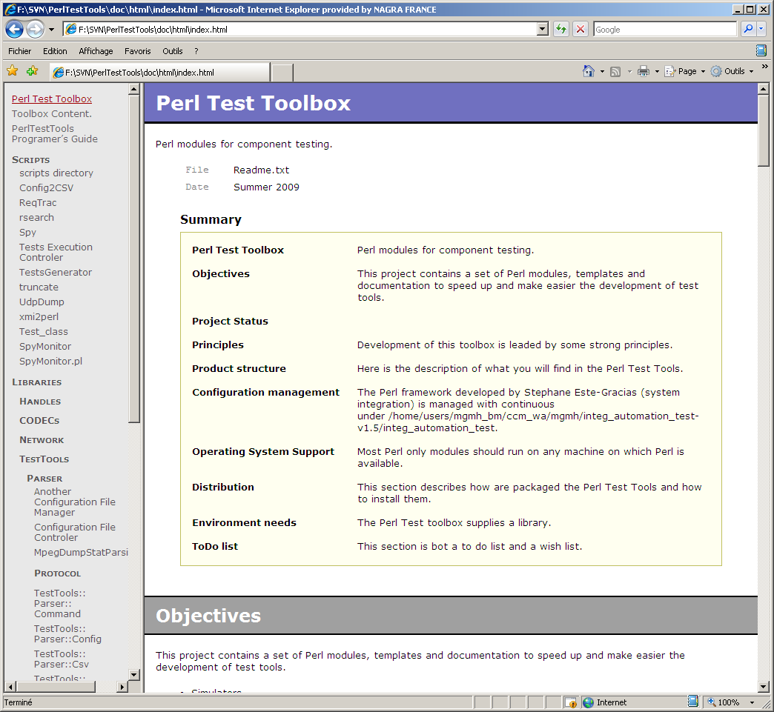
Figure 1, Perl Test Tools API documentation
Several PowerPoints and White papers under $FTF/doc

Templates
Templates are files that you should adapt and customize to create your own test suite.

Class.pm | a class template.
script.pl | a Perl script template
perltest.t | a Perl test template
test.pl | a component test template
bclient.pl | a template for a simple TCP/IP client, this one is based on the socket library and can only handle one client at the same time.
client.pl | A template for a TCP/IP client, this one is based on the Event library and can handle many clients at the same time.
server.pl | A template for a TCP/IP server, based on the Event library, it can handle many clients and many connections at the same time.

server.pl and FiboService.pm are templates of a TCP/IP server. FiboService contains the service definition. In our case this server computes the result of the Fibonacci sequence. To supply a full example the server can emulate asynchronism and return the results out of order. It is also possible to ask the server to return a random quantity of erroneous replies. It is both a template and an example.
client.pl and FiboSequence.pm are templates for a TCP/IP client test. This client sends some requests to the Fibonacci server and checks the accuracy of the result. It is also able to measure the time of service of each request.

Libraries
The libraries contain all the classes that you can use to implement your tests.
The Events directory contains the support for events driven programming. The Network programming contains equivalent support in blocking context.
The CODECs directory contains already available CODECs, the support to write new ones is contained inside the Protocol library.
The Doc library contains module for documentation generation.

Scripts
The scripts of the toolbox provide a service. You may use them without modification. Of course they are written in Perl and the source is supplied, you can use them as examples, and you can adapt them to your needs.

spy.pl | Spy is a TCP/IP connection player/recorder. It can act like a proxy between a server and a client and record the transmitted data. It is integrated with the framework and can be used to symbolically dump your messages if you have the associated CODEC.
truncate.pl | A script to truncate or extract parts of a binary file
runall.pl | A test suite controller, this script is able to parse a directory and execute the files matching a pattern. It has been part of the toolbox since the beginning, almost never used, It have is replaced it by a simple shell script invoking each test, line by line.  The only drawback of this approach, is that you can discover on Monday that the test suite that you have started on Friday, is stuck at the second test. To avoid this a test scheduler should contain some kind of timeout mechanism. Perhaps that I will modify it to include such mechanism.
rsearch.pl | A platform to apply a treatment to file recursively. It is a kind of ‘find . –exec {} \;’. It is written in Perl, therefor it is easy to add new specific treatments. Currently there are a few that search or replace patterns, count the lines, etc.
tcl.pl | This is a small script to generate a test suite script from a comma separated values spreadsheet. The spreadsheet must contain one line per test, with columns containing the parameters values. It is possible to select the test to execute in the spreadsheet and to choose the columns to use as parameters.  The same script also has a result import mode in which tests result are parsed and included in a special column of your spreadsheet.  The test report generator, initially another script has been merged into this one. It can generate the report in ASCII, XML and Open Office format.

Quick Start Guide

Installation
Just extract the whole repository from https://www.prosvn.org/flubber/devtools/Perl/FTF (to move in its own project if I want to give access to other people). And set the FTF environment variable to the root of the directory.

With the Bash shell:

export FTF=<check out directory>/FTF
With a csh:
setenv FTF <check out directory>/FTF
You need a Perl interpreter with some additional modules from CPAN.

Running a script
If your environment is correctly set up you can try to execute a simple script:
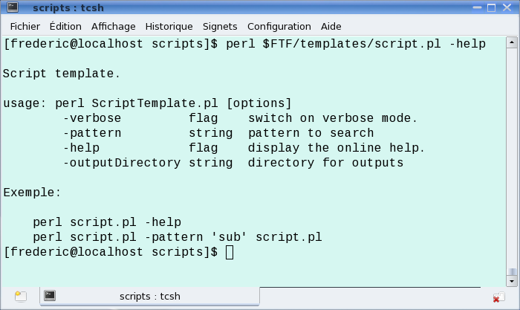
Figure 2, Environment check
Check that you get the same output.

Scripts and Tests

There is not a lot of code in the toolbox related to scripts and tests. The added value of this section is more to give all the tests the same basic behavior and look and feel than to provide a lot of features. It is more based on conventions than on code.

By using the toolbox you will get:

- A common look and feel for all the tests
- A common set of basic options that you can extend
- A common configuration file and command line parameter mechanism
- A common way of generating classes API HTML documentation
- A common logger mechanism
- Standardized tests outputs, all the tests will put their results at the same place in the same format.

Writing your first script
- Copy the $FTF/templates/script.pl into MyFirstScript.pl
- Check your environment.
- Start changing the template to adapt it to your need. I marked the point to change by a “# To customize” comment.

Scripts logger
The script default logger is controlled by the $FTF/conf/log4perl.conf file. Edit it and comment out the following line to get all the possible traces:
# log4perl.rootLogger = ALL, Console, LogFile
I you run the script again you will get all the logs on the screen and in the script default log file. The default log file is defined by the logFilename function in the ExecutionContext module. By default this method creates a log file with the basename of the script and the '.log' extension. This log file is put in the current directory when the FTF_LOG environment variable is not defined. FTF_LOG defines the directory name to put the log files. If you want you can call the logFilename routine to set a different name or directory. Do It before the first traces or you will mess the logging.
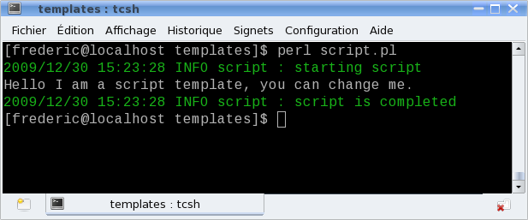
Figure 3, Script execution logs

By default all scripts have a logger named by the base name of the script. You can specifically control the logs of your script with the following line in the log4perl.conf file.
log4perl.logger.my_script = INFO, Console

To invoke a log method, insert lines like the following one in your Perl scripts:

$Self->info("Protocol Encoder Integer Encoding Test");

Here are the log methods on the script default logger:

Method | level | Comment
“trace” | TRACE | Log on the default logger at trace level.
“debug” | DEBUG | Log on the default logger at debug level.
“info” | INFO | Log on the default logger at info level.
“warn” | WARN | Log on the default logger at warn level.
“error” | ERROR | Log on the default logger at error level.
“fatal” | FATAL | Log on the default logger at fatal level.

Adding new parameters
To add new command line parameters just complete the %OptionSet hash table.

# This hash table is used to declare and define options.
# To customize: replace and add your own parameters
my %OptionSet = (
pattern => {
type => "string",
description => "pattern to search",
default => "pattern"
},
);
Parameters are fetched by:
my $pattern = TestTools::Conf::ScriptConfig::GetOption('pattern');
Look into “Libraries - TestTools - ScriptConfig” in the HTML documentation for details.

Online Help
All scripts have a default online help that can be invoked with the –help option. It displays all the commands accepted by the script and you can customize the strings displayed before and after the commands by replacing the $usage and $footer string variables.

Configuration file
All command line parameters can be set in a configuration file instead of typed on the command line.
In our case the configuration file is named “my_script.ini” and if can contains lines like “pattern = xxx”.

API HTML documentation
The templates are compliant with NaturalDocs. If you follow the NaturalDocs convention you will be able to generate documentation similar to the one available in $FTF/doc/html/index.html. NaturalDocs has been chosen instead of POD because of its multi-language support and because its syntax is very simple.

Writing your first test
It is exactly the same process as writing a script:
- Create a directory to handle your tests
- Copy the $FTF/templates/TestsTemplate.pl into my_first_test.pl
- Check your environment.
- Start changing the template to adapt it to your needs
Everything that you can customize on a script can be customized for a test. In fact tests are also scripts.
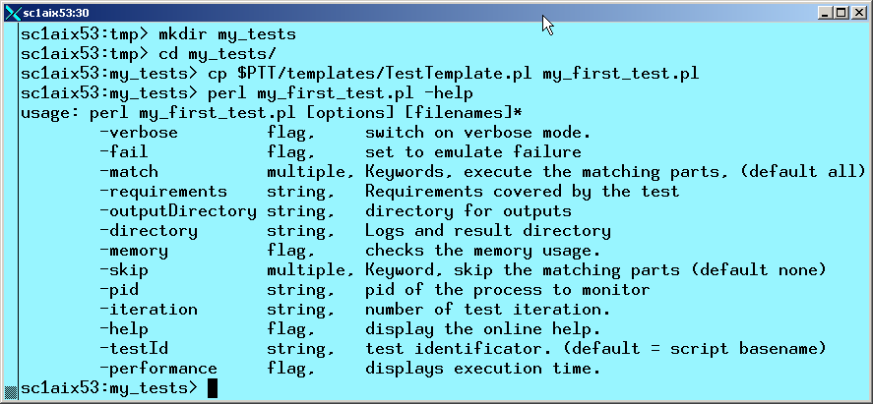
Figure 4, Test online help

Controlling Outputs
The script logging mechanism has been refined for tests. Tests have sub-loggers, each one with a different purpose. If you do not care you can still perform all the logging at the root level.
It has been decided that the test default logger should be the only channel for tests to report information. It helps because all outputs are standardized across a single mechanism. It will be much simpler for example to develop a test report generator if all the tests use the same mechanism.
The default logger is named “Tests” for the tests. It is subdivided into five sub-loggers named “.Doc”, “.Checks”, “.Traces”, “.IO” and “.Counters”.
Loggers are controlled by editing the $FTF/templates/log4perl.conf.
With the following line you get the maximal verbosity for all the loggers.
log4perl.logger.Tests = ALL, Console
With the following setting you only get the information related to the assertion checks.

# ----------------------------------------------------------------
# log4perl.logger.Tests = INFO, Test
log4perl.logger.Tests = ALL, Console, LogFile
# log4perl.logger.Tests.Traces = ALL, Test, TestFile
# log4perl.logger.Tests.Checks = INFO, ShortTest, TestFile
# log4perl.logger.Tests.Doc = INFO, Test, TestFile
# log4perl.logger.Tests.Counters = INFO, Test, TestFile
# log4perl.logger.Tests.IO = INFO, Console, ContextFile
# ----------------------------------------------------------------

Look at the log4perl module documentation for details.

Here is an example of successful test result:

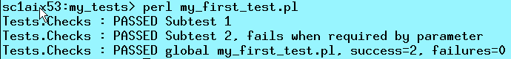
Figure 5, Successful test result

Here is the result of a failed test:

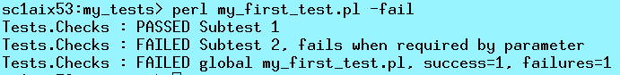
Figure 6, Failed test result

Assertion Checks
Our tests are based on assertion evaluations. The only thing that you have to do in your tests is to create functions that are evaluated to true when the check is successful and to false otherwise. Description strings are attached to each assertion evaluation.
The two main assertion control methods are ‘ok’ and ‘is’. Depending on the result of the evaluation, the associated string is logged at the ‘ERROR’ or ‘WARN’ level. It is possible to have silent tests in case of success which becomes verbose on failures.
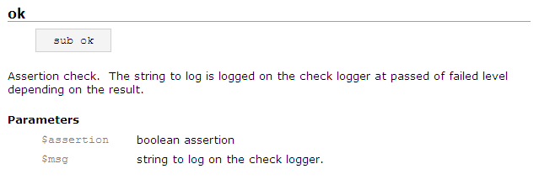
Figure 7, ‘ok’ method API

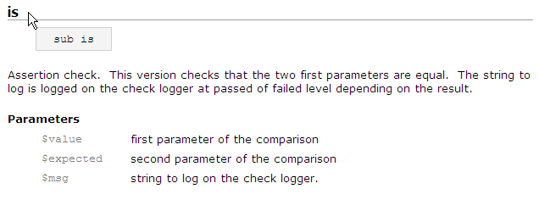
Figure 8, 'is' method API
Usage in you test:

$Self->ok( !$must_fail, "Subtest 2, fails when required by parameter" );

Tests Outputs Methods
It is recommended to use the following methods to report test information. It is almost mandatory if you want to use the test report generator.
Method | Sub-logger | level | Comment
“passed” | “.Check” | WARN | Used to report a successful control. Automatically called by the assertion check routines.
“failed” | “.Check” | ERROR | Used to report an unsuccessful control. Automatically called by the assertion check routines.
“logCounter” | “.Counters” | INFO | Use it to report memory usage, performance, etc. It is recommended to use comma separated “name”=”value”
“logLowLevelIO” | “.IO” | DEBUG | Used to log hexadecimal dumps of IOS.
“logHighLevelIO” | “.IO” | INFO | Used to dump interpreted human readable data
“trace” | “.TRACES” | TRACE | Used to report test execution traces
“doc” | “.Doc” | INFO | Used to report execution context, documentation, test purpose, ect.

All the tests outputs use a log4perl logger, so you can control format and verbosity. I you intend to use the test report generator you must be sure that the information used by the test result parser is actually produced in the test result file.

Writing your first class
Just copy the template from $FTF/template/Package.pm. Standard packages in the toolbox have a default logger named like the class. They use NaturalDocs for documentation and are object oriented.

Test suite organization
One problem with the Perl Tests Tools library is its flexibility. As there is almost no constraint on how to organize the test suites, users may have the feeling that the toolbox provides little support on how to structure the tests. As customization can imply the setting of obscure parameters it may also gives the wrong idea that the toolbox is complex to use.
In this section I will present the organization of a small test suite relying as much as possible on default settings. This architecture is not necessarily the best one for you, but it should be the fastest to deploy if your needs are not too special.
Test organization practices:
- All the tests are derived from the TestTemplate.pl script. This choice already restricts the number of possibilities. It determines the assertion module. It implies that all the tests are written in Perl, even if they are simple wrappers around other programs. It implies that all the test outputs are done through log4perl.
- All the tests use the ‘testId’ parameter, this test identifier must be a reference to tests described into the software test description document.
- The test result of each test will be put into an individual file. All tests results use the ‘testId’ as base name. For example the logs for the test ‘TEST42_PERF’ will be put in the file named ‘TEST42_PERF.log’.
- The ‘outputDirectory’ parameter will be used to define the result directory. It is recommended to use one specific directory for each run.
- The list of tests to execute is maintained inside a single shell script. This test list could eventually become the input of a test scheduler. The only advantage of a test scheduler over a shell script is its ability to cancel a test execution if the test execution goes wild and enter an infinite loop.

Tests Workflow
Testing steps:
- Selection of the test to run and configuration. This can be done either in a spreadsheet or in the test suite script.
- If you selected the tests from a spreadsheet, generation of the test suite script with the tcl.pl program.
- Execution of the test suite script. This can be done in one or several runs.
- Generation of the test report from the test results directory and the test cases list. The test cases list is used to ensure that all the selected tests have been executed.
- The last step which is also optional is the import of the results in the spreadsheet.
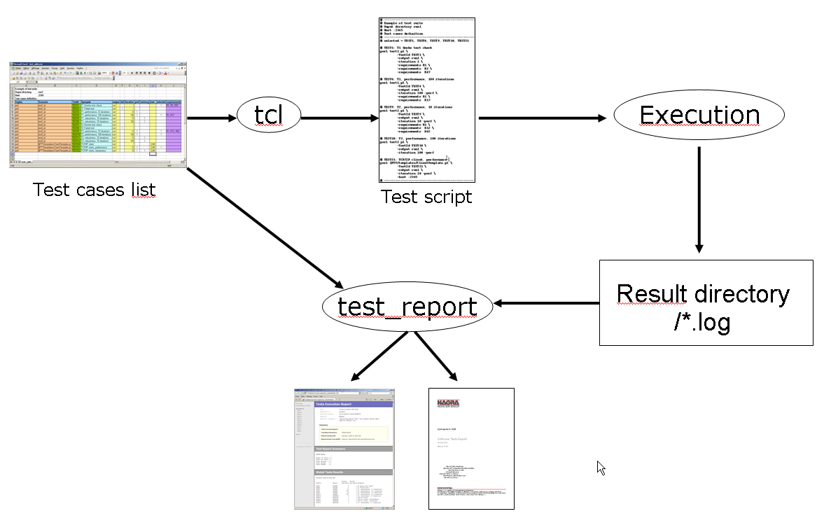
Figure 9, Tests workflow

Test Script Generation
It is possible to generate the test list script from a spreadsheet, in which columns contain parameters. The tests to run can be selected just by putting a Boolean value into a field.
If you generate the test list from a spreadsheet, it will be possible to re-inject the results into the same spreadsheet.
Note that the current version of the toolset is only able of handling spreadsheet with comma separated values (CSV). By default the separator is the semi column “;”. That way the comma can be used to separate values inside fields containing multiple values.
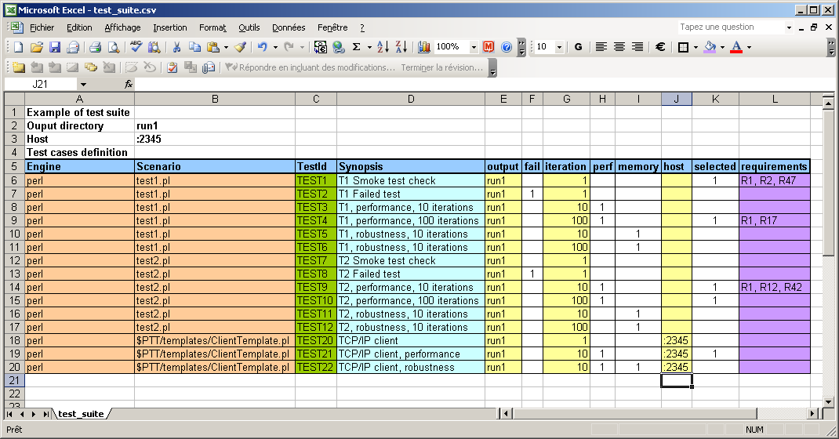
Figure 10, Test Cases List

To generate the script from the spread sheet, you can use the tcl.pl Perl script. You have to select the title line, and from which column you want to generate parameters. I recommend keeping the invocation of the script in a file itself.
WARNING: the current version of tcl requires UNIX like end of lines for the csv file. You have to transform it, or the last column will not be correctly processed.
The following command generates a test case list from the spreadsheet; only selected lines from 1 to 100 will generate lines in the script.
perl $FTF/scripts/tcl.pl \
-title 4 \
-last 100 \
-script test_suite.sh \
-testId TestId \
-argument Engine \
-argument Scenario \
-selector selected \
-synopsis "Synopsis" \
-parameter "TestId" \
-parameter "output" \
-flag "fail" \
-parameter "iteration" \
-flag "perf" \
-flag "memory" \
-parameter "host" \
-csv requirements \
test_suite.csv

Example of generated test cases list:

# --------------------------------------------------------------------------------
# Example of test suite
# Ouput directory run1
# Host :2345
# Test cases definition
# --------------------------------------------------------------------------------
# selected = TEST1, TEST4, TEST9, TEST10, TEST21

# TEST1: T1 Smoke test check
perl test1.pl \
-TestId TEST1 \
-output run1 \
-iteration 1 \
-requirements R1 \
-requirements R2 \
-requirements R47

# TEST4: T1, performance, 100 iterations
perl test1.pl \
-TestId TEST4 \
-output run1 \
-iteration 100 -perf \
-requirements R1 \
-requirements R17

# TEST9: T2, performance, 10 iterations
perl test2.pl \
-TestId TEST9 \
-output run1 \
-iteration 10 -perf \
-requirements R1 \
-requirements R12 \
-requirements R42

# TEST10: T2, performance, 100 iterations
perl test2.pl \
-TestId TEST10 \
-output run1 \
-iteration 100 -perf

# TEST21: TCP/IP client, performance
perl $FTF/templates/ClientTemplate.pl \
-TestId TEST21 \
-output run1 \
-iteration 10 -perf \
-host :2345
# --------------------------------------------------------------------------------

The result of the execution of the previous script will generate the test results in the directory named ‘run1’.

Test suite Execution
Just execute the script containing your test list. It is a simple script therefore it is really easy to modify it to skip tests, activate only one test, etc.
Currently there is no support to give up a test execution when it enters an infinite loop. We rely on the test implementation to manage timeouts, so if a test never return, the whole suite is blocked.
Eventually I’ll modify the ‘runtst.pl’ script to accept this format of test list as input and will add support for test execution timeout.

Test Report Generation
Once the tests suite has been executed in one or several steps, you can generate the tests report. The test report generator parses the test log files. Currently there is one parser which knows the log4perl output format. The parser is written in Perl and takes advantage of the Perl facilities for pattern matching.
The parser looks for the following patterns:
- First of all, it checks if the result file log exists, if not the test is declared not found.
- “Tests.Checks” to identify assertion checks. It looks for the global result at the end of the file. If this pattern is not found, the test is declared aborted. When the pattern is found, the line is used to determine if the test is passed or failed and the number of sub-tests passed and failed.
- “Tests.Doc”, there are two kind of documentation lines; the one which contains an equal sign “=” are used to define variables. It is the mechanism used by the test to report all kind of information, its identity, its synopsis, the requirements checked by the test, etc. There is a method in the API of the test result parser to get the value of these variables.
All others documentation lines are free text. These lines will be copied in the individual test reports by the test reporter. They can be used to transmit any kind of description.
Some high level business assertion checks could be marked to be extracted as documentation items as a list of things checked by the test.
- “Tests.Counters”, there is also two types of counters; with the scalar one a test reports a global numeric information. The second type is used to record tables of numerical data for which several measurements are done. Typical examples are; memory usage, request reply time, CPU usage, etc.
All other information from the log file is ignored (output from the trace and IO loggers).
The test report generator compares your test list with the files found in the result directory.
The test report generator has been organized to have a clear separation between the result parser (currently only log4perl output are recognized) and the report generator backend. There is support for ASCII generation, XML and Open Office documents.

ASCII report Generation
All the back ends can display the same information. The details of the test reports content will be describe in this section. See the annex for a full example.
All test report generators can display the following information:
- Some information on the report generation context; date, operator, machine, command line to invoke the generator.
- Then some optional lines from the test cases list header.
- The global result of the test suite execution with the number of FAILED, PASSED, ABORTED and NOT_FOUND tests. It is the executive summary.
Global results:
###############

Number of tests - 11
Tests not found - 0
Tests aborted - 4
Tests FAILED - 1
Tests PASSED - 6

- Then the result of each individual test with its synopsis and number of sub-assertions failed and passed.
| Passed Failed
| TestId Result sub-tests sub-tests Synopsis

| TEST1 PASSED 3 0 T1 Smoke test check
| TEST2 FAILED 2 1 T1 Failed test
| TEST3 PASSED 30 0 T1, performance, 10 iterations
| TEST4 PASSED 300 0 T1, performance, 100 iterations
| TEST5 ABORTED 0 0 T1, robustness, 10 iterations
| TEST6 ABORTED 0 0 T1, robustness, 100 iterations
| TEST7 PASSED 3 0 T2 Smoke test check
| TEST9 PASSED 30 0 T2, performance, 10 iterations
| TEST10 PASSED 300 0 T2, performance, 100 iterations
| TEST20 ABORTED 0 0 TCP/IP client
| TEST22 ABORTED 0 0 TCP/IP client, robustness
- The requirements traceability matrices.
And for each individual test:
- Information on its status and execution context.
- Some documentation in free format if the test has printed it in its log file.
- The value of each counter.
- All the tables. Tables are information reported several time during the test execution. They are reported in name=value format, separated by commas for table with multiple values. They are intended to report memory usage, performance, etc.
Initially, I though use a Perl module to display the tables in graphical diagrams, but I am running out of time.

HTML report Generation
There is currently no HTML engine. I have just managed to have the ASCII report compatible with the NaturalDocs markup language. That way I can have the tests reports online, in HTML with navigation to the individual test report without any extra effort. Of course a more professional looking result would require more work, for example to provide some XSLT transformation sheets to display directly the XML output.

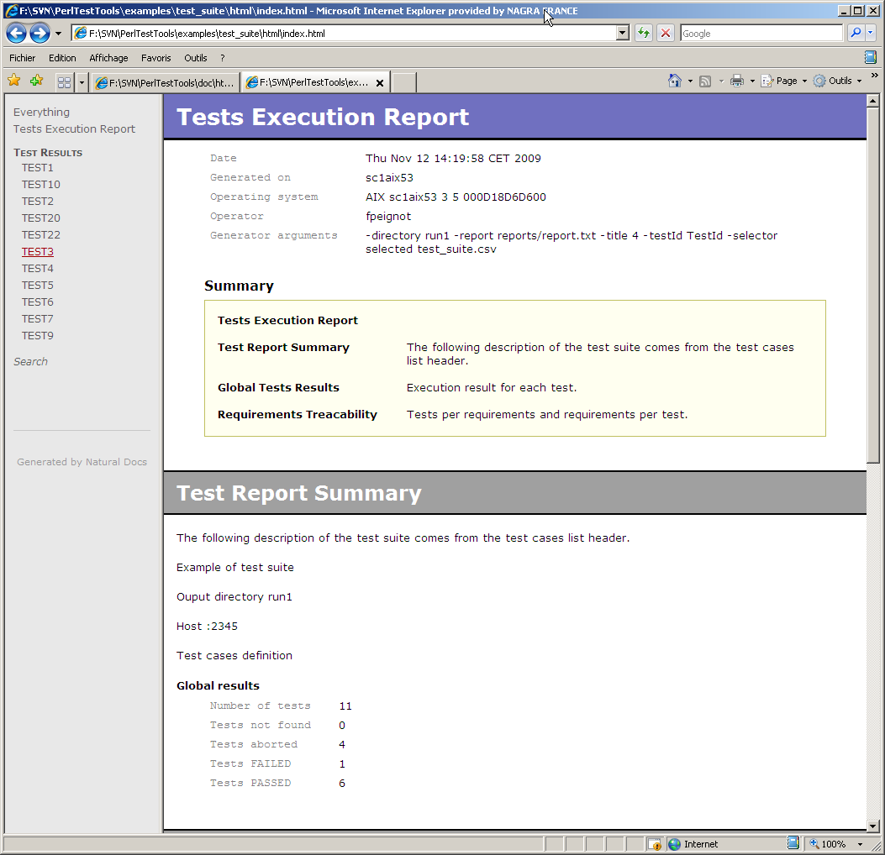  Figure 11, HTML global report | 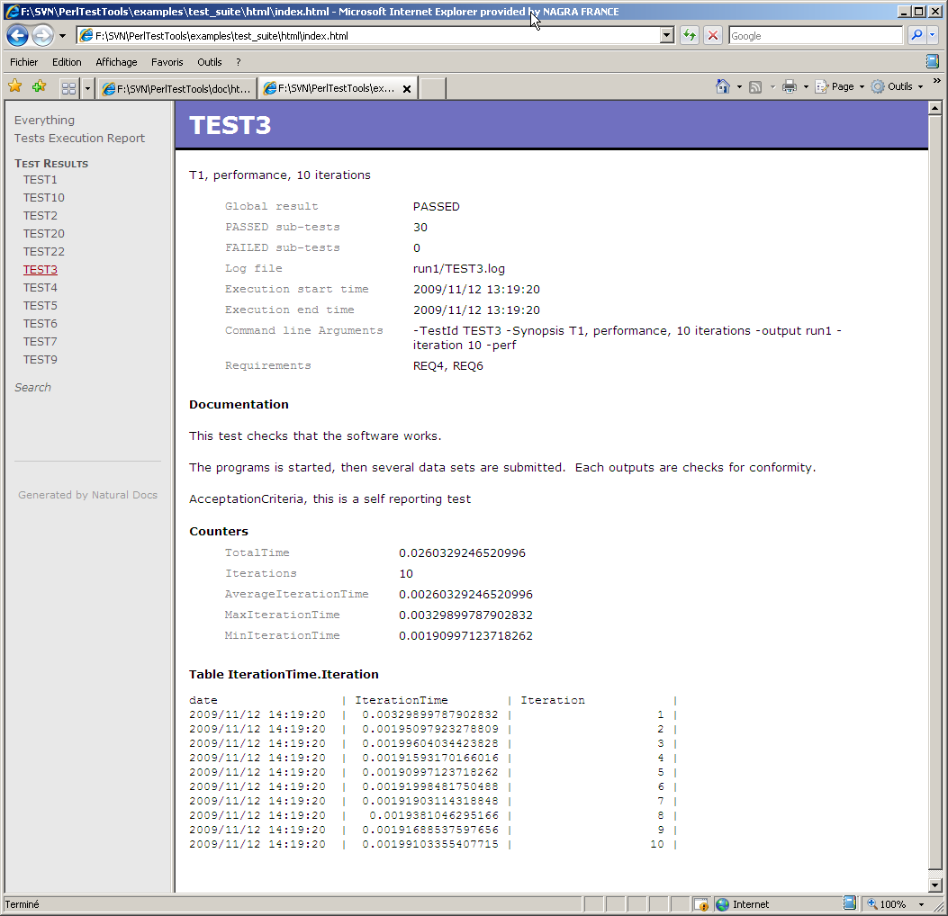  Figure 12, HTML individual report

XML report Generation
This backend is for inter operability with other tools still to be defined. By using a published test report format it will be possible to use other test report generation tools, or to use the test report generator included in the toolbox to generate test reports from tests developed outside of the framework.

Open Office report Generation
With this backend, it is possible to generate Open Office Test reports. There are two advantages to this approach:
- First it is possible to write part of the document manually. The test report generator takes a template as input parameter. This template is already an Open Office document with the company look and feel and several chapters can be written by a human being. The report generator only completes the document with the test results.
- By generating Open Office or pdf documents (Open Office suite integrates a pdf generator) you can attach the test report to an email, you can archive the test reports in the project repository, etc. You do not need to have access to a specific intranet server or machine to consult a test reports.

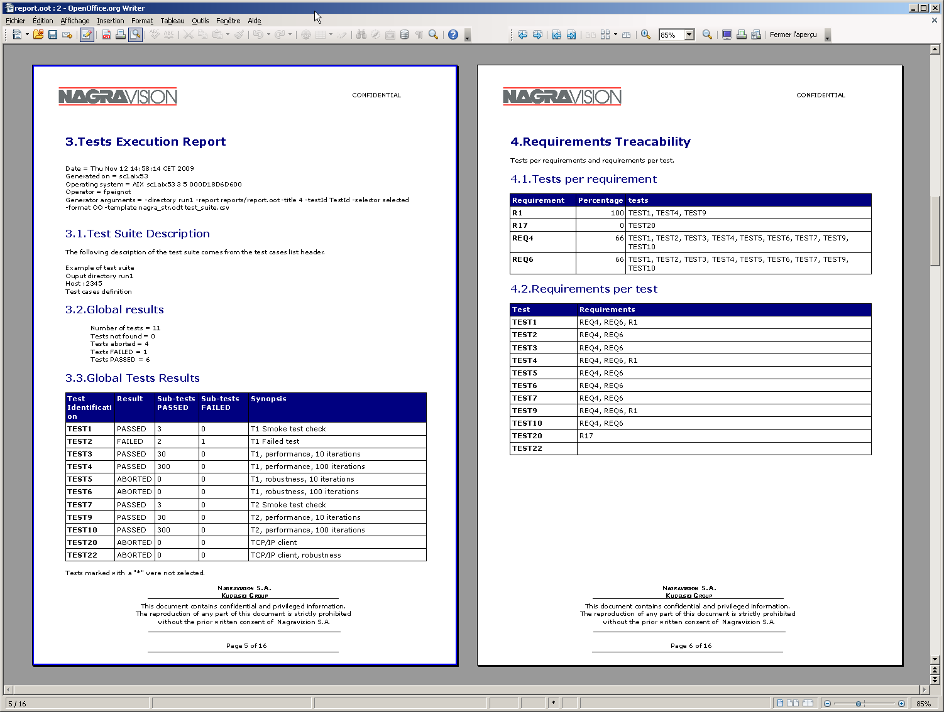
Figure 13, Open Office Test Report

Import of the tests results in the spreadsheet
The same tcl.pl script can be used to import results inside the initial spreadsheet. You just have to specify in which column the results are to be imported.

Elements of Software Tests Description
It often happens that the details of several tests scenarios only differ by the configuration parameters or by the data set on which the test is executed.
The detail of the performed checks is also often described in a software tests description document but also contained in the tests themselves. To avoid duplication of the information, it can be convenient to either extract the tests configuration parameter from the tests description document or to extract some parts of the test description documents from the tests. For example, traceability matrix can often be efficiently extracted from the tests.
We have to notice that this point is less important than the generation of test reports, the information is less dynamic. The results of a tests suite can change dramatically from one execution to the other; the description of the tests is not likely to change as dynamically.

Utilities

Configuration files access and modifications
The package used to handle configuration file is name ‘Aconfig.pm’, its name stands for “another configuration file management package”.
Compared to other Perl modules used to manage configuration files, this one has the following characteristics:
- Simple interface to access or change variables values.
- Supports comments and preserves them when opening, changing and saving a configuration file with comments.
- Possibility to edit existing configuration files or generate them from scratch.
- Support for single variables, lists and sections.
- Keeps track of line number for an easier error reporting
- Can be used to edit Makefiles.
Example of configuration file:
# comments are marked by a pound sign
# this module preserves them. (Most of the time
# there is no support for end of line comments).

Var1 = value1 # variable definition

[section1] # section definition

List = value1, Value2, Value3 # List definition

# Lists can also be spread on several lines with backslash markers.
# This feature is convenient to handle Makefiles.
List = firstValue \
secondValue \
lastValue

A special effort has been made to make access to the variable values easy. All methods have a section and a variable parameter; the section parameter can be left undefined to refer to the variables declared before the first section.

# Load a configuration file
my $cfg = new TestTools::Parser::Aconfig('filename' => 'test.cfg');

# To get the value of the variable ‘var4’ in section ‘[Interfaces]’
my $value = $cfg->value ('Interfaces', 'var4');
# To change the value of this variable
$cfg->value ('Interfaces', 'var4', 4);

# Then save the initial configuration
$cfg->save('test.cfg');

There is also a quite sophisticated configuration file checker, able to perform a lot of checks on configuration files. It is able to check them for mandatory sections and variables and to check rules on variable contents, etc.

File lists
File Lists is a module able to recursively record the content of a directory. These objects can be compared for different directory contents, different file size and content, etc. It is used to check if a tested program has accessed or modified some files in the file system.

XML parsing and generation
I use the twig module from CPAN as XML parser. It supports SAX and DOM parsing, but also a mixed of the two models as well as a more flexible syntax to address XML elements.

Event Driven Programming

Principles
Here is a short introduction on the problem; you will find more information on the internet or in a good Perl book.
I only know two paradigms to handle concurrency and simultaneous access to multiple devices:
- Event driven programming. Programs have a single thread of execution and are organized around and event loop processing. Handlers are attached to events to process input and output data.
- Blocking multi-threaded application. In this case there is one thread of control attached to every device descriptor and the thread is blocked when operations on the device are not possible.
Event driven programming is considered more efficient in computer resources (memory and CPU) because it does not require the management of several threads of control with their associated resources (thread control blocks and stacks). It also does not require thread context switches which are a time consuming operations.
Event driven programs are also considered simpler to write because they do not require protecting data against concurrent access. In pure model you only have one thread of control, so whatever the action that you are executing you have the guarantee to not be interrupted by a higher priority action.
These reasons and perhaps the fact that efficient multi-thread libraries have appeared only recently in Perl environments, have made event driven programming the preferred method with interpreted languages.
Note that the relative complexity of the concepts presented here is related to the management of a certain level of concurrency. If your problematic is basically sequential, and a lot of test programs can be sequential, just skip this section and write sequential test programs.

The Events library
The Events library contains all the support for event driven programming in the toolbox. It is organized around two main classes; the event manager which provides an event processing loop and routines to register or unregister event handlers and the “Connector” class. All events handlers are objects that derive from the “Connector” class, they provide the same service.
Objects are a convenient way to handle business context, it is why this layer has some added value. The event manager is a thin layer on top of the CPAN Event package. Initially I used a package written by Stephane to manage events, but this one is more flexible and has more features. A good thing about having a façade is that you can replace the event manager mechanism without having any impact on the test programs.
The Events library contains the following classes:

./Events/UDPReader.pm | Connector for UDP/IP listener
./Events/Console/Test.pm | Console driver unit test
./Events/Socket.pm | TCP/IP socket management, it is a Connector
./Events/Console.pm | Connector to access console and keyboard
./Events/EchoService.pm | Example of TCP/IP service.
./Events/SMA.pm | State Machine Automaton class. State machine automatons are convenient to organize event driven programs and this version uses the Timer Connector to manage timeouts.
./Events/File.pm | Connector for file descriptors
./Events/Program.pm | Connector to control input and output of a Unix program
./Events/ProxyService.pm | Proxy service. This connector has been develop for the spy program which is a proxy in recording mode.
./Events/Server.pm | TCP/IP Server Connector
./Events/Timer.pm | Timer connector
./Events/EventsManager.pm | Event manager. Register connectors and process the event loop.
./Events/Replay.pm | Replay service. This service has been written for the spy script.
./Events/Connector.pm | Ancestor of all handlers.
./Events/SMATimer.pm | Timers for the State Machine Automaton
./Events/ScenarioDumper.pm | Dumper for recorded TCP/IP sessions, used by spy.
./Events/ClientSequencer.pm | Support for TCP/IP clients
./Network/Client.pm | Simple blocking TCP/IP client class. This class is not event driven, it provide the same interface for a blocking client.

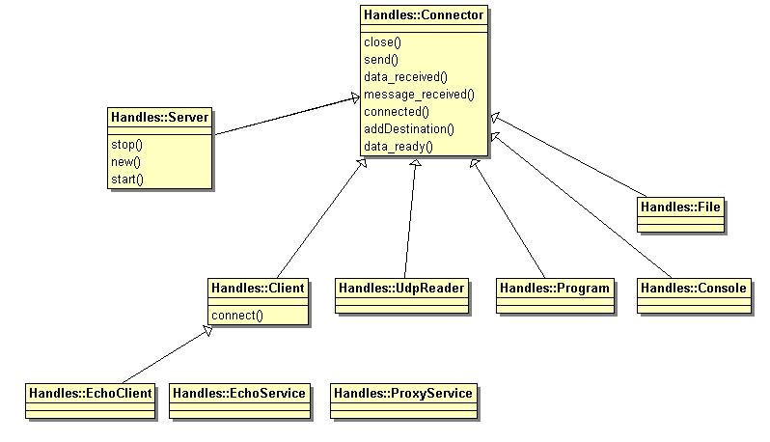
Figure 14, Connectors class diagram

State Machine Automaton
I have seen a lot of state machine automaton manager which would have been advantageously replaced by a few lines of well written code. People often decide to use a state machine manager because during design it helps to think about the problem as a state machine.
It often result in programs more difficult to understand and more difficult to debug.
There is one case however where state machine automatons come in handy, it is with event driven programming. In this case all the control of your program is dispatched among multiple low level handlers and it is difficult to control the global logic of the program.
By using a simple state machine automaton and having your handlers just triggering automaton transitions, things are easier to handle.
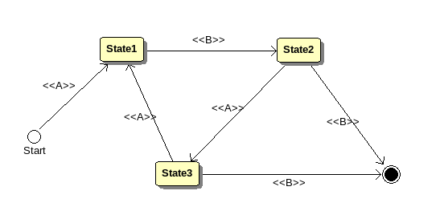
Figure 15, Simple state machine automaton
The toolbox contains a state machine automaton manager. It has all the good features to decrease the hassle of usual automaton:
- Declarative programming for the constructor parameters. Creation of a SMA, is just a question of providing a list of states, events and transitions.
# Declarative part, let's build a SMA
# -----------------------------------
my $sma = new Events::SMA(
states => [ 'Initial', 'State1', 'State2', 'Terminal' ],
events => [ 'A', 'B', 'Error' ],
initial => 'Terminal',
transitions => {
'Initial' => { 'Start' => 'State1' },
'State1' => {
'A' => 'State2',
'B' => 'Terminal'
}
},
finals => { 'Terminal' => 1 },
record => 1
);

- History feature; it is possible to record all the events that have happened during the life of the SMA and control all the transitions.
- Entry and Exit callbacks; it is possible to attach entry and exit callbacks to states or group of states. Entry callbacks are called each time the SMA enters a state during a transition, exit callbacks are executed when the SMA leaves the state. It is possible to attach generic callbacks triggered on any event, or specific ones which are triggered on specific events.
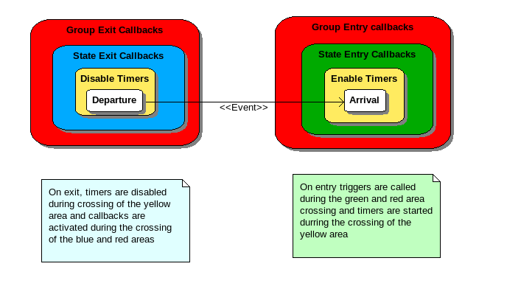
Figure 16, SMA callbacks
- Safe timers; safe timers are events which are automatically triggered after a timeout. They are safe because they are attached to states and automatically activated when you enter a state and automatically disabled when you leave a state. That way you have the guarantee that timeouts do not happen in states in which they are not expected.
- Nested automaton; transitions, callbacks and timeouts can refer to individual states or to group of states. By convention, nested states are identified with a dotted notation. For example the name “test.phase1.A” refers to a state “A” of a sub automaton named “phase1”, itself a sub automaton of a global state name “test”. With this mechanism it is easy to attach a timeout at the global test level or at any sub level.

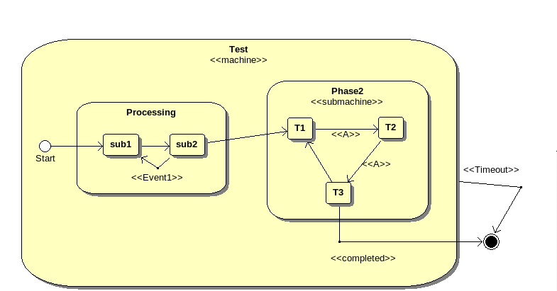
Figure 17, Nested SMA

Networking
This section explains how to build networking components based on the event driven programming support provided by the “Events” classes. See chapter on “Event Driven Programming” for the justification of the choices.

Note that to write purely sequential programs, you should rather look at the BlockingClient template and use directly the IO::Socket module or the Network::Client which provides an object oriented wrapper.

Writing a Simple TCP/IP client
We consider that you already have a CODEC class to handle your communication protocol. If you do not have a CODEC, read the section about CODECs and come back later.
This section explains how to develop a simple TCP/IP client test program. We want to checks that the tested TCP/IP server replies as expected to transmitted requests.
The test scenario is simple, a set of predefined requests are sent to a server. Request service times are measured and validity of the replies is checked. The test counts the number of compliant and non compliant replies; it is supposed to be globally passed when there are no unexpected replies (or lack of replies). Note that some of the messages are voluntarily erroneous to check the reaction from the server to erroneous requests. It is really the typical test scenario of a TCP/IP server.
There is an example in $FTF/templates/CLientTemplate.pl; it is the test of a small Fibonacci sequence server. We need just to replace the logic to change the test scenario.
First copy and customize two files:
- $FTF/templates/ClientTemplate.pl copied into MySimu.pl
- $FTF/templates/FiboSequence.pm copied into MySequence.pm
As for other templates, the places to change are marked by a “# To customize” comment. Rename all the references to Fibo something into the correct classes name; replace the CODECs::Telnet by the correct one.
First as most of the requests are static in our test scenario, lets create a module to contain all the requests and name it MyMessages.pm. It is a good idea to take advantage of the readable syntax used to defined messages, but there is no direct support in the CODEC to generate some of the erroneous messages.
Note: I did not implement any support to encode incorrect message but it is something that would make sense in a test toolbox. For example we could add some support to explicitly duplicate some fields or encode erroneous values.
The only differences between all the tests on the interface are the messages sent and the expected replies, so we are going to pass the test ID parameter to the sequence. The sequence will adapt the messages to send and expected replies according to the test Id.

Writing a TCP/IP server simulator
The ServerTemplate.pl is already a multiple client, multiple connection TCP/IP server. You can use it and just need to supply a service factory object. A service factory is a class that creates an object to handle a connection.
Of course the object that you return must contain the implementation of your service.

Complex TCP/IP Servers and Clients
As the clients and servers are events based, you can declare as many different clients and servers that you want in the same script, there will all be scheduled by the same event loop.

CODECs Management
CODECs libraries are the classes used to analyze binary buffers to convert them into business data and to generate binary buffers from business data. They are used in networking to interpret the received messages and to generate messages to send. They are also used to read and write structured binary files.

Explicit support to perform this kind of operations is not mandatory. It is perfectly possible to let each programmer implement these features his own way. However it is more efficient when it is not redone every time and the programmers can take advantage of some high level libraries.

It is also interesting to standardize the way that CODECs are implemented because other layers of the framework rely on a standard set of services from the CODECs. For example, all the network objects may have a CODECs object reference that they use to dump messages in high level traces.

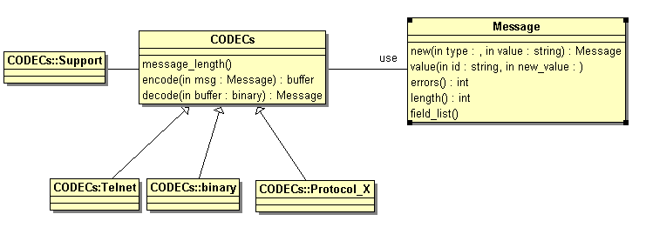
Figure 18, CODECs class diagram

CODECS are organized around the following classes:

- CODECs which is an abstract class with three methods:
  - Encode which translate a structured message into a binary buffer.
  - Decode which translate a binary buffer into message.
  - Message_length which analyze a binary buffer and returns the length of the first message found.
- Message which is a generic container for structured data. Messages can contain scalars, records and lists. Sub-elements can themselves be scalar, records and lists. The Message class contains all the methods needed to build messages or access to sub-elements.

As CODECs is an abstract class, programmers are supposed to provide an implementation for every protocol that they want to use. We will see below that the class CODECs::Support contains routines which would make this task easy in most of the cases. If you do not find the services that you would like in this class do not hesitate to ask for evolutions. If your request is not too specific better to do it in the common classes that in the one specific to your protocol.

Design Choices Justification
I have developed support for this problem several times and I have seen even more implementations from other developers. I want to explain why I have done the choice described above, in comparison with other alternatives.

Bytes arrays
I have seen in some of our components pieces of codes in which the CODEC layer did not exist. In this code the messages are just byte sequences generated by the emitter and received by the receiver.
The main problem with this approach is that you have no separation between the business aspect of the message and the layout. When you want to change the layout to replace for example a 16 bits unsigned integer by a 32 one, every piece of code which use the message is impacted. The end result is that it can take weeks for software teams to propagate this kind of changes in a whole system.

One class per message type
This point is also very important. When people want a clean approach of the problem, they decide to use objects to handle messages and naturally design one class of each message type, with access methods to access each sub-element.
This approach is clean but does not scale up well. It is not rare to write around 1 000 lines of code for each type of message.
So instead of providing one class per message type, I propose the use the “Message” class which is a container for all types of possible messages. With this approach, the control that a list of values is compliant with a special layout is done by the encode method. It means that the control is done at execution time rather than at compile time. I prefer compilation time checks than execution time checks each time that I can, but on this case it is possible to save a lot of developer time, so I think that it worth it.
At last, even if you really need to have one class for each message type in your application you will be able to save a lot of time by using the “Message” and “CODECs” approach to implement these classes.

Code generation
Code generation has been my answer to the problem as long as I did not reject the one message type – one class paradigm. It is a very efficient approach to generate a lot of code with a regular structure. But if you prefer the one class approach, the need for code generation disappears.

Usage
See the HTML API documentation for details (Class CODECS and Messages).

Messages
The Message class has been designed to support a very natural syntax for its constructor. Note that the dump method is compatible and generates an output which can be cut/and pasted in the code to create new messages.

$msg = new Message(
type => 'SCHEDULE',
value => {
'ID' => 12,
'COMMENT' => "Only during the first quarter",
'CLASS_LIST' => [
{'DAY' => MONDAY,
'START_TIME' => {'HOUR' => 8, 'MINUTE' => 30},
'END_TIME' => {'HOUR' => 9, 'MINUTE' => 30},
'TEACHER' => 12,
'ROOM' => 402},
{'DAY' => FRIDAY,
'START_TIME' => {'HOUR' => 15, 'MINUTE' => 0},
'END_TIME' => {'HOUR' => 17, 'MINUTE' => 30},
'TEACHER' => 7,
'ROOM' => 123}
]
}
);

If you prefer you can change the values of an existing message or create it step by step by using the programmatic interface.

Access to message sub components
Once the message structured value is defined, it is really easy to encode it using a specific CODEC.
Note also the dotted notation used to access messages subcomponents. Fields separated by dots are used to identify a field of a record, numbers into square brackets are used to identify list elements.

$decoded = Decode( 'SCHOOL', $bin );

my $id = $decoded->value('ID');
my $start = $decoded->value('CLASS_LIST.[0].START_TIME.HOUR');

CODECs Development Support
The best way is first to start from an existing one.
Initially, I thought that the most important thing about CODECs was their interface. As long as a CODEC is compliant to the CODEC specification it can be used inside the framework. So I supplied a support class for TLV messages, and started to write CODECs. After a while I realized that with this approach most of the CODECs were going to have their own design and that it would not be efficient. So I have re-used the design made for the initial Tcl toolbox, which is quite ambitious, perhaps slightly complex but much closer from the ultimate solution for this kind of problem.
The idea is simply to define combinable data types with the ability to encode messages and generate binary buffers and to parse binary buffers according to the types.
There are two kinds of types, the basic types (integer, string, binary buffers) and the containers (lists and records). Then any protocol can be expressed as a combination of basic and complex types organized into containers.
When such support is available and reasonably bug free, it is the most efficient approach to protocol support. As soon as your protocol is specified in the formal format, you are done. Experience with the Tcl toolkit has demonstrated almost an order of magnitude in efficiency improvement. Experience has also demonstrated the importance of traces during protocol parsing. When a message is rejected for being not compliant with the protocol definition you need a very detailed error report to understand why.
To be honest, when bugs have been discovered in the parser during protocol definition, the time saving has not been so huge.
One main difference between the Tcl and Perl implementation is that the Perl one is fully object oriented. It makes the code cleaner and for example container development is much easier. You will find below the protocol parsing and encoding support classes.
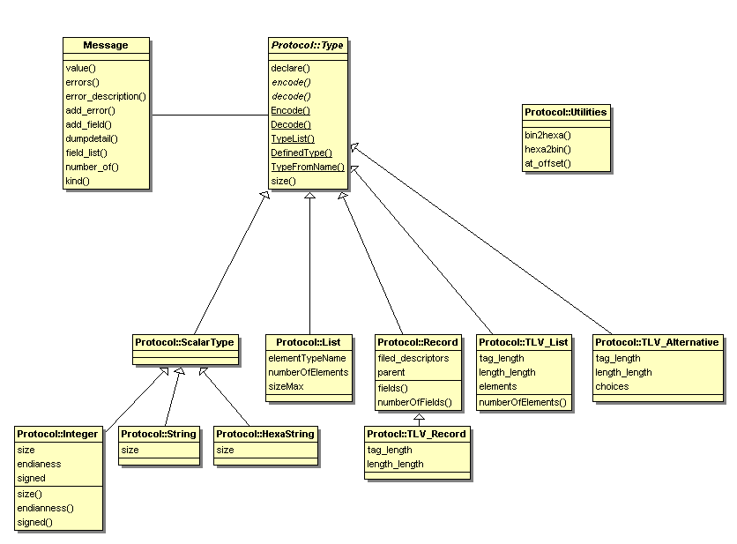
Figure 19, Parser::Protocol class diagram

Using types by name
Type support is fully object oriented and you can declare new types with their attributes and use these new objects to encode or decode messages
Example:

my $str8 = new TestTools::Parser::Protocol::String(name => 'string8',
size => 8);
my $buffer = $str8->encode("01234567");

To make code easier to read there is an access by name to the declared types. A table of existing types is updated when types are created. It is possible to encode and decode messages using the Encode and Decode static methods which take a type name instead of a type object. These two method names start by an upper case character to distinguish them from the object methods.

There is also an alias to the constructor, named ‘declare’ which can be used when you intend to use the types only by name. If you change your mind, there is also a routine named ‘TypeFromName’ which return the type object from its name.

Example:

declare TestTools::Parser::Protocol::String(name => 'string8', size => 8);

my $buffer = Encode ("string8", "01234567");

Supported types

Integers
This class provides the support for signed and unsigned integers on 1, 2, 4 and 8 bytes. By default generated bytes are encoded in big Endean mode.
For convenience the following types are predefined: “byte”, “unsigned16” and “unsigned32”.

Strings
This class provides the support for fix size and unbounded strings. It only supports 8 bits characters.
For convenience the type “string” is already predefined, it can contain a variable size string.

HexaStrings
This class provides the support for binary buffers expressed in hexadecimal. It supports fixed size and unbounded binary strings. Except for readability, this type is universal and you could use it to encode or decode any message.
For convenience the type “binary” is predefined and can contain binary string of any size.

Lists
Lists are sequences of same type elements. Each element can be addressed by a numerical index. The first element of the list is referenced by the index 0.
Lists can be either bounded and have a maximal number of elements or unbounded. To specify a bounded list use the NumberOfElement attribute.
To encode a list you must provide a reference to a list of values (a list of comma separated values inside square brackets).
Example:

declare TestTools::Parser::Protocol::List(
name => 'int_3_list',
numberOfElements => 3,
'elementTypeName' => 'unsigned16'
);
my $buffer = Encode('int_3_list', [1, 2, 3]);

The previous example would encode a binary buffer containing “000100020003”.
Type of the sub-element must have been already declared.
When the attribute named numberTypeName is present, the number of elements in the list is encoded in an integer of the referenced type. In the following example, the number of elements in the list (2) is encoded inside a byte prior to the list elements.

declare TestTools::Parser::Protocol::List(
name => 'list_with_nb',
numberTypeName => 'byte',
'elementTypeName' => 'unsigned16'
);
$buffer = Encode('list_with_nb', [0xDEAD, 0xBEEF, 0xDEAD]);
is( bin2hexa($buffer), lc("02DEADBEEF"), "list with number of elements" );

The previous example would be encoded according to the following layout:
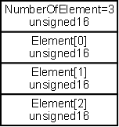
Figure 20, Protocol::List layout
During decoding an error is reported if the binary buffer does not contain at least the number found inside the number of elements field. Decoding is truncated when too much binary data are provided.

Records
Records are sequences of fields. Each field can be of different types. Fields are accessed by name.
To encode a record you must provide a reference to a hash table.
Example:
declare TestTools::Parser::Protocol::Record(
name => 'date',
field_descriptors => [
{name => 'day', type => 'byte'},
{name => 'month', type => 'byte'},
{name => 'year', type => 'unsigned16'}
]
);
The previous type is encoded according this layout:
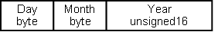
Figure 21, Protocol::Record layout

Parent attribute
Records can have a parent attribute, in which case the real list of fields is the combination of the list of field of the parent plus the one of the record.

Default and value attribute
Record fields can also have a default or value attribute; they allow the specification of a value for a field at type declaration. When a value is defined in the type it is useless to supply it at the encode method. The difference between value and default is that it is possible to overwrite a default but not a value and that the decode method also check that found values are compliant to the one defined with the type.
Example:
# Record with predefined values
declare TestTools::Parser::Protocol::Record(
name => 'currentDate',
field_descriptors => [
{name => 'day', type => 'byte'},
{name => 'month', type => 'byte'},
{name => 'year', type => 'unsigned16', value => 2009}
]
);

# Record with a default value
declare TestTools::Parser::Protocol::Record(
name => 'currentDateDefault',
field_descriptors => [
{name => 'day', type => 'byte'},
{name => 'month', type => 'byte'},
{name => 'year', type => 'unsigned16', default => 2009}
]
);

Conditional field
It is also possible to specify a condition attached to a field. When a condition is present, it is evaluated during encoding and decoding and the associated field is only expected when it evaluates to true.
In the following example, we manage a record with a field ‘driver_id’ which only exists when the person is over eighteen.

# Record with conditional values
declare TestTools::Parser::Protocol::Record(
name => 'citizen',
field_descriptors => [
{name => 'name', type => 'string8'},
{name => 'age', type => 'byte'},
{name => 'driver_id',
type => 'unsigned16',
condition => "\$value->{'age'} >= 18"},
{name => 'zip', type => 'unsigned32'}
]
);

What is exactly supported is not simple to explain, in fact it is everything which can be interpreted in the context of the ‘encode’ and ‘decode’ routines. By convention, the values of the record fields are contained in a hash table referenced by a variable named $value. During decoding, this variable only contains the value of the fields previously decoded, so the conditions can only refer to fields placed before the conditional ones.
Note that due to the recursive nature of the encoding and decoding process, there is currently no support to include conditions referring to the nesting scopes.

TLV
TLV are special containers which are encoded according to the tag-length-value format. The value of the ‘length’ field is computed automatically during encoding and set to the length of the “value” field.
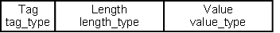
Figure 22, Protocol::TLV layout
In the initial implementation TLV records were just a special kind of records. They derived from the record class. It was working but you had to add the prefix ‘VALUE’ each time that you wanted to address a sub-component; it made the syntax more difficult to read.

TLV_List
TLV lists can contain only TLV records. They support single or multiple occurrences of each field. You must provide a hash table to encode such a data type. When an element is multiple you must provide a list for it.

declare TestTools::Parser::Protocol::TLV_List
(name => 'msg1_params',
elements => [
{name => 'TR_PERIOD', mandatory => TRUE, multiple => FALSE},
{name => 'STB_CA_SN', mandatory => TRUE, multiple => FALSE},
{name => 'TR_NUMBER', mandatory => FALSE, multiple => TRUE},
{name => 'D_KEY', mandatory => FALSE, multiple => FALSE}
]);

my $bin = Encode ('msg1_params', {
TR_PERIOD => 1,
STB_CA_SN => 2,
D_KEY => "0123456789ABCDEF0123456789ABCDEF"
});

The previous list will be encoded according to the layout below:

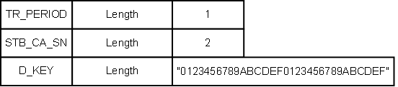
Figure 23, Protocol::TLV_List layout

TLV_Message
TLV messages are the encapsulation of a header record, and a TLV with a list of TLV parameters as value. They provide support for the a frequent pattern, made of a list of positional fields, followed by a tag and length and a set of TLV parameters. The TLV parameters are themselves TLV encoded.
Here is a TLV_Message declaration:

my $tlvm = new TestTools::Parser::Protocol::TLV_Message(
name => 'msg',
field_descriptors => [
{name => 'protocol', type => 'byte'},
{name => 'version', type => 'unsigned32'}
],
tag => 0x35,
tag_type => 'byte',
length_type => 'unsigned32',
elements => [
{name => 'TR_PERIOD', mandatory => TRUE, multiple => FALSE},
{name => 'STB_CA_SN', mandatory => TRUE, multiple => FALSE},
{name => 'TR_NUMBER', mandatory => FALSE, multiple => TRUE},
{name => 'D_KEY', mandatory => FALSE, multiple => FALSE}
]
);

This type can then be used this way:
my $buffer = Encode('msg', {
protocol => 47,
version => 0xFF,
TR_PERIOD => 1,
STB_CA_SN => 2,
D_KEY => "0123456789ABCDEF0123456789ABCDEF"
});
Message layout:
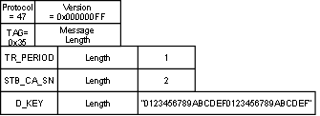
Figure 24, Protocol::TLV_Message layout

TLV_Alternative
TLV alternatives are a facility used for decoding. They can return a message from any type from the defined list of TLV records or TLV messages.

declare TestTools::Parser::Protocol::TLV_Alternative
(name => 'alternative',
choices => ['TR_PERIOD', 'STB_CA_SN', 'TR_NUMBER', 'D_KEY']);

my $bin = Encode ('TR_NUMBER', {VALUE => 0xFFFFFFFF});
my $msg = Decode ('alternative', $bin);

Once you have decoded a message using an alternative, the message is exactly as if it had been decoded using directly the correct type.

Protocol Decoding traces strategy
One of the things learned with the Tcl library is the highest importance of the traces during the decoding process. When you write yourself all the code to encode and decode messages, you usually start from the basic messages blocks and you add more messages and more complexity along the development. It is an iterative process, you usually add little complexity at each step and you debug them continuously. The result is that you always have a working system with increasing capability of handling more and more complex messages.
When you use a declarative approach, it is much easier to declare all the messages before to start the tests. When a binary string containing a complex message is rejected by a decoding method it is hard to understand the reason. It may be because the message is actually badly formatted or because of an error in the protocol specification. When the reason is a mismatch found deep inside the message structure debugging may be complex.
There are several types of information that a decoding routine can display:
- its identity
- its contextual parameters, for example an integer debugging method can decode integer with several sizes
- the binary buffer to process
- the binary buffer actually processed (usually shorter)
- the error detected at this level
- the fact that errors have been found in nested components
- the resulting message
- all the choices made when the type is a variable one (list size, TLV alternative, TLV list)
Note also that as the mechanism is highly recursive, we must take into account if the traces of the sub-elements are displayed before or after the traces of each container.

Trace | The whole input binary buffer. Note that it can be quite big and tends to clutter the display.
Debug | The actually used binary buffer. We usually only know its limit at the end of the decoding routine
Info | resulting value
Warn | Contextual parameters, choices
Error | Routines identity, detected errors
Fatal

C and C++ libraries bindings
Even if Perl is a convenient language for tests development, there are some times when it is required to use libraries developed in other languages. Most of the time it is because a development has already be done in another language and we want to re-use it.
Typically in our case we want to re-use cryptographic libraries containing custom algorithms.
There are several technologies to create C++ and C bindings usable by Perl. The oldest one is Perl XS. XS is an interface description file format used to create an extension interface between Perl and C code (or a C library) which one wishes to use with Perl. The XS interface is combined with the library to create a new library which can then be either dynamically loaded or statically linked into perl. The XS interface description is written in the XS language and is the core component of the Perl extension interface.

We have made some experiment on Perl XS, and there is even a white paper explaining how to use it on AIX in the toolbox. However it is not so easy to use and we have preferred swig to XS.

How to use swig to create a C++/Perl binding
The following section explains how we heave used swig to create a C++ binding. You are invited to read the full swig documentation for details; this chapter should help you to start.
Our example is a small set of C sources and include files.
Swig source files contains mainly the C declarations of the C library, plus some directives on parameter conventions.
Swig declaration:
%module sclbinding

%{
#include "3des.h"
%}

%include "cstring.i"

%include "3des.h"

/* ------------------------------------------------------------------------
* The following instructions allocate a binary buffer
* that can be used as a Perl return value.
* Warning: Swig does not check the spelling of these declarations.
* Spelling mistakes generate runtime errors.
* ------------------------------------------------------------------------
*/

/* fixe size output */
%cstring_chunk_output (char * rk, 176);
%cstring_chunk_output (char * outciphertext, 16);
%cstring_chunk_output (char * outplaintext, 16);

/* char pointers + size input */
%apply (char *STRING, int LENGTH) { (char *pxKey, int xKeySize) };
%apply (char *STRING, int LENGTH) { (char *data, int dataLength) };

%inline %{
Binding for one routine:
/* ------------------------------------------------------------------------
* routine: SCL_AES_Decrypt
* AES decryption
*
* parameters:
* rk - pointer on the expanded key
* ciphertext - pointer on a 16 bytes ciphertext block
* plaintext - pointer on the 16 bytes plain text result
* ------------------------------------------------------------------------
*/
void SCL_AES_Decrypt (const char * rk,
const char * ciphertext,
char * outplaintext) {
AES_Decrypt ((const unsigned long *) rk,
(const unsigned char *) ciphertext,
(unsigned char *) outplaintext);
}

Then the swig source file is compiled with the compiler provided in the swig distribution, it generates some C files and a Perl module. The C files are also compiled with a C compiler to generate the library that will be loaded by the Perl module.
It is usually easier to perform the parameter checks in Perl than in C, so I recommend to encapsulate the swig generated Perl module by a more user friendly one in charge of performing the parameters checks and eventually to provide some related services.
Once the binding is generated, you can test it.
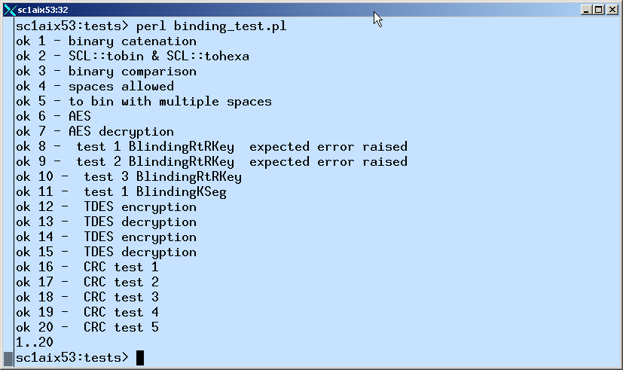
Figure 25, Result of the binding unit test

Databases

There is no need for additional support to access databases in Perl. The module DBI provides a generic interface to a lot of databases, including Oracle.
By using this module you can send SQL queries and process the replies. There is a short example using SQLite in the toolbox.

Interfaces

- Example of test log

2009/10/28 10:26:02 DEBUG Tests.Traces:407 Tests.Traces : Test _init
2009/10/28 10:26:02 WARN Tests.Doc:407 Tests.Doc : Script path = /home/users/fpeignot/SVN/PerlTestTools//templates/ClientTemplate.pl
2009/10/28 10:26:02 INFO Tests.Doc:407 Tests.Doc : Script basename = ClientTemplate
2009/10/28 10:26:02 INFO Tests.Doc:407 Tests.Doc : Configuration file name = /home/users/fpeignot/SVN/PerlTestTools//templates//ClientTemplate.ini
2009/10/28 10:26:02 INFO Tests.Doc:407 Tests.Doc : Log file = run1/TEST20.log
2009/10/28 10:26:02 INFO Tests.Doc:407 Tests.Doc : log4perl configuration file = /home/users/fpeignot/SVN/PerlTestTools//templates/log4perl.conf
2009/10/28 10:26:02 INFO Tests.Doc:407 Tests.Doc : Logger = log4perl.logger.Tests
2009/10/28 10:26:02 WARN Tests.Doc:407 Tests.Doc : Date = Wed Oct 28 10:26:02 CET 2009
2009/10/28 10:26:02 WARN Tests.Doc:407 Tests.Doc : User = fpeignot
2009/10/28 10:26:02 WARN Tests.Doc:407 Tests.Doc : OS = aix
2009/10/28 10:26:02 WARN Tests.Doc:407 Tests.Doc : Command line Arguments =
2009/10/28 10:26:02 WARN Tests.Doc:407 Tests.Doc : Configuration =
verbose => 0
block_size => 0
match =>
requirements =>
directory => .
outputDirectory => run1
host => :2345
memory => 0
skip =>
pid => 0
iteration => 1
help => 0
testId => TEST20
performance => 0
2009/10/28 10:26:02 INFO Tests.Doc:407 Tests.Doc : --------------------------------------------------------------------------------
2009/10/28 10:26:02 INFO Tests.Doc:407 Tests.Doc : Keywords =
2009/10/28 10:26:02 INFO Tests.Doc:407 Tests.Doc : Requirements =
2009/10/28 10:26:02 INFO Tests.Doc:407 Tests.Doc : --------------------------------------------------------------------------------
2009/10/28 10:26:02 TRACE Tests.Traces:407 Tests.Traces : Test matching for ()
2009/10/28 10:26:02 TRACE Tests.Traces:407 Tests.Traces : Test testId started
2009/10/28 10:26:02 TRACE Tests.Traces:407 Tests.Traces : SetUp
2009/10/28 10:26:02 DEBUG CODECs.Telnet:41 Creating instance of CODECs::Telnet
2009/10/28 10:26:02 DEBUG CODECs.Binary:43 Creating instance of CODECs::Binary
2009/10/28 10:26:02 DEBUG Tests:49 (127.0.0.1:2345) connected
2009/10/28 10:26:02 INFO Tests:184 -> 10
2009/10/28 10:26:02 INFO Tests:184 -> 11
2009/10/28 10:26:02 INFO Tests:184 -> 12
2009/10/28 10:26:02 INFO Tests:184 -> 13
2009/10/28 10:26:02 INFO Tests:184 -> 14
2009/10/28 10:26:02 TRACE Tests:307 data_ready, bytes to write = 15
2009/10/28 10:26:02 TRACE Tests:325 data_ready, bytes written = 15
2009/10/28 10:26:02 DEBUG Tests:328 -> (127.0.0.1:2345) 31300a31310a31320a31330a31340a
2009/10/28 10:26:02 TRACE Tests:210 Connector::data_received from IO::Socket::INET=GLOB(0x110b38380)
2009/10/28 10:26:02 DEBUG Tests:230 <- (127.0.0.1:2345) 6669626f2028313029203d2038390a6669626f2028313129203d203134340a6669626f2028313229203d203233340a6669626f2028313329203d203337380a6669626f2028313429203d203631310a
2009/10/28 10:26:02 TRACE Tests:233 input buffer length = 79
2009/10/28 10:26:02 INFO Tests:249 <- fibo (10) = 89
2009/10/28 10:26:02 WARN Tests.Checks:407 Tests.Checks : PASSED fibo(10) = 89
2009/10/28 10:26:02 INFO Tests:184 -> 15
2009/10/28 10:26:02 INFO Tests:249 <- fibo (11) = 144
2009/10/28 10:26:02 WARN Tests.Checks:407 Tests.Checks : PASSED fibo(11) = 144
2009/10/28 10:26:02 INFO Tests:184 -> 16
2009/10/28 10:26:02 INFO Tests:249 <- fibo (12) = 234
2009/10/28 10:26:02 ERROR Tests.Checks:407 Tests.Checks : FAILED fibo(12) = 233
2009/10/28 10:26:02 INFO Tests:184 -> 17
2009/10/28 10:26:02 INFO Tests:249 <- fibo (13) = 378
2009/10/28 10:26:02 ERROR Tests.Checks:407 Tests.Checks : FAILED fibo(13) = 377
2009/10/28 10:26:02 INFO Tests:184 -> 18
2009/10/28 10:26:02 INFO Tests:249 <- fibo (14) = 611
2009/10/28 10:26:02 ERROR Tests.Checks:407 Tests.Checks : FAILED fibo(14) = 610
2009/10/28 10:26:02 INFO Tests:184 -> 19
2009/10/28 10:26:02 TRACE Tests:307 data_ready, bytes to write = 15
2009/10/28 10:26:02 TRACE Tests:325 data_ready, bytes written = 15
2009/10/28 10:26:02 DEBUG Tests:328 -> (127.0.0.1:2345) 31350a31360a31370a31380a31390a
2009/10/28 10:26:02 TRACE Tests:210 Connector::data_received from IO::Socket::INET=GLOB(0x110b38380)
2009/10/28 10:26:02 DEBUG Tests:230 <- (127.0.0.1:2345) 6669626f2028313529203d203938370a6669626f2028313629203d20313539370a6669626f2028313729203d20323538340a6669626f2028313829203d20343138310a6669626f2028313929203d20363736360a
2009/10/28 10:26:02 TRACE Tests:233 input buffer length = 84
2009/10/28 10:26:02 INFO Tests:249 <- fibo (15) = 987
2009/10/28 10:26:02 WARN Tests.Checks:407 Tests.Checks : PASSED fibo(15) = 987
2009/10/28 10:26:02 INFO Tests:184 -> 20
2009/10/28 10:26:02 INFO Tests:249 <- fibo (16) = 1597
2009/10/28 10:26:02 WARN Tests.Checks:407 Tests.Checks : PASSED fibo(16) = 1597
2009/10/28 10:26:02 INFO Tests:249 <- fibo (17) = 2584
2009/10/28 10:26:02 WARN Tests.Checks:407 Tests.Checks : PASSED fibo(17) = 2584
2009/10/28 10:26:02 INFO Tests:249 <- fibo (18) = 4181
2009/10/28 10:26:02 WARN Tests.Checks:407 Tests.Checks : PASSED fibo(18) = 4181
2009/10/28 10:26:02 INFO Tests:249 <- fibo (19) = 6766
2009/10/28 10:26:02 ERROR Tests.Checks:407 Tests.Checks : FAILED fibo(19) = 6765
2009/10/28 10:26:02 TRACE Tests:307 data_ready, bytes to write = 3
2009/10/28 10:26:02 TRACE Tests:325 data_ready, bytes written = 3
2009/10/28 10:26:02 DEBUG Tests:328 -> (127.0.0.1:2345) 32300a
2009/10/28 10:26:02 TRACE Tests:210 Connector::data_received from IO::Socket::INET=GLOB(0x110b38380)
2009/10/28 10:26:02 DEBUG Tests:230 <- (127.0.0.1:2345) 6669626f2028323029203d2031303934360a
2009/10/28 10:26:02 TRACE Tests:233 input buffer length = 18
2009/10/28 10:26:02 INFO Tests:249 <- fibo (20) = 10946
2009/10/28 10:26:02 WARN Tests.Checks:407 Tests.Checks : PASSED fibo(20) = 10946
2009/10/28 10:26:02 DEBUG Tests:163 (127.0.0.1:2345) connection closed
2009/10/28 10:26:02 INFO Tests.Counters:407 Tests.Counters : window size = 4
2009/10/28 10:26:02 INFO Tests.Counters:407 Tests.Counters : messages sent = 11
2009/10/28 10:26:02 INFO Tests.Counters:407 Tests.Counters : messages received = 11
2009/10/28 10:26:02 INFO Tests.Counters:407 Tests.Counters : number of errors = 4
2009/10/28 10:26:02 INFO Tests.Counters:407 Tests.Counters : sequence start time = 1256721962.58545
2009/10/28 10:26:02 INFO Tests.Counters:407 Tests.Counters : sequence stop time = 1256721962.96822
2009/10/28 10:26:02 INFO Tests.Counters:407 Tests.Counters : sequence duration = 0.382765054702759
2009/10/28 10:26:02 INFO Tests.Counters:407 Tests.Counters : transactions total time = 1.08274149894714
2009/10/28 10:26:02 INFO Tests.Counters:407 Tests.Counters : transactions number = 11
2009/10/28 10:26:02 INFO Tests.Counters:407 Tests.Counters : transactions average time = 0.0984310453588312
2009/10/28 10:26:02 INFO Tests.Counters:407 Tests.Counters : transactions min time = 0.0588729381561279
2009/10/28 10:26:02 INFO Tests.Counters:407 Tests.Counters : transactions max time = 0.14555811882019
2009/10/28 10:26:02 INFO Tests.Counters:407 Tests.Counters : IterationTime = 0.394570112228394, Iteration = 1
2009/10/28 10:26:02 TRACE Tests.Traces:407 Tests.Traces : CleanUp
2009/10/28 10:26:02 ERROR Tests.Checks:407 Tests.Checks : FAILED global testId, success=7, failures=4
Example of ASCII test report

Section: Tests Execution Report
###############################

Date - Thu Nov 12 14:19:58 CET 2009
Generated on - sc1aix53
Operating system - AIX sc1aix53 3 5 000D18D6D600
Operator - fpeignot
Generator arguments - -directory run1 -report reports/report.txt -title 4 -testId TestId -selector selected test_suite.csv

Section: Test Report Summary
############################

The following description of the test suite comes from the test cases list header.

Example of test suite
Ouput directory run1
Host :2345
Test cases definition

Global results:
###############

Number of tests - 11
Tests not found - 0
Tests aborted - 4
Tests FAILED - 1
Tests PASSED - 6

Section: Global Tests Results
#############################

Execution result for each test.

| Passed Failed
| TestId Result sub-tests sub-tests Synopsis

| TEST1 PASSED 3 0 T1 Smoke test check
| TEST2 FAILED 2 1 T1 Failed test
| TEST3 PASSED 30 0 T1, performance, 10 iterations
| TEST4 PASSED 300 0 T1, performance, 100 iterations
| TEST5 ABORTED 0 0 T1, robustness, 10 iterations
| TEST6 ABORTED 0 0 T1, robustness, 100 iterations
| TEST7 PASSED 3 0 T2 Smoke test check
| TEST9 PASSED 30 0 T2, performance, 10 iterations
| TEST10 PASSED 300 0 T2, performance, 100 iterations
| TEST20 ABORTED 0 0 TCP/IP client
| TEST22 ABORTED 0 0 TCP/IP client, robustness

Tests marked with a "*" were not selected.

Section: Requirements Treacability
##################################

Tests per requirements and requirements per test.

Tests per requirement:
| R1 100% TEST1, TEST4, TEST9
| R17 0% TEST20
| REQ4 66% TEST1, TEST2, TEST3, TEST4, TEST5, TEST6, TEST7, TEST9, TEST10
| REQ6 66% TEST1, TEST2, TEST3, TEST4, TEST5, TEST6, TEST7, TEST9, TEST10

Requirements per test:
| TEST1 REQ4, REQ6, R1
| TEST2 REQ4, REQ6
| TEST3 REQ4, REQ6
| TEST4 REQ4, REQ6, R1
| TEST5 REQ4, REQ6
| TEST6 REQ4, REQ6
| TEST7 REQ4, REQ6
| TEST9 REQ4, REQ6, R1
| TEST10 REQ4, REQ6
| TEST20 R17
| TEST22
- Example of individual test result
Section: TEST3
##############

T1, performance, 10 iterations

Global result - PASSED
PASSED sub-tests - 30
FAILED sub-tests - 0
Log file - run1/TEST3.log
Execution start time - 2009/11/12 13:19:20
Execution end time - 2009/11/12 13:19:20
Command line Arguments - -TestId TEST3 -Synopsis T1, performance, 10 iterations -output run1 -iteration 10 -perf
Requirements - REQ4, REQ6

Documentation:
This test checks that the software works.

The program is started, and then several data sets are submitted.
Each output is checked for conformity.

AcceptationCriteria, this is a self reporting test

Counters:

TotalTime - 0.0260329246520996
Iterations - 10
AverageIterationTime - 0.00260329246520996
MaxIterationTime - 0.00329899787902832
MinIterationTime - 0.00190997123718262

Table IterationTime.Iteration:

| date | IterationTime | Iteration |
| 2009/11/12 14:19:20 | 0.00329899787902832 | 1 |
| 2009/11/12 14:19:20 | 0.00195097923278809 | 2 |
| 2009/11/12 14:19:20 | 0.00199604034423828 | 3 |
| 2009/11/12 14:19:20 | 0.00191593170166016 | 4 |
| 2009/11/12 14:19:20 | 0.00190997123718262 | 5 |
| 2009/11/12 14:19:20 | 0.00191998481750488 | 6 |
| 2009/11/12 14:19:20 | 0.00191903114318848 | 7 |
| 2009/11/12 14:19:20 | 0.0019381046295166 | 8 |
| 2009/11/12 14:19:20 | 0.00191688537597656 | 9 |
| 2009/11/12 14:19:20 | 0.00199103355407715 | 10 |
- Example of protocol definition

# ----------------------------------------------------------------------------
#
# Title: Class CODECs::Schedule
#
# File - CODECs::Schedule.pm
#
# Name:
#
# package CODECs::Schedule
#
# Abstract:
#
# This is an example of CODEC implementation using the TestTools::Parser::Protocol
# support. This protocol handles several kinds of TLV messages;
# - Teachers
# - Rooms
# - Classes which have a start and end time, a teacher and a room
# - schedules which are lists of classes
# - ACK which is the acknowledge message to the above ones.
#
# This protocol has not been designed to be useful in any way, but to demonstrate
# the services provided by the encoding method.
# ----------------------------------------------------------------------------
package CODECs::Schedule;

use strict;
use vars qw($VERSION @ISA @EXPORT @EXPORT_OK);

use CODECs;
use CODECs::Support;

use TestTools::Parser::Protocol::Type;
use TestTools::Parser::Protocol::Record;
use TestTools::Parser::Protocol::List;
use TestTools::Parser::Protocol::TLV;
use TestTools::Parser::Protocol::TLV_List;
use TestTools::Parser::Protocol::TLV_Alternative;
use TestTools::Parser::Protocol::TLV_Message;

$VERSION = 1;
@ISA = qw(CODECs);

##################################
# Section: Protocol definition
##################################

# Command tags
my $msg_tags = {
ACK => 0,
TEACHER => 0x10,
ROOM => 0x11,
CLASSE => 0x20,
SCHEDULE => 0x21};

# parameters tags
my $param_tags = {
ID => 0x00,
NAME => 0x01,
SUBJECT => 0x02,
COMMENT => 0x03,
ERROR => 0x04,
DESCRIPTION => 0x05,
CLASS_LIST => 0x55AA
};

# Message parameters internal types
declare_record ('TIME', [
{name => 'HOUR', type => 'byte'},
{name => 'MINUTE', type => 'byte'}
]);

# ------------------------------------------------------------------
declare_record ('CLASS', [
{name => 'DAY', type => 'byte'},
{name => 'START_TIME', type => 'TIME'},
{name => 'END_TIME', type => 'TIME'},
{name => 'TEACHER', type => 'unsigned32'},
{name => 'ROOM', type => 'unsigned32'},
]);

declare TestTools::Parser::Protocol::List(
'name' => 'CLASS_LIST_VALUE',
'numberTypeName' => 'unsigned32',
'elementTypeName' => 'CLASS'
);

# ------------------------------------------------------------------
# Messages parameters
# name | tag type | length type | value type
declare_parameter('ID' , 'unsigned16', 'unsigned16', 'unsigned32');
declare_parameter('NAME' , 'unsigned16', 'unsigned16', 'string');
declare_parameter('SUBJECT' , 'unsigned16', 'unsigned16', 'string');
declare_parameter('COMMENT' , 'unsigned16', 'unsigned16', 'string');
declare_parameter('ERROR' , 'unsigned16', 'unsigned16', 'unsigned32');
declare_parameter('DESCRIPTION', 'unsigned16', 'unsigned16', 'string');
declare_parameter('CLASS_LIST' , 'unsigned16', 'unsigned16', 'CLASS_LIST_VALUE');

# Declaration of messages
declare_message ('ACK', [
{name => 'ERROR', mandatory => TRUE, multiple => FALSE},
{name => 'DESCRIPTION', mandatory => FALSE, multiple => FALSE},
]);

declare_message('TEACHER', [
{name => 'ID', mandatory => TRUE, multiple => FALSE},
{name => 'NAME', mandatory => TRUE, multiple => FALSE},
{name => 'SUBJECT', mandatory => TRUE, multiple => TRUE}
]);

declare_message('ROOM', [
{name => 'ID', mandatory => TRUE, multiple => FALSE},
{name => 'NAME', mandatory => FALSE, multiple => FALSE},
]);

declare_message('SCHEDULE', [
{name => 'ID', mandatory => TRUE, multiple => FALSE},
{name => 'COMMENT', mandatory => FALSE, multiple => FALSE},
{name => 'CLASS_LIST', mandatory => TRUE, multiple => FALSE},
]);

# It is possible to receive any of the defined messages
declare TestTools::Parser::Protocol::TLV_Alternative (
name => 'SCHOOL',
choices => ['ACK', 'TEACHER', 'ROOM', 'SCHEDULE']);

# ============================================================================

##################################
# Section: CODECs Support
##################################

# ----------------------------------------------------------------------------
# method: message_length
#
# This method analyses a buffer and return the length of the first
# applicative message or -1 when the buffer does not contain any full message.
#
# Parameters:
# $buffer - binary buffer to analyze
# ----------------------------------------------------------------------------
sub message_length {
my ( $Self, $buffer ) = @_;

$Self->{'Logger'}->info("Schedule::message_length");

# not enough space for tag and length
return -1 if ( length($buffer) < 4 );

# read tag and length
my ( $tag, $len ) = unpack( "n n", $buffer );
return -1 if ( length($buffer) < $len + 4 );

return $len + 4;
}

# ----------------------------------------------------------------------------
# method: decode
#
# decode a binary message and return a structured message. The buffer is
# supposed to have the correct length.
#
# Parameters:
# $bin - binary buffer truncated at a full application message
#
# Returns: a hash reference.
# ----------------------------------------------------------------------------
sub decode {
my ( $Self, $bin ) = @_;

$Self->{Logger}->info( "Schedule::decode (" . bin2hexa($bin) . ")" );
return Decode('ECS_KM', $bin);
}

# ----------------------------------------------------------------------------
# method: encode
#
# encode a structured message and return a binary buffer, or die when the supplied
# values does not allow encoding.
#
# Parameters:
# $msg - structured message to encode.
# ----------------------------------------------------------------------------
sub encode {
my ( $Self, $msg ) = @_;

$Self->{Logger}->info( "Schedule::encode, " . $msg->{'type'} );
return Encode($msg->type(), $msg->value());
}

# ============================================================================

##############################################
# Section: Routines to improve the readibility
##############################################

# ----------------------------------------------------------------------------
# routine: declare_parameter
#
# Declare a TLV parameter using the $param_tags hash to associate tags and
# tag names.
#
# Parameters:
# $name - parameter name
# $tag_type -
# $length_type -
# $value_type -
# ----------------------------------------------------------------------------
sub declare_parameter {
my ($name, $tag_type, $length_type, $value_type) = @_;

declare_tlv($name, $param_tags->{$name}, $tag_type, $length_type, $value_type);
}

# ----------------------------------------------------------------------------
# routine: declare_message
#
# Declare a TLV message using the $msg_tags hass to associate tags and
# tag names.
#
# Parameters:
# $name - message type name
# $field_descriptors - TLV parameters
# ----------------------------------------------------------------------------
sub declare_message {
my ($name, $field_descriptors) = @_;

declare TestTools::Parser::Protocol::TLV_Message(
name => $name,
tag => $msg_tags->{$name},
tag_type => 'unsigned16',
length_type => 'unsigned16',
elements => $field_descriptors
);
}

1;

End of document

