Git-Bash Tutorial
It might be helpful to introduce users to what Git is which is explained on the website- http://git-scm.com/book/en/Getting-Started-Git-Basics ; this is very helpful.
This tutorial briefly reveals how to clone an online repository (which sets up a local version on your machine); how to make changes to files; and add, commit, and push those changes to the online repository using the Git bash terminal window. You will also be introduced to conflict resolution which may arise if you are working in a group.

You are assumed to have setup an account on Github, to have joined the NEON group, and to have Git bash and Microsoft Excel installed on your computer. Git bash is a basic command line tool for interacting with Git (the version control system) and Github (the web-based hosting service for projects that use Git). Other command line or graphical user interfaces will work, but we can’t provide a tutorial for each. Git bash is minimalistic and can be installed as an option when installing Git.

If you have downloaded, but not set up Git, see: https://help.github.com/articles/set-up-git

Note: you can continue even if you run into problems setting up your username and password

Troubleshooting setting username problems:
https://groups.google.com/forum/#!msg/git-users/PVagUpsDqCM/5YSAXJ2kkcAJ
http://www.kernel.org/pub/software/scm/git/docs/git-config.html

Getting Started

With Git downloaded, installed, and setup, open the Git bash shell, not to be confused with GitShell. You can find GitBash by going to your start menu→All Programs→Git→GitBash.

Git Shell is a different component that is downloaded with GitHub; an icon for GitShell is displayed on the desktop, do not use this program, use GitBash.

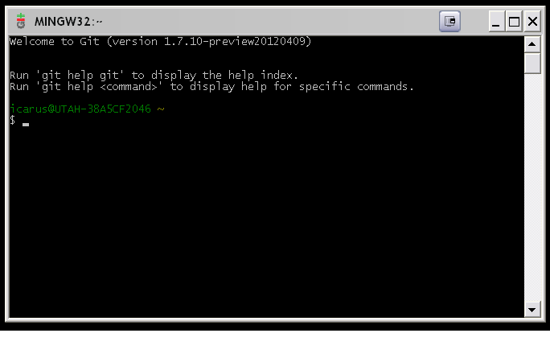

If you haven’t yet created a clone of the repository on your local machine, then navigate to the folder where you want to create your clone of the Git repository:

cd path/to/folder
(e.g., on Windows – cd C://Users/username/Documents/GitHub/neonetods)

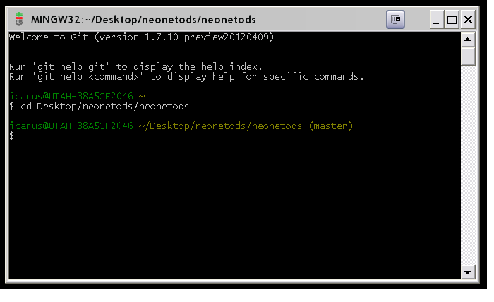

The generic clone command is:

git clone git@github.com:group_directory/repository.git

specs for neonetods repository in screenshot
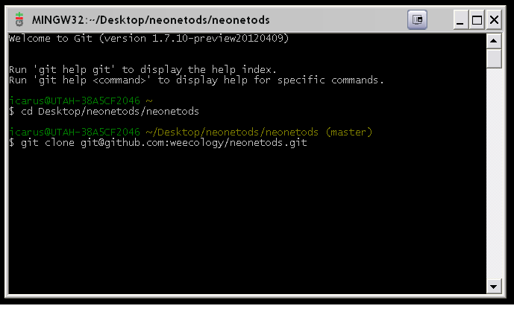

After you have entered the clone command you will receive a response confirming that cloning is taking place, and you will be asked “are you sure you want to continue connecting?” Answer yes!

Workflow: make changes, Add, Commit, Pull, Push

Pull

If you’ve already created the Git clone as a local repository on your machine, then navigate to that folder and pull the latest version from GitHub:

git pull

You’ll need to enter the passphrase or username and password you chose when you set up Git:

Once again, you will be asked “are you sure you want to continue connecting?” Answer yes.
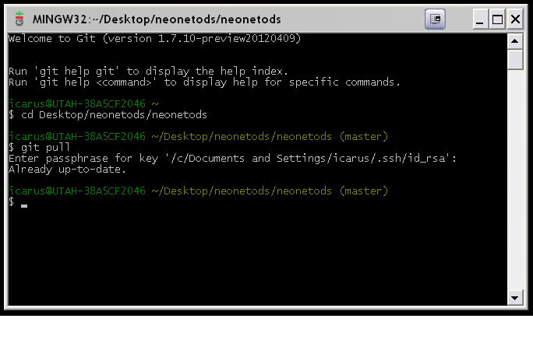
You should do this EVERY TIME you get started for the day and during the commit process as described below.

Make Changes and Save

Once you have an updated version of the repository, you are free to open files (e.g. activities.csv) and modify them in an Explorer window. Here, the activities.csv file has been changed to reflect that books.google.com has no useful links to species information for the DEJU site.

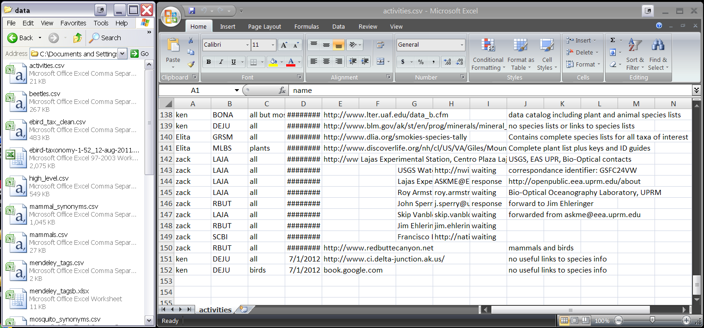

Once you’ve added your desired changes, you’ll want to save them. When you do this with .csv files in Excel you may be asked whether you want to keep the Excel workbook in the .csv format. Choose ‘Yes’:

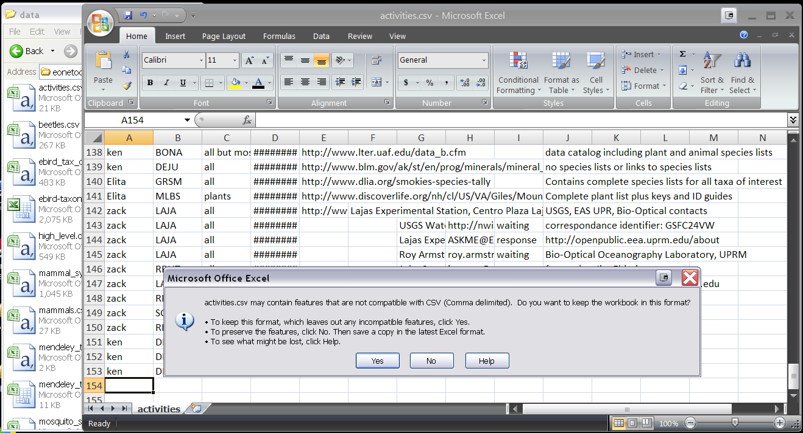

Note that saving your changes to the file does not add or commit them to your local repository.

When closing the file, you may be asked whether you want to save your changes. Choose ‘Yes’. You may be told that the file already exists and asked whether you want to replace it. Choose ‘Yes’ or ‘Replace’. Afterwards, you may be asked, once more, whether you want to keep the file in the .csv format. Choose ‘Yes’:

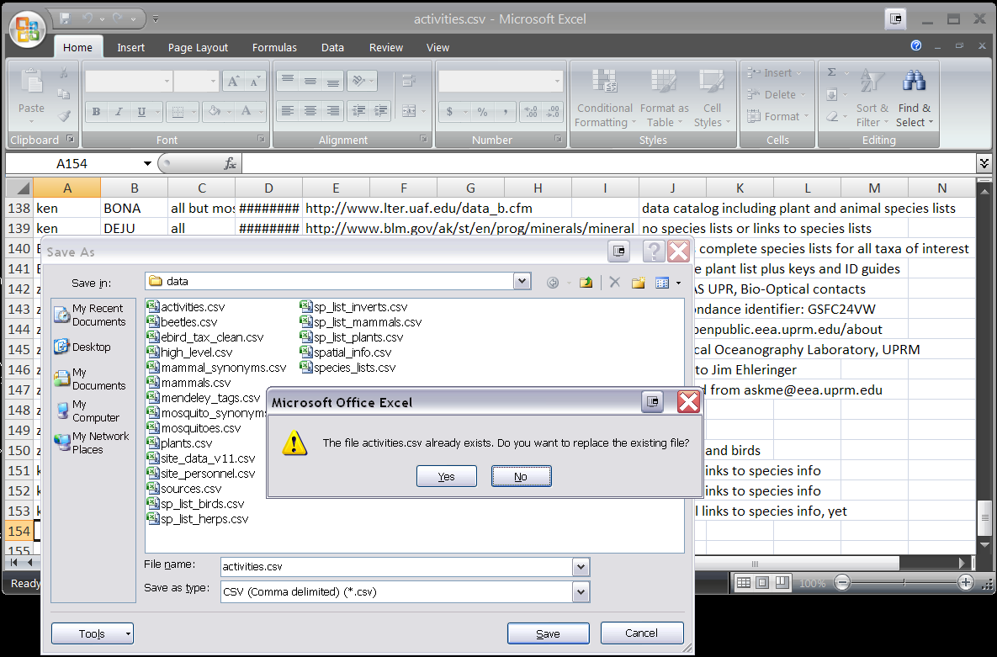

The file will close and your changes will be saved. However, you’ll need to add the changes to your local version of the repository.

You will also interact similarly with the task_matrix.csv, and sp_list tables. It is important that, if you are updating a file that requires a source url from the online Mendeley library (e.g. a reference for recent entries into the sp_list_mammals.csv for a particular site), then you will need to obtain that source’s url from the online Mendeley library, and then proceed with saving your changes, adding and committing them to the local repository, and pushing them to the online version (See Mendeley Tutorial).

Add

Go to your Git bash terminal window, ensure that you are in the folder containing your local repository, and enter:

git add .

The ‘.’ option adds changes made to all files in the repository. Using this option will help you avoid repository conflicts. Without the ‘.’ option, you’ll have to specify the file you want changes added to. Once you’ve added your changes, you must commit them to your local repository (i.e. your clone).

Commit

To commit your changes, enter:

git commit –m “a short message of what you did”

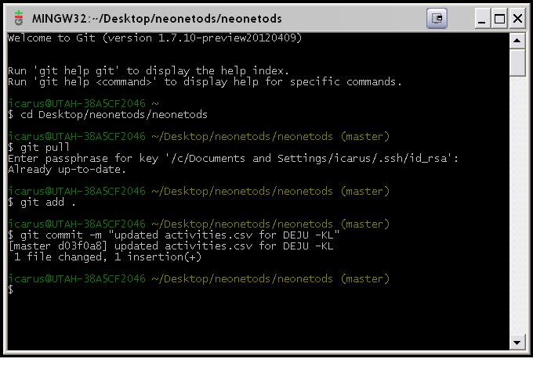
You will receive a statement of your changes.

Pull (ALWAYS pull before pushing)

Next, you MUST pull from the Github repository once more to ensure that you are about to push your committed changes to the most updated version. This will help you to avoid conflicts when Git attempts to merge your local changes with the web-based repository. Type:

git pull

Again, you will be asked for your passphrase or username/password.

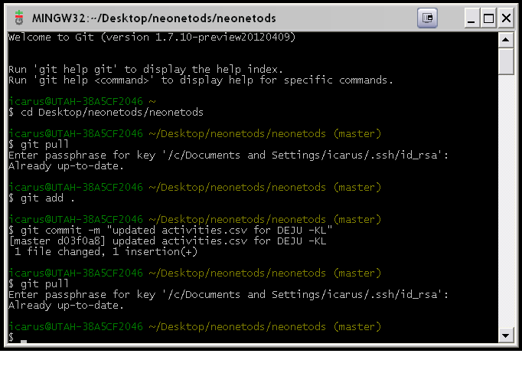

Push

Now, you are ready to push your local changes to the online repository; type:

git push

You will be asked for your authentication again.

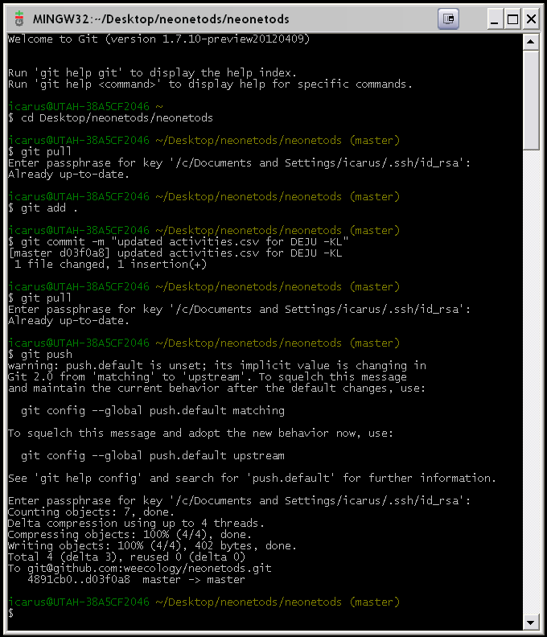

You may be given a warning that push.default is unset. This does not prevent your changes from being committed. You will be asked for your passphrase. Git will then commit your changes to the online repository. The changes to your local repository (i.e. clone) are now added to the online version. Note that this final window includes all standard operations when updating the local repository (git pull), making changes to files (git add, git commit) and pushing them to the online repository (git pull, git push).

Resolving a Conflict

If you are working simultaneously with someone else or someone neglects pulling before pushing, changes to the same file may result in a conflict that you will need to resolve. The process could look something like this:

Original file committed to repository. Robert MacArthur commits a change.

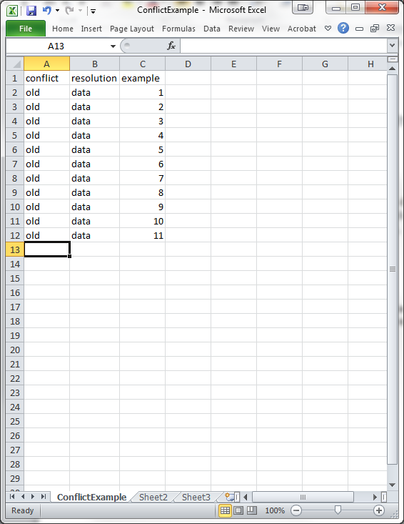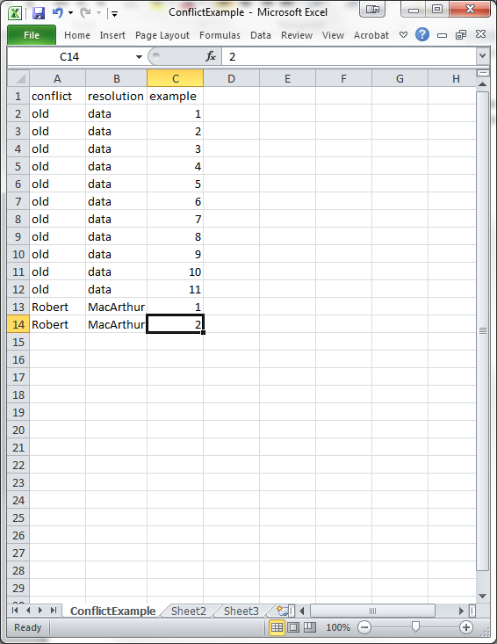

Odum makes a change without MacArthur’s changes,

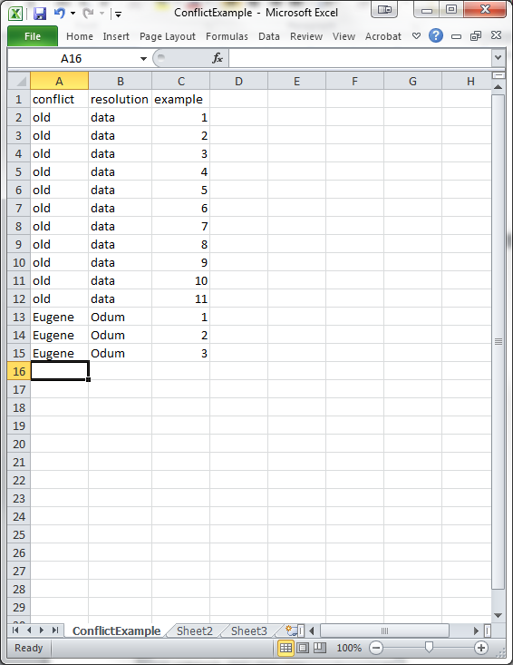

which causes a conflict.

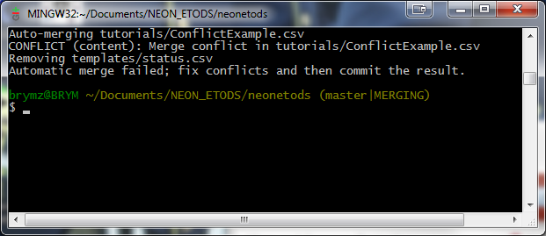

When you open the file back up, it looks something like this. Delete the unncessary lines, add ., commit –m “conflict on file.csv resolved”

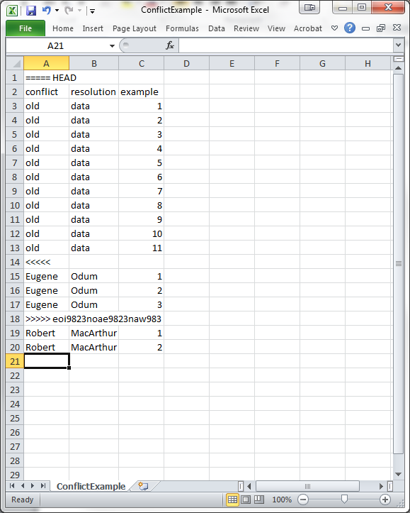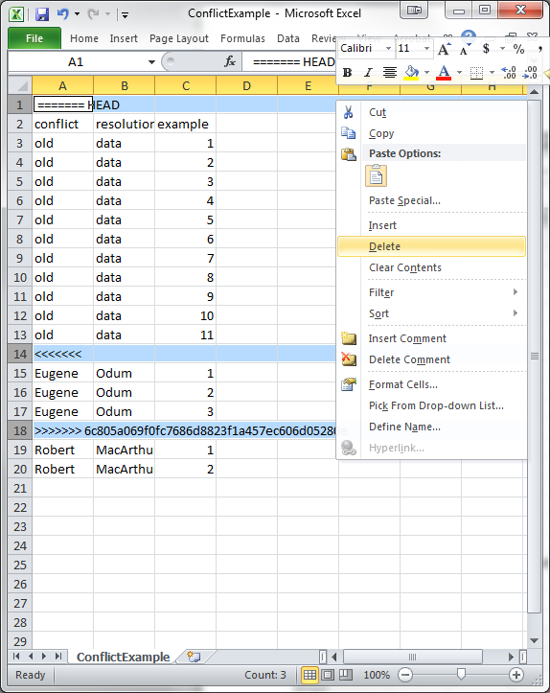

It is possible that the =/</> signs cause the .csv file to appear in one cell (A1) when opened back up in Excel. In this case, it is best to open the .csv file in notepad or text edit, delete the unwanted lines from the text file and then save using the .csv extension. This will maintain the formating of the file and will now open properly in Excel.

Sometimes the conflict follows a rewrite, which means that two largely duplicate tables are stacked on top of each other. This is more difficult to resolve because you have to find out what part of the file is duplicated for deletion, but the steps are largely the same.

