Search Protocol Tutorial

This tutorial describes how to orient yourself to the data that has already been collected and then to continue finding and recording data in a similar fashion. Most of this will be a step-by-step process; however, some decision-making is required to determine the strength of the source and its appropriateness for the database.

General Steps

- Go to the SpeciesLists tab in the “task management for awesome technicians” Google spreadsheet. This is our “prioritization matrix”. Select an unassigned species list that is next in terms of prioritization. Add your initials to the site and taxa that you will be working on. For your given site and taxa combination, check in the USU column to see if people from USU had started working on it.
  - If YES → go to: K:\FSU1\Informatics\Species_Lists\USU_and_related_files and then check these two spreadsheets:
    - Task_matrix – this will tell you what exactly the USU folks have done (started, finished, didn’t find anything, etc)
    - Discrepancy_matrix_2012_10_23 – this will tell you if there is a discrepancy between what USU people said they did/found and what Mel found is actually available in our files or online
  - If NO → this means no work has been done on this site-taxa combination so you will need to start from scratch.

- Visit the website for the research station/site where the NEON site is located (there is an excel file named “research site’s website” in the data file in neonetods*) and seek out complete species lists, site personnel or other existing data. You can find site-specific information by checking K:\FSU1\Informatics\Species_Lists\NEON_site_information.csv. You are looking for data already compiled by programs at the site. This site-specific data, intentionally generated for a complete species inventory, is first priority data. At this time, it is also useful to evaluate if working with one taxonomic group or all of them at once is a more efficient use of your time. As a general rule, you start with what you find and then fill in the missing parts. Similarly, if you are looking at regional scale species information and find data that will apply to a site that has a lower priority, it is ok to skip ahead and collect data for a lower priority site as well. (See the screenshot below for examples)
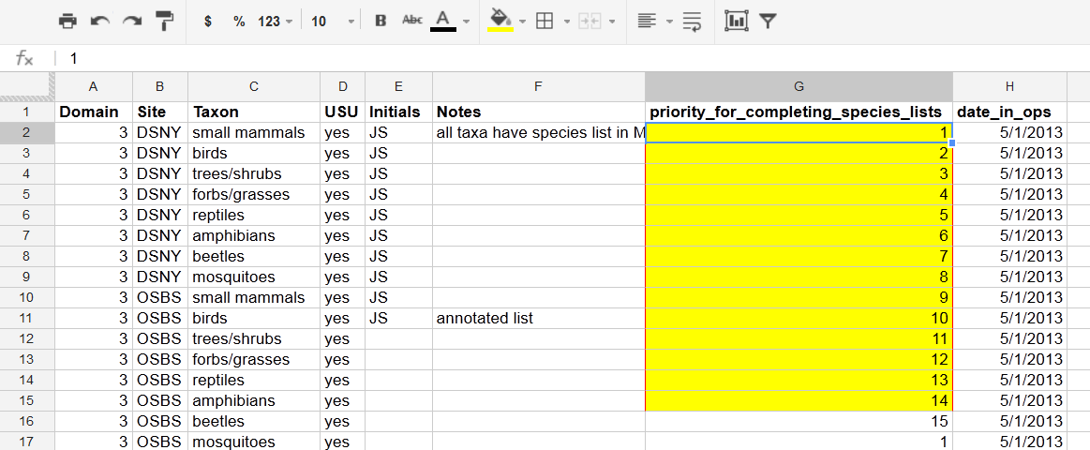

3. Evaluate the other NEON sites in the domain to determine if there is a central contact or resource for all sites in the domain.

- Fill in the note cell in the Prioritization Matrix in the Google spreadsheet with site and taxa level comments, describing what you found and what you intend to work on next (See screenshot below)
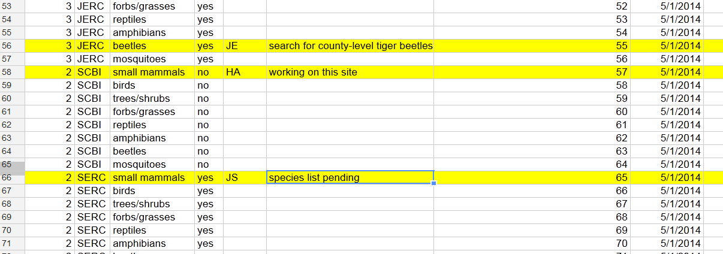

5. Relatively few sites have all of the data we need freely available on their website. Send the form email to any appropriate contact available on the site website or found to be affiliated with the site during a web search (site affiliated faculty, agencies, museum curators, university researchers), requesting the data you require (See Communications Tutorial).

6. Follow the Site Level Search Protocol to find and evaluate acceptable data.

7. Before you enter any data into your local repository, it is very important that you first refresh your local repository from GitHub using command - git pull (See Git Bash Tutorial) OR by syncing your GitHub interface with the main repository.

8. In order to build a species list for our database, we need the following information:
Site | Genus | Sp | Subsp | Common_name | source
4 letter NEON site code (ex: SRER) | Genus name | Species name | Subspecies if applicable | Common name of organism if provided by source | The URL of the source as saved in Mendeley (ex: http://www.mendeley.com/c/5397092164/g/2058663/medina-2003-historical-and-recent-flora-of-the-santa-rita-experimental-range/)
It is important to make sure that your column headers are the same as what is listed in the table above. Otherwise the table you make will not merge properly with the master species list later on. Save your species list file as a CSV.

9. If possible, try uploading the completed CSV file via the TOS data portal website: http://specieslists.katethibault.com/upload/ via the “upload species list CSV” link.
10. Add sources to Mendeley with appropriate details and tags (See Mendeley Tutorial). Use Mendeley Add-on / Extension for saving websites (See Getting Started Tutorial).

11. Add any final work notes to the notes column in the Google spreadsheet. It is important that we maintain clear records of where we have searched and what we have found (even if our search returns no results) to keep our progress traceable and to avoid duplicate effort.

12. When finished with your site/taxa combination, update the species_list_progress spreadsheet located at: K:\FSU1\Informatics\Species_Lists\species_list_progress.csv. You should fill in the date you completed it and your name.
***If you are unclear about the completeness of the list or the legitimacy of your sources, check with Kali or Kate.

Site Level Search Protocol

We are working to generate a complete species list for each site and taxonomic group. Once that is complete no further steps are required. This section will outline how to prioritize your data search and evaluate the sources you find. We are looking to gather existing data related to species lists, site personnel, spatial extent, or other useful data (i.e. biomass, abundance, allometry). Conservation status is also a part of this project but will be completed as a separate effort. Below you will find the search criteria and data source priority levels.

Search Directives

Begin search for Level 1 data and work down the list. Once a complete species list is generated, no further steps are required to explore lower source priority levels.

All species found will be listed, including non-focal taxa (i.e. large mammals, amphibians, non-carabid beetles will be maintained in the database).

Duplicate records for species should be included. In other words, include all species listed in the source even if they already exist in the database at the site you are currently working on. This will create some redundancy, but allows sources to be dropped later and avoids extra work for you!

List only species components found on your search. Do not list species epithet or common name if not present within the data resource.

Only record information from species lists at a genus or species level. Family level is too broad for this project.

The depth of search required if a complete species list is not available immediately at the research station/site site website depends on the current stage of the project. First, the operation will be to collect as much data from as many sites as quickly as possible. In this stage, consider moving on to a different taxonomic group or site if the search becomes 1 pub / spp. Following the initial search, sites will be returned to and more effort will be made to find any existing data or extract data from a relevant database or any useful resource.

Spatial Priority:
site - source boundaries closely overlap site boundaries,
super site - source site boundaries are larger but include NEON site
off –site - source site boundaries are mutually exclusive of NEON site but are within a reasonable distance (~20 to 50km) and share a similar habitat type. Google maps should help you determine how similar the habitat is to the NEON site. Use your best judgment or ask the coordinator.
county and state records will be used for the Regional Species Pool and are only to be used if no other site-level data is available

Source Priority Levels

Level 1. Complete species list from research station/site website or from a research program (academic or agency) of which boundaries encompass the NEON site (See Getting Started Tutorial).

Level 2. Complete species list from book or thesis of which boundaries are clear enough to parse out species found specifically at site

Level 3. Complete species list from reputable naturalist organization with observations at site

Level 4. Incomplete species list from academic publication

Level 5. Incomplete species list from hobby naturalist.

Websites in order of priority level.
1. Research station/site at the NEON site Website
2. books.google.com / university library website
3. google.com
4. scholar.google.com
5. OTHER:
BBS: http://www.mbr-pwrc.usgs.gov/bbs/trend/rtehtm10a_nlcd.html
Natural Parks Species Lists: https://irma.nps.gov/App/Species/Search
Bug guide: http://bugguide.net/node/view/157741
…

