Team25 Saturation Interface
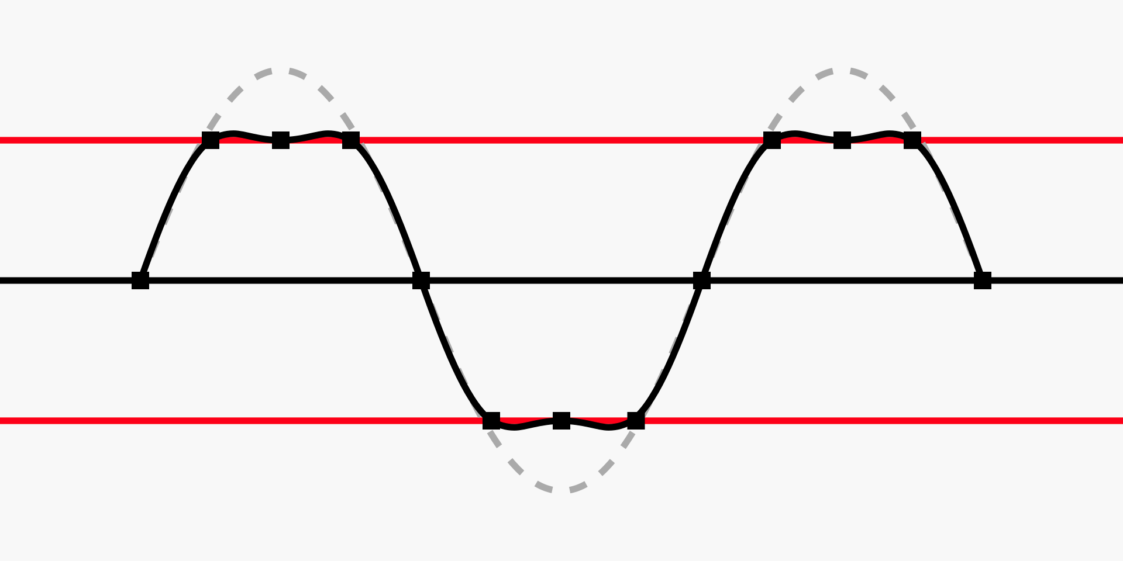
Work by Gutten på Hemsen; CC BY-SA 4.0
Output from convolution with a filter can produce signals that clip, with a number of bits larger than available further along the data path. As such, a saturation module is needed to ensure digital audio signals are saturated at too high or low signals - preventing seemingly unpredictable output.

IO
Name | Size | Input/Output | Function
ena | 1 | input | Enable module.
d_in | N | input | Signed digital audio data in.
d_out | M | output | Signed digital audio data out. M ≤ N.
clip | 1 | output | High if clipping high, low if clipping low
slice | 2^(N-M+1) | input | Lowest bit of the slice from d_in.

Typical Configuration
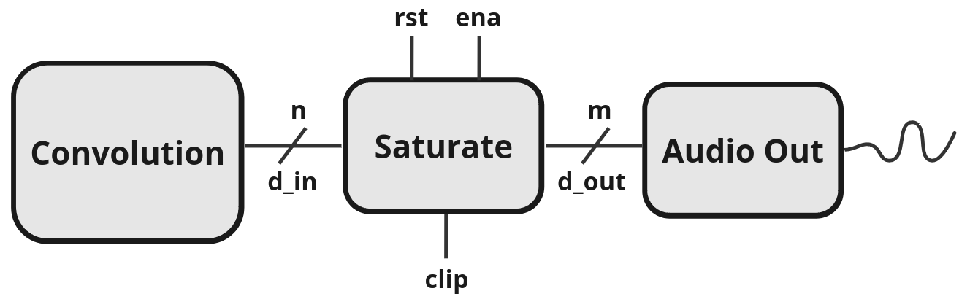b

Input/Output Size
Input and output bit sizes are arbitrary and parameterized. However, the size of d_out must be smaller than the size of d_in.

Slice

Theory of Operation
The saturate module checks for overflow and underflow of the N bits of d_out. If d_in is positive, check for 1s in the upper N-M bits of d_in. Then, if there are any 1s, output d_out = maximum (2^M-1). If d_in is negative, check for 0s in the upper N-M bits of d_in. Then, if there are any 0s, output d_out = minimum (M’b0).

