DocuSign Integration OT Component

The Browser Client

The client was built on metronic template (responsive bootstrap) but is self contained and uses jsrender templates stored in separate html files to make it very easy to include on any page. Once again the opentaps/docusign/webapp/docusign/assets/global folder was excluded from the repo and needs to be added back or paths adjusted accordingly.

The only html that need to be included on the web page is the a div wrapper
<div id="docusign"></div> for the docusign.js templates to attach to and the sibling element
<div id="spinner"></div> that the progress indicator attaches to.

Note: for the POC the metronic page is presented in an iframe in an FTL, this is so I didn't have to deal with css conflicts and it's purpose is to show all works in OT. In production the assets will need to be included in the common header and paths adjusted accordingly.

The POC UI is just an example of how exposed function calls could be used. The js object DocuSign requires the following options to be set.

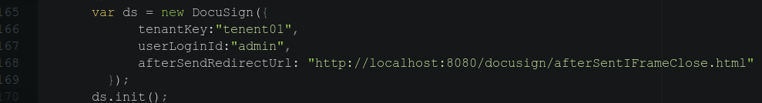
tenantKey: determines which Authenticating User is used for the account. We have a docusign account mapped to each tenant and then any number of users within that account.
userLoginId: is the OT user login.
afterSendRedirectUrl: is a page in our component, which can be seen in the file opentaps/docusign/webapp/docusign/afterSentIFrameClose.html. The API redirects to this provided url after sending document from the embedded iframe view. In our case at this point we want to close the iframe so integration is seamless. This page contains js code that signals the parent page which then closes the iframe.

The DocuSign js object exposes the following methods
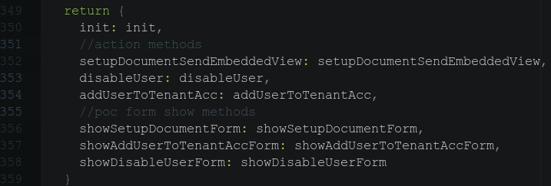
The action methods are what you would use to integrate into your own ui. The parameters for each method can be found in the docusign.js file.

setupDocumentSendEmbeddedView: line 164
addUserToTenantAcc: parameter example line 240
disableUser: parameter example line 306

Setup Document
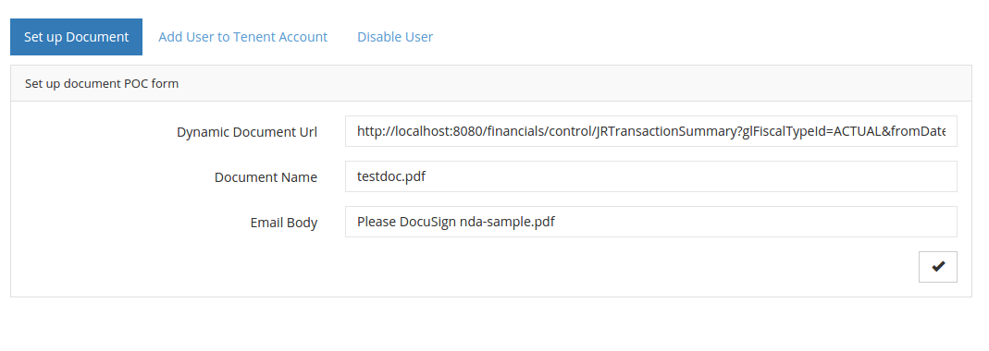
During testing the following URL was used from the financials web app.
http://localhost:8080/financials/control/JRTransactionSummary?glFiscalTypeId=ACTUAL&fromDate_c_compositeType=Timestamp&fromDate_c_date=8%2F6%2F15&fromDate_c_hour=12&fromDate_c_minutes=0&fromDate_c_ampm=AM&thruDate_c_compositeType=Timestamp&thruDate_c_date=8%2F6%2F15&thruDate_c_hour=11&thruDate_c_minutes=59&thruDate_c_ampm=PM&tag1=ANY&tag2=ANY&tag3=ANY&isPosted=Y&type=pdf&reportAction=

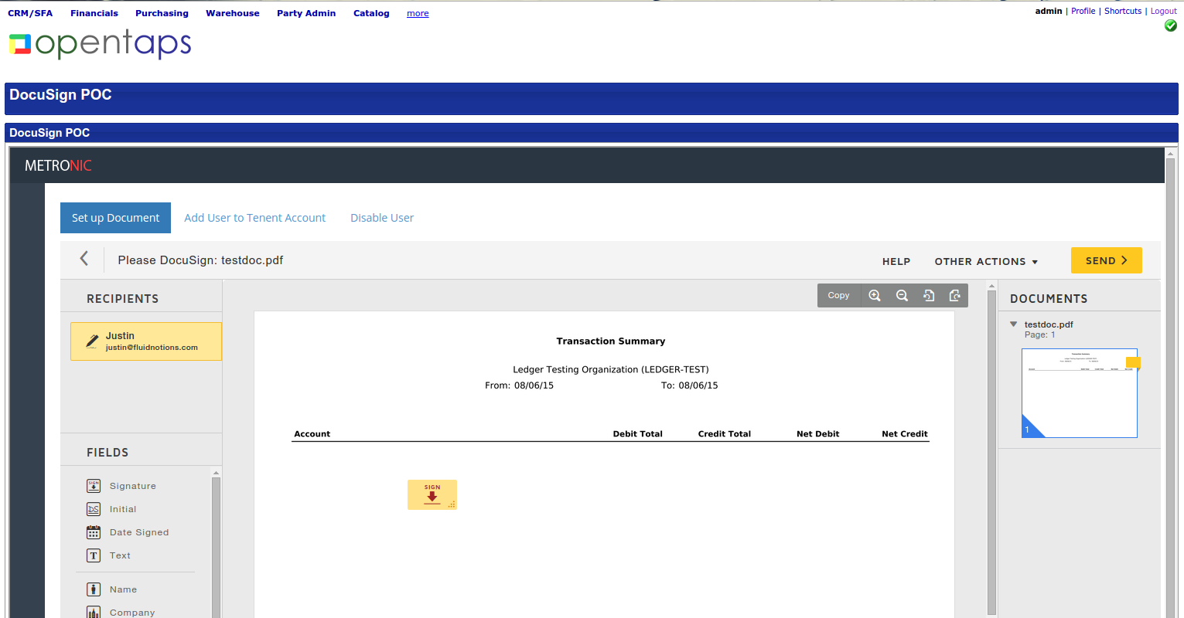
You would construct the url for the data attribute in the FTL using data available in the page context, if it's a page where a download pdf button already exists all the parameters should already be in the FTL.
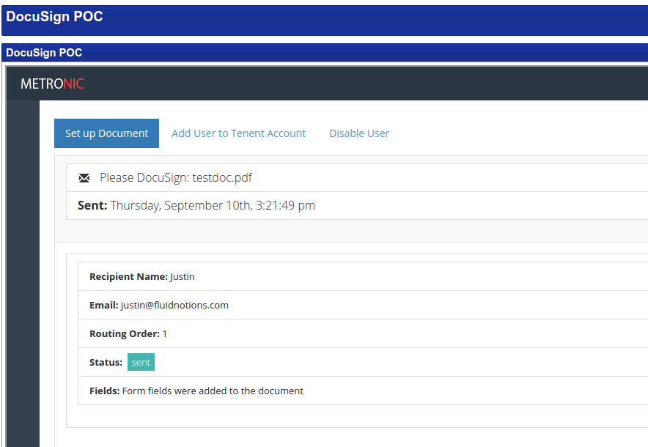

After adding fields, setting routing order, recipients etc you'd click send,
the API then redirects to our provided Url, which closes the embedded view and does a EnvelopeInformation call to the API, this call then creates the envelope in the OT database, then also displays on screen.

Add User To Tenant Account

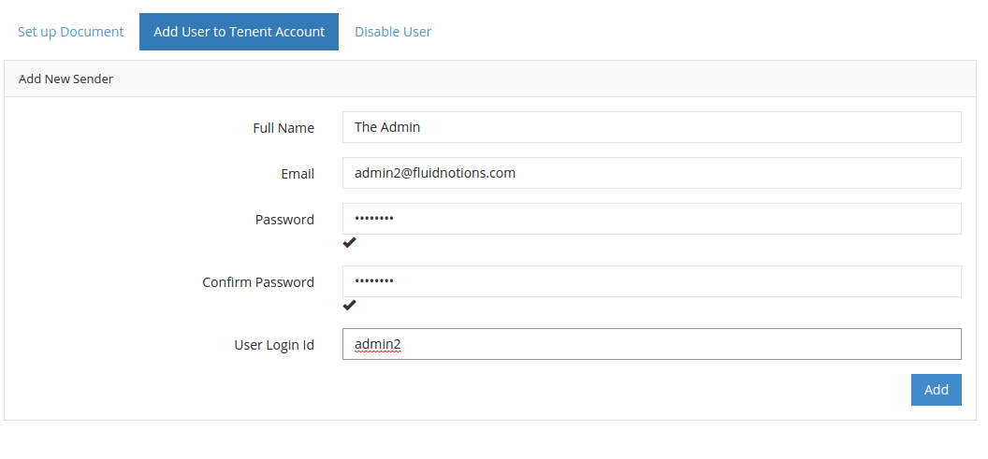
The user will then be sent an activation email, they need to click the link and log into docuSign to activate the account for the first time. This may be possible to disable but no such setting seems to exist in the developer sandbox. If the new user tries to send a document without activation the following error displays.

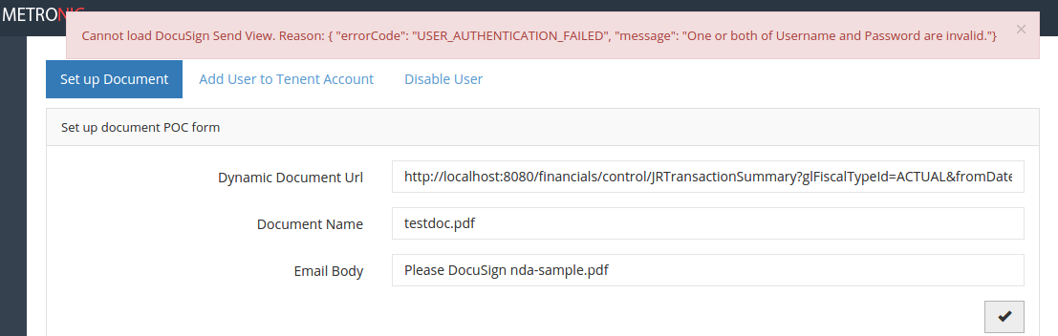
To make it easier to provide default user settings and other property values for new users there is the json file located at opentaps/docusign/src/com/fluidnotions/docusign/services/NewUserDefaults.json, this is used to initialize fields in the NewUser object. One user setting which should never be change is allowEmailChange = false. This is because OT entities use the DocuSign user email address as a userId. If the user goes and changes this, the integration will not work correctly. (Using email address rather then docuSignUserId is necessary due to apparent bugs in the API)

The custom build script also copies it to the appropriate location in the webapp folder. Just be aware in case you load the component in another folder besides opentaps, the path in build.xml would need to be updated.

Disable User
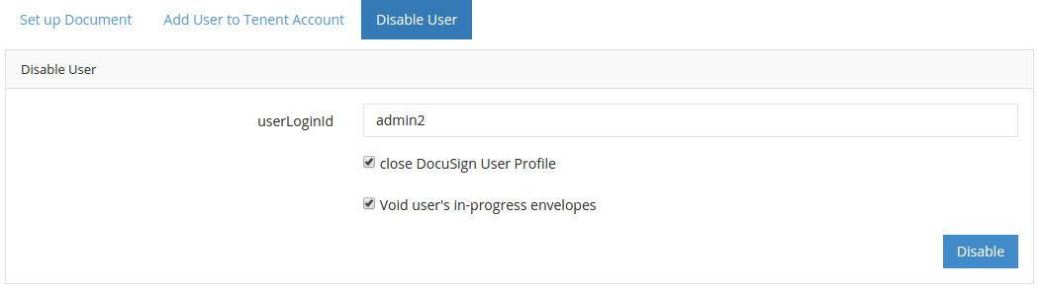

The disable user has 2 options that can be selected which act on the api and OT entities.

Updating Envelope Status

Although DocuSign does have a feature called DocuSign connect which allows real time status updates this was not implemented due to time constraints.
Instead we have a spring scheduled API call which requests envelope changed status every 5 min and updates appropriate OT entities. The method call can be found in com.fluidnotions.docusign.services.DocuSignScheduledTasks.updateAllEnvelopesStatus()
Associated properties can be found in opentaps/docusign/config/docusign.properties the apiTimezone
should not be changed, a bug in the API requires this time zone for API calls regardless of the time zone set in the account.

Authenticating User Setup

Each tenant has a single authenticating user, with admin permissions for the account. The integration uses this to impersonate other users on the account. This primary account needs to be setup through the DocuSign website and then the values saved in an OT entity. This entity must be placed in the main database (Not the tenant database)

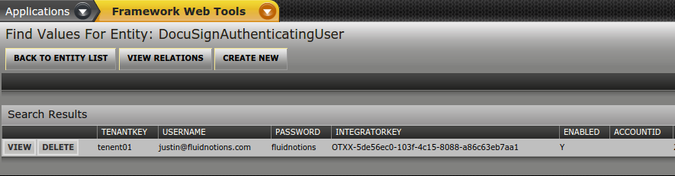
The accountId is not required. All the other values can be gotten from the DocuSign website.

OT Entities

There are 3 entities defined in opentaps/docusign/entitydef/entitymodel.xml.
The most important thing to mention here is that DocuSignEnvelope and DocuSignUser belong in the tenant database, while DocuSignAuthenticatingUser belongs in the main database.

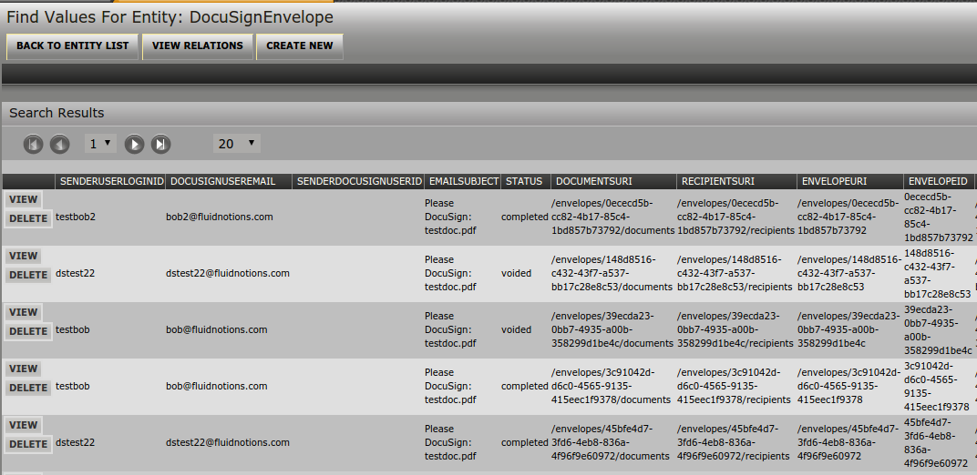

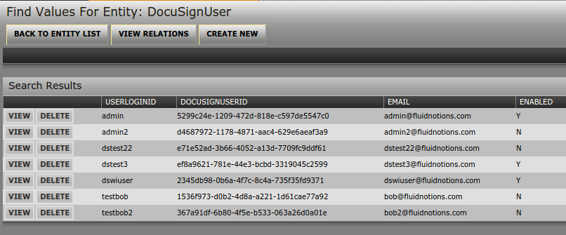
User Credentials for Programmatic Dynamic Document Generation

Since the component gets hard copies of dynamically generated pdfs by downloading them to a temp folder
we need login credentials with appropriate permissions so that the request that generates the report
can be called programmatically. These need to be set in the opentaps/pdfsigner/config/pdfsigner.properties file.
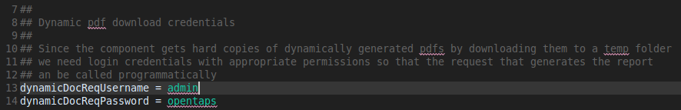
Integrating with myFIOERP Backend

The tenant delegator lookup code needs to be completed … for convenience it was placed in a static utility class (com.fluidnotions.opentaps.integration.docusign.OTUtil)

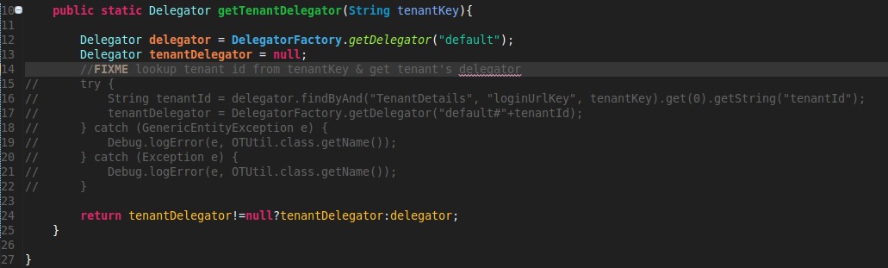
Implementation is a spring boot web app modified to run in tomact 6, servlet 2.5.
Custom build script ensures source code is handled appropriately. Also see comments in opentaps/docusign/config/docusign.properties

