Undergraduate Final Year Project Proposal
Medical Admittance WEbApplication
Crystal Gajraj and Christopher Flus
BSc. Computer Science
810002957 & 81000394

Title
A Medical Management Admittance Application to facilitate the storing of patients admittance and medical information in a public medical institution.

Overview/Introduction
In recent articles published in Trinidad and Tobago Guardian and Express newspapers the Minister of Health noted that in most public hospitals in Trinidad there is an overcrowding issue. There are more patients than the number of beds and this is due because of the lack of proper track record keeping of each patient. Patients get discharged and they remain in the wards, because of the lack of record keeping, both administrative and medical staff is unaware which patient have been discharged. Most hospitals in the Caribbean use manual record keeping. The WCA Hospital in the United States of America uses electronic means for storing patient’s information.
Medical Management Admittance Application is an applications used by medical staff to eliminate the overcrowding of public hospital in Trinidad and Tobago. It allows for both entering and retrieving patients admittance and medical information. Only when a person is admitted to the ward/hospital their records are entered into the system. Administrations are responsible for entering patient admittance information this includes their name, address, contact information. Each ward has a limited amount of space/beds which allows staff to keep track of how many patients can actually be admitted and the total number of patients currently in the system.

Aim
The aim of the proposed project is to develop and implement a mobile Medical Management Admittance Application to minimise overcrowding in public medical facilities throughout Trinidad.

Objectives
  - Complete a literature review of previous running applications and techniques used to build these applications
1.1.1 Research Existing Medical Applications
1.1.2 Research the current admission systems in hospitals in Trinidad
1.1.3 Interview individuals who use the current admission system
1.1.4 Overcrowding of hospitals in Trinidad

  - Develop the application
    - Develop the manager page – generate username and password for administration and medical staff
1.2.2 Develop the request page for administration – administration request username and password from manager
1.2.3 Develop login for administration staff
1.2.4 Develop the “Main Activity” page for administration – enter patient information
1.2.5 Develop the request for medical staff – medical staff requests the manager for username and password
1.2.6 Develop login for medical staff – doctors/nurses
1.2.7 Create the “Main Activity” page for medical staff

1.3 Testing the application

1.4 Evaluate the application
1.4.1 Invite individuals to take the application hands-on to assess

1.5 Complete the final report and representation

Legal, Social and Ethical
- Users of the application will need to provide their personal information
- All user information will not be shared
- Patient information will only be used by doctors/nurses registered with the application for the hospital. It will remain confidential due to the doctor/patient agreement.
- There may be descriptive content not suitable for young individuals.
- Using open source frames to reduce the illegalities of using closed source frameworks

Professional

- Users will need to have some training to use the site correctly
- With the increase in the size of the database servers will have to be updated frequently

Planning

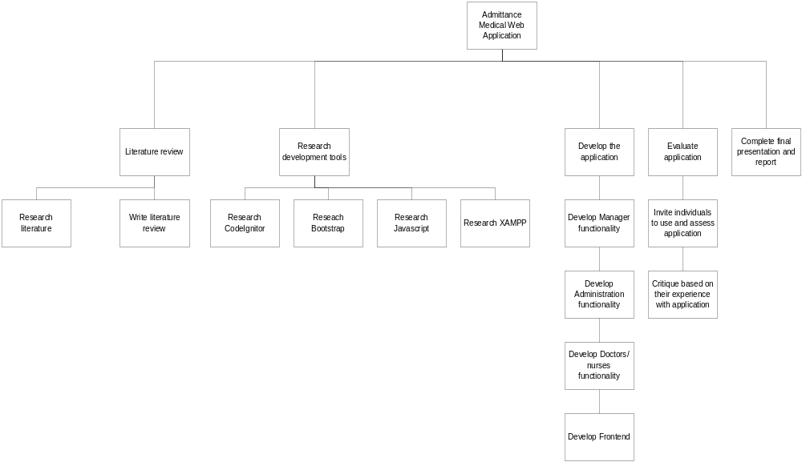

Initial References
Ramdass, Anna, “Trini sick, lazy,” Trinidad Express, January 14, 2014, 5.

Ready to discharge patients myself – Khan on hospital overcrowding. http://www.tntfinder.com/articles/01114

Electronic health records making life easier for WCA. http://post-journal.com/page/content.detail/id/636012/Electronic-Health-Records-Making-Life-Easier-At-WCA.html?nav=5192

