Introduction

In recent articles published in Trinidad and Tobago Guardian and Express newspapers the Minister in the Ministry of Health highlighted that public hospitals are overcrowded, that is the number of patients exceeds the number of beds and this is due because of the lack of proper track record keeping of each patient. Issues highlighted were patients are discharged and they remain in the wards, because of the lack of record keeping, both administrative and medical staff is unaware which patient have been discharged.

Patient Admittance Application targeted audience are cleaners, triage and administrative staff. It allows for both entering and retrieving of patients admittance and medical information. Only when a person is admitted to the ward/hospital their records are entered into the system. Administrations are responsible for entering patient admittance information this includes their first and last name. Each ward has a limited amount of space/beds which allows staff to keep track of how many patients can actually be admitted and the total number of patients currently in the system.

The first phase of the project involved meeting with a member staff at the Eric Williams Medical Sciences Complex to obtain information of the current process of admitting and discharging a patient at the health facility. The next phase of the project involved researching global trends of medical mobile application development and use, also analyse the information to formulate the project proposal.

The next phase of the project is be to build the mobile application in the prioritized areas of interest, that is the admitting a patient to a ward/bed according to the requirements discussed in phase one. The final deliverable of this phase is this report with a detailed discussion of the various aspect of the project, including the formulation and recommendation of technology.

System Implementation

The basics of creating applications

To begin to program this application, frameworks such as Codeignter and Bootstrap were utilise to keep code and file organised and most importantly it is suitable for teamwork, which allowed us to work on separate parts of the project and then merge our code.

The Codeigniter framework provides a Model/View/Controller Pattern

* **Model** – represent the data structures that interfaces with the database
* **View** – contain page templates and output (User Interface)
* **Controller** – handle HTTP page request and passes data to the view. It binds everything together

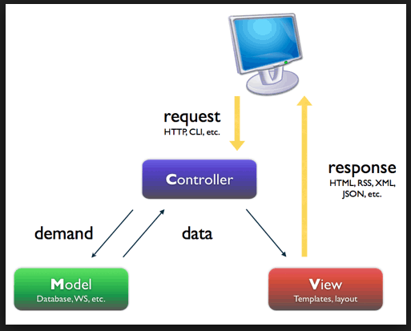

System Design

Triage - The triage staff is responsible for determining the priority of patients treatment based on the severity of their conditions upon entry into the hospital and the admittance of a patient to bed in a ward according to the hospital’s system.

The triage view consist of three tabs

* My profile – allows a user (triage staff member) to edit their profile information.
* Vacant Beds – Provides an additional menu. It also provides a further menu
* Logout – Log out of the current state (triage view).

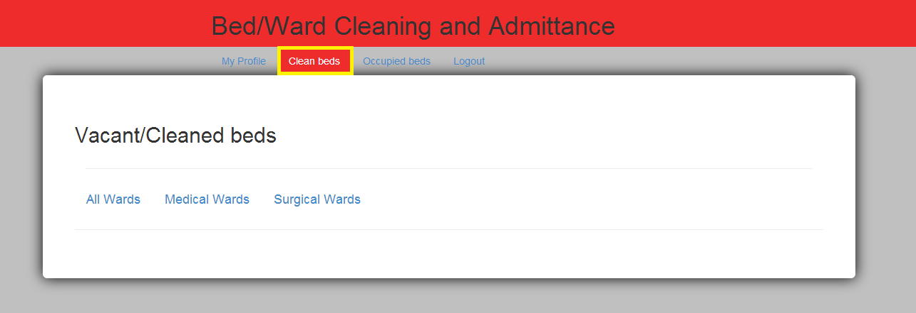

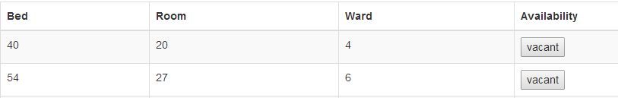

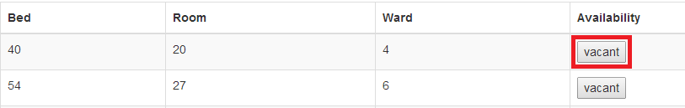

Vacant button -

