同济大学
计算机科学与技术系

计算机组成原理课程实验报告



学 号 1650917
姓 名 杨晨
专 业 计算机科学与技术
授课老师 郝泳涛
日 期 2019.4.22

- 实验目标
1.深入了解CPU的原理。
2.画出实现31条指令的CPU的通路图。
3.学习使用Verilog HDL语言设计实现31条指令的CPU。
- 实验原理
1）需要实现的 31 条 MIPS 指令，见图
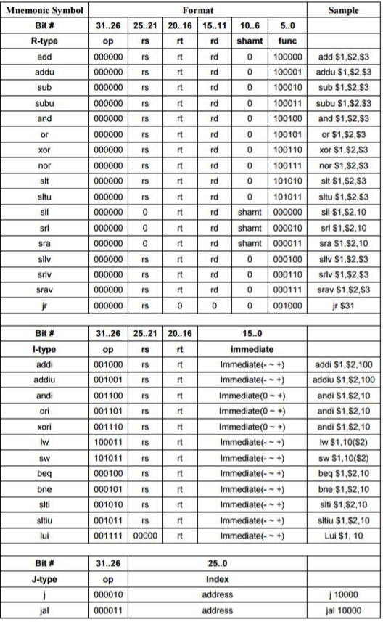
2)单周期数据通路设计的一般性方法
1.阅读每条指令，对每条指令所需执行的功能与过程都有充分的了解
2.确定每条指令在执行过程中所用到的部件
3.使用表格列出指令所用部件，并在表格中填入每个部件的数据输入来源
4.根据表格所涉及部件和部件的数据输入来源，画出整个数据通路
- 数据通路设计
1.指令ADD、ADDU、SUB、SUBU、AND、OR、XOR、NOR、SLT、SLTU、SLLV、SRLV、SRAV、LUI的数据通路如下：
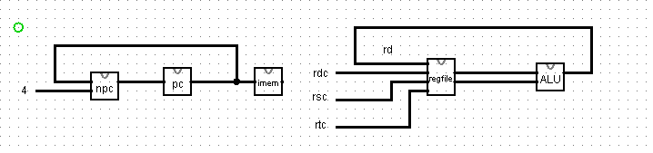
2.指令SLL、SRL、SRA、LUI的数据通路如下：
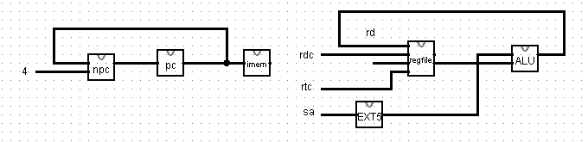
3.指令ADDI、ADDIU、ANDI、ORI、XORI的数据通路如下：
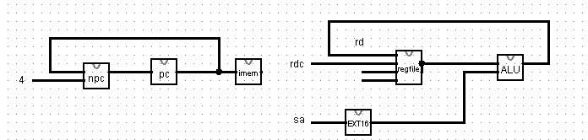
4.指令LW的数据通路如下：
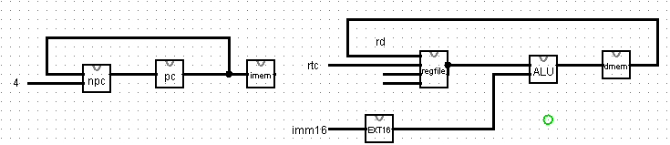
5.指令SW的数据通路如下：
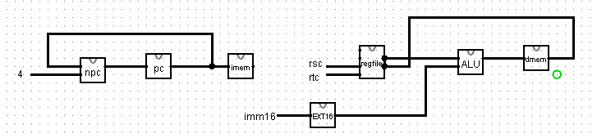
6.指令BEQ、BNE的数据通路如下：
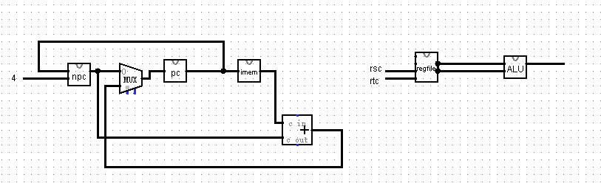
7.指令SLTI、SLTIU的数据通路如下：
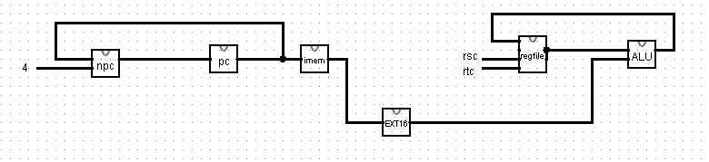
8.指令J、JAR、JR的数据通路如下：
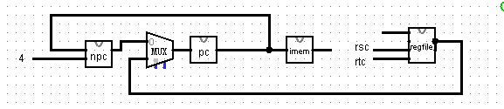

9.数据通路总图：
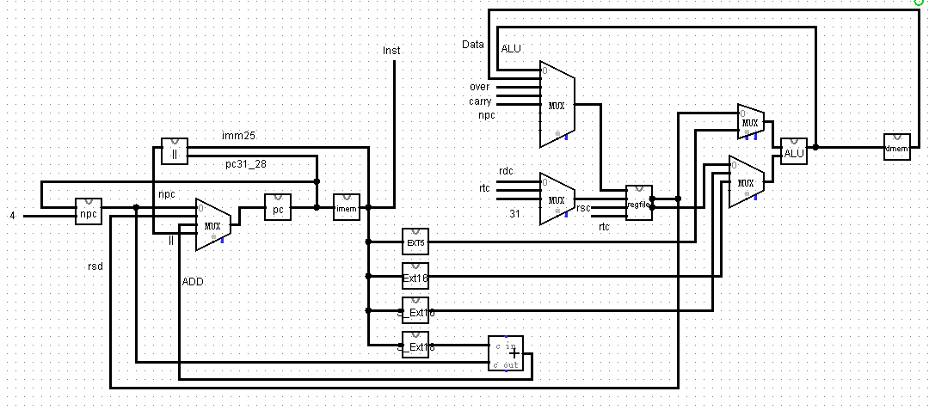

各部件输入输出关系如下：
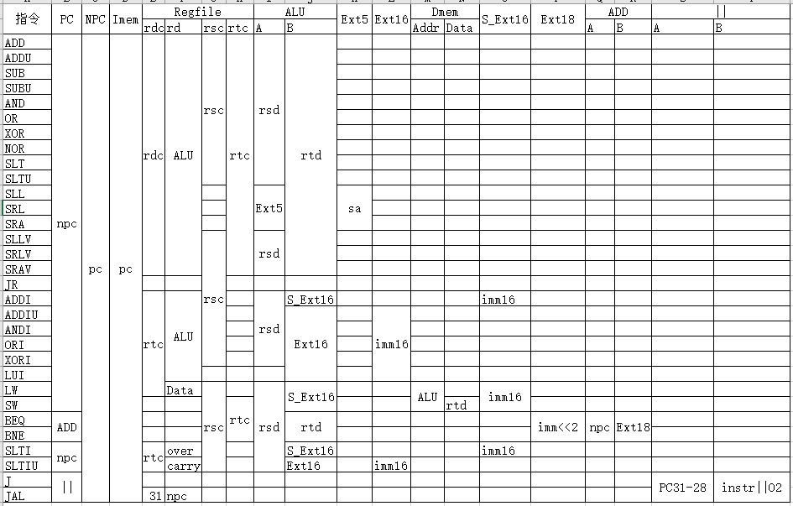

- 控制部件设计

经过整理，控制信号如下：
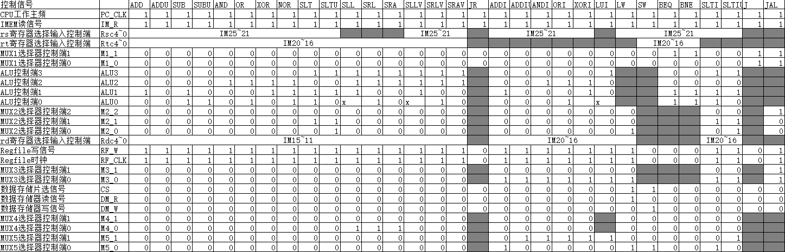
PC_CLK=CLK;
IM_R=1;
M1_1=BEQ+BNE+J+JAL;
M1_0=J+JAL;
ALU3=SLT+SLTU+SLL+SRL+SRA+SLLV+SRLV+SRAV+LUI+SLTI+SLTIU;
ALU2=AND+OR+XOR+NOR+SLL+SRL+SRA+SLLV+SRLV+SRAV+ANDI+ORI+XORI;
ALU1=ADD+SUB+XOR+NOR+SLT+SLTU+SLL+SLLV+ADDI+XORI+BEQ+BNE+SLTI+SLTIU;
ALU0=SUB+SUBU+OR+NOR+SLT+SRL+SRLV+ORI+BEQ+BNE+SLTI;
M2_2=JAL;
M2_1=SLT+SLTU+SLTI+SLTIU;
M2_0SLTU+LW+SLTIU;
M3_1=JAL;
M3_0=ADDI+ADDIU+ANDI+ORI+XORI+LUI+LW+SLTI+SLTIU;
CS=LW+SW;
DM_R=LW;
DM_W=SW;
M4=SLL+SRL+SRA;
M5_1=ADDIU+ANDI+ORI+XORI+LUI+SLTIU;
M5_0ADDI+LW+SW+SLTI;
图中黑色单元格表示不需要控制信号，即可以为任意值，对结果无影响。

- 实验结果分析
1.前仿真：
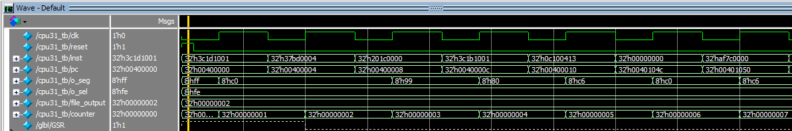

2.后仿真：
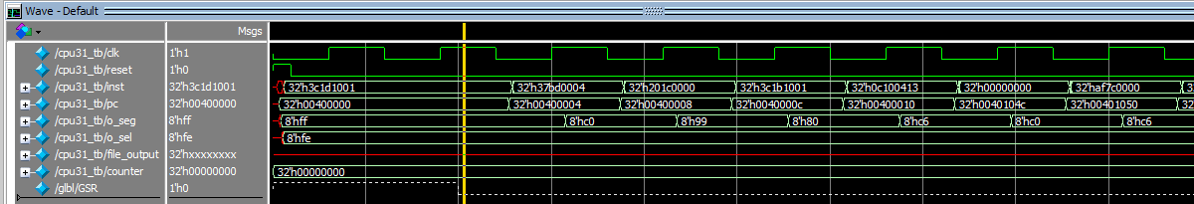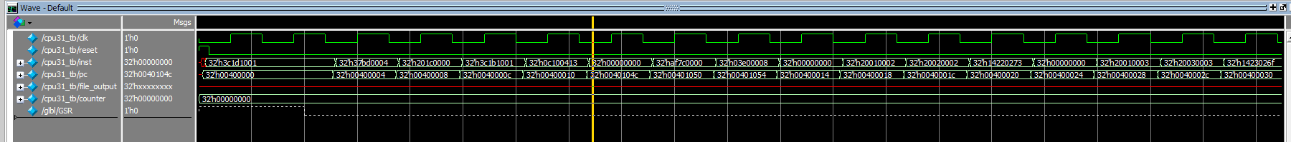

3.下板：
下板结果：用给定的coe文件七段数码管显示00400fe0

- 心得体会及收获
在这次cpu设计实现过程中，主要的收获有以下几点：
1.进行31条指令数据通路和控制信号的设计，完成了MIPS 31条指令的CPU。
2.通过vivado和modolsim进行仿真，练习了仿真调试的过程。
3.巩固了自己verilog编程的能力。
在编写的过程中，也遇到过很多的问题，比如在pc寄存器中，时钟上升沿有效还是下降沿有效，ALU运算出现错误等等，此外，对31条指令的测试也是一件十分需要耐心的工作，单纯从代码方面去检查并改正这些错误是十分困难的，这时候，仿真就起到了非常重要的作用，通过对仿真过程中各个数据通路的值进行监视，十分高效的进行错误排查，使得程序的编写效率大大提高。

- 模块代码
module sccomp_dataflow(
input clk_in,
input reset,
output wire [31:0]inst,
output wire [31:0]pc
);
wire[31:0]alu;
wire CS;
wire DM_W;
wire DM_R;
wire [31:0]Data;
cpu sccpu(.clk_in(clk_in),.reset(reset),.inst(inst),.pc(pc),.CS(CS),.DM_W(DM_W),.DM_R(DM_R),.alu(alu),.Data(Data));
Dmem Dmem1(.clk(clk_in),.ena(CS),.wena(DM_W),.rena(DM_R),.address(alu),.data(Data));
myImem Imem1(.clk(clk_in),.ena(1),.wena(0),.rena(1),.pc((pc-32'b0000_0000_0100_0000_0000_0000_0000_0000)>>2),.Instruction(inst));
endmodule

`define ADD_flag 31'b1000_0000_0000_0000_0000_0000_0000_000
`define ADDU_flag 31'b0100_0000_0000_0000_0000_0000_0000_000
`define SUB_flag 31'b0010_0000_0000_0000_0000_0000_0000_000
`define SUBU_flag 31'b0001_0000_0000_0000_0000_0000_0000_000
`define AND_flag 31'b0000_1000_0000_0000_0000_0000_0000_000
`define OR_flag 31'b0000_0100_0000_0000_0000_0000_0000_000
`define XOR_flag 31'b0000_0010_0000_0000_0000_0000_0000_000
`define NOR_flag 31'b0000_0001_0000_0000_0000_0000_0000_000
`define SLT_flag 31'b0000_0000_1000_0000_0000_0000_0000_000
`define SLTU_flag 31'b0000_0000_0100_0000_0000_0000_0000_000
`define SLL_flag 31'b0000_0000_0010_0000_0000_0000_0000_000
`define SRL_flag 31'b0000_0000_0001_0000_0000_0000_0000_000
`define SRA_flag 31'b0000_0000_0000_1000_0000_0000_0000_000
`define SLLV_flag 31'b0000_0000_0000_0100_0000_0000_0000_000
`define SRLV_flag 31'b0000_0000_0000_0010_0000_0000_0000_000
`define SRAV_flag 31'b0000_0000_0000_0001_0000_0000_0000_000
`define JR_flag 31'b0000_0000_0000_0000_1000_0000_0000_000
`define ADDI_flag 31'b0000_0000_0000_0000_0100_0000_0000_000
`define ADDIU_flag 31'b0000_0000_0000_0000_0010_0000_0000_000
`define ANDI_flag 31'b0000_0000_0000_0000_0001_0000_0000_000
`define ORI_flag 31'b0000_0000_0000_0000_0000_1000_0000_000
`define XORI_flag 31'b0000_0000_0000_0000_0000_0100_0000_000
`define LUI_flag 31'b0000_0000_0000_0000_0000_0010_0000_000
`define LW_flag 31'b0000_0000_0000_0000_0000_0001_0000_000
`define SW_flag 31'b0000_0000_0000_0000_0000_0000_1000_000
`define BEQ_flag 31'b0000_0000_0000_0000_0000_0000_0100_000
`define BNE_flag 31'b0000_0000_0000_0000_0000_0000_0010_000
`define SLTI_flag 31'b0000_0000_0000_0000_0000_0000_0001_000
`define SLTIU_flag 31'b0000_0000_0000_0000_0000_0000_0000_100
`define J_flag 31'b0000_0000_0000_0000_0000_0000_0000_010
`define JAL_flag 31'b0000_0000_0000_0000_0000_0000_0000_001

module InstructionDecoder(
input clk,
input [31:0] Instruction,
input reset,
input zero,
output reg PC_CLK,
output reg IM_R,
output reg [1:0]M1,
output reg [3:0]aluc,
output reg [2:0]M2,
output reg RF_W,
output reg RF_CLK,
output reg [1:0]M3,
output reg CS,
output reg DM_R,
output reg DM_W,
output reg M4,
output reg [1:0]M5
);
reg [30:0] control;
wire [5:0] op;
wire [5:0] func;
assign op=Instruction[31:26];
assign func=Instruction[5:0];

always@(*)
begin
if(reset)
begin
PC_CLK<=0;
IM_R<=0;
M1<=2'b00;
aluc<=4'b0000;
M2<=3'b100;
RF_W<=0;
RF_CLK<=0;
M3<=2'b00;
CS<=0;
DM_R<=0;
DM_W<=0;
M4<=0;
M5<=2'b0;
end
else
begin
case(op)
6'b000000:
begin
PC_CLK<=1;
IM_R<=1;
M1<=2'b00;
M2<=3'b000;
RF_W<=1;
RF_CLK<=1;
M3<=2'b00;
CS<=0;
DM_R<=0;
DM_W<=0;
M5<=2'b00;
case(func)
6'b100000:
begin
control<=`ADD_flag;
aluc<=4'b0010;
M4<=0;
end
6'b100001:
begin
control<=`ADDU_flag;
aluc<=4'b0000;
M4<=0;
end
6'b100010:
begin
control<=`SUB_flag;
aluc<=4'b0011;
M4<=0;
end
6'b100011:
begin
control<=`SUBU_flag;
aluc<=4'b0001;
M4<=0;
end
6'b100100:
begin
control<=`AND_flag;
aluc<=4'b0100;
M4<=0;
end
6'b100101:
begin
control<=`OR_flag;
aluc<=4'b0101;
M4<=0;
end
6'b100110:
begin
control<=`XOR_flag;
aluc<=4'b0110;
M4<=0;
end
6'b100111:
begin
control<=`NOR_flag;
aluc<=4'b0111;
M4<=0;
end

6'b101010:
begin
control<=`SLT_flag;
aluc<=4'b1011;
M4<=0;
end
6'b101011:
begin
control<=`SLTU_flag;
aluc<=4'b1010;
M4<=0;
end
6'b000000:
begin
control<=`SLL_flag;
aluc<=4'b1110;//111x
M4<=1;
end
6'b000010:
begin
control<=`SRL_flag;
aluc<=4'b1101;
M4<=1;
end
6'b000011:
begin
control<=`SRA_flag;
aluc<=4'b1100;
M4<=1;
end
6'b000100:
begin
control<=`SLLV_flag;
aluc<=4'b1111;//111x
M4<=0;
end
6'b000110:
begin
control<=`SRLV_flag;
aluc<=4'b1101;
M4<=0;
end
6'b000111:
begin
control<=`SRAV_flag;
aluc<=4'b1100;
M4<=0;
end
6'b001000:
begin
control<=`JR_flag;
M1[0]<=1;
RF_W<=0;
RF_CLK<=0;
end
default:
begin
PC_CLK<=0;
IM_R<=0;
M1<=2'b00;
aluc<=4'b0000;
M2<=3'b100;
RF_W<=0;
RF_CLK<=0;
M3<=2'b00;
CS<=0;
DM_R<=0;
DM_W<=0;
M4<=0;
M5<=2'b0;
end
endcase
end
6'b001000:
begin
control<=`ADDI_flag;
PC_CLK<=1;
IM_R<=1;
M1<=2'b00;
aluc<=4'b0010;
M2<=3'b000;
RF_W<=1;
RF_CLK<=1;
M3<=2'b01;
CS<=0;
DM_R<=0;
DM_W<=0;
M4<=2'b00;
M5<=2'b01;
end
6'b001001:
begin
control<=`ADDIU_flag;
PC_CLK<=1;
IM_R<=1;
M1<=2'b00;
aluc<=4'b0000;
M2<=3'b000;
RF_W<=1;
RF_CLK<=1;
M3<=2'b01;
CS<=0;
DM_R<=0;
DM_W<=0;
M4<=2'b00;
M5<=2'b10;
end
6'b001100:
begin
control<=`ANDI_flag;
PC_CLK<=1;
IM_R<=1;
M1<=2'b00;
aluc<=4'b0100;
M2<=3'b000;
RF_W<=1;
RF_CLK<=1;
M3<=2'b01;
CS<=0;
DM_R<=0;
DM_W<=0;
M4<=2'b00;
M5<=2'b10;
end
6'b001101:
begin
control<=`ORI_flag;
PC_CLK<=1;
IM_R<=1;
M1<=2'b00;
aluc<=4'b0101;
M2<=3'b000;
RF_W<=1;
RF_CLK<=1;
M3<=2'b01;
CS<=0;
DM_R<=0;
DM_W<=0;
M4<=2'b00;
M5<=2'b10;
end
6'b001110:
begin
control<=`XORI_flag;
PC_CLK<=1;
IM_R<=1;
M1<=2'b00;
aluc<=4'b0110;
M2<=3'b000;
RF_W<=1;
RF_CLK<=1;
M3<=2'b01;
CS<=0;
DM_R<=0;
DM_W<=0;
M4<=2'b00;
M5<=2'b10;
end
6'b001111:
begin
control<=`LUI_flag;
PC_CLK<=1;
IM_R<=1;
M1<=2'b00;
aluc<=4'b1000;//100x
M2<=3'b000;
RF_W<=1;
RF_CLK<=1;
M3<=2'b01;
CS<=0;
DM_R<=0;
DM_W<=0;
M4<=2'b00;
M5<=2'b10;
end
6'b100011:
begin
control<=`LW_flag;
PC_CLK<=1;
IM_R<=1;
M1<=2'b00;
//aluc<=4'b0101;
M2<=3'b001;
RF_W<=1;
RF_CLK<=1;
M3<=2'b01;
CS<=1;
DM_R<=1;
DM_W<=0;
M4<=2'b00;
M5<=2'b01;
end
6'b101011:
begin
control<=`SW_flag;
PC_CLK<=1;
IM_R<=1;
M1<=2'b00;
//aluc<=4'b0101;
M2<=3'b001;
RF_W<=0;
RF_CLK<=0;
M3<=2'b01;
CS<=1;
DM_R<=0;
DM_W<=1;
M4<=2'b00;
M5<=2'b01;
end
6'b000100:
begin
control<=`BEQ_flag;
PC_CLK<=1;
IM_R<=1;
if(zero==1)M1<=2'b10;
else M1<=2'b00;
aluc<=4'b0011;
M2<=3'b001;
RF_W<=0;
RF_CLK<=0;
M3<=2'b00;
CS<=0;
DM_R<=0;
DM_W<=0;
M4<=2'b00;
M5<=2'b00;
end
6'b000101:
begin
control<=`BNE_flag;
PC_CLK<=1;
IM_R<=1;
if(zero!=1)M1<=2'b10;
else M1<=2'b00;
aluc<=4'b0011;
M2<=3'b001;
RF_W<=0;
RF_CLK<=0;
M3<=2'b00;
CS<=0;
DM_R<=0;
DM_W<=0;
M4<=2'b00;
M5<=2'b00;
end
6'b001010:
begin
control<=`SLTI_flag;
PC_CLK<=1;
IM_R<=1;
M1<=2'b00;
aluc<=4'b1011;
M2<=3'b010;
RF_W<=1;
RF_CLK<=1;
M3<=2'b01;
CS<=0;
DM_R<=0;
DM_W<=0;
M4<=2'b00;
M5<=2'b01;
end
6'b001011:
begin
control<=`SLTIU_flag;
PC_CLK<=1;
IM_R<=1;
M1<=2'b00;
aluc<=4'b1010;
M2<=3'b011;
RF_W<=1;
RF_CLK<=1;
M3<=2'b01;
CS<=0;
DM_R<=0;
DM_W<=0;
M4<=2'b00;
M5<=2'b10;
end
6'b000010:
begin
control<=`J_flag;
PC_CLK<=1;
IM_R<=1;
M1<=2'b11;
//aluc<=4'b1010;
//M2<=3'b011;
RF_W<=0;
RF_CLK<=0;
//M3<=2'b01;
CS<=0;
DM_R<=0;
DM_W<=0;
//M4<=2'b00;
//M5<=2'b10;
end
6'b000011:
begin
control<=`JAL_flag;
PC_CLK<=1;
IM_R<=1;
M1<=2'b11;
//aluc<=4'b1010;
M2<=3'b100;
RF_W<=1;
RF_CLK<=1;
M3<=2'b10;
CS<=0;
DM_R<=0;
DM_W<=0;
//M4<=2'b00;
//M5<=2'b10;
end
default:
begin
PC_CLK<=0;
IM_R<=0;
M1<=2'b00;
aluc<=4'b0000;
M2<=3'b100;
RF_W<=0;
RF_CLK<=0;
M3<=2'b00;
CS<=0;
DM_R<=0;
DM_W<=0;
M4<=0;
M5<=2'b0;
end
endcase
end
end
endmodule

module cpu(
input clk_in,
input reset,
input[31:0]inst,
output wire [31:0]pc,
output wire CS,
output wire DM_W,
output wire DM_R,
inout wire [31:0]Data,
output wire [31:0]alu
);
wire PC_CLK;
wire IM_R;
wire RF_W;
wire RF_CLK;

wire[31:0]npc;
wire[31:0]add;

wire[31:0]parallel;
wire[31:0]mux1;
wire[31:0]mux2;
wire[4:0]mux3;
wire[31:0]mux4;
wire[31:0]mux5;

wire [1:0]M1;
wire [2:0]M2;
wire [1:0]M3;
wire M4;
wire [1:0]M5;

wire [4:0] shamt;
wire [15:0] imm16;
wire [25:0] add26;
wire [4:0] rsc;
wire [4:0] rtc;
wire [4:0] rdc;
wire [31:0]rd;
wire[31:0]rs;
wire[31:0]rt;

assign shamt=inst[10:6];
assign imm16=inst[15:0];
assign add26=inst[25:0];
assign rsc=inst[25:21];
assign rtc=inst[20:16];
assign rdc=inst[15:11];

wire [31:0]ext5;
wire[31:0]ext16;
wire[31:0]s_ext18;
wire[31:0]s_ext16;

wire [3:0]aluc;
wire zero;
wire carry;
wire negative;
wire overflow;
wire [30:0]control;

assign Data=DM_W==1?rt:0;
assign npc=pc+4;
InstructionDecoder InstructionDecoder1(.clk(clk_in),.reset(reset),.Instruction(inst),.zero(zero),.PC_CLK(PC_CLK),.IM_R(IM_R),.M1(M1),.aluc(aluc),.M2(M2),.RF_W(RF_W),.RF_CLK(RF_CLK),.M3(M3),.CS(CS),.DM_R(DM_R),.DM_W(DM_W),.M4(M4),.M5(M5));

regfile cpu_ref(.clk(clk_in),.reset(reset),.we(RF_W),.raddr1(rsc),.raddr2(rtc),.waddr(mux3),.wdata(mux2),.rdata1(rs),.rdata2(rt));

ALU ALU1(.a(mux4),.b(mux5),.aluc(aluc),.r(alu),.zero(zero),.carry(carry),.negative(negative),.overflow(overflow));

selector41 MUX1(.iC0(npc),.iC1(rs),.iC2(add),.iC3(parallel),.iS1(M1[1]),.iS0(M1[0]),.oZ(mux1));
selector81 MUX2(.iC0(alu),.iC1(Data),.iC2(overflow),.iC3(carry),.iC4(npc),.iC5(0),.iC6(0),.iC7(0),.iS2(M2[2]),.iS1(M2[1]),.iS0(M2[0]),.oZ(mux2));//over carry 鏀惧埌control閲?
selector41 MUX3(.iC0(rdc),.iC1(rtc),.iC2(31),.iC3(0),.iS1(M3[1]),.iS0(M3[0]),.oZ(mux3));
selector21 MUX4(.iC0(rs),.iC1(ext5),.iS0(M4),.oZ(mux4));
selector41 MUX5(.iC0(rt),.iC1(s_ext16),.iC2(ext16),.iC3(0),.iS1(M5[1]),.iS0(M5[0]),.oZ(mux5));

Ext5 Ext5_1(.iData(shamt),.oData(ext5));
Ext16 Ext16_1(.iData(imm16),.oData(ext16));
S_Ext16 S_Ext16_1(.iData(imm16),.oData(s_ext16));
S_Ext18 S_Ext18_1(.iData({imm16,2'b0}),.oData(s_ext18));

pc pc1(.clk(clk_in),.reset(reset),.ena(1),.iData(mux1),.oData(pc));
ADD add1(.a(npc),.b(s_ext18),.c(add));
Parallel parallel1(.pc31_28(pc[31:28]),.imm26(add26),.parallel(parallel));

endmodule

module ALU(a,b,aluc,r,zero,carry,negative,overflow);
input [31:0] a;
input [31:0] b;
input [3:0] aluc;
output reg [31:0] r;
output reg zero,carry,negative,overflow;
wire [31:0] ADDU,ADD,SUBU,SUB,AND,OR,XOR,NOR,LUI,SLT,SLTU,SRA,SLA,SRL;
assign ADDU=a+b;
assign ADD=a+b;
assign SUBU=a-b;
assign SUB=a-b;
assign AND=a&b;
assign OR=a|b;
assign XOR=a^b;
assign NOR=~(a|b);
assign LUI={b[15:0],16'b0};
assign SLT=($signed(a)<$signed(b))?1:0;
assign SLTU=(a<b)?1:0;
assign SRA=($signed(b))>>>a;
assign SLA=b<<a;
assign SRL=b>>a;
always @(*)
begin
casex(aluc)
4'b0000:
begin
r=ADDU;
zero=(r==0)?1:0;
if(r<a||r<b)carry=1;
else carry=0;
negative=r[31];
end
4'b0010:
begin
r=ADD;
zero=(r==0)?1:0;
negative=r[31];
overflow=0;
if(a[31]==1&&b[31]==1&&r[31]==0)overflow=1;
if(a[31]==0&&b[31]==0&&r[31]==1)overflow=1;
end
4'b0001:
begin
r=SUBU;
zero=(r==0)?1:0;
if(a<b)carry=1;
else carry=0;
negative=r[31];
end
4'b0011:
begin
r=SUB;
zero=(r==0)?1:0;
negative=r[31];
overflow=0;
if(a[31]==1&&b[31]==0&&r[31]==0)overflow=1;
if(a[31]==0&&b[31]==1&&r[31]==1)overflow=1;
end
4'b0100:
begin
r=AND;
zero=(r==0)?1:0;
negative=r[31];
end
4'b0101:
begin
r=OR;
zero=(r==0)?1:0;
negative=r[31];
end
4'b0110:
begin
r=XOR;
zero=(r==0)?1:0;
negative=r[31];
end
4'b0111:
begin
r=NOR;
zero=(r==0)?1:0;
negative=r[31];
end
4'b100x:
begin
r=LUI;
zero=(r==0)?1:0;
negative=r[31];
end
4'b1011:
begin
r=SLT;
zero=(a==b)?1:0;
negative=(a<b)?1:0;
end
4'b1010:
begin
r=SLTU;
zero=(a==b)?1:0;
if(a<b)carry=1;
else carry=0;
negative=r[31];
end
4'b1100:
begin
r=SRA;
zero=(r==0)?1:0;
negative=r[31];
if(a>0&&a<33)carry=b[a-1];
else if(a>32)carry=b[31];
end
4'b111x:
begin
r=SLA;
zero=(r==0)?1:0;
negative=r[31];
if(a>0&&a<33)carry=b[32-a];
else if(a>32)carry=0;
end
4'b1101:
begin
r=SRL;
zero=(r==0)?1:0;
negative=r[31];
if(a>0&&a<33)carry=b[a-1];
else if(a>32)carry=0;
end
endcase
end
endmodule

module regfile(clk,reset,we,raddr1,raddr2,waddr,wdata,rdata1,rdata2);
input clk;//下降沿写入数据
input reset;//异步复位信号，高电平时寄存器清零
input we;//高电平时允许写入，低电平时允许输出
input[4:0] raddr1,raddr2,waddr;//读取数据的地址和写入数据的地址
input [31:0] wdata;//写入的数据
output wire [31:0] rdata1,rdata2;//读取的数据
reg[31:0]array_reg[31:0];
always@(negedge clk or posedge reset)
begin
if(reset==1)
begin
array_reg[0]<=32'b0;
array_reg[1]<=32'b0;
array_reg[2]<=32'b0;
array_reg[3]<=32'b0;
array_reg[4]<=32'b0;
array_reg[5]<=32'b0;
array_reg[6]<=32'b0;
array_reg[7]<=32'b0;
array_reg[8]<=32'b0;
array_reg[9]<=32'b0;
array_reg[10]<=32'b0;
array_reg[11]<=32'b0;
array_reg[12]<=32'b0;
array_reg[13]<=32'b0;
array_reg[14]<=32'b0;
array_reg[15]<=32'b0;
array_reg[16]<=32'b0;
array_reg[17]<=32'b0;
array_reg[18]<=32'b0;
array_reg[19]<=32'b0;
array_reg[20]<=32'b0;
array_reg[21]<=32'b0;
array_reg[22]<=32'b0;
array_reg[23]<=32'b0;
array_reg[24]<=32'b0;
array_reg[25]<=32'b0;
array_reg[26]<=32'b0;
array_reg[27]<=32'b0;
array_reg[28]<=32'b0;
array_reg[29]<=32'b0;
array_reg[30]<=32'b0;
array_reg[31]<=32'b0;
end
else
begin
if(we==1&&waddr!=0)array_reg[waddr]<=wdata;

end
end
assign rdata1=array_reg[raddr1];
assign rdata2=array_reg[raddr2];
endmodule

