Hints for creating a new Flutter project.
- Install Android Studio
- Install the Flutter, Dart, and Code Together Cloud plugins
- Visit https://docs.flutter.dev/install/manual, select your operating system, and download the Flutter file. Look for a .zip download.
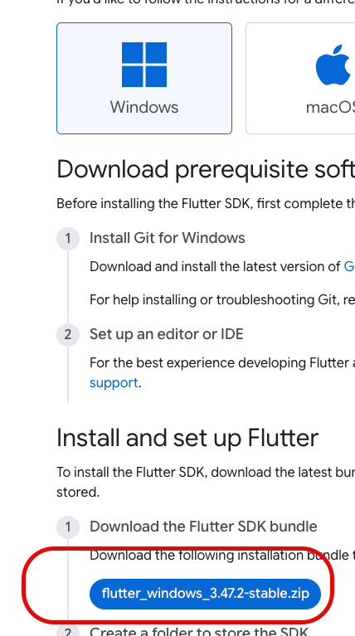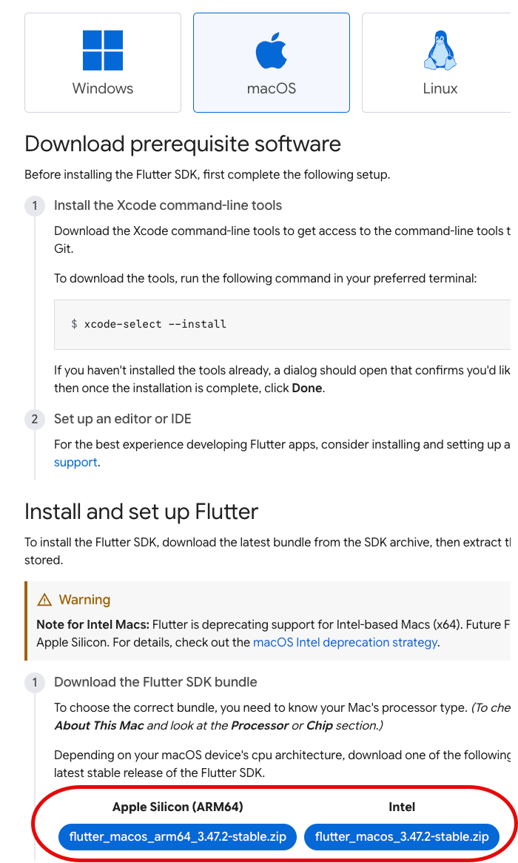
- Copy the uncompressed download to your home directory. (Your home directory is usually the computer’s Users directory followed by some variation on your name. For example, my home directory on Mac is /Users/bburd. On Windows, its \Users\bburd.
- In the Android Studio Welcome panel, with Projects selected on the left side, click New Flutter Project.
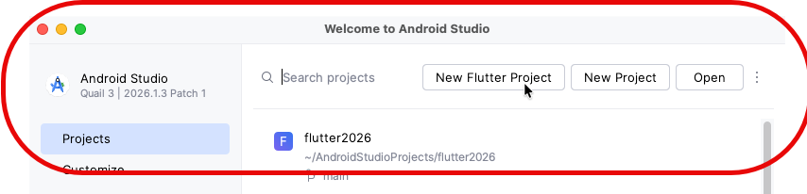
- In the New Project window, make sure that Flutter is selected on the left side. (See the next page. This has been making trouble for people.) In the Flutter SDK Path field, type the name of your home directory, followed by /flutter (for Mac) or \flutter (for Windows).
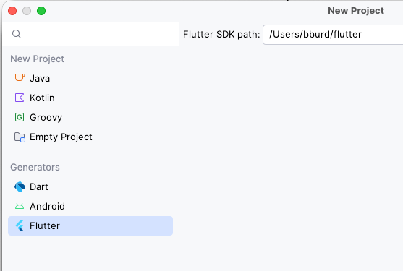
- In the New Project window, click Next. This opens another New Project window asking you for a project name. Type any name you want but use only lowercase letters, digits, and underscores. You can leave all the other fields at their defaults.
- Click Create. This should open up a project that looks like the one I started to go over in class. (You can check to make sure there’s a lib folder on the left side of the window.)

