$ salloc -N 8
$ scripts/launch -c trinary
$ flux topo -H | dot -Tpng | display
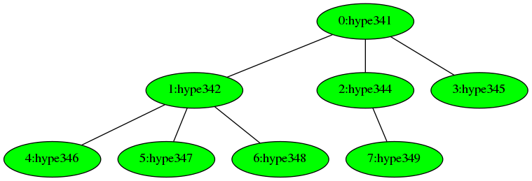

$ flux peer --rank 1 panic
$ flux up
ok: [0,2-7]
slow:
fail: 1
unknown
$ flux topo -H | dot -Tpng | display

