Student ID: 103582556

Name: John Tran

# Setup Screenshot

# Task 1 Screenshot

# Task 2 Screenshot

# Task 3 Screenshot

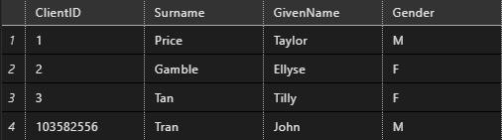

# Task 4 Screenshot

Query 1: