SSY Analytics: High Level Design:

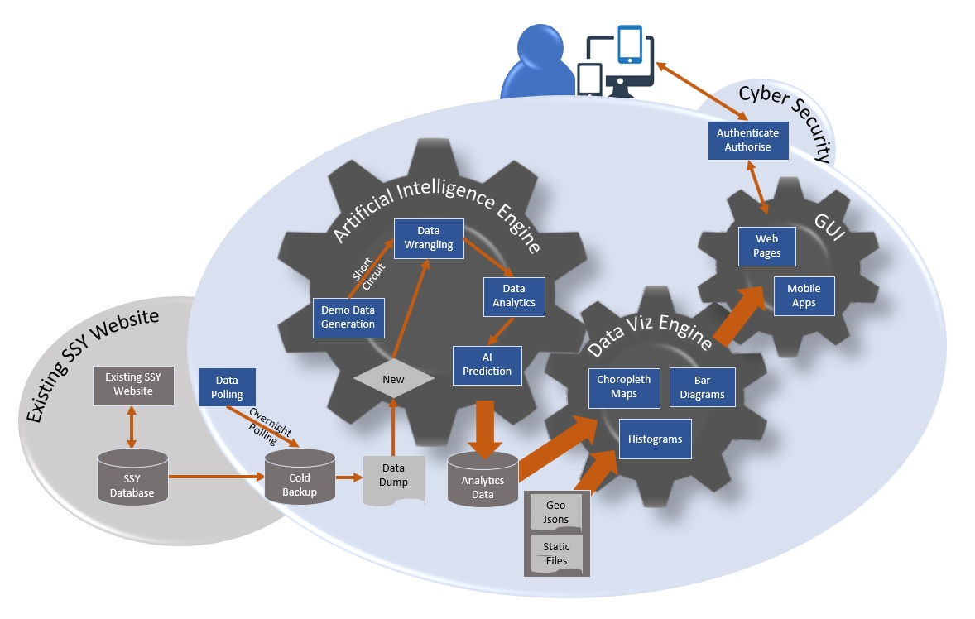

Fig 1: HLD Diagram

|  |  |
| --- | --- |
| 1. The architecture will be Rest API based and will be outlined in detail for each component in low level design documents. 2. This High-Level Design diagram will sit below Architecture diagram and above low level design. 3. Cold backup of existing SSY Database should be taken 4. A data polling function should poll the cold backup database of SSY data periodically, preferably weekly. This should be an overnight batch process so that performance of other functionalities will not be affected. 5. A data dump will be created as a result of this polling. This will be preferably in a .csv format. | 1. If this data dump will have new data, it will be used as training data and the following steps will be performed. 2. In case of demo application or simulation data generation, the data generation scripts will be run to generate the training data. No data from SSY database need to be extracted in this case. 3. Once data is available, data wrangling will be done to organize the data for further processing. 4. Subsequently data analytics will be performed on the historical data. 5. Thereafter, this data will be used as training data and future predictions will be made using machine learning and artificial intelligence. |

|  |  |
| --- | --- |
| 1. The results of step 7 and 8 will be stored in a data repository. 2. Subsequently the data from step 9 along with Geo Json files, static resources and configuration files will be used by the data visualization engine to generate choropleth maps, bar diagrams etc. 3. The visual components which are output of step 10, will be rendered by GUI (responsive web pages and mobile apps) as response to user request. | 1. User will be able to filter the information request according to Subdivision, District, Gender, Caste, Worker Type, Age and Timeline. 2. Dropdown boxes and Slider controls in the control panel will be used to do this filtering. 3. User access will be granted through authentication and authorization. Other cyber security controls will be used and will be detailed in low level design. |