Faye Van Roekel

January 9, 2020

WEB-425 Exercise 2.3

Before a name is populated:

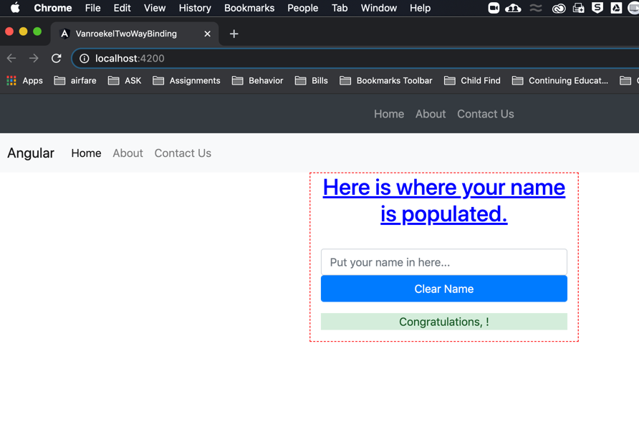

After name is populated

