Faye Van Roekel

January 9, 2020

WEB-425 Exercise 2.2

Before click:

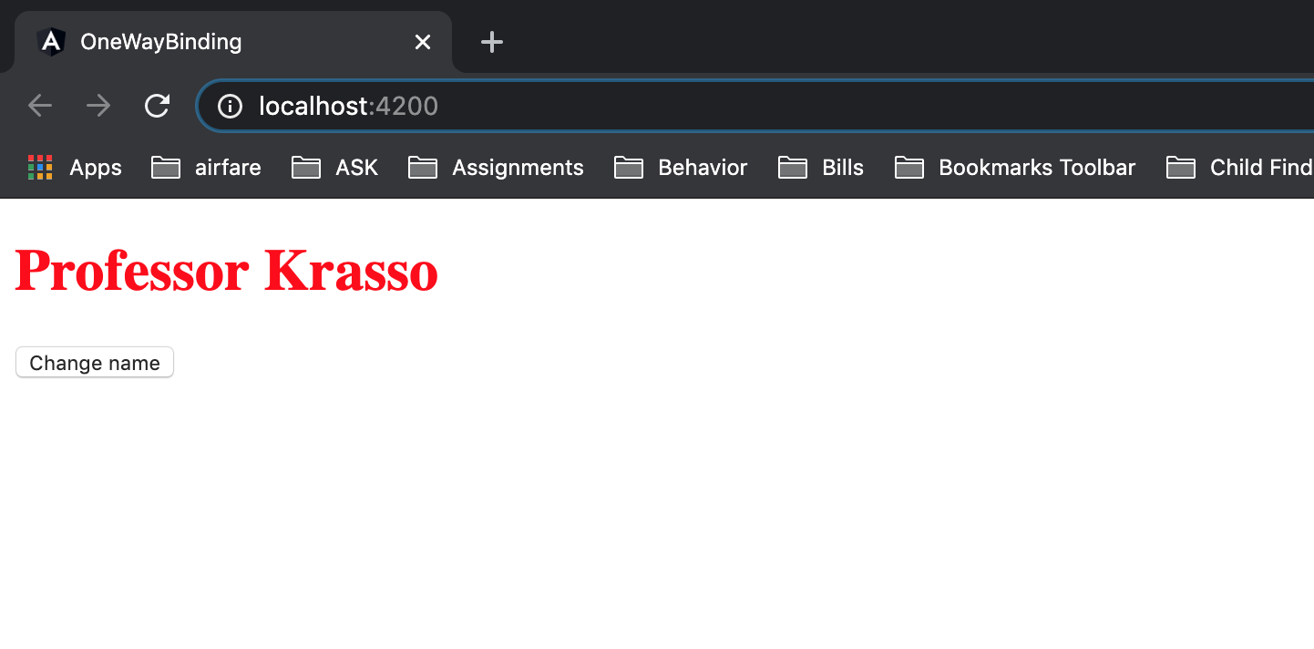

After click:

