Faye Van Roekel

Assignment 9.3 Web-425

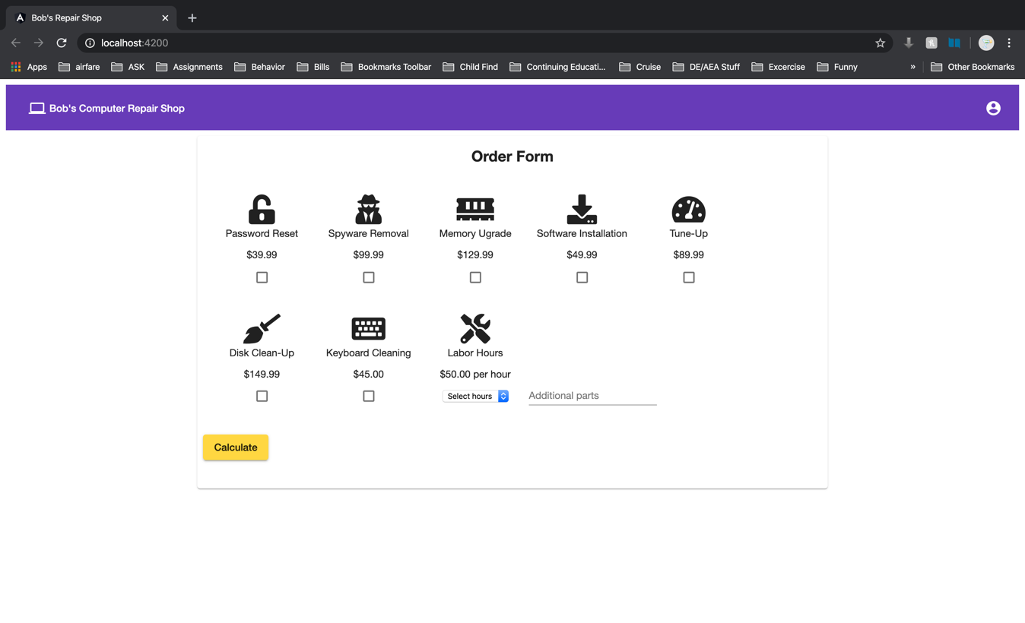February 27, 2020



