Selected Stocks: 3968.HK and 1044.HK

Part I: Data analysis (10%)

1. Time series of realized volatilities for S1 and S2  
   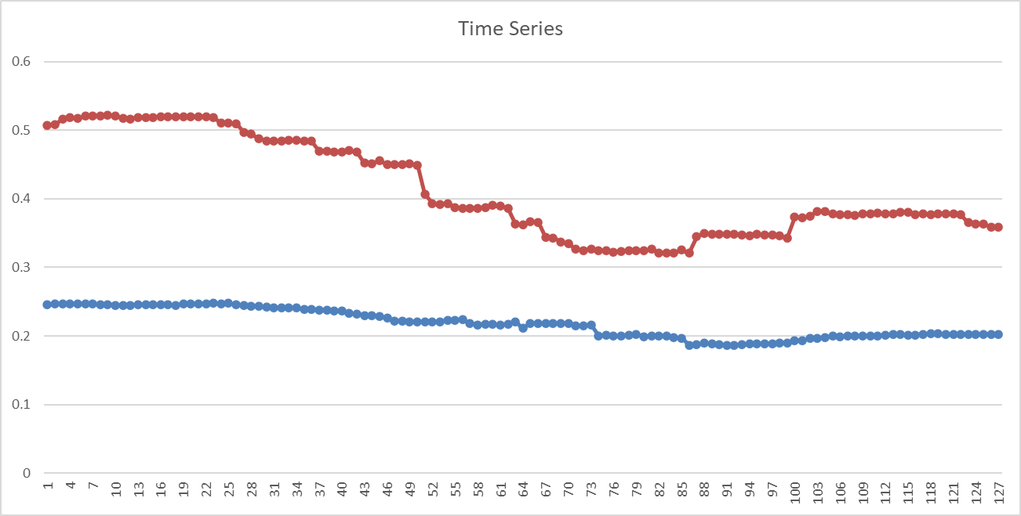  
   Average volatility:   
   σ̅1= 0.412893738

σ̅2= 0.218050355

1. We can calculate by using the =CORREL(H7:H252,I7:I252) formula.

ρ12= 0.440247039

1. Time series of the correlation coefficient

Part II: Exotic option pricing (30%)

i)

ii)

Part III: Pricing of a structured product (60%)

1. Fair price F1

2. Fair price F2

3. By trial and error, we keep on changing the CP value until the profit margin gets as close as possible to F1.

4. If the above procedure is modified by taking these into account, the coupon calculated will be lower. As there will be fewer trading days. Which means it has a lower chance of triggering an event. Resulting in a higher chance of paying a higher coupon. To compensate for this change, the coupon calculated will be higher than CP calculated in question 3.