UNDERTAKING BY {companyName}.
FOR MAINTAINING SAFETY AND OBTAINING PERMISSION
To Whomsoever It May Concern,
We hereby undertake full responsibility for all risks associated with drone flying and data acquisition, conducted with type certified/ non-type certified drones. We will ensure the safety of all manned and unmanned aircraft, personnel, property, and the privacy of the public during the drone operation. We further undertake that all drone flying activities will be conducted with the highest standards of safety, under the strict supervision of authorized personnel. Additionally, we shall obtain the necessary permissions from all concerned authorities, including those specified for red zones by the Ministry of Civil Aviation.
We also confirm that the drones used for this operation/survey are not of Chinese origin.

Yours sincerely,
Date: {letterDate}

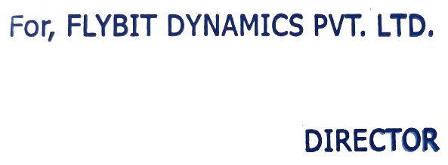
Signature
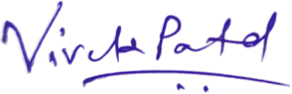

Name: {signatoryName}
Designation: {signatoryTitle}

