1. boxplot( hitRate~p+fName, data=rst.df, main="hitRate~p+fName" )

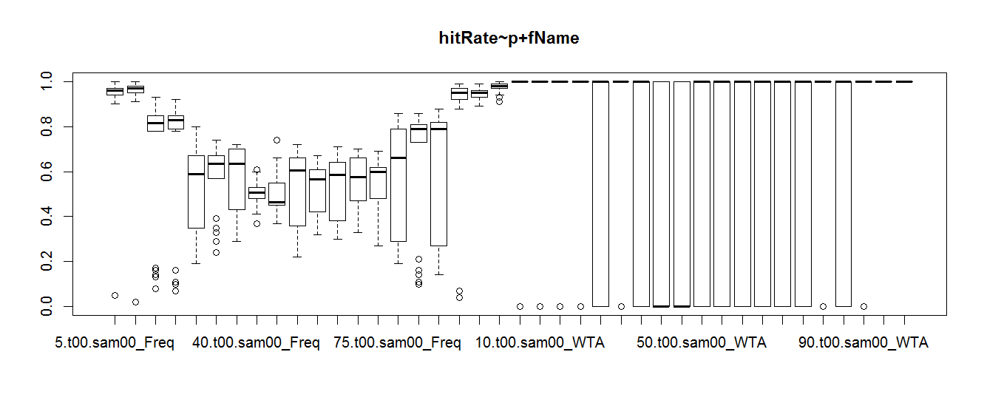

2. plot( hitRate~p, data=rst.df, subset=f, main="t00.sam00_Freq" )

fName <- "t00.sam00_Freq"; f <- rst.df$fName==fName

plot( hitRate~p, data=rst.df, subset=f, main="t00.sam00_Freq" )

