打包和发布

发布python程序

使用zipapp生成可执行的python档案包

使用zipapp创建独立引用

安装PyInstaller模块

使用PyInstaller生成EXE程序

zipapp模块用于生成可执行的python档案包，它包含目录下的所有python程序，如果使用pip工具先将python程序所依赖的模块下载大目的地，那么就可以生成可独立运行的python程序——只要目标机器上安装有python解释器即可。

PyInstaller工具则更强大，可以直接将python程序编译成windows，linux等平台上可执行程序，而无需安装python环境。

# zipapp

## 命令

python3 -m zipapp app -o first.pyz -m "test:main"

python3 -m zipapp <source> <options>

该命令的options支持如下选项

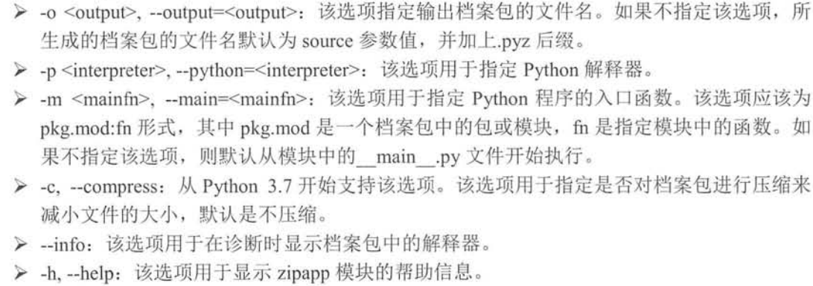

## 示例

root@2004a:/home# tree test/

test/

├── app

│   ├── add.py

│   ├── hello.py

│   ├── sub.py

│   └── test.py

└── first.pyz

1 directory, 5 files

root@2004a:/home#

0 directories, 4 files

root@2004a:/home/test#

root@2004a:/home/test# cat hello.py

def say_hello():

print("hello!")

root@2004a:/home/test# cat add.py

def do_add(a,b):

return a+b

root@2004a:/home/test# cat sub.py

def do_sub(a,b):

return a-b

root@2004a:/home/test# cat test.py

from hello import *

from add import *

from sub import *

def main():

say_hello()

print(do_add(6,4))

print(do_sub(6,4))

root@2004a:/home/test#

root@2004a:/home/test# python3 test.py

hello!

10

2

root@2004a:/home/test#

python3 -m zipapp app -o first.pyz -m "test:main"

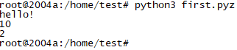

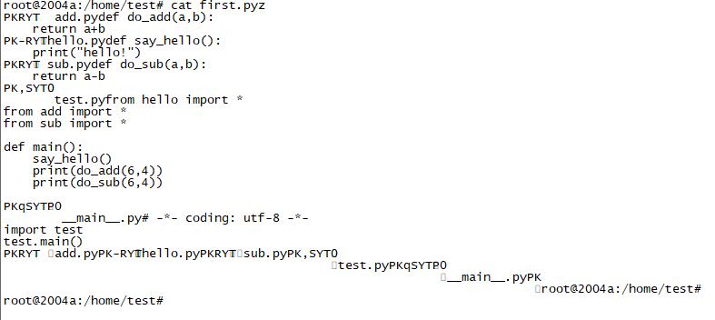

# zipapp创建独立应用

假设应用程序要用到第三方依赖，比如mysql，如何打包呢？

打包过程将分两步：

下载依赖到指定目录

对指定目录打包

示例：

#用到了mysql数据库

dbapp/__main__.py

from exec_select import *

query_db()

dbapp/requirements.txt

mysql-connector-python

python -m pip install =r requirements.txt --target dbapp

python -m zipapp dbapp #没有使用-m选项指定程序入口，该程序会使用包中的__main__.py文件作为程序入口

# 使用PyInstaller生成可执行程序

## 安装pyinstaller

#python默认不安装pyinstaller

pip install pyinstaller

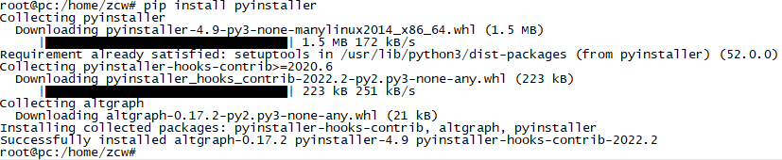



root@pc:/home/zcw# which pyinstaller

/usr/local/bin/pyinstaller

## 语法(pyinstaller 选项 python源文件)

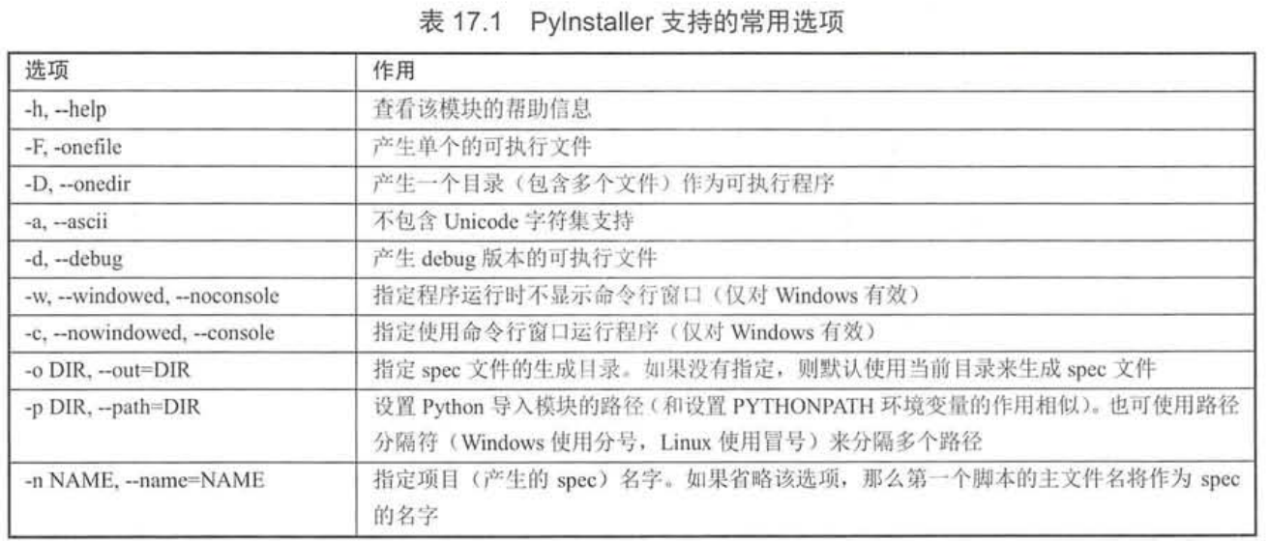

## 命令行界面程序(pyinstaller -F app.py)

|  |  |
| --- | --- |
| root@pc:/home/zcw/app# tree  .  ├── app.py  └── say_hello.py | pyinstaller -F app.py  root@pc:/home/zcw/app# tree  .  ├── app.py  ├── app.spec  ├── build  │   └── app  │   ├── Analysis-00.toc  │   ├── app.pkg  │   ├── base_library.zip  │   ├── EXE-00.toc  │   ├── PKG-00.toc  │   ├── PYZ-00.pyz  │   ├── PYZ-00.toc  │   ├── Tree-00.toc  │   ├── Tree-01.toc  │   ├── warn-app.txt  │   └── xref-app.html  ├── dist  │   └── app #可执行程序  ├── __pycache__  │   └── app.cpython-39.pyc  └── say_hello.py  4 directories, 16 files  root@pc:/home/zcw/app# |

root@pc:/home/zcw/app# pyinstaller -F app.py

86 INFO: PyInstaller: 4.9

87 INFO: Python: 3.9.7

93 INFO: Platform: Linux-5.13.0-30-generic-x86_64-with-glibc2.34

94 INFO: wrote /home/zcw/app/app.spec

97 INFO: UPX is not available.

98 INFO: Extending PYTHONPATH with paths

['/home/zcw/app']

436 INFO: checking Analysis

436 INFO: Building Analysis because Analysis-00.toc is non existent

436 INFO: Initializing module dependency graph...

438 INFO: Caching module graph hooks...

454 INFO: Analyzing base_library.zip ...

6980 INFO: Processing pre-find module path hook distutils from '/usr/local/lib/python3.9/dist-packages/PyInstaller/hooks/pre_find_module_path/hook-distutils.py'.

6981 INFO: distutils: retargeting to non-venv dir '/usr/lib/python3.9'

12707 INFO: Caching module dependency graph...

13060 INFO: running Analysis Analysis-00.toc

13113 INFO: Analyzing /home/zcw/app/app.py

13118 INFO: Processing module hooks...

13119 INFO: Loading module hook 'hook-distutils.py' from '/usr/local/lib/python3.9/dist-packages/PyInstaller/hooks'...

13146 INFO: Loading module hook 'hook-xml.etree.cElementTree.py' from '/usr/local/lib/python3.9/dist-packages/PyInstaller/hooks'...

13146 INFO: Loading module hook 'hook-xml.py' from '/usr/local/lib/python3.9/dist-packages/PyInstaller/hooks'...

13280 INFO: Loading module hook 'hook-_tkinter.py' from '/usr/local/lib/python3.9/dist-packages/PyInstaller/hooks'...

13381 INFO: checking Tree

13382 INFO: Building Tree because Tree-00.toc is non existent

13382 INFO: Building Tree Tree-00.toc

13398 INFO: checking Tree

13398 INFO: Building Tree because Tree-01.toc is non existent

13399 INFO: Building Tree Tree-01.toc

13462 WARNING: Tcl modules directory /usr/share/tcltk/tcl8.6/../tcl8 does not exist.

13464 INFO: Loading module hook 'hook-multiprocessing.util.py' from '/usr/local/lib/python3.9/dist-packages/PyInstaller/hooks'...

13468 INFO: Loading module hook 'hook-heapq.py' from '/usr/local/lib/python3.9/dist-packages/PyInstaller/hooks'...

13470 INFO: Loading module hook 'hook-pickle.py' from '/usr/local/lib/python3.9/dist-packages/PyInstaller/hooks'...

13473 INFO: Loading module hook 'hook-distutils.util.py' from '/usr/local/lib/python3.9/dist-packages/PyInstaller/hooks'...

13475 INFO: Loading module hook 'hook-difflib.py' from '/usr/local/lib/python3.9/dist-packages/PyInstaller/hooks'...

13477 INFO: Loading module hook 'hook-lib2to3.py' from '/usr/local/lib/python3.9/dist-packages/PyInstaller/hooks'...

13507 INFO: Loading module hook 'hook-encodings.py' from '/usr/local/lib/python3.9/dist-packages/PyInstaller/hooks'...

13595 INFO: Loading module hook 'hook-sysconfig.py' from '/usr/local/lib/python3.9/dist-packages/PyInstaller/hooks'...

13618 INFO: Looking for ctypes DLLs

13724 INFO: Analyzing run-time hooks ...

13732 INFO: Including run-time hook '/usr/local/lib/python3.9/dist-packages/PyInstaller/hooks/rthooks/pyi_rth_subprocess.py'

13735 INFO: Including run-time hook '/usr/local/lib/python3.9/dist-packages/PyInstaller/hooks/rthooks/pyi_rth_pkgutil.py'

13740 INFO: Including run-time hook '/usr/local/lib/python3.9/dist-packages/PyInstaller/hooks/rthooks/pyi_rth_multiprocessing.py'

13745 INFO: Including run-time hook '/usr/local/lib/python3.9/dist-packages/PyInstaller/hooks/rthooks/pyi_rth_inspect.py'

13758 INFO: Looking for dynamic libraries

14310 INFO: Looking for eggs

14311 INFO: Python library not in binary dependencies. Doing additional searching...

14368 INFO: Using Python library /lib/x86_64-linux-gnu/libpython3.9.so.1.0

14376 INFO: Warnings written to /home/zcw/app/build/app/warn-app.txt

14433 INFO: Graph cross-reference written to /home/zcw/app/build/app/xref-app.html

14457 INFO: checking PYZ

14457 INFO: Building PYZ because PYZ-00.toc is non existent

14457 INFO: Building PYZ (ZlibArchive) /home/zcw/app/build/app/PYZ-00.pyz

15271 INFO: Building PYZ (ZlibArchive) /home/zcw/app/build/app/PYZ-00.pyz completed successfully.

15280 INFO: checking PKG

15280 INFO: Building PKG because PKG-00.toc is non existent

15281 INFO: Building PKG (CArchive) app.pkg

19672 INFO: Building PKG (CArchive) app.pkg completed successfully.

19675 INFO: Bootloader /usr/local/lib/python3.9/dist-packages/PyInstaller/bootloader/Linux-64bit-intel/run

19675 INFO: checking EXE

19675 INFO: Building EXE because EXE-00.toc is non existent

19676 INFO: Building EXE from EXE-00.toc

19676 INFO: Copying bootloader EXE to /home/zcw/app/dist/app

19677 INFO: Appending PKG archive to custom ELF section in EXE

19828 INFO: Building EXE from EXE-00.toc completed successfully.

root@pc:/home/zcw/app#

生成的可执行文件对glibc库还是有很大依赖的，不保证跨平台能够运行

root@pc:/home/test/Music# file app

app: ELF 64-bit LSB executable, x86-64, version 1 (SYSV), dynamically linked, interpreter /lib64/ld-linux-x86-64.so.2, BuildID[sha1]=ac40f3d3f795f9ee657f59a09fbedea23c4d7

root@pc:/home/test/Music# ./app

program begin to execute...

sunwukong, hello!

root@pc:/home/test/Music#

如果只有app.py, 找不到依赖文件say_hello.py会怎么样？

打包过程能正常进行下去，生成的app.spec也一样，但就是无法运行

root@pc:/home/zcw/app/dist# ./app

Traceback (most recent call last):

File "app.py", line 1, in <module>

ModuleNotFoundError: No module named 'say_hello'

[12756] Failed to execute script 'app' due to unhandled exception!

root@pc:/home/zcw/app/dist#

## 图形用户界面程序(pyinstaller -F -w app.py)

root@pc:/home/zcw/app# cat app.py

from tkinter import *

root = Tk()

root.title('windows title')

w = Label(root, text="hello Tkinter!")

w.pack()

root.mainloop()

root@pc:/home/zcw/app# pyinstaller -F -w app.py

root@pc:/home/zcw/app# tree

.

├── app.py

├── app.spec

├── build

│   └── app

│   ├── Analysis-00.toc

│   ├── app.pkg

│   ├── base_library.zip

│   ├── EXE-00.toc

│   ├── PKG-00.toc

│   ├── PYZ-00.pyz

│   ├── PYZ-00.toc

│   ├── Tree-00.toc

│   ├── Tree-01.toc

│   ├── warn-app.txt

│   └── xref-app.html

├── dist

│   └── app

└── __pycache__

└── app.cpython-39.pyc

4 directories, 15 files

root@pc:/home/zcw/app#

root@pc:/home/zcw/app# cp dist/app /home/test/Desktop/

root@pc:/home/zcw/app# chmod a+x /home/test/Desktop/app

