https://www.cnblogs.com/xueweihan

HelloDjango:

git clone https://github.com/HelloGitHub-Team/HelloDjango-blog-tutorial.git

python关键字：

https://www.cnblogs.com/xueweihan/p/4518022.html

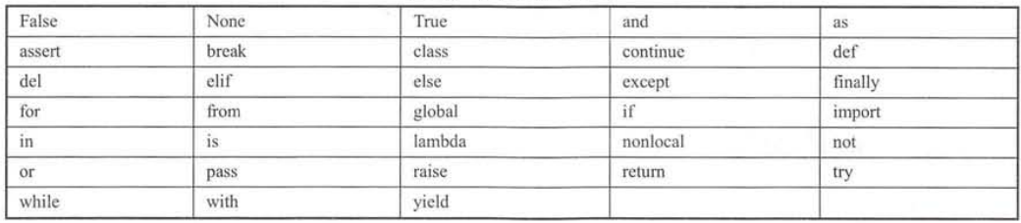

python3内置函数：

https://www.runoob.com/python3/python3-built-in-functions.html