As a python training project, I made an interactive version of my CV.

To test my interactive CV please copy the python code into an online compiler.

Of the once I testet, this is the best: https://trinket.io/features/python3 (works best fullscreen)
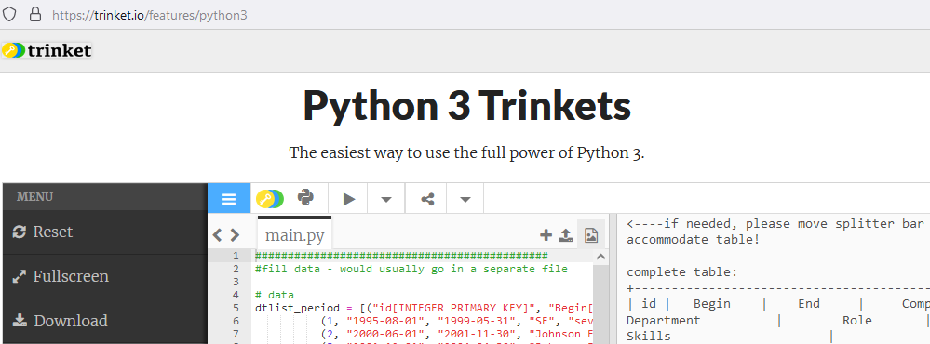

An alternative test site would be: https://www.codabrainy.com/en/python-compiler.

Known issues: - some online compilers seem to run into timeout after a while. Just start again.

This is the code:

#############################################
#fill data - would usually go in a separate file

# data
dtlist_period = [("id[INTEGER PRIMARY KEY]", "Begin[DATE NOT NULL]", "End[DATE NOT_NULL]", "Company[Text]", "Department[TEXT]", "Role[TEXT]", "Skills[TEXT]", ),
(1, "1995-08-01", "1999-05-31", "Company A", "several", "Apprentice", "mech. manufact, electric",),
(2, "2000-06-01", "2001-11-30", "Company B", "Maintenance", "Electric Mechanic", "mech. and elec. maintenance",),
(3, "2001-12-01", "2004-04-30", "Company B", "Industrialization department", "Technician", " PLC, Electrical wiring, drawing el.schematics",),
(4, "2004-05-01", "2011-11-30", "School", "Advanced Diploma..", "Software Engineer", "C++",),
(5, "2004-05-01", "2011-11-30", "Company B", "Industrialization department", "Software Engineer", "PLC, LabView",),
(6, "2011-01-01", "2022-09-30", "Company C", "Developement/Support", "Software Engineer", "PLC, LabView, GIT",),
(7, "2023-01-01", "2023-06-30", "private study", "projects and certification", "Software Engineer", "C++, Python, embedded(arduino&co), GIT",)]

import sqlite3

class DatabaseObject:
def __init__(self, connection):
self.conn = connection
self.cursor = self.conn.cursor()

def insert_data_into_list(self, table_name, data_list):
col_names = [col.split('[')[0] for col in data_list[0]]
col_infos = [col.split('[')[1].split(']')[0] for col in data_list[0]]
placeholders = ', '.join(['?'] * len(data_list[0]))
query_create_table = "CREATE TABLE IF NOT EXISTS " + table_name + " ("
for i in range(len(col_names)):
query_create_table = query_create_table + col_names[i] + " " + (col_infos[i] if i < len(col_infos) else "") + ("," if i < len(col_names)-1 else ")")
insert_query = f"INSERT INTO {table_name} (" + ",".join(col_names) + f") VALUES ({placeholders})"

try:
self.cursor.execute(query_create_table)
self.cursor.executemany(insert_query, data_list[1:]) # Assuming the first tuple is for column names and types

except Exception as e:
print("problem writing database:" + e)

def readDB_Select(self, table_name, cols="*", wherecond="", tpl_searchstr="", sortcond=""):
records = None
query = "SELECT " + cols + " FROM " + table_name
if wherecond != "":
query = query + " WHERE " + wherecond
if sortcond != "":
query = query + " ORDER BY " + sortcond
try:
if tpl_searchstr=="":
self.cursor.execute(query)
else:
cursor.execute(query, tpl_searchstr)
records = self.cursor.fetchall()
if cols == "*":
query = f"PRAGMA table_info({table_name})"
self.cursor.execute(query)
headers = [i[1] for i in self.cursor.fetchall()]
records.insert(0,headers)
except Exception as e:
print("problem reading from database:" + e)
else:
pass #print(" read OK")
finally:
return records

def __del__(self):
conn.close()
print("data base disconnected..")

##############################################
# this would be the GUI file:
#another version with a nicer GUI with buttons didn't work in the online implementation of matplotlib:

class GUI:
def __init__(self):
self.vline = "|"
self.hline = "-"

def print_horline(self,colwidths):
print("+", "-" * (sum(colwidths)-1+len(colwidths)), "+", sep="") #print horizontal line

def print_row(self, values, colwidths):
line = []
for i in range(len(colwidths)):
line.append(str(values[i]).center(colwidths[i]))
print(self.vline + self.vline.join(line) + self.vline)

def printTable(self, records, col_names="*", withid=False):
records = [i[1::] for i in records] if withid == False else records #strip id column
col_wds = [max([len(str(row[i])) +2 for row in records]) for i in range(len(records[1]))]
self.print_horline(col_wds)
self.print_row(records[0], col_wds)
self.print_horline(col_wds)
for record in records[1::]:
self.print_row(record, col_wds)
self.print_horline(col_wds)
self.print_row(alphabet[:len(col_wds):], col_wds)
self.print_horline(col_wds)

def print_emptyscreen(self):
print("\n" * 20)

def print_help(self, big=False):
if big:
print("********************************************************************************")
print("use full screen mode\n")
print("<----If needed, please move splitter bar to the left to accommodate table!\n")
print("Sometimes the online compiler seem to have a timeout, just start again with run\n")
print("Enter column and row for the cell after which you would like to filter:")
print("Example: enter first \"g7\" and then \"2\" to get all entries with python skills")
if big:
print("********************************************************************************")

##############################################
# this would be the main file

from time import sleep

alphabet = tuple(map(chr, range(97, 123)))

# Create a connection to the in-memory database
conn = sqlite3.connect(':memory:')

# Create DB instance with connection
db = DatabaseObject(conn)

tblprinter = GUI()

print("initializing simulated database..\n")
tblprinter.print_help(big=True)
sleep(2) #make it look more dramatic ;)

# Insert data into the table
db.insert_data_into_list("Periods", dtlist_period)

while True:
#read and display original table
records = db.readDB_Select("Periods")

print("\ncomplete table:")
tblprinter.printTable(records, withid=True)
tblprinter.print_help()
inpt = input("\nEnter column letter and row number or ? for help or ! for exit: ")
if inpt.lower() == "!":
break
elif inpt.lower() == "?":
tblprinter.print_emptyscreen()
tblprinter.print_help(big=True)
tblprinter.print_emptyscreen()
elif inpt[:1:].lower() in alphabet[:(len(records[0])):] and inpt[1:3:] in [str(i) for i in range(1,len(records))]:
wherecol = whereval = ""
for row in records:
if str(row[0]) == inpt[1:3:]:
wherecol = str(records[0][alphabet.index(inpt[:1:].lower())])
whereval = str(row[alphabet.index(inpt[:1:].lower())])
if whereval.find(",") > -1: #if several items in column, ask which one
print("\nwhich of the following would you like to filter for:")
options = [a.strip() for a in whereval.split(",")]
inpt = input("".join([f"{options[i]}=[{i+1}] " for i in range(len(options))]))
if int(inpt) in range(1,len(options)+1):
search_string = options[int(inpt) - 1]
else:
search_string = whereval.split(",")[0].strip()
records = db.readDB_Select("Periods", wherecond=f"{wherecol} LIKE ('%{search_string}%')") # replacement not working yet: LIKE ('%' || ? || '%')
tblprinter.print_emptyscreen()
print(f"{wherecol} \"contains\" {search_string}:")
else:
records = db.readDB_Select("Periods", wherecond=f"{wherecol} = \'{whereval}\'")
tblprinter.print_emptyscreen()
print(f"{wherecol} = {whereval}:")

if records != None:
tblprinter.printTable(records, withid=True)
inpt = input("\npress enter to go back to original table:")
inpt = ""
tblprinter.print_emptyscreen()
else:
inpt = ("something went wrong... press enter")
tblprinter.print_emptyscreen()

break #break of for row in records
else:
inpt = input("\ninvalid! Do you want to exit: [n]=NO all others =YES ")
if inpt.lower() != "n":
break

# normal exit
del db
print("\n\nThank you for taking time to watch my interactive CV! Looking forward to hear from you...")
##############################################

