Kimberly Hess

Mt. Whipple Observatory – short term proposal

3/5/2020

**Abstract of Scientific Justification:**

I propose to complete a transit method exoplanet analysis of two stars: XO-6 and WASP-92. XO-6 is a class F5 star with an apparent magnitude of 10.25. It has 1 observable planet, with a 1.7 day orbit and a transit depth of .014. The second star is WASP-92, is a type F7 star with a magnitude of 13.18. It has an orbiting planet with 2.17 orbital period and a transit depth of .0135. The intent of this study is to work through the process of detecting a transit of an exoplanet using the “transit method”. Having 2 targets, with known exoplanets with relatively short orbital periods will increase our probability of detecting a transit.

**Scientific justification:**

The scientific goal of this project is to get familiar with and capable of completing an exoplanet transit analysis to a level of degree that will allow me to transfer this technique to a course at a local observatory. Following the detection of the transit I will calculate the radius of the planet from the observed fraction of diminished light. I will also calculate the period of the planet’s orbit. Long term the techniques gathered during this period of observation will transfer to further studies of different star systems with fewer known details of possible exoplanet transits.

**Experimental design:**

In order to detect an exoplanet using the transit method we need a star visible for an extended period. The moon during our period of observation will be at less than 20% illumination. Both stars will be viewable during evening twilight and at midnight but by morning twilight will no longer be visible. Saturn will be a good fixed target for tuning our observation for both targets.

The worst-case projection for air mass is below. Due to the high declination of the stars air mass will not be an issue.

**Proposed target 1: XO-6-b**

RA: 94.79321242, DEC: 73.82766444

Exposure time required: with g filter 5.3 seconds, for ~1000 S/N, filter change does not have a large impact.

Air mass: 1.70

Planet mass = 1.9 x Jupiter

Date of transit: 03/17/20 (2458926.773 HJD)

Apparent magnitude: 10.25

Transit depth: 0.013

Duration of transit: 174 minutes

Altitude /Azimuth at evening twilight: 47.85819945034061, 0.23306487072709825

Altitude /Azimuth at midnight: 35.33388758412547, 341.0647253621733

Altitude /Azimuth morning twilight: 18.186911152657594, 350.11870724703454

Time of transit: begin: 3/18/2020, 5:05 UTC (00:05 LST, 3/10), mid: 6:32 UTC (01:32 LST) end: 7:59 (02:05LST),

Locations: Begin: 41N, Mid: 36N, End: 30NW

Location of start and its transit through the night are depicted as follows:

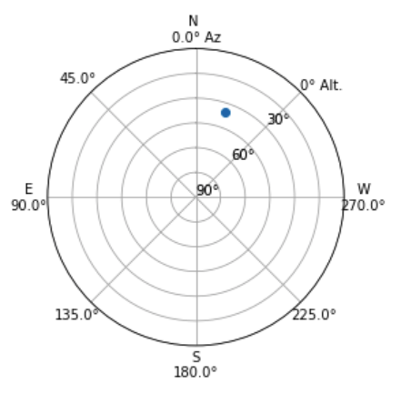 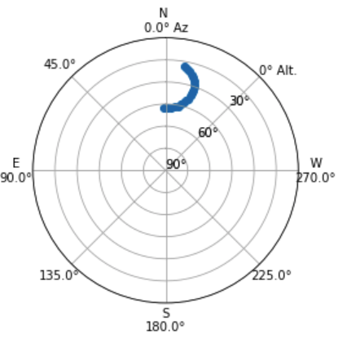

**Proposed target 2: WASP-92-b**

RA: 246.69207832, DEC: 51.04108114

Apparent Magnitude: 13.18

Transit depth: 0.0135

Duration of transit: 133 minutes

Exposure time required: .84 seconds for ~100 S/N , 84 seconds for ~1000S/N

Air mass: 1.97

Orbital period: 2.17 days

Date of transit: 03/18/20 Local date (**2458927.827**HJD)

Time of transit: begin: 3/19/2020 06:27 UTC (23:27 LST, 3/18/2020), mid: 7:50 UTC (00:50 LST) end: 09:13 UTC (02:13, 3/19/2020 LST),

Altitude /Azimuth evening twilight: not viewable

Altitude /Azimuth at midnight: 30.34293003348464, 45.82864134207626

Altitude /Azimuth morning twilight: 69.96966572747299, 13.319673900012

Locations: Begin: 28NE, Mid: 41NE, End: 54NE

Location of start and its transit through the night are depicted as follows:

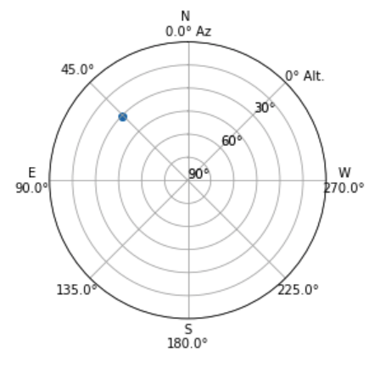 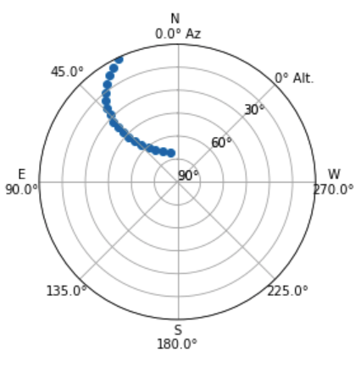

**Method of detection:**

Using the CCD the method of detection will include plotting the light curve of the star. This method is capable of finding Jupiter sized planets orbiting close to their star that have an orbital plane relatively in line with Earth’s.

Target stars for alignment and orientation through the night are Vega, Polaris, M1, and M42. All four of those targets will be visible in March and throughout the time of observing. Below are some star plots to help us find the target stars.

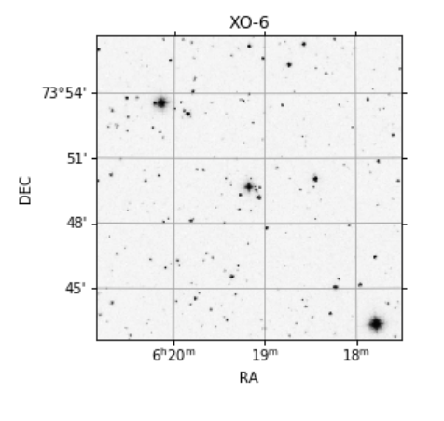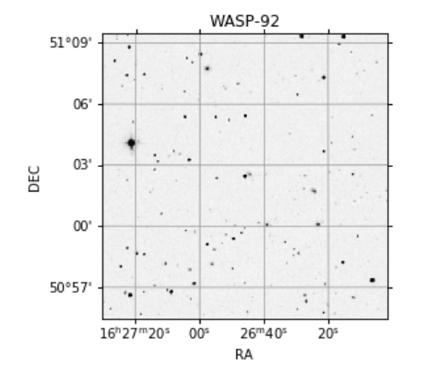

**Conclusion:**

With these two options we should be able to capture an exoplanet transit. While we won’t be actively discovering new planets we will be employing techniques that could lead to the discovery of a new planet. The technique of analyzing a light curve can be applied to many other facets of interpreting ccd derived data. By learning these techniques and analysis tools and then extending the knowledge to future students the time speant on the Whipple telescope will have far reaching impact.

**References:**

1. Python notebooks that are attached with source data from astroplan and astropy
2. Transit photometry: <https://www.nasa.gov/kepler/overview/abouttransits>. 03/03/2020
3. For sourcing known transits during our visit at the telescope: <http://var2.astro.cz/ETD/predict_detail.php?STARNAME=HAT-P-36&PLANET=b&delka=250&sirka=31>. 03/06/2020
4. For details on the stars and known planets: <http://exoplanet.eu/catalog/HAT-P-36_b/>. 03/05/2020