BreakLoop Native Architecture v6
Version 5 • 2026-01-31 • Native-first runtime (Kotlin + Jetpack Compose)

Why v6
v6 is a reset of the architecture to prioritize interception quality (immediate decisions), runtime stability, and predictable behavior during app switch / quit / re-enter. The monitored-app interception path is 100% native. Non-critical surfaces (e.g., Settings) are allowed to iterate, but they do not sit on the runtime path.

Design principles
- Single source of truth for session lifecycle and mode: SessionManager (native).
- Decisions happen only in native (foreground detection → decision gate → launch).
- Overlay UI is deterministic and passive: renders state, emits user actions, never decides policy.
- App switch / quit / re-enter are unified as a Context Change event.
- Debounce + suppression enforced at native entry points to avoid storms and double-starts.

Architecture overview
High-level components and responsibilities:
Native Runtime (Kotlin) | Foreground detection, decision gate, quota checks, suppression windows, launching/closing overlay.
SessionManager (Native) | Authoritative session record (sessionId/app/kind/mode), preserve/resume semantics, end conditions, snapshot handling.
Overlay UI (Jetpack Compose) | Quick Task UI + Intervention UI. Reads SessionManager state, sends user actions. No policy.
Main App (Jetpack Compose) | Settings (minimal), stats dashboards, onboarding. Never participates in interception logic.
Storage | DataStore for settings, Room/SQLite for event log and aggregates, optional persisted snapshots for restore.
Stats pipeline | Event logger -> aggregator -> read models for UI and export.

Updated diagram:
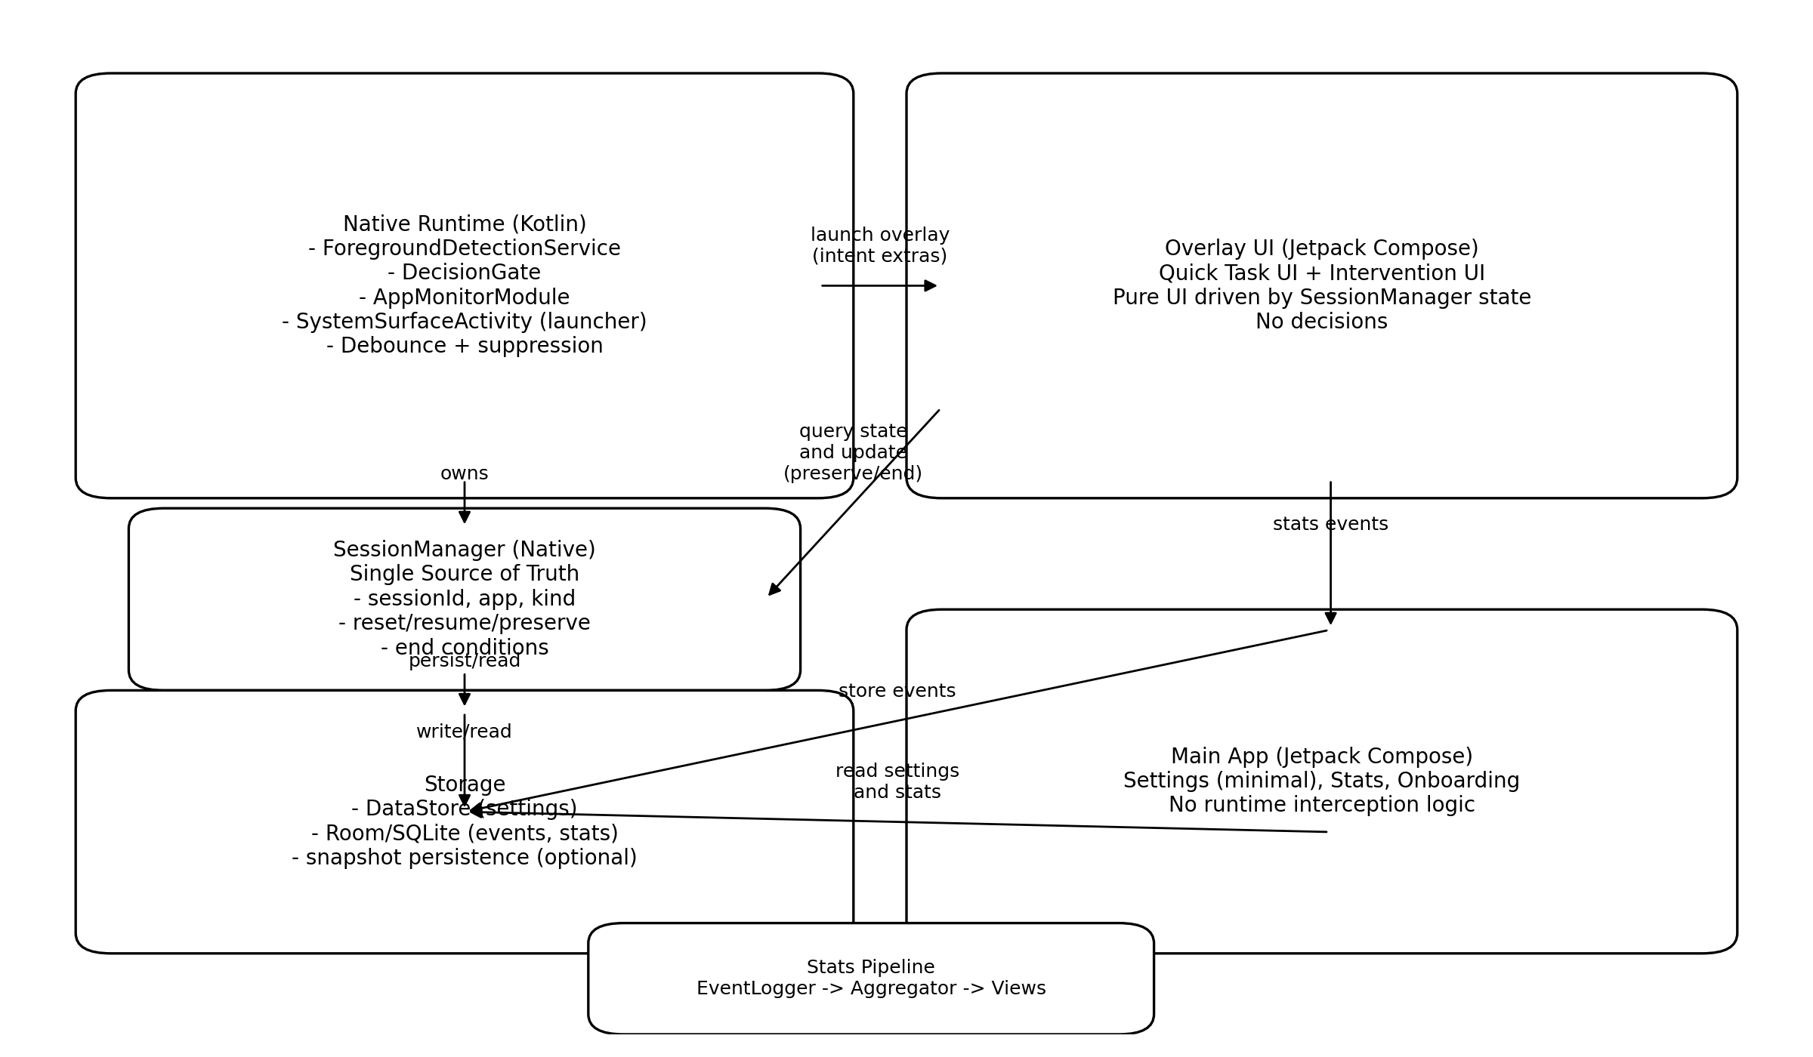

Runtime contexts and process model
- ForegroundDetectionService runs continuously and is the only component that receives OS foreground events.
- SystemSurfaceActivity is the overlay activity used only for interception UI.
- Main App is a standard activity stack for user-initiated settings and stats.
- SessionManager is process-wide and is accessible to both Overlay UI and Main App.

Key flows

1) Monitored app entry → decision → overlay
- Service detects foreground change to a monitored package.
- DecisionGate evaluates: eligibility, quota, suppression, and current session state.
- SessionManager returns an authoritative (kind, mode, sessionId).
- Native launches SystemSurfaceActivity with extras derived only from SessionManager.
- Overlay UI renders immediately from SessionManager state.

2) Preserve → resume (Action Timer only)
- Preserve is allowed only during Action Timer for the same app.
- SessionManager stores a minimal snapshot (remainingSec + timing metadata).
- Same-app re-entry while snapshot valid forces mode=RESUME.
- Any mismatch downgrades to RESET for safety.

3) Unified Context Change handling
Context Change covers: app switch while overlay is active, quit and later re-enter, and same-app re-entry.
- If (same app AND preserved snapshot valid) -> RESUME.
- Else -> RESET (new sessionId).
- Context Change itself must not end a session as a side effect; only explicit outcomes end sessions.

Interfaces and contracts
All runtime-critical communication is native contracts (enums/sealed classes).

Core types (conceptual)
enum class SessionMode { RESET, RESUME }
enum class SessionKind { QUICK_TASK, INTERVENTION }
data class ActionTimerSnapshot(val remainingSec: Int, val startedAtMs: Long)
sealed class SessionOutcome { object Completed; object Cancelled; data class Aborted(val reason: String) }

Migration strategy
- Implement SessionManager v5 and wire DecisionGate to it.
- Rebuild Overlay UI in Compose (Quick Task + Intervention).
- Port Main App screens (Settings + Stats) to Compose incrementally.
- Delete legacy JS runtime paths once parity is achieved.

Appendix — Updates since v5 (Feb 2026)
- Native runtime now owns Post-Quick-Task (Post-QT) decision handling, including Continue→re-decision and Quit→cooldown/suppression.
- Native runtime now owns t_intention as a timer-backed mechanism: when t_intention expires while user remains on the monitored app, Intervention must re-trigger immediately (no re-entry required).
- Quick Task re-entry is prevented via an explicit protection window (t_quickTask) that survives app switching and timer expiry-away.
- Quick Task quota n_quickTask is defined as a fixed rolling window (bucketed) with selectable window sizes (1h/4h/12h/24h). Refill is passive (must not trigger UI by itself).
- Roadmap status: Track A2 is largely complete; next step is Track B1 (Native Flow Authority v0) to move remaining flow transitions out of JS.

