BreakLoop Architecture v3
Native-first, runtime-separated, deterministic control system
Status: Authoritative
Supersedes: BreakLoop Architecture v2
Last updated: Jan 25, 2026

This document defines the current authoritative architecture of BreakLoop on Android, including the operational details migrated from v2 (Quick Task state machine, timers/quota placement, commands/intents, and UI lifecycles).

Architecture diagram (authoritative)
High-level view of runtimes and authority boundaries.
- Native → System Brain: REQUEST_INTERVENTION_PAYLOAD(app, context)
- System Brain → Native: INTERVENTION_PAYLOAD(app, kind, payload Version)
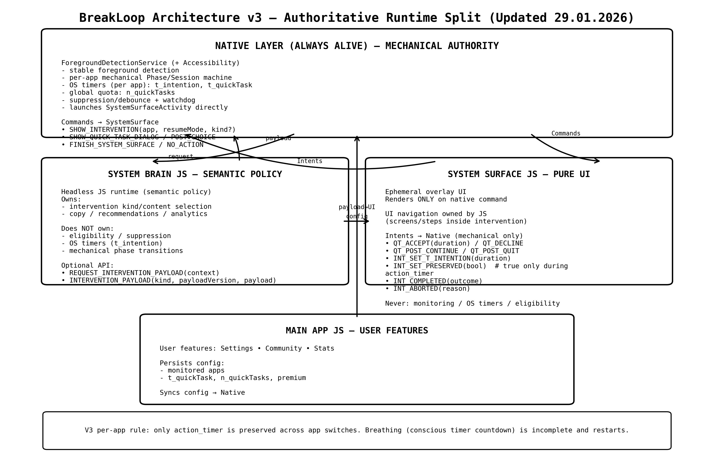

Core principles
- If a component can die, restart, or duplicate, it must not own decisions.
- Native decides; JS renders. JS may provide semantics, never mechanics.
- SystemSurface is UI-only and must never start monitoring or own timers.
- UI closure must never depend on JS. Native must be able to force-close the surface.

Runtime model

Native long-lived runtime (authoritative)
Components: ForegroundDetectionService (Accessibility-driven), SystemSurfaceManager (activity reference + force-finish), native timers/quota cache.
Responsibilities:
- Detect foreground app (via Accessibility events)
- Own Quick Task state machine (per monitored app)
- Own all timers and quota windows; decide eligibility
- Enforce invariants (debounce flicker, suppression gates)
- Guarantee UI closure (native-first finish + watchdog)

MAIN_APP JS runtime (user-initiated)
Main app UI: Settings / Community / Stats. Not guaranteed to be running.
Allowed: persist user config; sync config to native. Prohibited: timers/state inference/entry gating.

SYSTEM_SURFACE JS runtime (overlay UI)
Ephemeral UI runtime launched by SystemSurfaceActivity. Disposable by design.
Allowed: render commanded UI; collect explicit user intent. Prohibited: start monitoring; own timers; infer state.

SYSTEM_BRAIN JS runtime (semantic flow, not OS authority)
V3 clarification (29.01.2026): SYSTEM_BRAIN is responsible for the semantic intervention UI flow, but it never decides OS-trigger eligibility (start/suppress), timers, or native per-app phase transitions.
Native is authoritative for: per-app intervention phase (IDLE / INTERVENTION_ACTIVE), suppression windows, and timers (including t_intention). JS only renders screens and emits explicit user intents.
Headless/event-driven JS runtime for semantics, intervention content selection, and analytics.
Allowed: intention/meaning classification; intervention rule evaluation after native requests intervention. Prohibited: Quick Task mechanical decisions.
- System Brain owns content selection + analytics
- System Brain does NOT own timers / suppression / mechanical phase transitions
- Optional messages:
  - REQUEST_INTERVENTION_PAYLOAD(app, context)
  - INTERVENTION_PAYLOAD(app, kind, payloadVersion, payload)

Monitoring
Monitoring = receiving foreground-app signals and feeding the native decision engine.
Runtime | May start/own monitoring? | Notes
Native service | YES (always) | Authoritative owner of monitoring + decisions.
MAIN_APP JS | May request once | After config loads, may call a native 'ensure monitoring active' action.
SYSTEM_SURFACE JS | NO (never) | Starting monitoring here causes duplicate subscriptions and re-trigger loops.

Quick Task (native-owned)
Quick Task is a per-app state machine owned exclusively by native code. JS only renders UI and emits explicit user intent.

Per-app state record
- state: IDLE | DECISION | ACTIVE | POST_CHOICE
- expiresAt: ACTIVE timer end (nullable)
- postChoiceShown: guard to avoid duplicate post-choice UI
- quota window bookkeeping (e.g., 15-minute rolling window; remaining uses)
- suppression gates (quitSuppressionUntil, suppressWakeUntil) to treat flicker as noise

Timers and timestamps
Native in-memory truth (examples):
- expiresAt (Quick Task ACTIVE end per app)
- lastForegroundChangeTime + lastForegroundPackage (stability tracking)
- quitSuppressionUntil[app] (suppression window after explicit quit)
- systemSurfaceActiveTimestamp + finishRequestedAt (surface lifecycle gating)
Persisted configuration (JS-owned; synced to native):
- Monitored apps list
- Quick Task config: durationMs (t_quickTask), usesPerWindow (n_quickTask), premium flags
- Intervention configuration (rules/content)

Commands and intents

Commands (native → JS)
Command | Consumer | Meaning
SHOW_QUICK_TASK_DIALOG(app) | System Brain JS → launches SystemSurface | Show the initial Quick Task dialog.
SHOW_POST_QUICK_TASK_CHOICE(app) | System Brain JS → launches SystemSurface | Show post-choice UI after timer expiry.
SHOW_INTERVENTION(app, resumeMode, kindOrDefault) | System Brain JS → launches SystemSurface | Show an intervention flow (content decided by Brain).
NO_ACTION | System Brain JS | Eligibility decision requires no UI.
FINISH_SYSTEM_SURFACE (app, reason) | System Brain JS (semantic sync) | Inform JS to close the surface; native may force-finish.

User intents (SystemSurface JS → native)
JS owns UI navigation. Native owns mechanical session state; JS does not advance OS phase.
Intervention termination intents (required):
- reportInterventionCompleted(app, outcome): ends INTERVENTION_ACTIVE for that app; if outcome sets t_intention, native persists t_intention and transitions to IDLE.
- reportInterventionAborted(app, reason): ends INTERVENTION_ACTIVE for that app without setting t_intention.
Per-app completeness/preserved semantics (from Intervention_OS_Contract_V3, 29.01.2026):
- Incomplete intervention states (per app) are cleared on app switch; progress restarts next time.
- Only action_timer (alternative activity timer) is preserved across app switches; breathing (conscious timer countdown) is NOT preserved.

QuickTask:
Intent | Who sends | Native mechanical effect
QT_ACCEPT(app, durationMs) | SystemSurface JS | → ACTIVE; start timer; close surface.
QT_DECLINE(app) | SystemSurface JS | Decline quick task; may close surface.
QT_POST_CONTINUE(app) | SystemSurface JS | Exit POST_CHOICE without forcing home.
QT_POST_QUIT(app) | SystemSurface JS | User quit target app; may launch home; start suppression.
QT_SWITCH_TO_INTERVENTION(app) | SystemSurface JS | Transition to Intervention without closing surface.
Intervention:
- INT_SET_T_INTENTION(app, duration)
- INT_SET_PRESERVED(app, bool) (true only during action_timer)
- INT_COMPLETED(app, outcome)
- INT_ABORTED(app, reason)

SystemSurface lifecycle safety
V3 clarification (29.01.2026): Native directly launches SystemSurfaceActivity when emitting SHOW_INTERVENTION. JS must not be in the launch decision path; the JS command handler should be passive (e.g., logging / preparing UI state only).
SystemSurface start confirmation is native-to-native: SystemSurfaceActivity.onCreate/onStart notifies the native service (e.g., onSystemSurfaceOpened) to satisfy the watchdog and mark surfaceActive.
- SystemSurfaceManager holds a weak reference to the activity and can call finish() on main thread.
- • SystemSurfaceActivity 是你们那个“覆盖层/弹窗 UI”的 Android Activity（SystemSurface）。
- • SystemSurfaceManager 是一个 Native 单例，用来“记住”当前是否有一个 SystemSurfaceActivity 正在运行。
- 它“holds a weak reference（弱引用）”的意思是：
- 它保存的是 WeakReference<SystemSurfaceActivity>，不是强引用。
- 这样做的目的：避免内存泄漏。
如果用强引用把 Activity 永远握住，Activity 即使被系统销毁了也可能被“卡住”不能回收，最后出各种幽灵 overlay / crash / 泄漏问题。
- WeakReference 的特性：Activity 一旦被系统回收，weak ref 会自动变成 null，Manager 不会阻止回收。
- “can call finish() on main thread”的意思是：
- Android 的 UI 操作（比如 activity.finish()）必须在主线程（Main/UI Thread）执行，否则可能异常或行为不稳定。
- 所以 Manager 会用 Handler(Looper.getMainLooper()).post { activity.finish() } 这样的方式，确保 finish 在主线程执行。
- 这就是你们现在“native-first finish”的核心：哪怕 JS 死了，native 也能强制把 overlay 关掉，手机不会被无形覆盖层冻住。

- ForegroundDetectionService emits FINISH for semantic sync, then immediately force-finishes natively as failsafe.
- Watchdog verifies the surface is not stuck; force-closes on timeout.

Flicker handling and quit suppression
After POST_QUIT, native starts a short suppression window (e.g., 1500ms) for the quit app to avoid immediate re-trigger from animation flicker.
- Unstable re-entry is ignored; deferred rechecks wait for stability (>=200ms foreground).
- Rechecks are bounded and suppression state is cleaned up to avoid loops.
- If user genuinely returns after suppression/stability, the dialog may show again (intended).

Non-negotiable invariants
- Native is sole authority for Quick Task entry/timers/state transitions.
- SystemSurface never starts monitoring.
- UI closure never depends on JS; native can force-finish.
- JS never infers/gates Quick Task state from timers.
- Flicker is treated as noise via stability + suppression gates.

