

**Application Note: Auto Exposure**

|  |  |
| --- | --- |
| Abstract | This documents is an application note |
| Version | 0.1 |
| Status | Draft |
| Date | 2020/07/22 |

Revision history

|  |  |  |
| --- | --- | --- |
| Version | Date | Content |
| 0.1 | 2020/07/22 | Initial version |
|  |  |  |
|  |  |  |
|  |  |  |
|  |  |  |

|  |  |
| --- | --- |
|  | ELDIM 1185 Rue d’Epron (Ancienne) 14200 Hérouville Saint-Clair France |
|  | Copyright © 2020 All rights reserved. Printed in France. |
|  | ELDIM, the ELDIM logo and other product names referenced herein are trademarks of ELDIM.  Other product names, designations, logos, and symbols are trademarks or registered trademarks of their respective owners. |
|  | NO WARRANTY. The technical documentation is being delivered to you AS-IS and ELDIM makes no warranty as to its accuracy or use. Any use of the technical documentation or the information contained therein is at the risk of the user. Documentation may include technical or other inaccuracies or typographical errors. ELDIM reserves the right to make changes without prior notice. |
|  | ELDIM considers information included in this documentation as Confidential Information. The access and use of this confidential information are subject to the terms and conditions of the Software license agreement, with which you agree to comply.  This documentation cannot be reproduced in any way without the prior agreement and written permission of ELDIM. |

Table of contents

1 Introduction 5

2 Mechanism 5

3 Measurement Area 5

3.1 Parameter range 5

3.2 Measurement Area Disabling 6

4 AutoExposure Usage 7

4.1 Configuration of criteria 7

4.2 MeasureAE 7

4.3 CaptureSequence 8

# Introduction

Measurement can be performed with Auto Exposure (command **MeasureAE)**

MeasureAE command works with several iterations and will take more time than Measure command.

# Mechanism

During the algorithm, an image is captured and processed (defect pixels only).

Then brightest pixel is measured and compared to a reference value.

Depending on the result of this measurement, exposure time is changed if the measurement does not fit the criteria or the capture is done.

The brightest pixel is picked inside the **measurement area**. The Smaller the area is, the faster the algorithm.

# Measurement Area

The area where the measurement is done for the auto exposure algorithm.

**note:** the bigger the area is, the slower the algorithm is.

**| AEMeasAreaX**

+---------------------------------+

| **|** |

| **|** |

**AEMeasAreaY -**|**-------**+-----------------+ | |

| |+++++++++++++++++| | | **AEMeasAreaHeight**

| |+++++++++++++++++| | |

| |+++++++++++++++++| | |

| |+++++++++++++++++| | |

| |+++++++++++++++++| | |

| +-----------------+ | |

| |

| |

+---------------------------------+

--**AEMeasAreaWidth--**

## Parameter range

|  |  |  |  |
| --- | --- | --- | --- |
| Name | Min | Max | Alignment |
| AEMeasAreaHeight | 0 | 6004 | 4 |
| AEMeasAreaWidth | 0 | 7920 | 16 |
| AEMeasAreaX | 0 | 7920 | 16 |
| AEMeasAreaY | 0 | 6004 | 2 |

Following is a 300*200 area in the center of the sensor

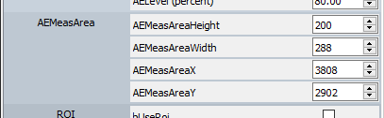

## Measurement Area Disabling

if all the parameters are set to 0, the measurement area is the full sensor

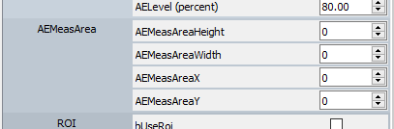

# AutoExposure Usage

## Configuration of criteria

In the algorithm, the brightest pixel is measured and compared to a reference value.

This reference value is a percentage of saturation and can be tuned with parameter **AELevel**

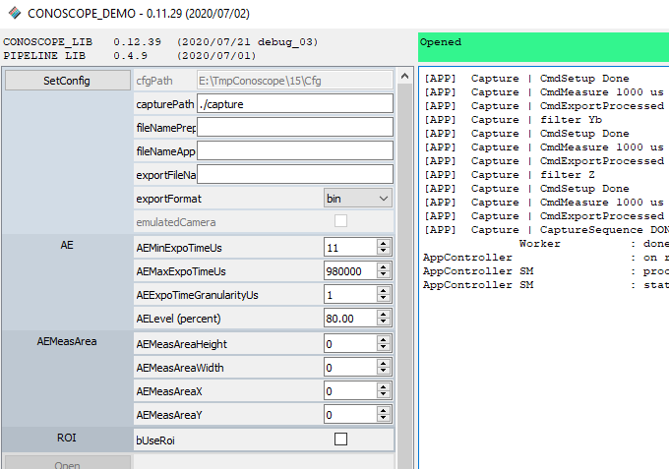

## MeasureAE

In **MeasureAE** command, parameter **exposureTimeUs** will be the starting point of the algorithm.

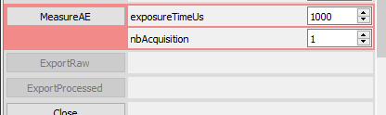

The closer **exposureTimeUs** is to the target, the faster the algorithm will be.

For example:

if the target is around 1500 us.

When **exposureTimeUs** set to 1000, the algorithm will require 3 steps:

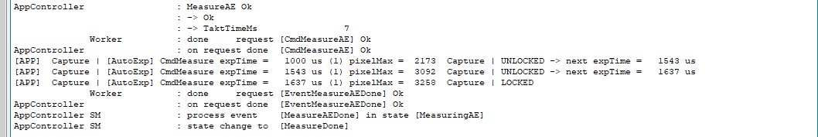

When **exposureTimeUs** set to 100000, the algorithm will require 8 steps:

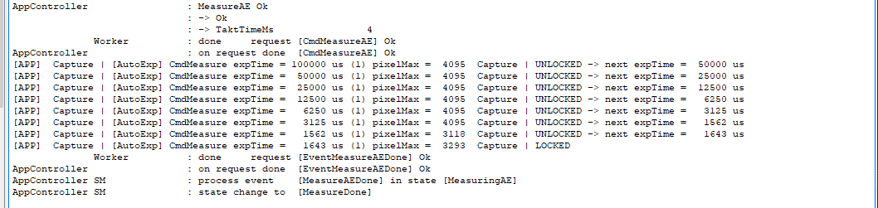

Note:

During MeasureAE processing, it is possible to know the status of the processing (**MeasureAEStatus**) and to stop the processing (**MeasureAECancel**)

## CaptureSequence

Similarly to MeasureAE, it is possible to set starting point of the AE algorithm.

Toset **exposureTimeUs**, follow those steps:

- configure the CaptureSequence without AE (uncheck **autoExpo** parameter)

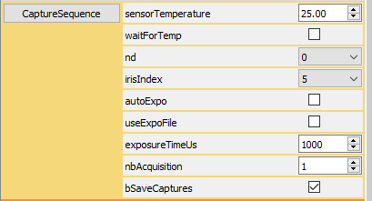

- Set **exposureTimeUs**

- then enable AE by checking **autoExpo**.

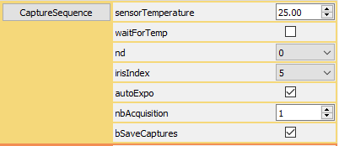

Then launch the capture by pressing **CaptureSequence**.