

**Application Note: Capture Sequence**

|  |  |
| --- | --- |
| Abstract | This documents is an application note |
| Version | 0.2 |
| Status | Draft |
| Date | 2020/07/23 |

Revision history

|  |  |  |
| --- | --- | --- |
| Version | Date | Content |
| 0.1 | 2020/07/22 | Initial version |
| 0.2 | 2020/07/23 | Add chapter about X, Y, Z images |
|  |  |  |
|  |  |  |
|  |  |  |

|  |  |
| --- | --- |
|  | ELDIM 1185 Rue d’Epron (Ancienne) 14200 Hérouville Saint-Clair France |
|  | Copyright © 2020 All rights reserved. Printed in France. |
|  | ELDIM, the ELDIM logo and other product names referenced herein are trademarks of ELDIM.  Other product names, designations, logos, and symbols are trademarks or registered trademarks of their respective owners. |
|  | NO WARRANTY. The technical documentation is being delivered to you AS-IS and ELDIM makes no warranty as to its accuracy or use. Any use of the technical documentation or the information contained therein is at the risk of the user. Documentation may include technical or other inaccuracies or typographical errors. ELDIM reserves the right to make changes without prior notice. |
|  | ELDIM considers information included in this documentation as Confidential Information. The access and use of this confidential information are subject to the terms and conditions of the Software license agreement, with which you agree to comply.  This documentation cannot be reproduced in any way without the prior agreement and written permission of ELDIM. |

Table of contents

1 Introduction 5

2 Exposure time configuration 5

2.1 Auto Exposure 5

2.2 Manual Exposure 5

2.3 Exposure File 6

3 Timing measurement 7

3.1 Capture Sequence 7

3.2 Measurement 8

4 X, Y, Z images génération 9

4.1 Calibration data 9

4.2 Processing 9

# Introduction

Capture sequence captures necessary images to generate X, Y, Z images.

5 capture are used:

- filter X

- filter Xz

- filter Ya

- filter Yb

- filter Z

# Exposure time configuration

Capture Sequence exposure time has 3 configurations:  
- AutoExposure  
- All the capture have the same exposure time  
- Exposure time are defined in a json file

## Auto Exposure

Check “**autoExpo**” so the exposure is calculated during the capture processing

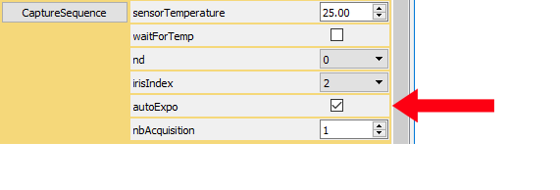

## Manual Exposure

Uncheck “autoExpo” and uncheck “useExpoFile”

Set exposure time in “exposureTimeUs” control.

All the captures are done with this exposure time

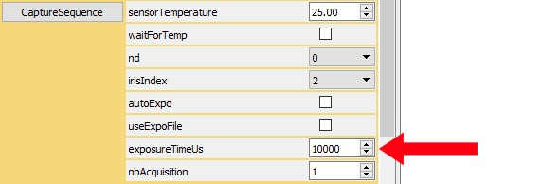

## Exposure File

Uncheck “autoExpo” and check “useExpoFile”

File “CaptureSequenceExposureTime.json” is used to retrieve the exposure time

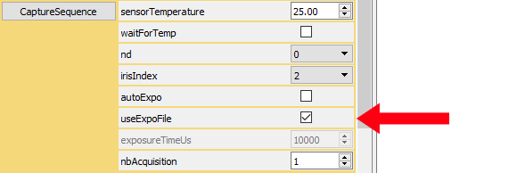

If “CaptureSequenceExposureTime.json” does not exist, it is created with default values.

CaptureSequenceExposureTime.json example:

{

"ExposureTimeUs": {

"Filter_X": 10001,

"Filter_Xz": 10002,

"Filter_Ya": 10003,

"Filter_Yb": 10004,

"Filter_Z": 10005

}

}

# Timing measurement

## Capture Sequence

Following table lists the steps required in the capture sequence:

|  |  |  |  |
| --- | --- | --- | --- |
|  | step | Step detail |  |
| 1 | Capture image X | Setup | Moves the filters |
|  |  | Measure | use AE or not, saved capture or not |
|  |  | Process |  |
| 2 | Capture image Xz | Setup | Moves the filters |
|  |  | Measure | use AE or not, saved capture or not |
|  |  | Process |  |
| 3 | Capture image Ya | Setup | Moves the filters |
|  |  | Measure | use AE or not, saved capture or not |
|  |  | Process |  |
| 4 | Capture image Yb | Setup | Moves the filters |
|  |  | Measure | use AE or not, saved capture or not |
|  |  | Process |  |
| 5 | Capture image Z | Setup | Moves the filters |
|  |  | Measure | use AE or not, saved capture or not |
|  |  | Process |  |
| 6 | Generate X, Y, Z |  |  |

## Measurement

Measurement depends on the PC performance for **Process** steps.

**Setup** duration is fixed and constrained by HW

Following figures are done for an exposure time of 1000us. (**Measure** duration will increase with exposure time)

|  |  |  |  |  |  |
| --- | --- | --- | --- | --- | --- |
|  | step | Step detail | No AE | AE meas area: 300x200 | AE meas area: full sensor |
|  |  |  |  | Measure is done in several steps of the AE algo |  |
| 1 | image X | Setup | 2.5 | 2.5 | 2.5 |
|  |  | Measure | 0.5 | 0.5 | 1.2 |
|  |  |  | 0.5 | 1.2 |
|  |  |  | 0.5 | 1.2 |
|  |  | Process | 1.8 | 2.2 | 1.8 |
| 2 | image Xz | Setup | 2.5 | 2.5 | 2.5 |
|  |  | Measure | 0.5 | 0.5 | 1.2 |
|  |  |  | 0.5 | 1.2 |
|  |  |  | 0.5 | 1.2 |
|  |  | Process | 1.8 | 2.2 | 1.9 |
| 3 | image Ya | Setup | 2.5 | 2.5 | 2.5 |
|  |  | Measure | 0.5 | 0.5 | 1.2 |
|  |  |  | 0.5 | 1.2 |
|  |  |  | 0.5 | 1.2 |
|  |  | Process | 1.8 | 2.1 | 1.8 |
| 4 | image Yb | Setup | 2.5 | 2.5 | 2.5 |
|  |  | Measure | 0.5 | 0.5 | 1.2 |
|  |  |  | 0.5 | 1.2 |
|  |  |  | 0.5 | 1.2 |
|  |  | Process | 1.8 | 2.5 | 1.9 |
| 5 | image Z | Setup | 2.5 | 2.5 | 2.5 |
|  |  | Measure | 0.5 | 0.5 | 1.2 |
|  |  |  | 0.5 | 1.2 |
|  |  |  | 0.5 | 1.2 |
|  |  | Process | 1.8 | 2.2 | 1.9 |
| 6 | Generate X, Y, Z |  |  |  |  |
|  | **Total** |  | **24** | **33** | **40** |

All sequences have been done in the same conditions.

AE exposure has been configured to be locked within 2 captures.

# X, Y, Z images génération

From the 5 pictures captures during the sequence, X, Y, Z are calculated by applying the calibration factor that have been calculated during the calibration.

## Calibration data

From file **OpticalColumn.xml**, ColorCoefComp and ColorCoefCorr are used

Note ColorCoefComp may be replaced by ColorCoef for older version (Unit1)

Calibration data are stored in an array

colorCoefComp[irisIndex][composantType][filterIndex]

where irisIndex is the index of the iris mounted on the taprisiot [2, 3, 4, 5]

composantType is the type of the image [X, Y, Z]

filterIndex is the filter setup [X, Xz, Ya, Yb, Z]

colorCoefCorr[filterIndex][ndIndex]

where filterIndex is the filter setup [X, Xz, Ya, Yb, Z]

NdIndex is the nd setup [0, 1, 2, 3, 4]

## Processing

irisIndex and NdIndex are the configuration of the Taprisiot

comp_X = img_X * cX +

img_Xz * cXz +

img_Ya * cYa +

img_Yb * cYb +

img_Z * cZ

Where cX = CoefComp[irisIndex][X][filter_X] * CoefCorr[filter_X] [NdIndex] / exp(img_X)

cXz = CoefComp[irisIndex][X][filter_Xz] * CoefCorr[filter_Xz][NdIndex] / exp(img_Xz)

cYa = CoefComp[irisIndex][X][filter_Ya] * CoefCorr[filter_Ya][NdIndex] / exp(img_Ya)

cYb = CoefComp[irisIndex][X][filter_Yb] * CoefCorr[filter_Yb][NdIndex] / exp(img_Yb)

cZ = CoefComp[irisIndex][X][filter_Z] * CoefCorr[filter_Z] [NdIndex] / exp(img_Z)

comp_Y = img_X * cX +

img_Xz * cXz +

img_Ya * cYa +

img_Yb * cYb +

img_Z * cZ

Where cX = CoefComp[irisIndex][Y][filter_X] * CoefCorr[filter_X] [NdIndex] / exp(img_X)

cXz = CoefComp[irisIndex][Y][filter_Xz] * CoefCorr[filter_Xz][NdIndex] / exp(img_Xz)

cYa = CoefComp[irisIndex][Y][filter_Ya] * CoefCorr[filter_Ya][NdIndex] / exp(img_Ya)

cYb = CoefComp[irisIndex][Y][filter_Yb] * CoefCorr[filter_Yb][NdIndex] / exp(img_Yb)

cZ = CoefComp[irisIndex][Y][filter_Z] * CoefCorr[filter_Z] [NdIndex] / exp(img_Z)

comp_Z = img_X * cX +

img_Xz * cXz +

img_Ya * cYa +

img_Yb * cYb +

img_Z * cZ

Where cX = CoefComp[irisIndex][Z][filter_X] * CoefCorr[filter_X] [NdIndex] / exp(img_X)

cXz = CoefComp[irisIndex][Z][filter_Xz] * CoefCorr[filter_Xz][NdIndex] / exp(img_Xz)

cYa = CoefComp[irisIndex][Z][filter_Ya] * CoefCorr[filter_Ya][NdIndex] / exp(img_Ya)

cYb = CoefComp[irisIndex][Z][filter_Yb] * CoefCorr[filter_Yb][NdIndex] / exp(img_Yb)

cZ = CoefComp[irisIndex][Z][filter_Z] * CoefCorr[filter_Z] [NdIndex] / exp(img_Z)