

**Application Note: Region of interest**

|  |  |
| --- | --- |
| Abstract | This documents is an application note |
| Version | 0.1 |
| Status | Draft |
| Date | 2020/07/22 |

Revision history

|  |  |  |
| --- | --- | --- |
| Version | Date | Content |
| 0.1 | 2020/07/22 | Initial version |
|  |  |  |
|  |  |  |
|  |  |  |
|  |  |  |

|  |  |
| --- | --- |
|  | ELDIM 1185 Rue d’Epron (Ancienne) 14200 Hérouville Saint-Clair France |
|  | Copyright © 2020 All rights reserved. Printed in France. |
|  | ELDIM, the ELDIM logo and other product names referenced herein are trademarks of ELDIM.  Other product names, designations, logos, and symbols are trademarks or registered trademarks of their respective owners. |
|  | NO WARRANTY. The technical documentation is being delivered to you AS-IS and ELDIM makes no warranty as to its accuracy or use. Any use of the technical documentation or the information contained therein is at the risk of the user. Documentation may include technical or other inaccuracies or typographical errors. ELDIM reserves the right to make changes without prior notice. |
|  | ELDIM considers information included in this documentation as Confidential Information. The access and use of this confidential information are subject to the terms and conditions of the Software license agreement, with which you agree to comply.  This documentation cannot be reproduced in any way without the prior agreement and written permission of ELDIM. |

Table of contents

1 Introduction 5

2 Sequence with no ROI 5

3 Sequence with ROI 6

# Introduction

A Region of interest (ROI) can be defined to capture only a part of the capture

# Sequence with no ROI

ROI is disable

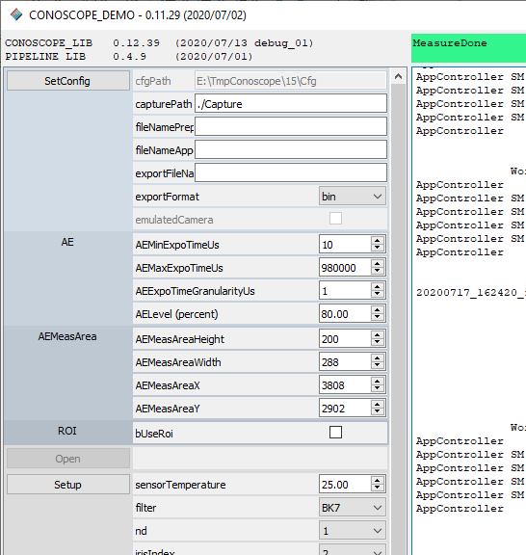

Perform “Measure”.

Export process data.

The result is in Capture folder (size is 6001*6001)

(please refer to User Manual to open the capture)

# Sequence with ROI

Following figure shows the configuration for a result image of 3000x3000 pixels

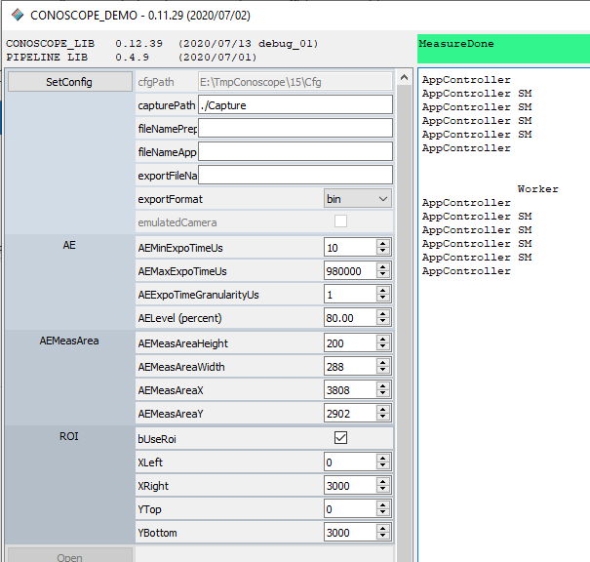

After “ExportProcess” capture is stored in Capture foldef

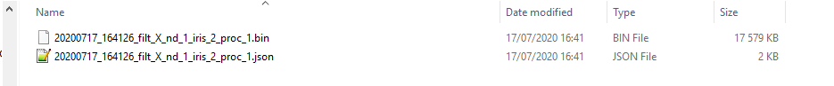

Opening the image with ImageJ:

