St. Joseph’s Anglo-Chinese School
Form 5 English Language
Paper 2 Writing – DSE 2022 Paper 2 (Part B): Learning from a sample script

Learning from a sample script — how a Level 5** script handles content and organisation (60-minute lesson)
Part 1: plan the task and the content (15 min) • Part 2: read the sample and see what it does with content and organisation (30 min) • Part 3: comment, score and write (15 min)
PART 1: BEFORE YOU WRITE — READ THE QUESTION AND PLAN THE CONTENT (15 minutes)
1. The question
The School Management is considering a four-day school week. Students would only need to attend school four days a week instead of five, but the length of each day would be increased by one hour.

You are a member of the Parent-Teacher Association (PTA). Write a letter to the President of the PTA stating your opinion either for or against a four-day school week. Give reasons to support your view.

(DSE 2022 English Language Paper 2, Part B, Question 9 — ‘Learning English through Debating’. Reproduced from the question paper. Part B asks for about 400 words.)
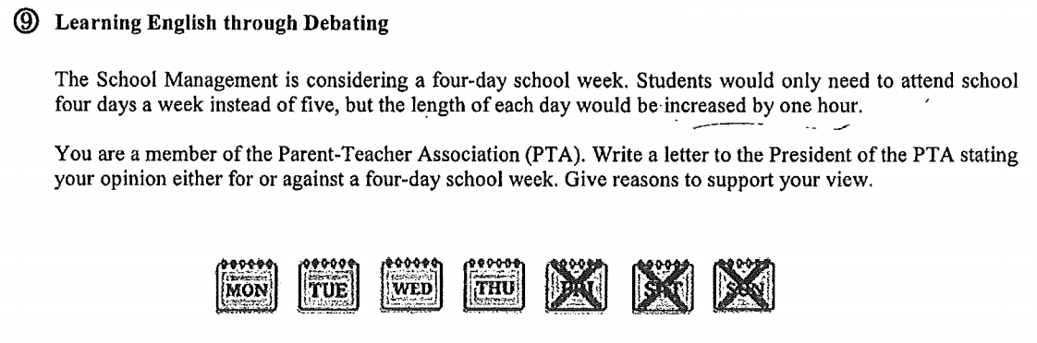
The question as printed in the question paper.
2. Task analysis
Genre | Formal letter
Target audience
Purpose of writing
Style and tone
Text-type features (opening and closing)
Word guide

3. Build your idea bank
Your letter needs to say WHO benefits and HOW. Fill in the table with as many reasons as you can, then keep the three strongest ones.
Who is affected? | Reasons FOR a four-day week | Reasons AGAINST a four-day week
Students
Teachers and other school staff
The school (management)
Parents and family life
4. Your writing plan
Plan your own letter before you read someone else’s. One line each is enough — you will come back to this plan in Part 3.
Greeting
Opening paragraph | purpose • your stance • the three points you will cover
Main body
Closing paragraph
Closing

PART 2: READ THE SAMPLE — WHAT IT DOES WITH CONTENT AND ORGANISATION (30 minutes)
A. The sample script (Level 5**) — the original pages. Read the seven pages of the script below, exactly as the marker read them: they are handwritten, with the writer’s own corrections. Paragraph numbers in the captions — [1] to [7] — tell you which part of the letter each page shows.
Length: 969 words in total. [2] opening 115 words • [3] 309 words • [4] 246 words • [5] 219 words • [6] closing 73 words. Part B asks for about 400 words, so this script is more than twice the guide — long paragraphs are one of its few weaknesses.
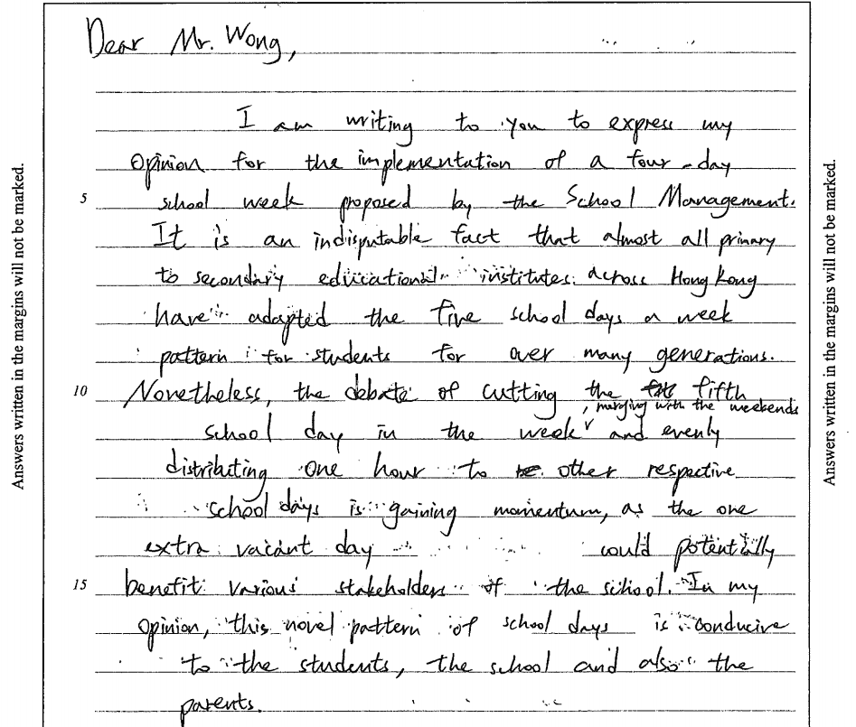
Script page 1 of 7 — the greeting and the opening paragraph [2] (115 words)
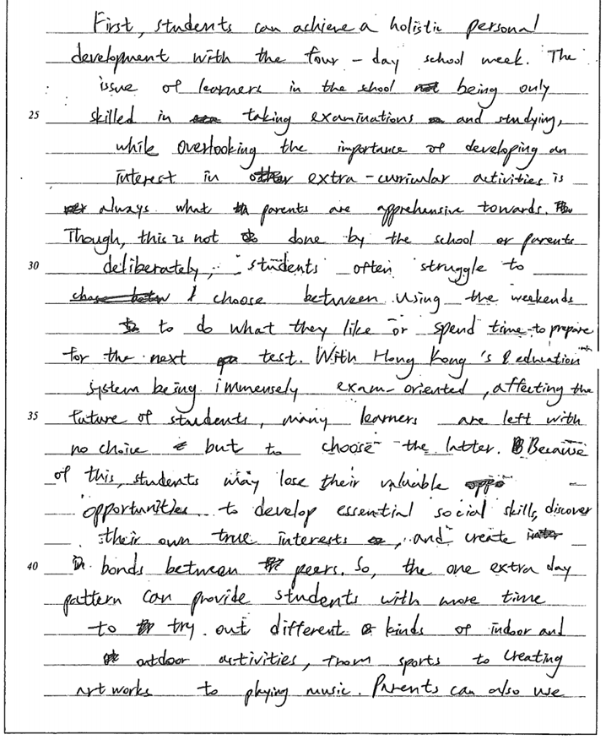
Script page 2 of 7 — paragraph [3], first half (309 words in the whole paragraph)
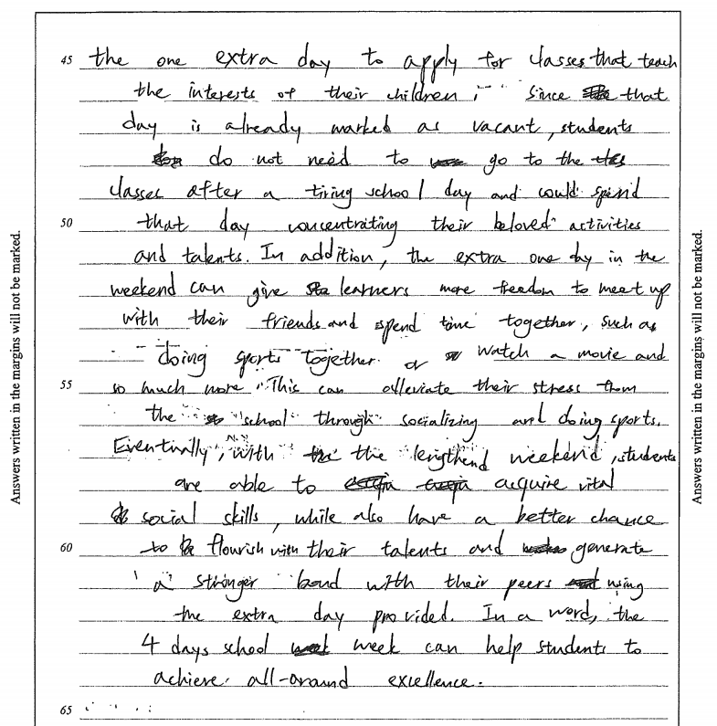
Script page 3 of 7 — paragraph [3], second half
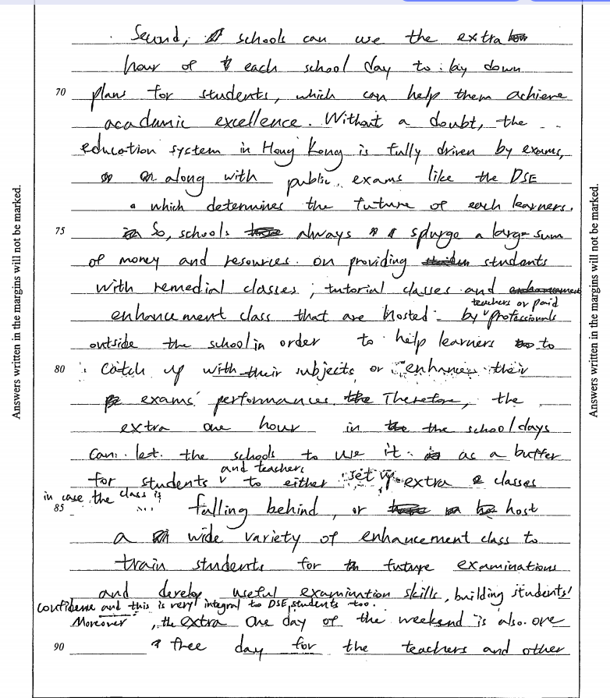
Script page 4 of 7 — paragraph [4], first half (246 words in the whole paragraph)
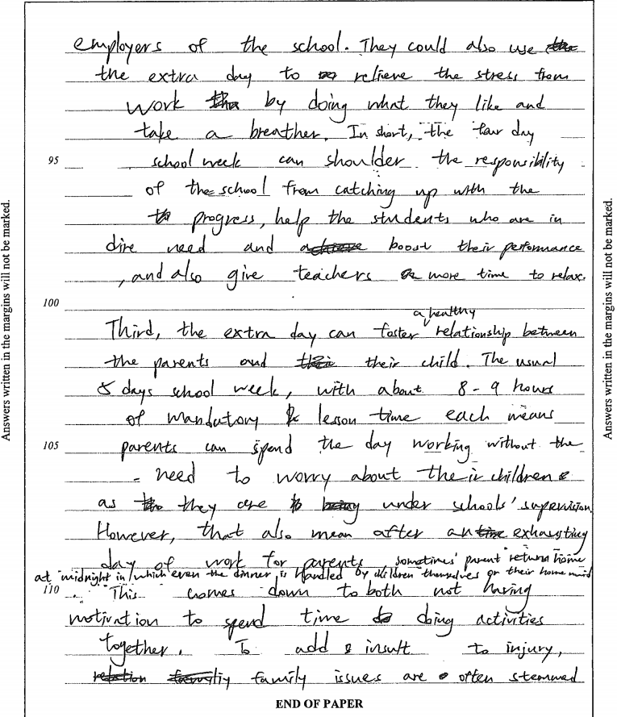
Script page 5 of 7 — the end of [4] and the start of [5]
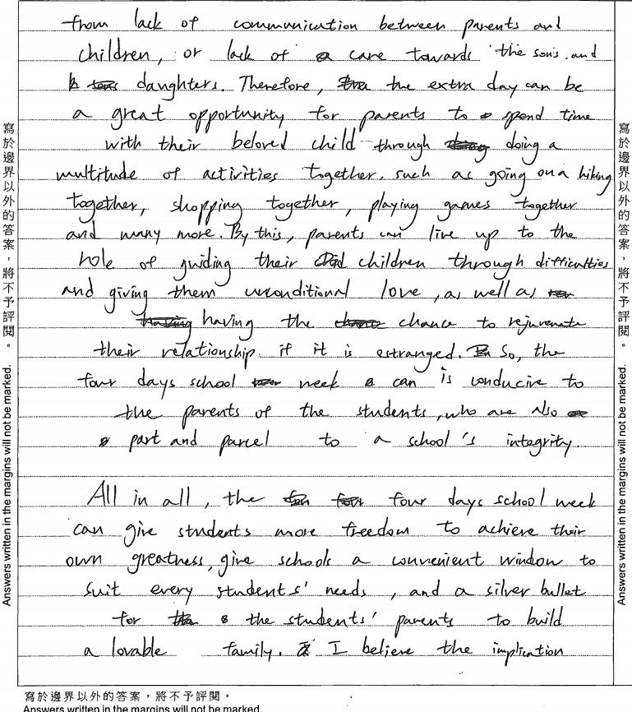
Script page 6 of 7 — the end of [5] and the start of [6] (73 words)
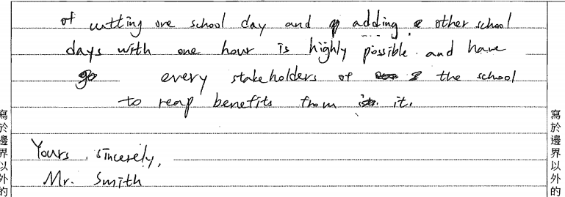
Script page 7 of 7 — the end of [6] and the sign-off [7]
B. Read for the gist (3 minutes)
1. Who is writing, and to whom?
2. Is the writer FOR or AGAINST the proposal? Write down the sentence that tells you.
3. One sentence each: what does paragraph [3] say students gain? What does paragraph [4] say the school gains? What does paragraph [5] say parents gain?
____________________________________________________________________________________
____________________________________________________________________________________
____________________________________________________________________________________

C. CONTENT — which ideas, and how are they made convincing?
Task 1. Look back at your idea bank in Part 1. Tick every idea that the sample writer also used. Then write down ONE good idea of yours that the writer did NOT use — could you add it?
____________________________________________________________________________________
____________________________________________________________________________________

Task 2. Complete the content map for the three body paragraphs.
Paragraph | Who benefits | The writer’s main point (one sentence) | What supports the point (an explanation of WHY it happens / a concrete example or comparison / a factual detail about Hong Kong / a reference to the other side)
[3]

[4]

[5]

Task 3. Content that scores 7. The writer does four things. Find and copy the evidence for each one from the sample.
What the writer does | Evidence from the sample (copy the words)
(a) Answers the whole question: states an opinion AND gives reasons
(b) Explains the cause, not just the benefit
(c) Uses concrete, Hong Kong-specific detail
(d) Shows he knows the other side, then answers it
Why does (d) — answering the other side — matter to the marker?
____________________________________________________________________________________
____________________________________________________________________________________

D. ORGANISATION — how the sample is built
Task 4. Label every move in the letter. Choose from the move bank and write the move in the last column.
Move bank: • Greeting (salutation) • Purpose of writing + your stance • ‘Road map’: the three points the letter will cover • Point 1 — benefit to students • Point 2 — benefit to the school and its teachers • Point 3 — benefit to parents / family life • Summary of the three points + what the writer hopes will happen • Sign-off
Move | Paragraph | What the writer is doing (choose from the move bank)
1 | [1]
2 | [2]
3 | [3]
4 | [4]
5 | [5]
6 | [6] and [7]
Task 4b. Look at paragraphs [3], [4] and [5]. Each one ends with a sentence that repeats the point of the paragraph (a ‘round-off’). Copy the round-off sentence of [4] and explain why an examiner likes it.
____________________________________________________________________________________
____________________________________________________________________________________

Task 5. The topic sentences
Copy the first sentence of paragraphs [3], [4] and [5] into the table, then answer the questions below.
Paragraph | Topic sentence
[3]
[4]
[5]
What do all three topic sentences have in common? (Think: how does each one begin? Whose benefit does each one promise?)
____________________________________________________________________________________
____________________________________________________________________________________
Which sentence in the closing paragraph ‘mirrors’ the three topic sentences? Copy it.
____________________________________________________________________________________
____________________________________________________________________________________

Task 6. Linking words — where they are, and how to improve them
(a) Find every sentence that begins with a linking word and put the linking word into the right box.
Adding more | Sequencing | Contrasting | Cause and effect | Summarising
(b) Your marker’s comment on this script was ‘mainly sentence-initial linking words’. Rewrite each sentence so that the linking word moves inside the sentence. The first one is done for you.
Sentence with a sentence-initial linker | Your rewrite
Therefore, students will be able to develop their own talents. | Students will therefore be able to develop their own talents.
However, parents will find it hard to spend time with their children.
In addition, teachers can use the free day for professional development.
(c) One more organisation fault to notice: paragraph [3] is 309 words long — the longest paragraph in the letter. Where would you split it into two paragraphs, and why?
____________________________________________________________________________________
____________________________________________________________________________________

E. LANGUAGE — words, and five advanced sentence patterns (10 minutes, or homework)
Task 7. Read each word or phrase and study how the writer uses it in the sample sentence.
Word / phrase | What it means | The sentence in the sample
indisputable | cannot be argued against; certain | It is an indisputable fact that almost all primary to secondary educational institutions across Hong Kong have adopted…
gaining momentum | becoming stronger / more widely supported | the debate of cutting the fifth school day in the week … is gaining momentum
stakeholders | the people who are involved and affected | the one extra valid day would potentially benefit various stakeholders of the school
conducive to | helpful to / good for | this novel pattern of school days is conducive to the students, the school and also the parents
alleviate | make (pain or stress) less severe | This can alleviate their stress from school through socializing and doing sports.
integral | very important (to something) | building students’ confidence and this is very integral to students too
in dire need | needing help very much | help the students who are in dire need
splurge (on) | spend a lot of money (on) | schools always splurge a larger sum of money and resources on providing students with…
live up to the role of | do what the role expects of you | parents can live up to the role of guiding their children through difficulties
part and parcel of | an essential part of | parents … are also a part and parcel to a school’s integrity
a silver bullet | a simple, instant solution to a problem | and a silver bullet for the students’ parents to build a lovable family
reap benefits | gain advantages | every stakeholder of the school (can) reap benefits from it

Five advanced sentence patterns used in this script. The pattern in each sentence is in bold. These are the structures that make a script read like a top script — learn one or two and use them in your own writing.
Pattern | The writer’s sentence (pattern in bold) | Why it earns marks
1. It is + adjective + that-clause  (an impersonal, confident opener) | It is an indisputable fact that almost all primary to secondary educational institutions across Hong Kong have adopted the five school days a week pattern for many generations. | States a fact as if nobody could argue with it, and it opens the paragraph with a full, formal sentence.
2. With + noun + -ing participle phrase  (fronted cause) | With Hong Kong’s education system being immensely exam-oriented, affecting the future of students, many learners are left with no choice but to choose the latter. | Packs a whole reason into one phrase before the main clause — the cause is clear, and it saves a sentence.
3. Relative clause (which / that / who)  (adding information to a noun) | schools can use the extra hours of each school day to lay down plans for students, which can help them achieve academic excellence. / enhancement classes that are hosted by professionals outside the school | Adds explanation and result without starting a new sentence. Markers see control, not a list of short sentences.
4. -ing participle clause  (result or by-product) | enhancement classes … to train students for the future examination, building students’ confidence… / acquire vital social skills while having a better chance to flourish their talents | Shows the writer can attach a second idea to the first smoothly — the kind of sentence top scripts use to pack information.
5. Long noun phrase as the subject + ‘what …’ clause | The issue of learners in the school being only skilled in taking examinations and studying while overlooking the importance of developing an interest in other extra-curricular activities is always what parents are apprehensive towards. | The subject itself carries the argument, so the sentence sounds mature and academic. (Careful: do not overdo it — this sentence is hard to read.)
Not in this script — one to add yourself: One pattern this writer did NOT use — inversion, which puts the adverb first to make the sentence emphatic: Not only CAN the extra day reduce students’ stress, but it CAN ALSO give them time to develop their talents. Rarely DO schools have the chance to rethink their timetable like this.

Task 8. Use TWO of the five patterns above and FOUR items from the word table to write TWO sentences about the four-day school week.
____________________________________________________________________________________
____________________________________________________________________________________
____________________________________________________________________________________
____________________________________________________________________________________
PART 3: COMMENT, SCORE AND WRITE (15 minutes)
1. Your comments and scores on the sample
Tick the criteria you can prove from the text, and write the evidence in the last column.
Criterion | What to look for | Evidence from the sample | Score
Content: | All task requirements fulfilled / Good arguments / Good elaboration |  | / 7
Language: | Accurate grammar / Good variety of vocabulary & structures / Right style and formality |  | / 7
Organisation: | Good flow of ideas / Good paragraphing / Coherent opening & closing paragraphs |  | / 7

2. The real marks
Three markers marked this script. Their marks:
Criterion | Marker 1 | Marker 2 | Third marker | Final (out of 7)
Content | 7 | 6 | 7 | 7
Language | 7 | 5 | 6 | 6
Organisation | 6 | 5 | 6 | 6
Total |  |  |  | 18.3 / 21 (≈ 87% → Level 5**)
Discussion: Which two criteria carried this script to a 5**? Where do you think marks were lost?
____________________________________________________________________________________
____________________________________________________________________________________

3. Even a 5** script is not perfect
This writer made 28 small slips in the whole script — we counted them, and they are listed in your teacher’s copy. Five of them are printed below: correct them.
Line from the sample | Your correction
the five school days a week pattern
the four days school week is conducive to the parents of the students …
students are able to acquire vital social skills while have a better chance to flourish their talents …
Third, the extra day can foster relationship between the parents and their child.
the extra one day of the weekend is also one free day for the teachers and other employers of the school

4. Your turn
Write the opening paragraph of your own letter (4–5 sentences, about 50 words). Use the plan you made in Part 1.
Greeting • I am writing to … (say what you are writing about) • your stance • tell the reader the three points you will cover
Use at least one pattern or word from the ‘steal these’ table.
____________________________________________________________________________________
____________________________________________________________________________________
____________________________________________________________________________________
____________________________________________________________________________________
____________________________________________________________________________________
____________________________________________________________________________________

5. What to take away
Content, Language and Organisation are 7 marks each in Part B. This script used its
ideas
and the
way they were arranged
to reach a 5** — 14 of its 21 marks — even though it still contains 28 small slips. Great writers at Level 5** make sure that (1) every requirement in the question is answered, (2) every reason is explained, not just listed, and (3) the reader always knows which point belongs to which paragraph.

