F6 English SP — Lesson 7 (DSE 2012 & 2013 Paper 1)
TEACHER’S VERSION & ANSWER KEY WITH EXPLANATIONS

Focus: the True / False / Not Given question type — 6 questions from the 2012 and 2013 HKDSE English Language Paper 1 (20 statements, 20 marks).
This key matches the revised student handout. No vocabulary and no exam tips: students read the printed paragraph(s), then tick T, F or NG. The other two questions of this type — 2012 Paper 1 Part B2 Q51 and 2013 Paper 1 Part B1 Q32 — are printed at the end with their answers, ready to slot back in if you want them.
Answer key at a glance: 2012 Q8: T/F/T · 2012 Q34: F/T/NG/T · 2013 Q6: NG/T/F · 2013 Q21: T/F/F · 2013 Q42: T/F/T · 2013 Q52: F/T/NG/F
Answers, the accepted wording and the candidate percentages (in brackets) come from the official HKEAA marking schemes. A percentage is the proportion of DSE candidates who got that statement right — useful for judging how hard each one really is.
Question 1 — DSE 2012 Paper 1, Part A, Q8 (3 marks, Text 1 paragraphs 8-9)
Decide whether the following statements are True, False, or the information is Not Given in paragraphs 8-9. Put a tick (✓) in the appropriate column. (4 marks)
Statement | Answer | % correct
Customers can play board games for two hours if they buy two drinks. | T | 78%
Pat never played Monopoly, Uno or Snakes & Ladders as a child. | F | 82%
Pat thinks computer games are not as challenging as some board games. | T | 72%
(i) “for that price you get to try out any game for an hour. Buy another drink and play for another hour.” (lines 34–36)
(ii) “I played nothing but Monopoly, Uno and Snakes & Ladders when I was a child,’ says Pat” (lines 42–44)
(iii) “I found a lot of interesting board games that were more challenging than anything on the computer.” (lines 47–49)
Note: Statement (ii) of the original paper — “You need good English to play games imported from Germany or the US.” (False, 39%) — is not used in this lesson, so the heading reads 3 marks while the printed examination instruction still says “(4 marks)”.
Text 1, paragraphs 8–9 (the passage printed in the student handout):
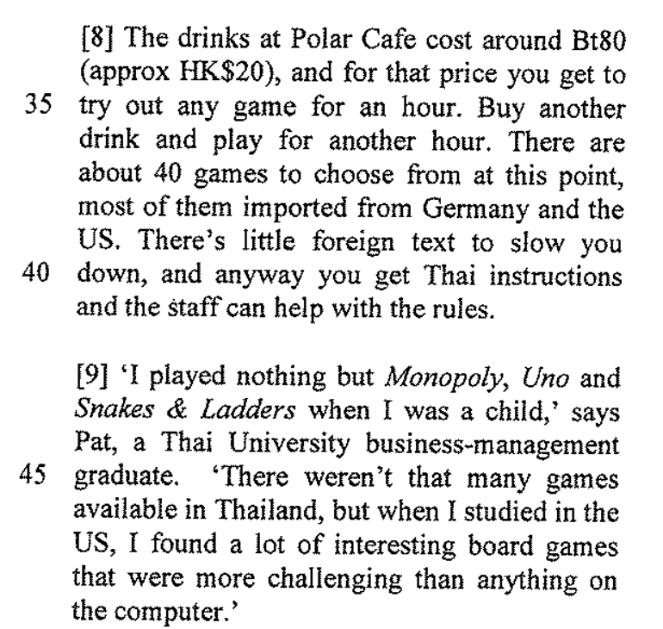
Question 2 — DSE 2012 Paper 1, Part B1, Q34 (4 marks, Text 2 paragraphs 13-21)
Decide whether the following statements are True, False, or the information is Not Given in paragraphs 13-21. Put a tick (✓) in the appropriate column. (4 marks)
Statement | Answer | % correct
Only children stitched the quilt. | F | 62%
Rachel and Jacob are related. | T | 68%
Jacob and Patrick are classmates. | NG | 64%
Each participant could express their personality through the pledge patches. | T | 59%
(i) ¶21 — an adult is sewing too: “I’m sewing together the beautiful strips that the kids have made,’ she [Phyllis Smith] says.” (lines 97–99)
(ii) ¶14 — “fourteen-year-old Rachel and her brother Jacob, who is two years younger” (lines 69–71)
(iii) ¶16 tells us about Jacob’s pledge and ¶17 about Patrick’s — the text never says the two boys are classmates (lines 76–83)
(iv) ¶17 “a chance for him to lend a hand and express his creativity” and ¶18 “I drew some smiley faces to reflect my personality.” (lines 81–87)
Text 2, paragraphs 13–21 (the passage printed in the student handout):
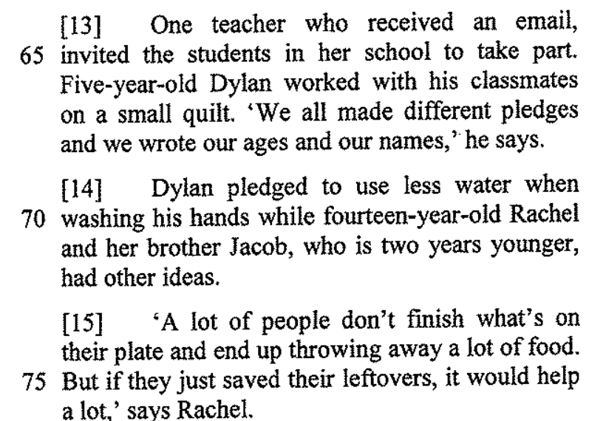 | 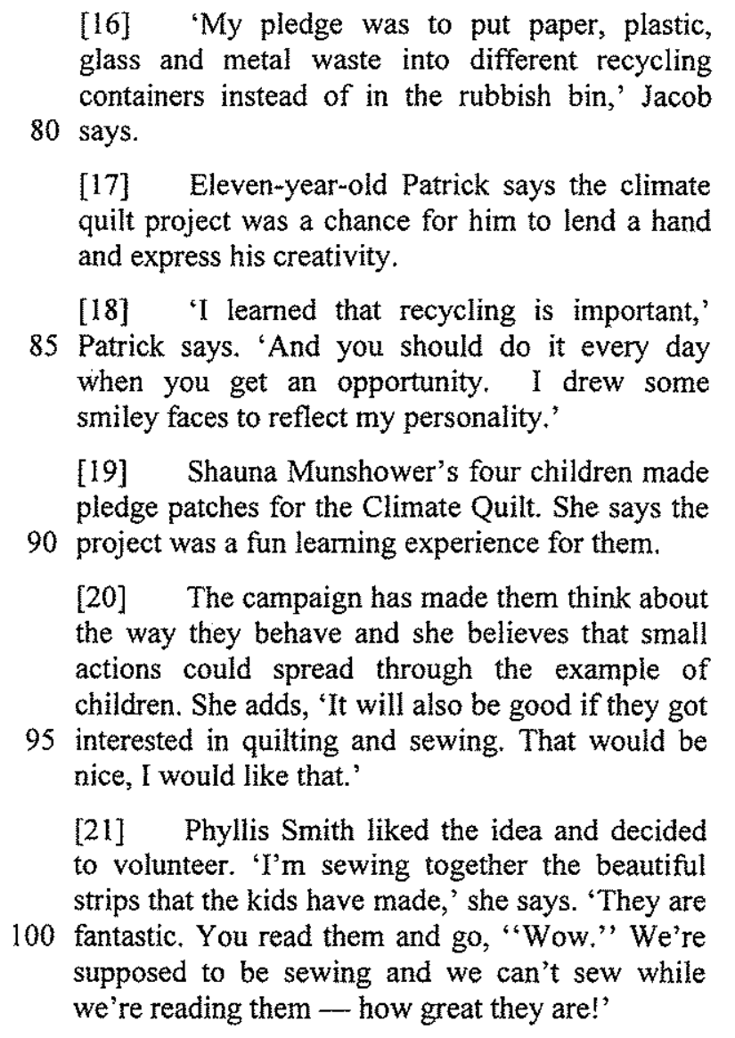
Question 3 — DSE 2013 Paper 1, Part A, Q6 (3 marks, Text 1 paragraphs 2-3)
Read paragraphs 2-3 and decide whether the following statements are True, False, or the information is Not Given. Blacken ONE circle only for each statement.
Statement | Answer | % correct
The three women in the persimmon orchard are the same age. | NG | 72%
The burial complex remains a mystery. | T | 61%
It usually takes a few hours to piece together a complete terra-cotta warrior. | F | 67%
(i) ¶2 calls them “three middle-aged women” and gives only Yang’s age (“a cheerful 57-year-old”) — the ages of the other two are not given (lines 6–10)
(ii) ¶2 — “the celebrated (and still dimly understood) burial complex of China’s first emperor, Qin Shi Huang Di” (lines 16–19)
(iii) ¶3 — “It usually takes Yang and her co-workers many days … but today they are lucky, accomplishing the task in a matter of hours.” (lines 20–24)
Note: The examination paper printed a 4th statement (iv) "Yang Rongrong has been piecing together terra-cotta warriors for 39 years." HKEAA deleted this item from marking, so it is left out here and this question is scored out of 3.
Text 1, paragraphs 2–3 (the passage printed in the student handout):
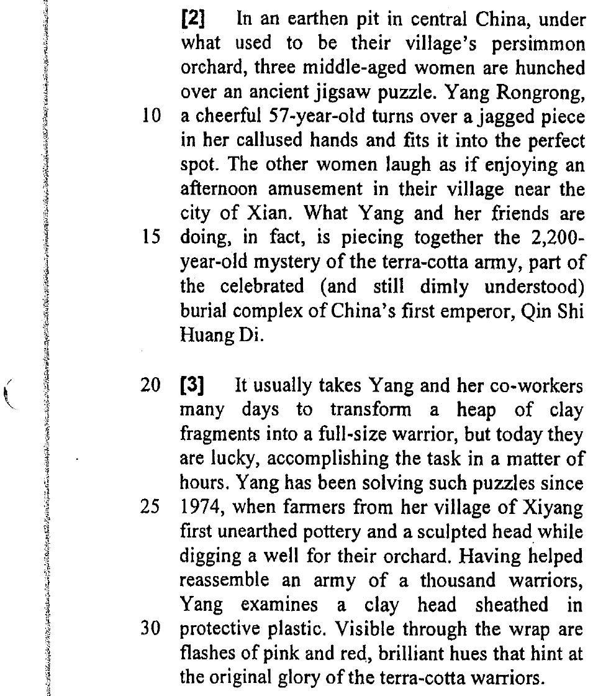
Question 4 — DSE 2013 Paper 1, Part A, Q21 (3 marks, Text 1 paragraph 11)
Read paragraph 11 and decide whether the following statements are True, False, or the information is Not Given. Blacken ONE circle only for each statement. (3 marks)
Statement | Answer | % correct
Only a small portion of the tomb has been excavated. | T | 64%
The speed of discovering new artifacts is slowing down. | F | 68%
In 2011, the museum completed the excavation of the central burial mound. | F | 40%
(i) ¶11 — “With less than one percent of the vast tomb complex excavated so far” (lines 119–120)
(ii) ¶11 — “the pace of discovery is quickening”: the opposite is true (line 122)
(iii) ¶11 — “In 2011 the museum launched two long-term excavation projects on the flanks of the 250-foot-high central burial mound”: it started them, it did not finish (lines 122–125)
Text 1, paragraph 11 (the passage printed in the student handout):
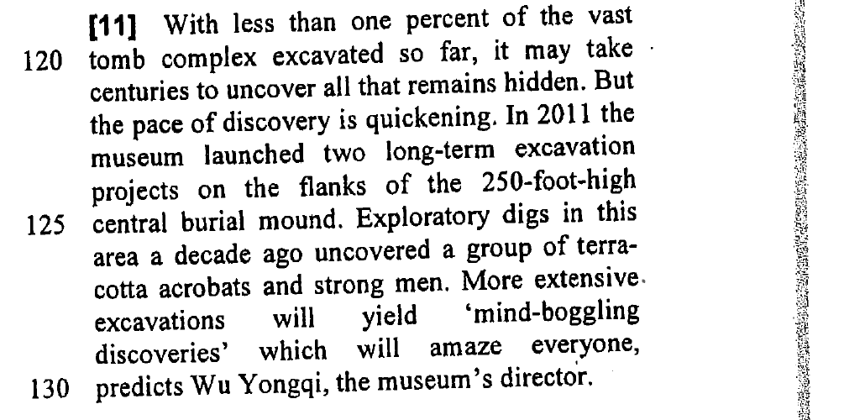
Question 5 — DSE 2013 Paper 1, Part B1, Q42 (3 marks, Text 3 paragraphs 7-9)
Read paragraphs 7-9 and decide whether the following statements are True, False, or the information is Not Given. Blacken ONE circle only for each statement. (3 marks)
Statement | Answer | % correct
People with low self-esteem feel that Facebook is a safe place to share information about themselves. | T | 57%
It is more difficult to read someone’s reaction when you talk to them face to face than through Facebook. | F | 36%
Participants of the study checked their e-mails even though they said they would rather sleep. | T | 47%
(i) ¶7 — “people with low self-esteem may feel that Facebook is a risk-free forum for making personal disclosures” (lines 59–60)
(ii) ¶8 — face to face “you might get an indication that they don’t like it”, but “On Facebook, you don’t see most of the reactions”: the reverse is true (lines 36–40)
(iii) ¶9 — “although the strongest desires were for sleep, checking work e-mails and updating a Facebook status are this generation’s actual nocturnal activities” (lines 46–51)
Text 3, paragraphs 7–9 (the passage printed in the student handout):
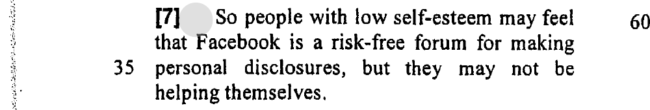 | 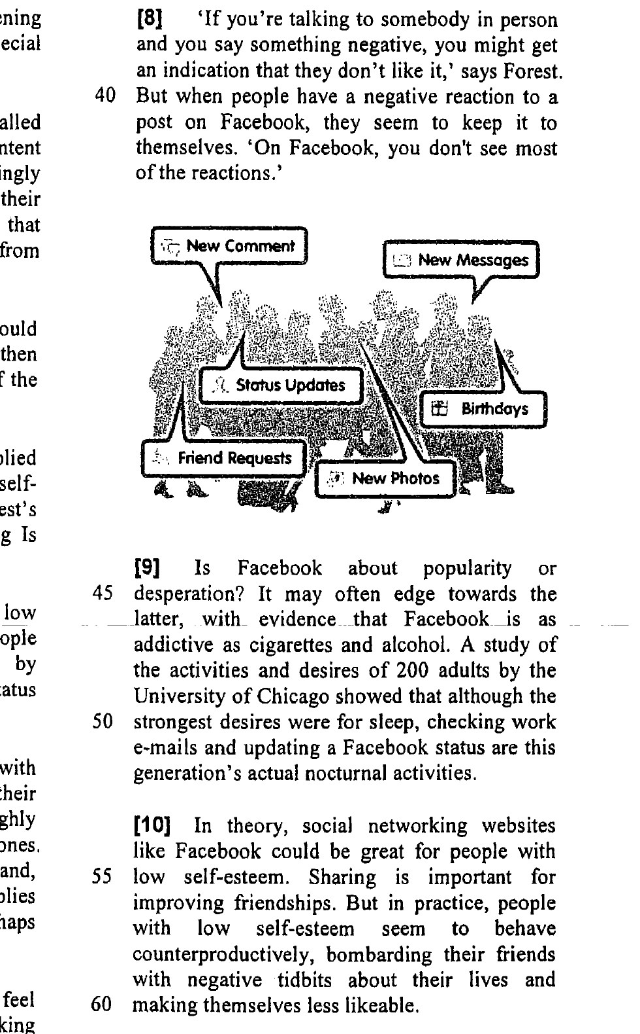
Question 6 — DSE 2013 Paper 1, Part B2, Q52 (4 marks, Text 4 paragraphs 4-5)
Read paragraphs 4-5 and decide whether the following statements are True, False, or the information is Not Given. Blacken ONE circle only for each statement. (4 marks)
Statement | Answer | % correct
The Hunger Games is the only example of the current popularity in dystopian fiction. | F | 84%
In the Uglies, teenagers conform to a standard prettiness by undergoing surgery. | T | 88%
Most participants of the Internet discussion board are teenagers. | NG | 87%
Brave New World and 1984 were written for American schoolchildren. | F | 68%
(i) ¶4 — “Collins’s trilogy is only the most visible example of a recent boom in dystopian fiction for young people.” (lines 39–40)
(ii) ¶4 — “all sixteen-year-olds undergo surgery to conform to a universal standard of prettiness” (lines 44–46)
(iii) ¶4 mentions the board only in passing — readers “post half-mocking protestations of agony … on Internet discussion boards” (lines 53–56) — and never says how old the people posting are
(iv) ¶5 — they are “twentieth century’s dystopian classics for adults” that schoolchildren are “assigned to read” (lines 76–80)
Text 4, paragraphs 4–5 (the passage printed in the student handout):
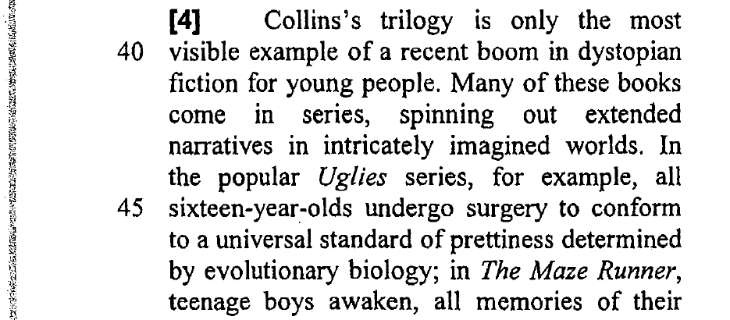 | 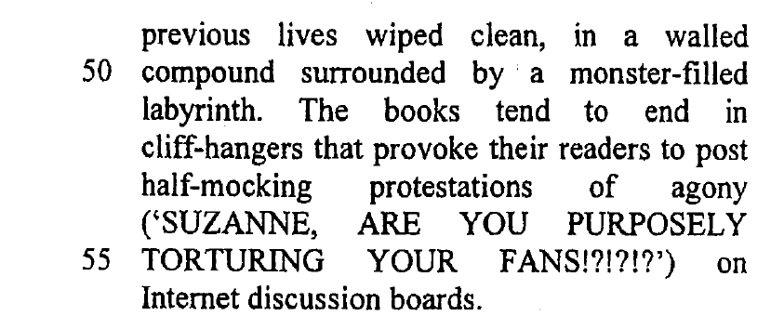
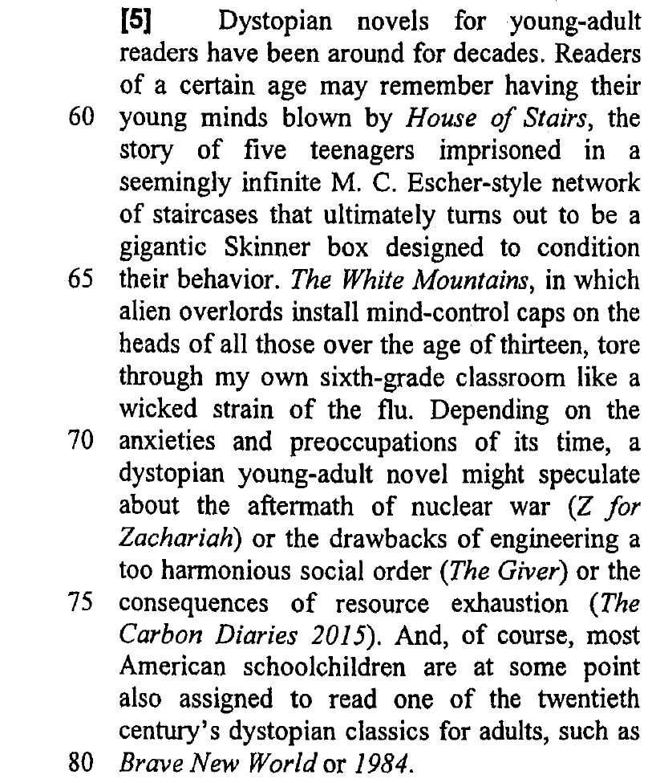
Marks at a glance
Q1 2012 Paper 1 Part A Q8: 3 marks — answer T / F / T (78%, 82%, 72%)
Q2 2012 Paper 1 Part B1 Q34: 4 marks — answer F / T / NG / T (62%, 68%, 64%, 59%)
Q3 2013 Paper 1 Part A Q6: 3 marks — answer NG / T / F (72%, 61%, 67%)
Q4 2013 Paper 1 Part A Q21: 3 marks — answer T / F / F (64%, 68%, 40%)
Q5 2013 Paper 1 Part B1 Q42: 3 marks — answer T / F / T (57%, 36%, 47%)
Q6 2013 Paper 1 Part B2 Q52: 4 marks — answer F / T / NG / F (84%, 88%, 87%, 68%)
Total: 20 marks (20 statements).
Hardest statements (lowest percentages): 2013 B1 Q42 (ii) – 36%, 2013 A Q21 (iii) – 40%, 2013 B1 Q42 (iii) – 47% (a three-way choice is hardest when the answer is False or when the exam text is near-silent). Easiest: 2013 B2 Q52 (ii) – 88%, 2013 B2 Q52 (iii) – 87%, 2012 A Q8 – 82% and 78%.
Timing suggestion
About 4–5 minutes per question — the six questions fit one double lesson, with the last 10 minutes on the NG answers. Read the instruction first: each question names its paragraphs, so students should not read the whole text. Insist on the proof words for every T and F, and on the reason for every NG — “the paragraph does not say”.
Common traps in this set: (1) usual vs a single exception — 2013 A Q6 (iii); (2) reversed statements — 2013 A Q21 (ii) “present perfect / past simple” ideas and 2013 B1 Q42 (ii); (3) numbers shifted — 2013 A Q21 (iii) “launched” read as “completed”; (4) NG statements built from words that DO appear (same age, classmates, favourite, teenagers) but are never stated.
Not used in this lesson — two more T/F/NG questions, ready to slot back in
DSE 2012 Paper 1, Part B2, Q51 (3 marks, Text 4 paragraphs 2-3)
Decide whether the following statements are True, False, or the information is Not Given in paragraphs 2-3. Put a tick (✓) in the appropriate column. (3 marks)
Statement | Answer | % correct
Chua was born in the Philippines. | NG | 82%
Chua forces her children to do certain activities. | T | 79%
Guo is unhappy her sons are learning painting and weiqi. | F | 84%
(i) ¶2 only says Amy Chua “is of Filipino-Chinese descent and lives in the U.S., not in China” — where she was born is not given (lines 5–6)
(ii) ¶2–¶3 contrast Guo with Chua: “I won’t be like Amy Chua … I don’t want to pressure them” and her sons love their hobbies “not because she forces them into it” — i.e. Chua does force hers (lines 6–12)
(iii) ¶3 “Guo says she believes her sons love their extracurricular hobbies, such as painting and learning how to play weiqi” (lines 10–12)
DSE 2013 Paper 1, Part B1, Q32 (4 marks, Text 2 the whole text)
Decide whether the following statements are True, False, or the information is Not Given. Blacken ONE circle only for each statement. (4 marks)
Statement | Answer | % correct
Zou teaches the guzheng. | T | 83%
The guzheng is Zou’s favourite instrument. | NG | 67%
No one else in Zou’s family can play the guzheng. | F | 76%
Famous people have attended Zou’s performances. | T | 51%
(i) ¶6 — “The school offers guzheng classes to children and adults taught by Zou.” (lines 33–34)
(ii) the text says the guzheng is “one of the most loved Chinese instruments” and that Zou plays it, but it never says it is her favourite (lines 8–10)
(iii) ¶5 — “Zou, born into a family of guzheng musicians who go back four generations” (lines 23–24)
(iv) ¶5 — “She has played for celebrities and politicians who include the former prime ministers of Australia and New Zealand, and former president Jiang Zemin.” (lines 25–29)

