F6 English SP — Lesson 7 (DSE 2012 & 2013 Paper 1)
TEACHER’S VERSION & ANSWER KEY WITH EXPLANATIONS

Focus: the True / False / Not Given question type — all eight questions of this type that appear in the 2012 and 2013 HKDSE English Language Paper 1 (28 statements, 28 marks).
No vocabulary and no exam tips in this lesson — students work straight through the exam questions. For each question the students read the printed paragraph(s), then tick T, F or NG.
Answer key at a glance: 2012 Q8: T/F/F/T 2012 Q34: F/T/NG/T 2012 Q51: NG/T/F 2013 Q6: NG/T/F 2013 Q21: T/F/F 2013 Q32: T/NG/F/T 2013 Q42: T/F/T 2013 Q52: F/T/NG/F
The answers, the candidate percentages (in brackets) and the accepted wording come from the official HKEAA marking schemes. Percentages are the proportion of candidates who got each statement right.
Question 1 — DSE 2012 Paper 1, Part A, Q8 (4 marks, Text 1 paragraphs 8-9)
Decide whether the following statements are True, False, or the information is Not Given in paragraphs 8-9. Put a tick (✓) in the appropriate column. (4 marks)
Statement | Answer | % correct
Customers can play board games for two hours if they buy two drinks. | T | 78%
You need good English to play games imported from Germany or the US. | F | 39%
Pat never played Monopoly, Uno or Snakes & Ladders as a child. | F | 82%
Pat thinks computer games are not as challenging as some board games. | T | 72%
(i) “for that price you get to try out any game for an hour. Buy another drink and play for another hour.” (lines 34–36)
(j) “most of them imported from Germany and the US. There’s little foreign text to slow you down, and anyway you get Thai instructions and the staff can help with the rules.” (lines 37–41)
(k) “I played nothing but Monopoly, Uno and Snakes & Ladders when I was a child,’ says Pat” (lines 42–44)
(l) “I found a lot of interesting board games that were more challenging than anything on the computer.” (lines 47–49)
Text 1, paragraphs 8–9 (passage printed in the student handout):
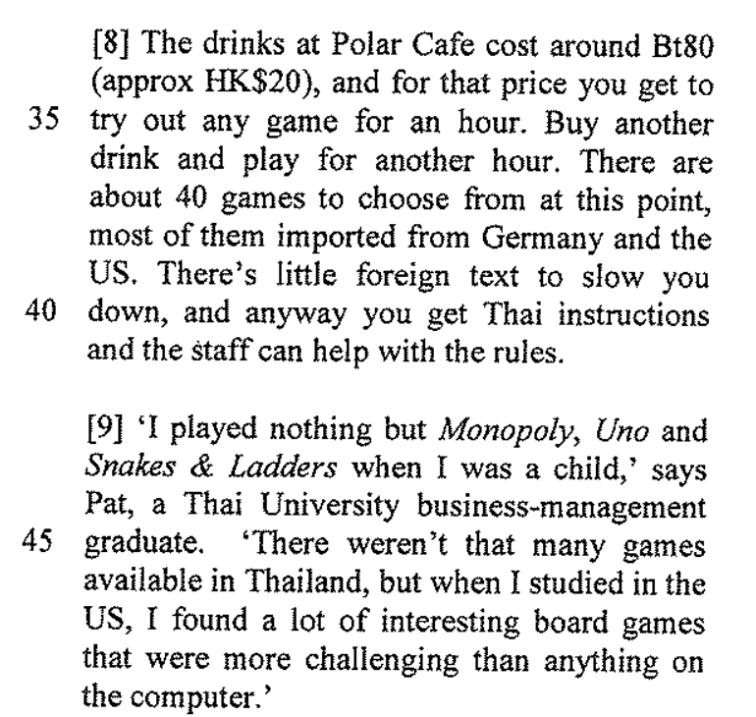
Question 2 — DSE 2012 Paper 1, Part B1, Q34 (4 marks, Text 2 paragraphs 13-21)
Decide whether the following statements are True, False, or the information is Not Given in paragraphs 13-21. Put a tick (✓) in the appropriate column. (4 marks)
Statement | Answer | % correct
Only children stitched the quilt. | F | 62%
Rachel and Jacob are related. | T | 68%
Jacob and Patrick are classmates. | NG | 64%
Each participant could express their personality through the pledge patches. | T | 59%
(i) ¶21 — an adult is sewing too: “I’m sewing together the beautiful strips that the kids have made,’ she [Phyllis Smith] says.” (lines 97–99)
(j) ¶14 — “fourteen-year-old Rachel and her brother Jacob, who is two years younger” (lines 69–71)
(k) ¶16 tells us about Jacob’s pledge and ¶17 about Patrick’s — the text never says the two boys are classmates (lines 76–83)
(l) ¶17 “a chance for him to lend a hand and express his creativity” and ¶18 “I drew some smiley faces to reflect my personality.” (lines 81–87)
Text 2, paragraphs 13–15 (passage printed in the student handout):
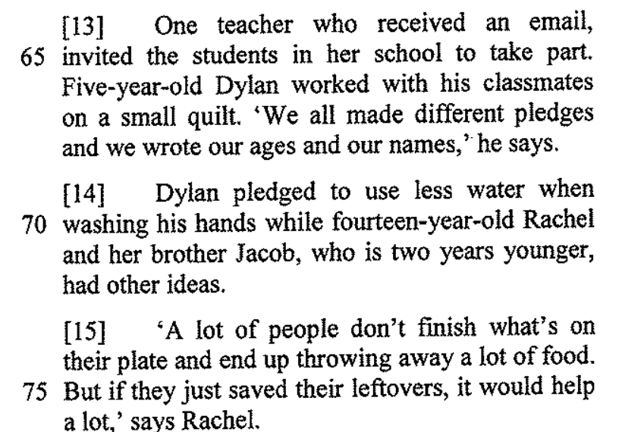 | 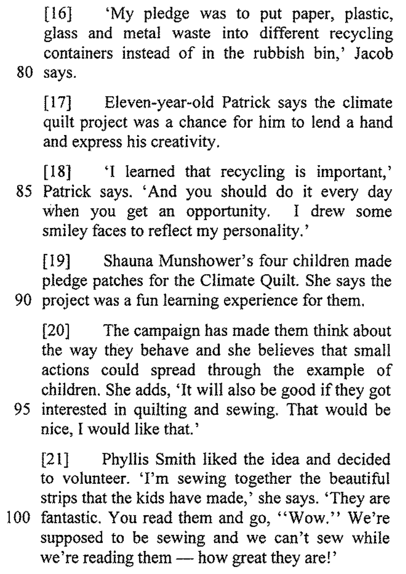
Question 3 — DSE 2012 Paper 1, Part B2, Q51 (3 marks, Text 4 paragraphs 2-3)
Decide whether the following statements are True, False, or the information is Not Given in paragraphs 2-3. Put a tick (✓) in the appropriate column. (3 marks)
Statement | Answer | % correct
Chua was born in the Philippines. | NG | 82%
Chua forces her children to do certain activities. | T | 79%
Guo is unhappy her sons are learning painting and weiqi. | F | 84%
(i) ¶2 only says Amy Chua “is of Filipino-Chinese descent and lives in the U.S., not in China” — where she was born is not given (lines 5–6)
(j) ¶2–¶3 contrast Guo with Chua: “I won’t be like Amy Chua … I don’t want to pressure them” and her sons love their hobbies “not because she forces them into it” — i.e. Chua does force hers (lines 6–12)
(k) ¶3 “Guo says she believes her sons love their extracurricular hobbies, such as painting and learning how to play weiqi” (lines 10–12)
Text 4, paragraphs 2–3 (passage printed in the student handout):
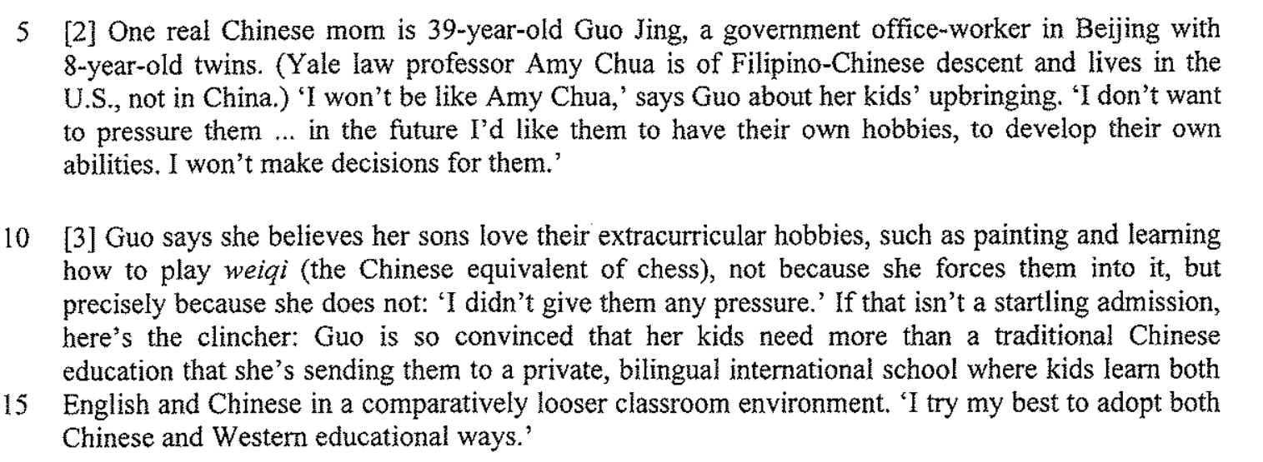
Question 4 — DSE 2013 Paper 1, Part A, Q6 (3 marks, Text 1 paragraphs 2-3)
Read paragraphs 2-3 and decide whether the following statements are True, False, or the information is Not Given. Blacken ONE circle only for each statement.
Statement | Answer | % correct
The three women in the persimmon orchard are the same age. | NG | 72%
The burial complex remains a mystery. | T | 61%
It usually takes a few hours to piece together a complete terra-cotta warrior. | F | 67%
(i) ¶2 calls them “three middle-aged women” and gives only Yang’s age (“a cheerful 57-year-old”) — the ages of the other two are not given (lines 6–10)
(j) ¶2 — “the celebrated (and still dimly understood) burial complex of China’s first emperor, Qin Shi Huang Di” (lines 16–19)
(k) ¶3 — “It usually takes Yang and her co-workers many days … but today they are lucky, accomplishing the task in a matter of hours.” (lines 20–24)
Note: The examination paper printed a 4th statement (iv) "Yang Rongrong has been piecing together terra-cotta warriors for 39 years." HKEAA deleted this item from marking, so it is left out here and this question is scored out of 3.
Text 1, paragraphs 2–3 (passage printed in the student handout):
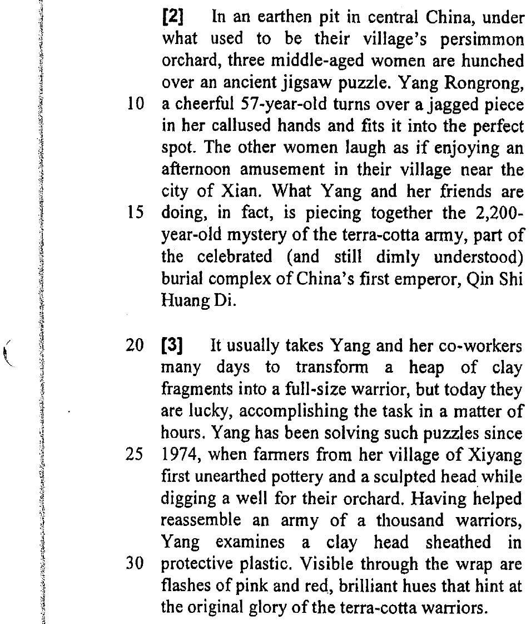
Question 5 — DSE 2013 Paper 1, Part A, Q21 (3 marks, Text 1 paragraph 11)
Read paragraph 11 and decide whether the following statements are True, False, or the information is Not Given. Blacken ONE circle only for each statement. (3 marks)
Statement | Answer | % correct
Only a small portion of the tomb has been excavated. | T | 64%
The speed of discovering new artifacts is slowing down. | F | 68%
In 2011, the museum completed the excavation of the central burial mound. | F | 40%
(i) ¶11 — “With less than one percent of the vast tomb complex excavated so far” (lines 119–120)
(j) ¶11 — “the pace of discovery is quickening”: the opposite is true (line 122)
(k) ¶11 — “In 2011 the museum launched two long-term excavation projects on the flanks of the 250-foot-high central burial mound”: it started them, it did not finish (lines 122–125)
Text 1, paragraph 11 (passage printed in the student handout):
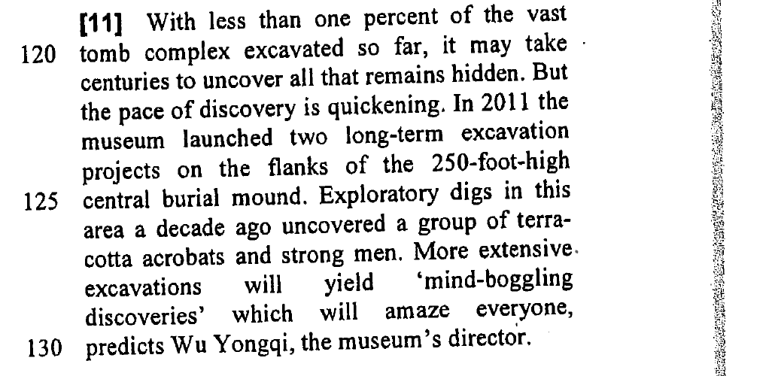
Question 6 — DSE 2013 Paper 1, Part B1, Q32 (4 marks, Text 2 the whole text)
Decide whether the following statements are True, False, or the information is Not Given. Blacken ONE circle only for each statement. (4 marks)
Statement | Answer | % correct
Zou teaches the guzheng. | T | 83%
The guzheng is Zou’s favourite instrument. | NG | 67%
No one else in Zou’s family can play the guzheng. | F | 76%
Famous people have attended Zou’s performances. | T | 51%
(i) ¶6 — “The school offers guzheng classes to children and adults taught by Zou.” (lines 33–34)
(j) the text says the guzheng is “one of the most loved Chinese instruments” and that Zou plays it, but it never says it is her favourite (lines 8–10)
(k) ¶5 — “Zou, born into a family of guzheng musicians who go back four generations” (lines 23–24)
(l) ¶5 — “She has played for celebrities and politicians who include the former prime ministers of Australia and New Zealand, and former president Jiang Zemin.” (lines 25–29)
Text 2, paragraphs 1–6 (passage printed in the student handout):
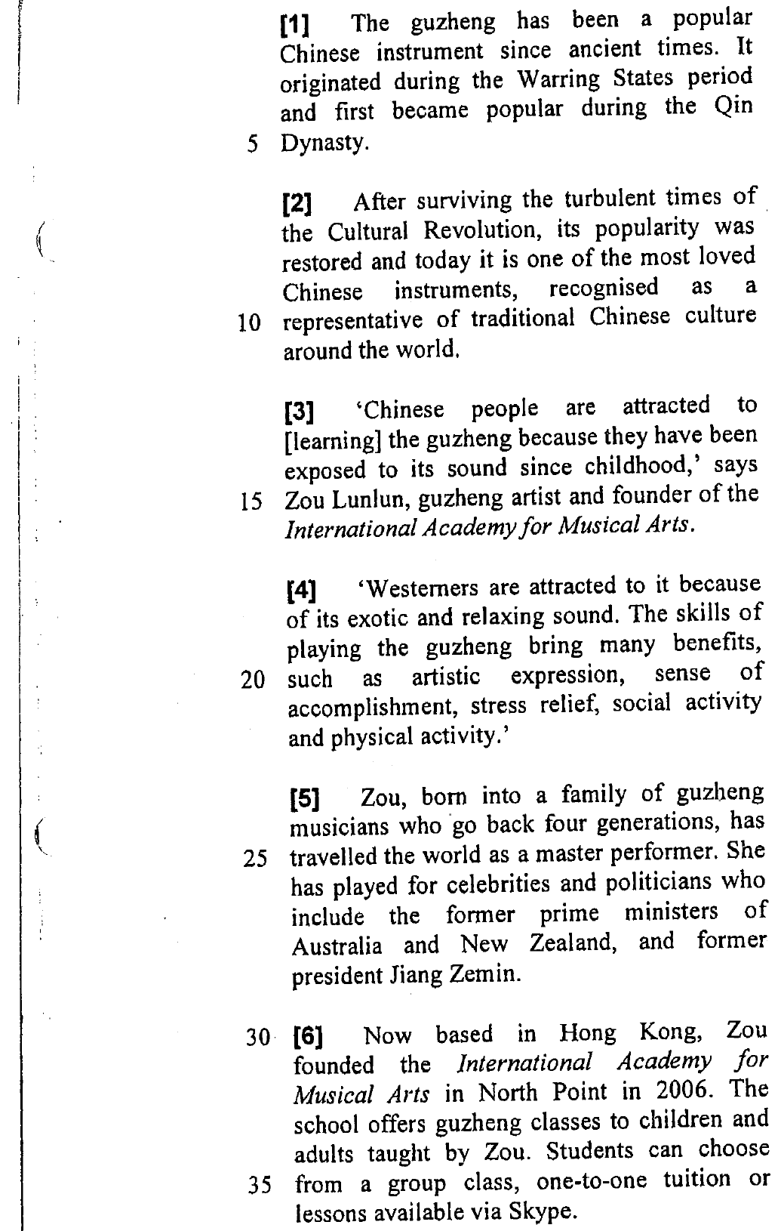
Question 7 — DSE 2013 Paper 1, Part B1, Q42 (3 marks, Text 3 paragraphs 7-9)
Read paragraphs 7-9 and decide whether the following statements are True, False, or the information is Not Given. Blacken ONE circle only for each statement. (3 marks)
Statement | Answer | % correct
People with low self-esteem feel that Facebook is a safe place to share information about themselves. | T | 57%
It is more difficult to read someone’s reaction when you talk to them face to face than through Facebook. | F | 36%
Participants of the study checked their e-mails even though they said they would rather sleep. | T | 47%
(i) ¶7 — “people with low self-esteem may feel that Facebook is a risk-free forum for making personal disclosures” (lines 59–60)
(j) ¶8 — face to face “you might get an indication that they don’t like it”, but “On Facebook, you don’t see most of the reactions”: the reverse is true (lines 36–40)
(k) ¶9 — “although the strongest desires were for sleep, checking work e-mails and updating a Facebook status are this generation’s actual nocturnal activities” (lines 46–51)
Text 3, paragraph 7 (passage printed in the student handout):
 | 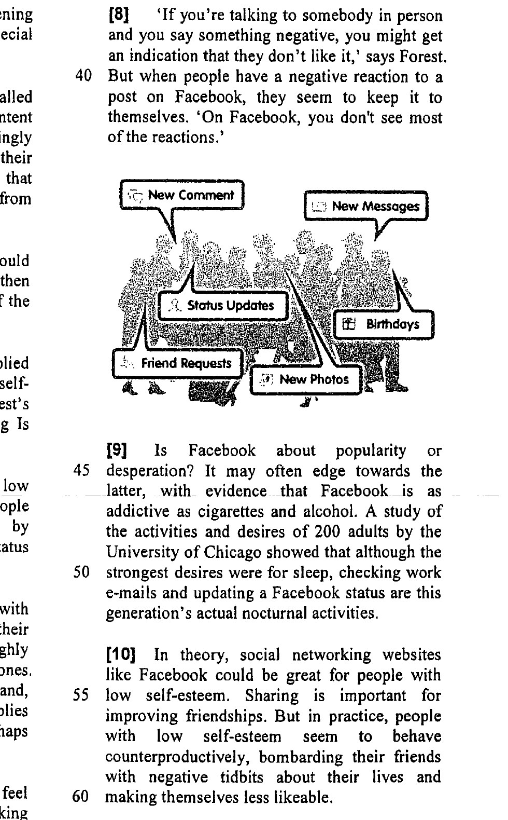
Question 8 — DSE 2013 Paper 1, Part B2, Q52 (4 marks, Text 4 paragraphs 4-5)
Read paragraphs 4-5 and decide whether the following statements are True, False, or the information is Not Given. Blacken ONE circle only for each statement. (4 marks)
Statement | Answer | % correct
The Hunger Games is the only example of the current popularity in dystopian fiction. | F | 84%
In the Uglies, teenagers conform to a standard prettiness by undergoing surgery. | T | 88%
Most participants of the Internet discussion board are teenagers. | NG | 87%
Brave New World and 1984 were written for American schoolchildren. | F | 68%
(i) ¶4 — “Collins’s trilogy is only the most visible example of a recent boom in dystopian fiction for young people.” (lines 39–40)
(j) ¶4 — “all sixteen-year-olds undergo surgery to conform to a universal standard of prettiness” (lines 44–46)
(k) ¶4–¶5 say nothing about the age of the people posting on the discussion board (lines 39–80)
(l) ¶5 — they are “twentieth century’s dystopian classics for adults” that schoolchildren are “assigned to read” (lines 76–80)
Text 4, paragraph 4 (passage printed in the student handout):
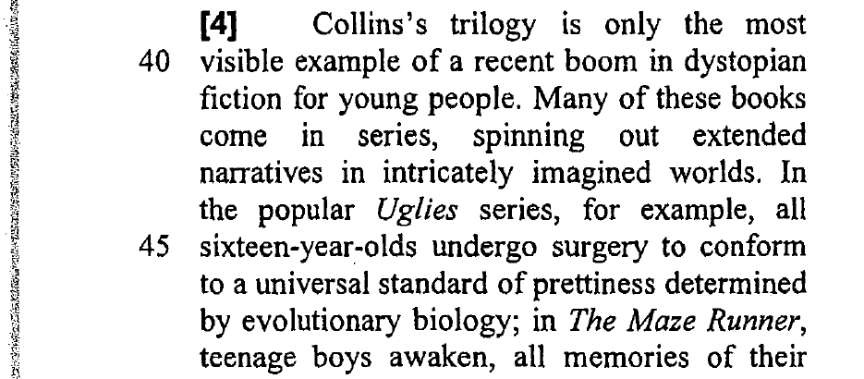 | 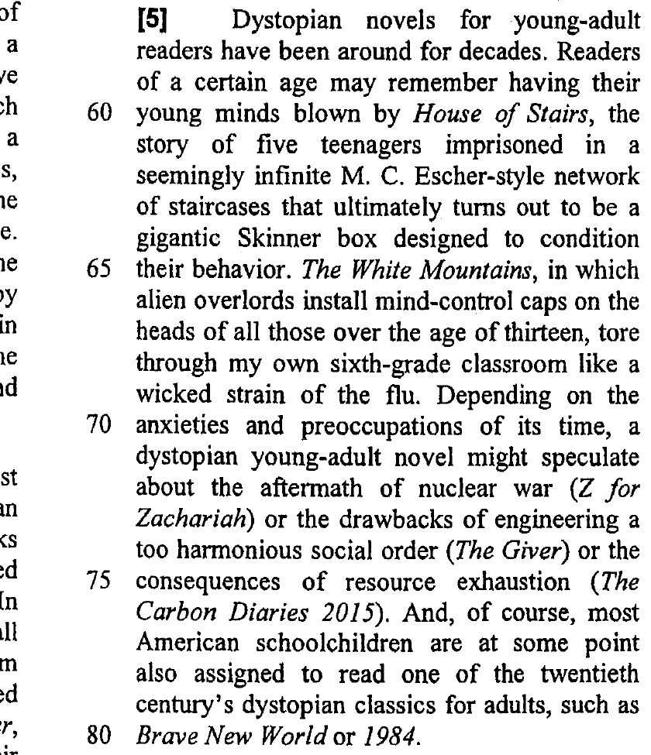
Marks at a glance
2012 Paper 1 Part A Q8: 4 marks — answer T / F / F / T (78%, 39%, 82%, 72%)
2012 Paper 1 Part B1 Q34: 4 marks — answer F / T / NG / T (62%, 68%, 64%, 59%)
2012 Paper 1 Part B2 Q51: 3 marks — answer NG / T / F (82%, 79%, 84%)
2013 Paper 1 Part A Q6: 3 marks — answer NG / T / F (72%, 61%, 67%)
2013 Paper 1 Part A Q21: 3 marks — answer T / F / F (64%, 68%, 40%)
2013 Paper 1 Part B1 Q32: 4 marks — answer T / NG / F / T (83%, 67%, 76%, 51%)
2013 Paper 1 Part B1 Q42: 3 marks — answer T / F / T (57%, 36%, 47%)
2013 Paper 1 Part B2 Q52: 4 marks — answer F / T / NG / F (84%, 88%, 87%, 68%)
Total: 28 marks.
Timing suggestion
About 4–5 minutes per question (8 questions ≈ one double lesson). Read the instruction first: some questions name the paragraphs, one (2013 B1 Q32) does not, so students must scan the whole text. Insist on the reason for every NG — “the paragraph does not say”.
How to use the PowerPoint
One slide per question: the exam instruction and the statements on the right, the exam paragraph(s) on the left. The tick and the candidate percentage appear one statement at a time on a click — ask for the students’ decision and the proof words before each click. Speaker notes carry the click script and the evidence.

