F6 English SP — Lesson 7
DSE Paper 1 — True / False / Not Given questions (2012 & 2013)

Question 1 — DSE 2012 Paper 1, Part A, Q8 (3 marks)
Decide whether the following statements are True, False, or the information is Not Given in paragraphs 8-9. Put a tick (✓) in the appropriate column. (4 marks).
Statement | T | F | NG
Customers can play board games for two hours if they buy two drinks.
Pat never played Monopoly, Uno or Snakes & Ladders as a child.
Pat thinks computer games are not as challenging as some board games.
Text 1, paragraphs 8–9
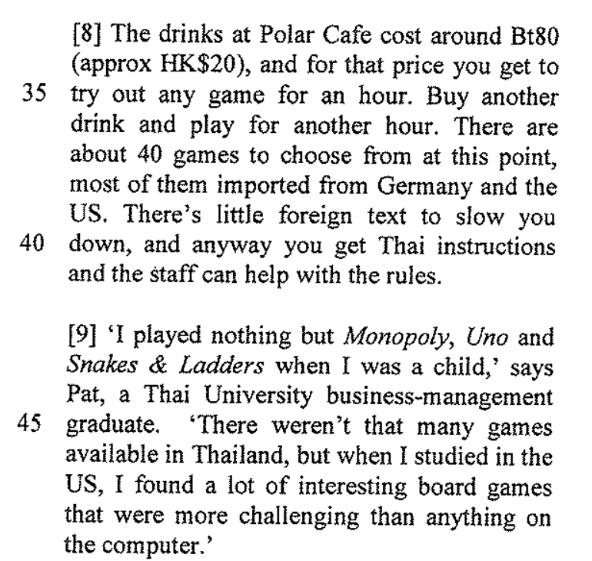

Question 2 — DSE 2012 Paper 1, Part B1, Q34 (4 marks)
Decide whether the following statements are True, False, or the information is Not Given in paragraphs 13-21. Put a tick (✓) in the appropriate column. (4 marks).
Statement | T | F | NG
Only children stitched the quilt.
Rachel and Jacob are related.
Jacob and Patrick are classmates.
Each participant could express their personality through the pledge patches.
Text 2, paragraphs 13–15
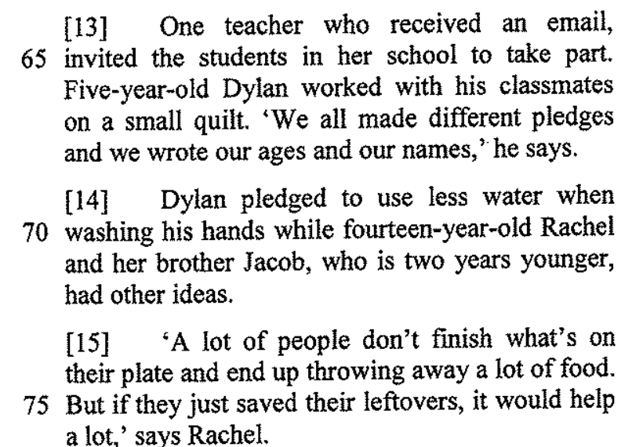 | 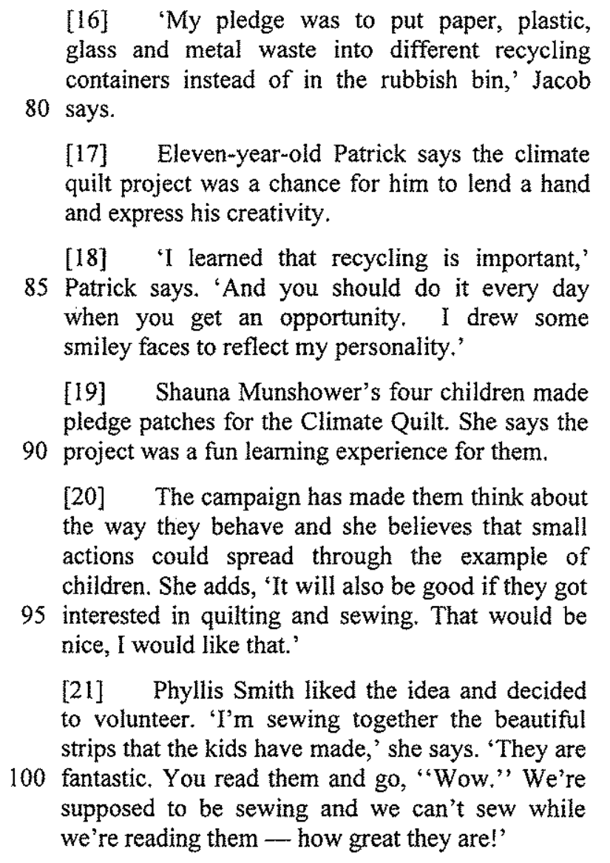

Question 3 — DSE 2013 Paper 1, Part A, Q6 (3 marks)
Read paragraphs 2-3 and decide whether the following statements are True, False, or the information is Not Given. Blacken ONE circle only for each statement.
Statement | T | F | NG
The three women in the persimmon orchard are the same age.
The burial complex remains a mystery.
It usually takes a few hours to piece together a complete terra-cotta warrior.
Text 1, paragraphs 2–3
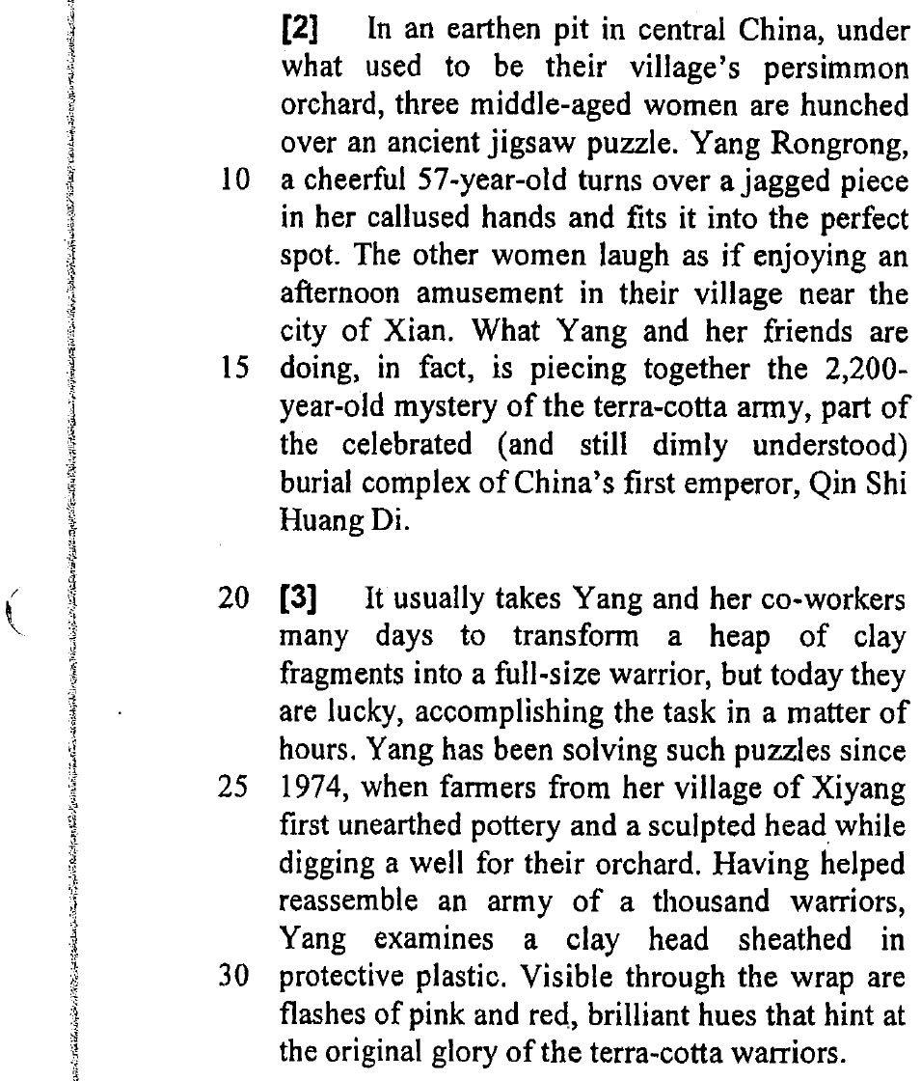

Question 4 — DSE 2013 Paper 1, Part A, Q21 (3 marks)
Read paragraph 11 and decide whether the following statements are True, False, or the information is Not Given. Blacken ONE circle only for each statement. (3 marks).
Statement | T | F | NG
Only a small portion of the tomb has been excavated.
The speed of discovering new artifacts is slowing down.
In 2011, the museum completed the excavation of the central burial mound.
Text 1, paragraph 11
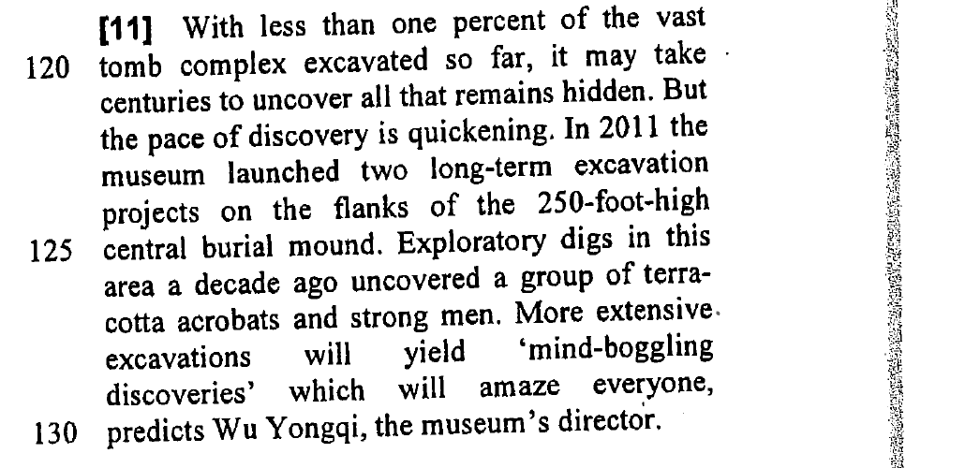

Question 5 — DSE 2013 Paper 1, Part B1, Q42 (3 marks)
Read paragraphs 7-9 and decide whether the following statements are True, False, or the information is Not Given. Blacken ONE circle only for each statement. (3 marks).
Statement | T | F | NG
People with low self-esteem feel that Facebook is a safe place to share information about themselves.
It is more difficult to read someone’s reaction when you talk to them face to face than through Facebook.
Participants of the study checked their e-mails even though they said they would rather sleep.
Text 3, paragraph 7
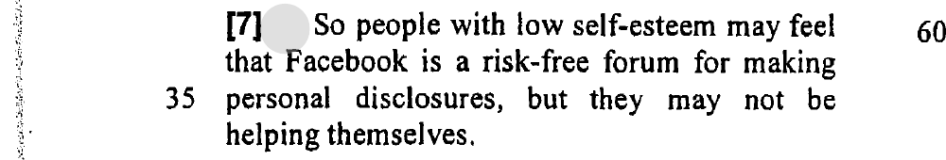 | 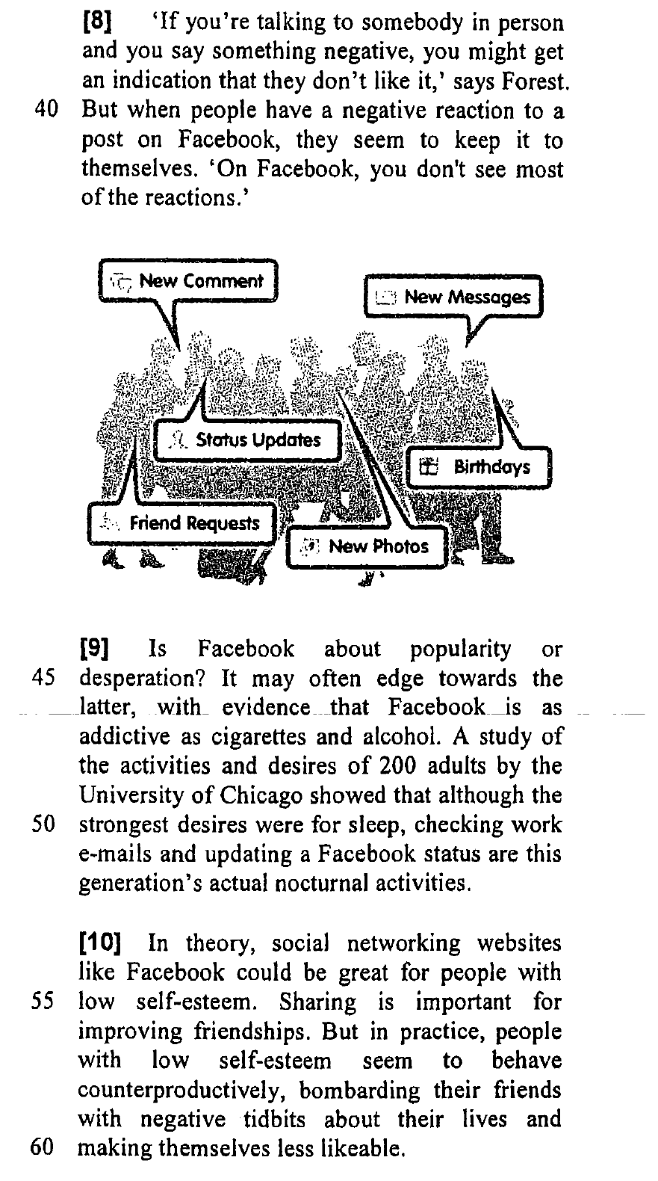
Question 6 — DSE 2013 Paper 1, Part B2, Q52 (4 marks)
Read paragraphs 4-5 and decide whether the following statements are True, False, or the information is Not Given. Blacken ONE circle only for each statement. (4 marks).
Statement | T | F | NG
The Hunger Games is the only example of the current popularity in dystopian fiction.
In the Uglies, teenagers conform to a standard prettiness by undergoing surgery.
Most participants of the Internet discussion board are teenagers.
Brave New World and 1984 were written for American schoolchildren.
Text 4, paragraph 4
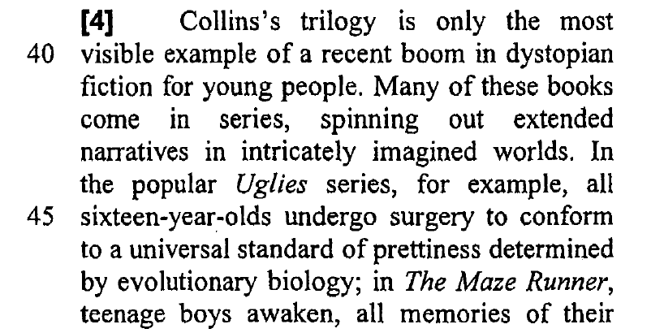 | 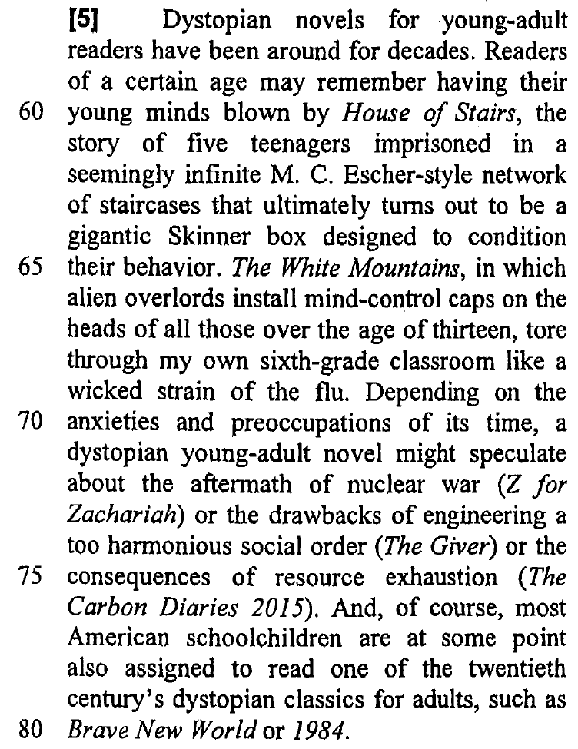
Total: _______________ / 20

