CS 405G Introduction to Database Systems

Fall 2013

Project Report

By

Feiyu Shi & Libby Ferland

12/1/2013

1. Database Design
2. ER Diagram

See Appendix.

1. Relational Schema Design, Functional Dependencies, and Normalization

**Entities:**

**Customer**(string:Email, string:Fname, string:LName, string:Password)

Email -> Fname, LName, Password

3NF

**Basket**(string:CEmail, int:BasketId, date: ShopDate)

CEmail, BasketId -> ShopDate

3NF

**Orders**(int:POrderID, string:Status)

POrderID -> Status

3NF

**Employee**(int:EId, string:EPassword, string:LastName, string:FirstName, Boolean:IsManager)

EId -> EPasword, LastName, FirstName, IsManager

3NF

**Item**(int:IId, string:IName, string:Category, string:Description, float:IPrice, int:Quantity, float:PromoPrice)

IId -> IName, Category, Description, IPrice, Quantity, PromoPrice

3NF

**ShipPrice**(string:ShipMethod, float:ShipRate)

ShipMethod -> ShipRate

3NF

**AddressBook**(int: AddrIndex, string: CEmail, string:AddrLine1, string:AddrLine2, string:City, string:State, int:Zip, Boolean: IsVisible)

AddrIndex, CEmail -> AddrLine1, AddrLine2, City, State, Zip, IsVisible

3NF

**PaymentMethods**(string:CEmail,int:CardNo,string:CHolderLastName,string:CHolderFirstName,date:CExpirDate, Boolean:IsVisible)

CEmail, CardNo -> CHolderLastName, CHolderFirstName, CExpirDate, IsVisible

3NF

**Relationships:**

**Purchase**(string:CEmail, int:InvoiceNo, int:PurchaseRating, string:Review, date:PurchaseDate)

CEmail, InvoiceNo -> PurchaseRating, Review, PurchaseDate

3NF

**Ship**(int:EId, int: OrderID, date:ShipDate)

EId, OrderID -> ShipDate

3NF

**Promote**(int:EId, int:IId, float:PromoRate, string:PStartDate, string:PEndDate)

EId, IId -> PromoRate, PStartDate, PEndDate

3NF

**BasketContains**(string:CEmail,int:BasketId, int:IId, int:BQuantity)

CEmail, BasktId, IId -> BQuantity

3NF

**OrderContains**(int: COrderID, int:IId, int:OQuantity)

COrderID, IId -> OQuantity

3NF

**BillingAddress**(string:CEmail, int:CardNo, int: AddrIndex, Boolean: IsVisible)

CEmail, CardNo, AddrIndex -> Isvisible

3NF

**ShippedTo**(int:OderID, string:CEmail, int:AddrIndex)

All attributes are primary keys, and they don’t depend on each other.

**PaidWith**(string:CEmail,int:CardNo, int:OrderID)

All attributes are primary keys, and they don’t depend on each other.

**ShippedBy**(int:OderID,string:ShipMethod)

All attributes are primary keys, and they don’t depend on each other.

1. Description of Programs
2. Program Functions
3. Search Engine

Input form:

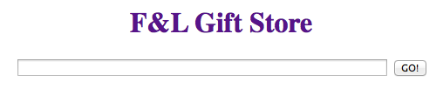

Sample output:

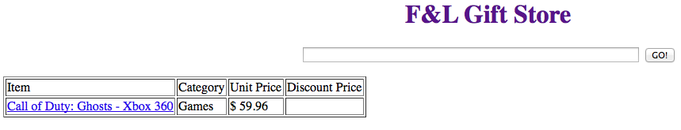

1. View by Category

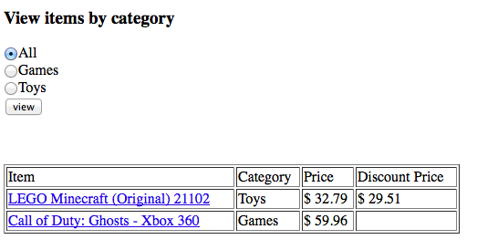

1. Customer Registration

Input form:

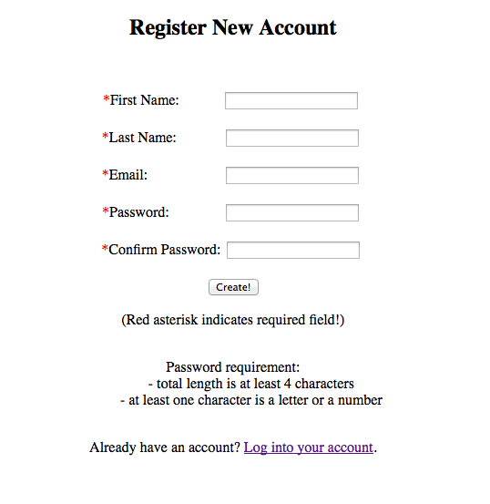

Output form 1 (errors):

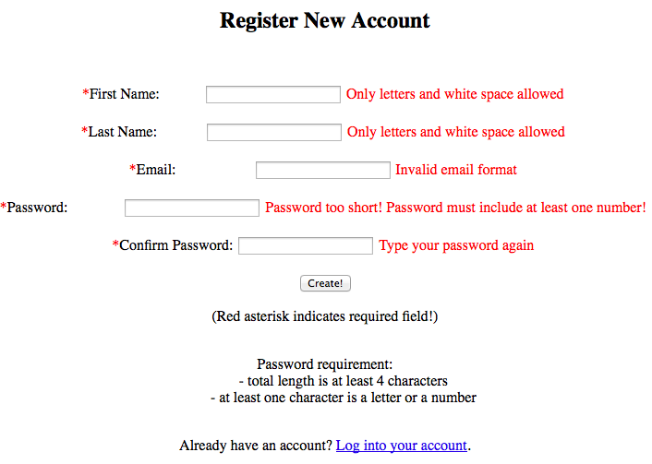

Output form 2:

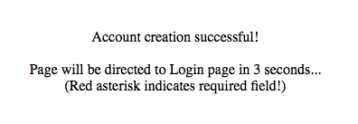

1. Customer Login

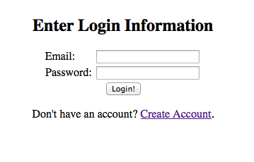

1. Customer Account

Page of new customer:

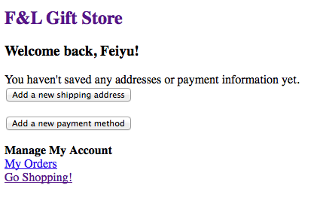

Page of old customer:

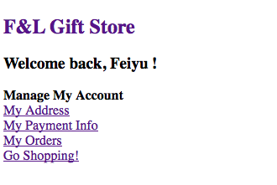

1. Address Book

Input form 1:

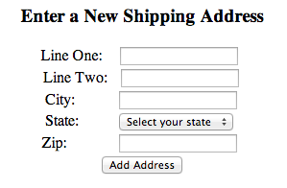

Input form 2:

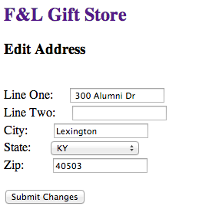

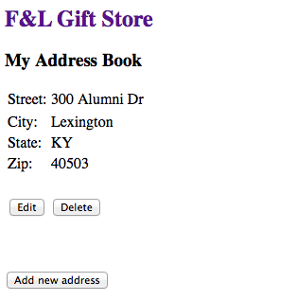

1. Payment Method

Input form 1:

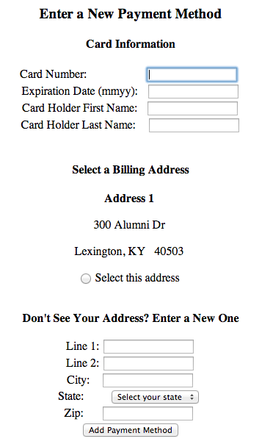

Input form 2 (error):

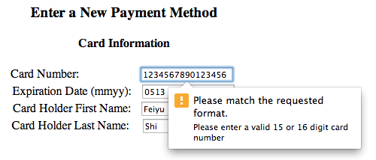

Input form 3 (error):

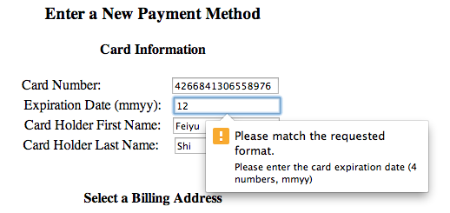

Input form 4:

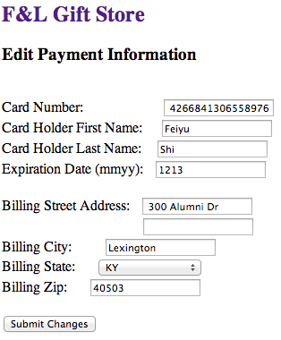

Output form:

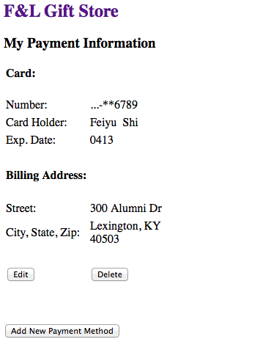

1. Item Page

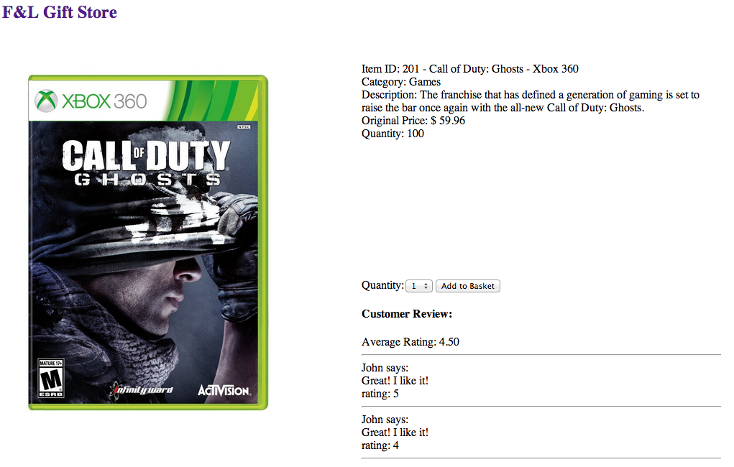

1. Customer Basket

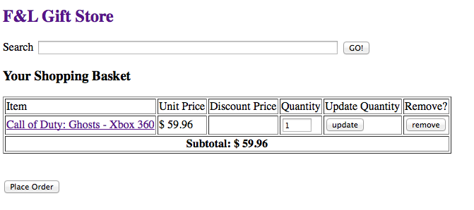

1. Order Placement

Output form 1:

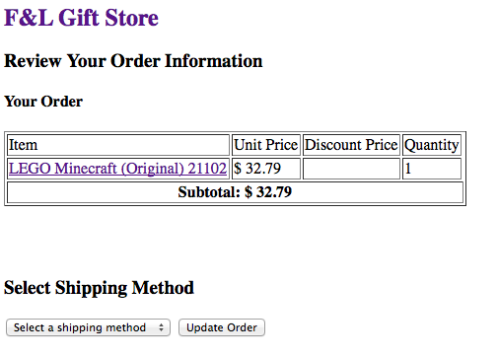

Output form 2:

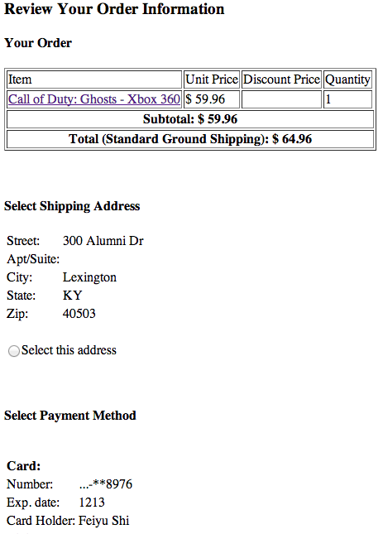

Output form 3:

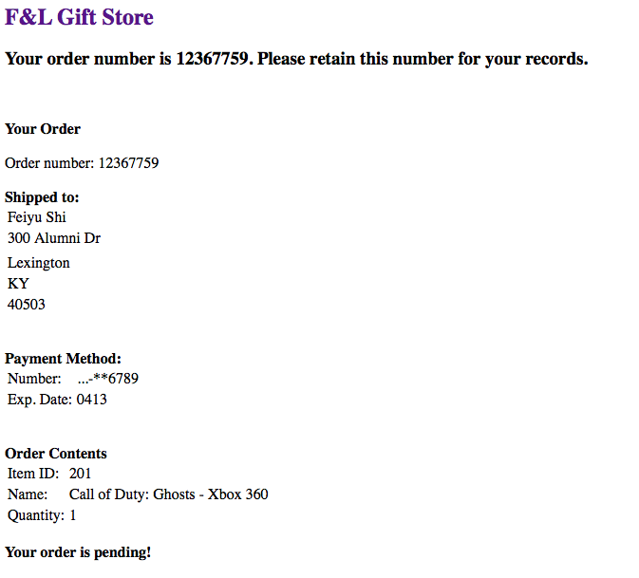

1. Employee Login

Input form:

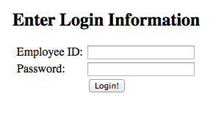

1. Employee Home

Output form 1:

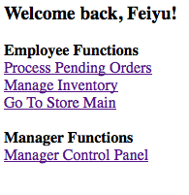

Output form2:

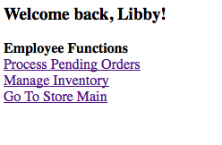

1. Pending Orders

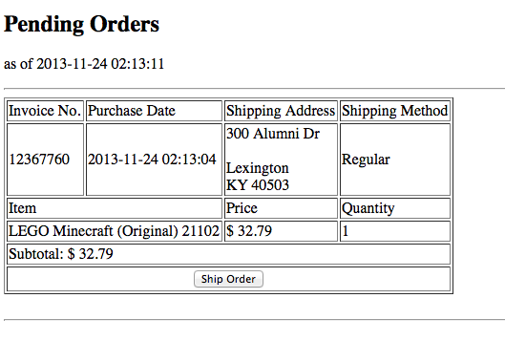

1. Inventory Management

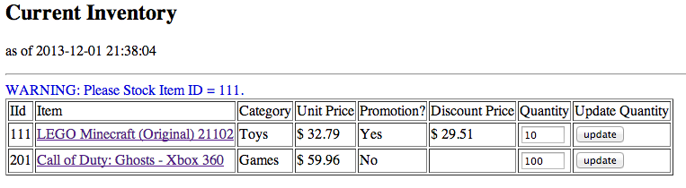

1. Manager Statistics

Output form 1 (sales, today):

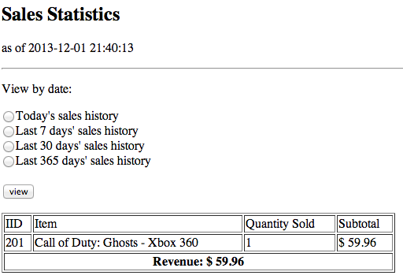

Output form 2 (sales, this year):

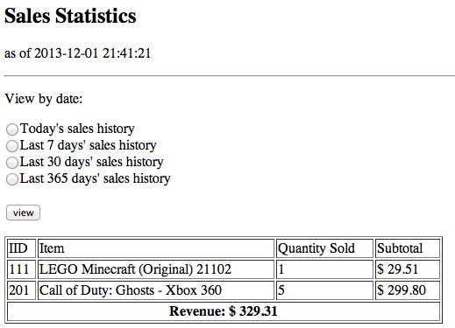

1. Manager Promotion

Output form 1:

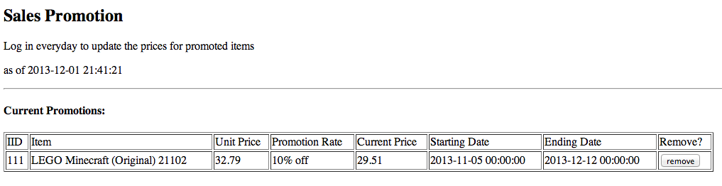

Output form 2:

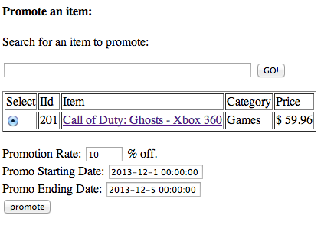

Output form 3:

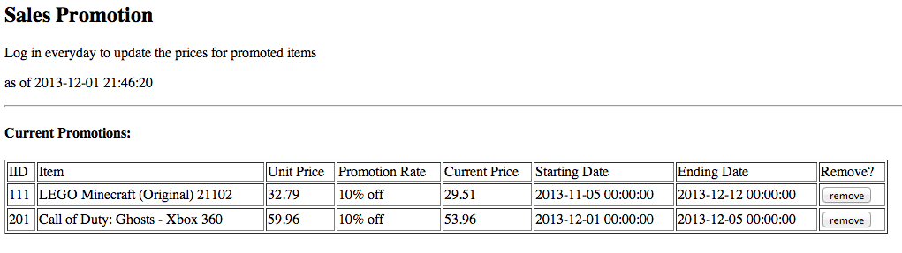

1. Testing