A Ludum Games Production

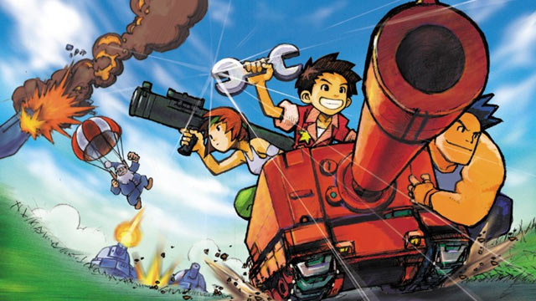

*Advanced Battle Specifications*

Trent Faris and Jeremy Hamilton

Change List

|  |  |  |  |
| --- | --- | --- | --- |
| version | summary | author | date |
| 0.1 | First Draft | Jeremy Hamilton | 09/20/2013 |
| 0.2 | Added Overview, Essential, and Stretch Goals | Jeremy Hamilton | 09/20/2013 |
| 0.3 | Added UMLs | Trent Faris | 09/20/2013 |

Contents

Introduction 4

Scope 4

Definitions 4

Overall Description 4

Goal of Advanced Battle 4

Rules of the Game 4

Pieces 5

Conditions of Victory 6

Multiplayer Feature 6

Constraints 6

Assumptions and Dependencies 6

Essential Requirements 6

Map Features 6

Touch Features 6

Playability 7

Stretch Goals 7

Additional Pieces 7

Additional Media Features 7

Additional Game Features 8

Multiplayer Functionality 8

UML Diagrams 8

# Introduction

The purpose of this document is to show a general overview of the design and goals of this project. It will cover a description of what the project is; the minimum requirements needed for complete functionality; a number of stretch goals beyond the minimum; and a couple of UML diagrams to help describe the flow of the program.

## Scope

This game is a way that multiple players can engage in a battle of strategy! It is a battle of wits, gamble, and intelligence. The scope of this project is to make a fun and enjoyable game that friends can enjoy.

## Definitions

This document may refer to several military terms. Be familiar with the terms of combat.

# Overall Description

Advanced Battle is a take off the old game Advance Wars. It is game that was created in 1988 by Intelligent Systems and was first introduced in North America in 2001. Since then, it has been considered a classic by gamers everywhere.

|  |  |
| --- | --- |
| Goal of Advanced Battle The goal of Advanced Battle is to claim resources, destroy enemy units, and take control of enemy owned cities. |  |

## Rules of the Game

Advanced Battle works by Players taking turns one at a time. Inside a player’s turn, a player can:

* **Move every piece in his control exactly once.**
* **Each piece has the option to attack once per turn or take another significant action (e.g. seizing a city).**
* **Purchase more troops.**
* **Use a CO power (stretch goal).**

Each piece will have a predetermined amount of health, and upon depletion, he is removed from the board.

Infantry when on an enemy owned city have an option to liberate a city, and reduces the liberation health equal to the amount of health points the infantry unit has.

When the liberation health of a city reaches zero it changes ownership to the player that stole it.

Players have a limited amount of funds. They have a predetermined starting amount and gain funds each turn dependent on the number of cities they own.

Players purchase more troops by selecting a factory and purchasing it from their available funds.

Some units have limited ammo and can only fire a certain number times before needing to reload.

Units can reload by either resting in a city, or having a supply truck move beside them.

Vehicles also have a limited amount of gas. Ground and water vehicles lose gas by how far they move, and aircraft and submerged submarines lose gas each round whether they move or not.

Units can refuel by either resting in a city, or by having a supply truck move beside them.

**Fog of War (Stretch Goal):**

Fog of War limits the players vision to a particular number of squares.

## Pieces

**Infantry:**

Unit that has an assault rifle, the ability to liberate cities, and can move through mountains.

**Demolition Infantry:**

Same as normal infantry but carry bazookas that are more effective against vehicles.

**Large Tank:**

Tank that has shell rounds and great defense.

**Small Tank:**

Same as Large Tank but is weaker and costs less.

**Scout:**

Vehicle that has extended vision, and carries an assault rifle.

**Supply Tank:**

Tank that is not able to attack, but when resting refills the gas and ammo of adjacent vehicles and Demolition Infantry.

**Artillery:**

Unit that can attack at a distance of 2 squares.

**Missile Launcher:**

Extended range attacking unit that can only target units in the air.

**Rocket Launcher:**

Extended range attacking unit that can only target units on the ground.

**Antiaircraft:**

Unit that has shells which are effective against air craft.

**Battleship:**

Ship that has long range missiles that can attack all units at a distance.

**Submarine:**

Unit that can attack other ships and can submerge underwater preventing it from being seen unless an enemy unit is adjacent to it.

**Recon Ship:**

Ship with extended vision that is effective against other ships.

**Helicopter:**

Aircraft that can attack land units with missiles. And air units with an assault gun.

**Fighter Jet:**

Aircraft effective at taking down other aircraft.

**Bomber:**

Aircraft that can only drop bombs on ground units

## Conditions of Victory

When a player has successfully liberated the enemy Headquarters the game ends.

## Multiplayer Feature

The game will involve taking turns by players. This is done by locally passing the phone off to the other player. A stretch goal is to enable play across the internet.

## Constraints

This game uses AndEngine which uses OpenGL ES2 which is only rated for Android 2.2 and above. Other constraints maybe a phone that has a limited amount of memory.

## Assumptions and Dependencies

A connection to the internet will be vital to downloading game content including images, music, and playing across the internet.

# Essential Requirements

These are the requirements that will be the minimum expected for a base functionality and experience.

## Map Features

The game should have a number of maps that are selectable and has a variety of landmarks that change how the game is played. The map will be the main game screen.

## Touch Features

The game will involve interacting with the player’s pieces by touching the screen. Players, by touching the screen should be able to do all of the following fairly intuitively:

**Traverse the map.**

**Select a unit to see possible moves.**

**Select a location to move a player.**

**Drag a route to have a unit follow a particular path.**

**Choose a unit action.**

**Select a factory and create a new unit.**

## Playability

As discussed earlier, it will be considered successful to have an application where two players can play in a local game on one phone. It is desirable that if possible to extend that to being able to play over the internet.

# Stretch Goals

## Additional Pieces

**Neo Tanks:**

Supped up large tank.

**Carrier Vehicles:**

A class of vehicles that will carry other units. One for land, one for water, and one for air.

**Mine Planter:**

Infantry unit that can plant a mine in a particular square.

## Additional Media Features

**Music:**

Adding music to the game will be cool but would be a last minute thing.

**Action Scenes:**

When a unit attacks another unit, it would be cool to have a little scene that shows the units fighting.

**Battle History:**

A way for saving your win count, a records of past battles.

## Additional Game Features

**CO Powers:**

Each army could have a special power that a player could use throughout the battle.

**Fog of War:**

Battle with limited vision as an adversary.

**Vehicle Abandonment:**

Maybe have a feature where a player can abandon a vehicle.

## Multiplayer Functionality

Being able to play over the internet is being seen as a stretch goal for this project. There are just a lot of pieces to getting a working network like that to function. We see getting this working inside the time parameters as possibly out of reach.

# UML Diagrams

## Activity Diagram

## Battle Scene Diagram