# Allocate Approaches Toolbox Manual

This is a brief document illustrating how to use Allocate approaches toolbox.

Run “MainProgram.exe “ (in the “dist” folder) to open the main interface.

The log file is located in “C:\Randompoints”.

# Toolbox main interface

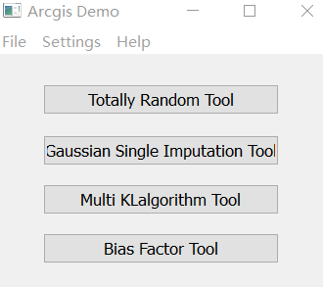

# Totally Random Tool

### 1. Click ‘Totally random tool’.

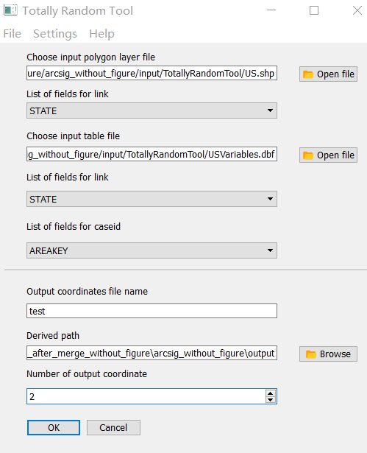

### 2. Add information, then click ‘ok’ to run the tool.

1) Click open file button to choose the Shapefile (in this example, US.shp). The files are available in the “input” folder.

2)Click C:\Users\yz719878\AppData\Roaming\Tencent\Users\117876752\QQ\WinTemp\RichOle\BX_HNIJZ{$}6K85DC%P@$R5.jpg in the “List of Fields for Link”, all the fields in Shapefile will be shown, choose the one that links to table (i.e. the variable that connects subunits to key units, in the US example, it is counties within states).

3) Click C:\Users\yz719878\AppData\Roaming\Tencent\Users\117876752\QQ\WinTemp\RichOle\1O]JSNGO%$BQ0RWP7AVW`6U.jpgto choose the Table (contains all variables for subunits), in this example it is “USvariables.dbf”.

4) Click C:\Users\yz719878\AppData\Roaming\Tencent\Users\117876752\QQ\WinTemp\RichOle\BX_HNIJZ{$}6K85DC%P@$R5.jpg in the “List of Fields for Link”, all the fields in Table will be shown, choose the one that links to Shapefile. The file name and value data type must be the same as the filed in 2).

5) Click C:\Users\yz719878\AppData\Roaming\Tencent\Users\117876752\QQ\WinTemp\RichOle\BX_HNIJZ{$}6K85DC%P@$R5.jpg, all the fields in Table will be shown, choose the one that represent unique case ID. It is AREAKEY in this example.

6) Type output file name.

7) Click browse button choose the output path.

8) Type how many sets of output coordinates to be generated.

### 3. The data processing messages will be shown.

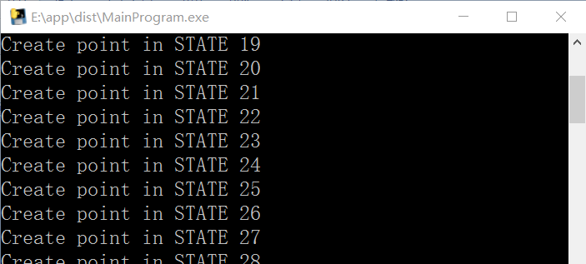

### 4. When tool completed. The progress bar will show 100% and the program can be closed.

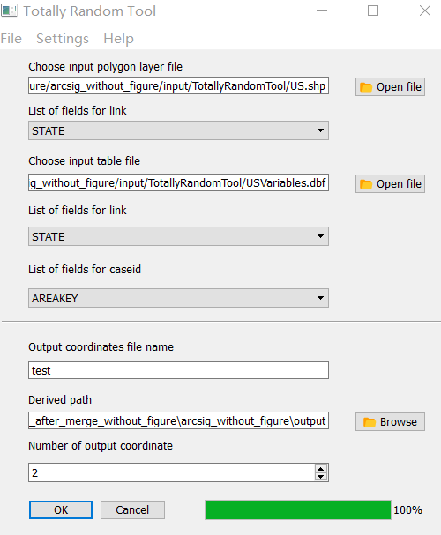

## Gaussian Single Imputation Tool, KL algorithm Tool and Bias Factor Tool manual

Gaussian Single Imputation tool, KL algorithm tool and Bias Factor tool have similar interface, all of them could use the following manual. Please note that for the field links to other files should have the same value data type as the value data type in other files.

### 1. Open tool and add information.

#### Input interface 1(Cases to be allocated Tab)

1) Click open file button to choose the Table (in this example,” For_MoranI_IntSite_NoMissing.dbf” in the “input” folder).

2) Click C:\Users\yz719878\AppData\Roaming\Tencent\Users\117876752\QQ\WinTemp\RichOle\BX_HNIJZ{$}6K85DC%P@$R5.jpg in the “Unique case IDs”, all the fields in dbf file will be shown, choose the one that represent unique case ID.

3) Click C:\Users\yz719878\AppData\Roaming\Tencent\Users\117876752\QQ\WinTemp\RichOle\BX_HNIJZ{$}6K85DC%P@$R5.jpg in the “Field linking to the largest unit”, all the fields in Table will be shown, choose the one that links to Shapefile.

4) Click C:\Users\yz719878\AppData\Roaming\Tencent\Users\117876752\QQ\WinTemp\RichOle\BX_HNIJZ{$}6K85DC%P@$R5.jpg in the “Ordinal variable”, choose the ordinal variable.

5) Input the boundary value for the ordinal variable in 4). See the figure below for the complete setting.

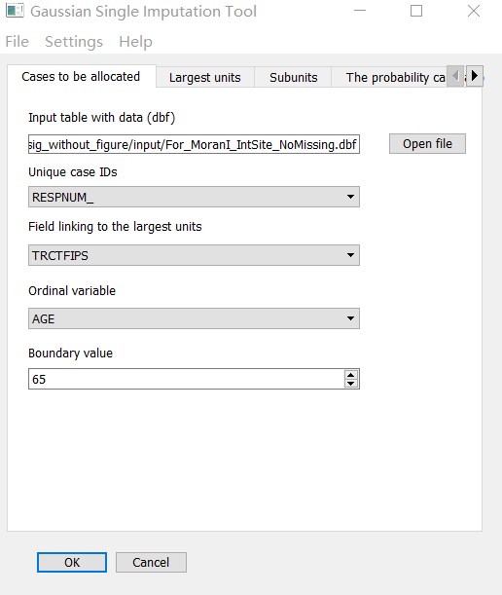

6) For Bias Factor tool, click C:\Users\yz719878\AppData\Roaming\Tencent\Users\117876752\QQ\WinTemp\RichOle\BX_HNIJZ{$}6K85DC%P@$R5.jpg, all the fields in Table will be shown, choose the fields that are biased and click the add button.

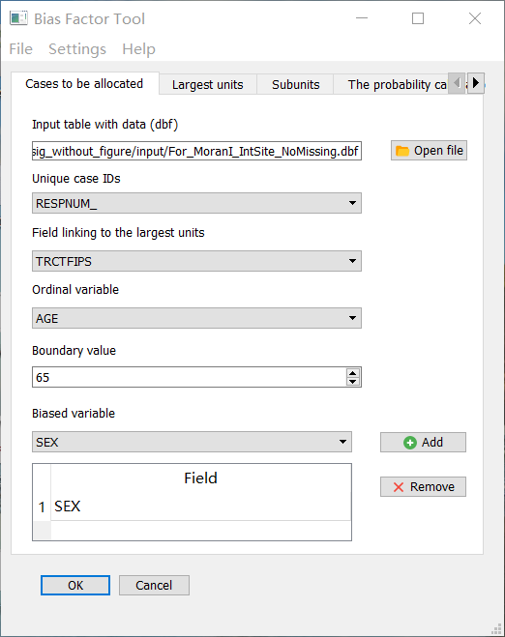

#### Input interface 2 (Largest units Tab)

1) Click open file button to choose the Shapefile for unit (in this example, IntSitePropotion3way.shp).

2) Click C:\Users\yz719878\AppData\Roaming\Tencent\Users\117876752\QQ\WinTemp\RichOle\BX_HNIJZ{$}6K85DC%P@$R5.jpg, all the fields in largest unit Shapefile will be shown, choose the one that linking case to be allocated.

3) Click C:\Users\yz719878\AppData\Roaming\Tencent\Users\117876752\QQ\WinTemp\RichOle\BX_HNIJZ{$}6K85DC%P@$R5.jpg, all the fields in largest unit Shapefile will be shown, choose the one that link to subunit Shapefile.

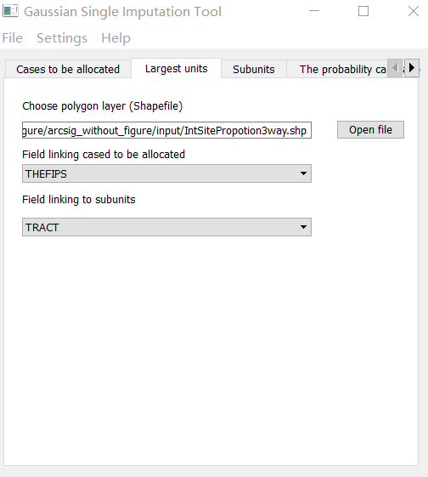

4) For KL algorithm interface, input the start and end columns index for the multi-way variables.

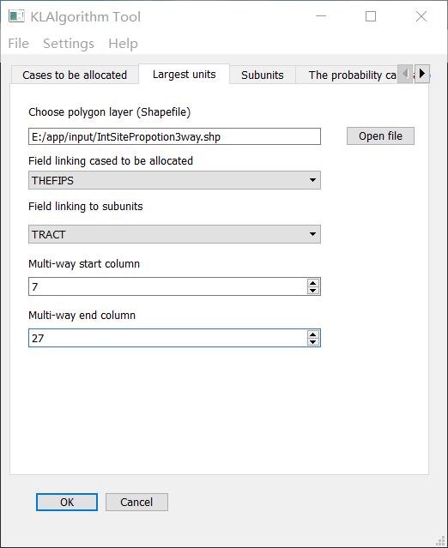

#### Input interface 3 (Subunits Tab)

1) Click open file button to choose the Shapefile for subunit (in this example, Int_Blk.shp).

2) Click C:\Users\yz719878\AppData\Roaming\Tencent\Users\117876752\QQ\WinTemp\RichOle\BX_HNIJZ{$}6K85DC%P@$R5.jpg, all the fields in subunit Shapefile will be shown, choose the one that link to largest unit Shapefile.

3) Click C:\Users\yz719878\AppData\Roaming\Tencent\Users\117876752\QQ\WinTemp\RichOle\BX_HNIJZ{$}6K85DC%P@$R5.jpg, all the fields in subunit will be shown, choose the one that represent unique subunit ID.

4) Click C:\Users\yz719878\AppData\Roaming\Tencent\Users\117876752\QQ\WinTemp\RichOle\BX_HNIJZ{$}6K85DC%P@$R5.jpg, all the fields in subunit will be shown, choose the one that represent total number in subunit.

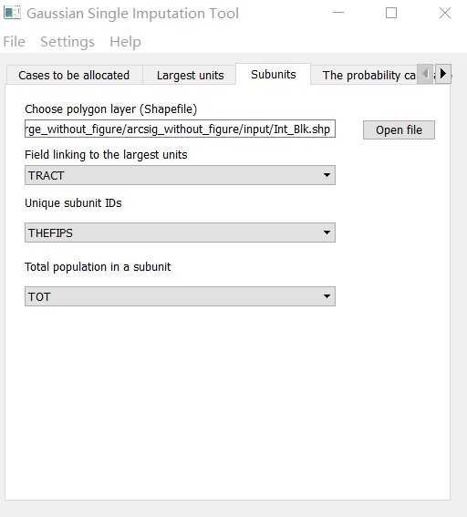

#### Input interface 4 (Probability calculation Tab)

1) Click C:\Users\yz719878\AppData\Roaming\Tencent\Users\117876752\QQ\WinTemp\RichOle\BX_HNIJZ{$}6K85DC%P@$R5.jpg, all the fields in subunit Shapefile will be shown, choose one or several fields that used for probability calculation.

2) Click C:\Users\yz719878\AppData\Roaming\Tencent\Users\117876752\QQ\WinTemp\RichOle\BX_HNIJZ{$}6K85DC%P@$R5.jpg, all the fields in case table will be shown, choose the one that corresponding variables for calculation in cases, then type values. Please note that the sequence in 1) and 2) must keep same. For example, ‘MALE’ in subunit is equal to ‘SEX =2’ in case table.

In this example:

1= [ 'MALE', 'FEMALE', 'LESSHIGH', 'HIGHGRAD','SOMECOLL','COLLEGE','POSTCOLL', 'AGELOW65', 'AGEABO65']

2 = ['SEX', 2],['SEX', 1], ['EDUCATION', 1],['EDUCATION', 2],['EDUCATION', 3],['EDUCATION', 4],['EDUCATION', 5], ['AGE', 0],['AGE', 1]

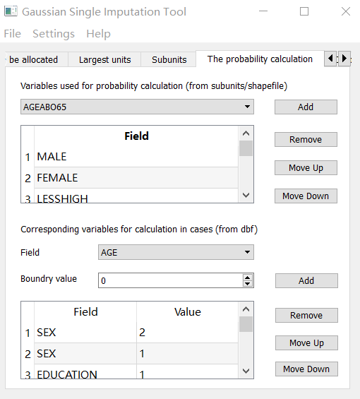

#### Input interface 5

1) Click the browse button to choose the output path.

2) Type output file name.

3) Type how many sets of output coordinates to be generated.

4) Type output proportion file name.

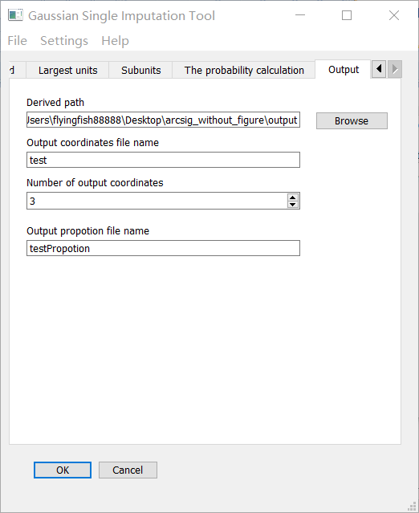

5) For KL algorithm interface, the number of consumers should be 1, because it is **single thread** version.

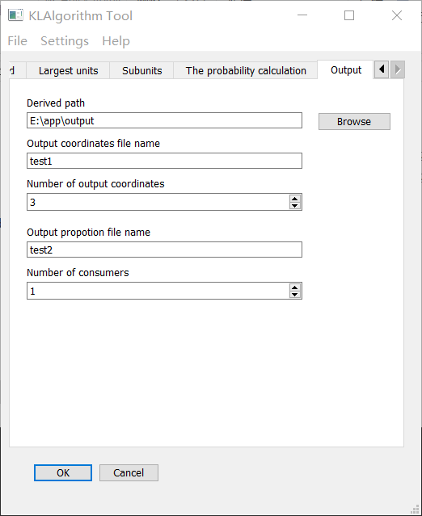

### 2.When tool completed. The progress bar will show 100%.

