**Flying Lions**

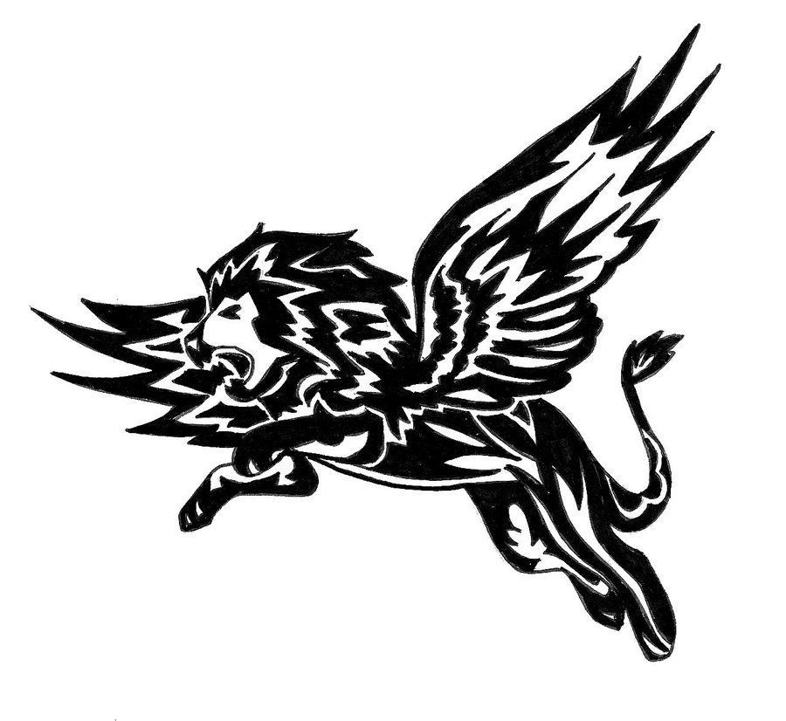

**Team Members:**

Wikus Richards

TinusNel

Pieter Pottas

Petrus Van Der Walt

Luthfiya Osman