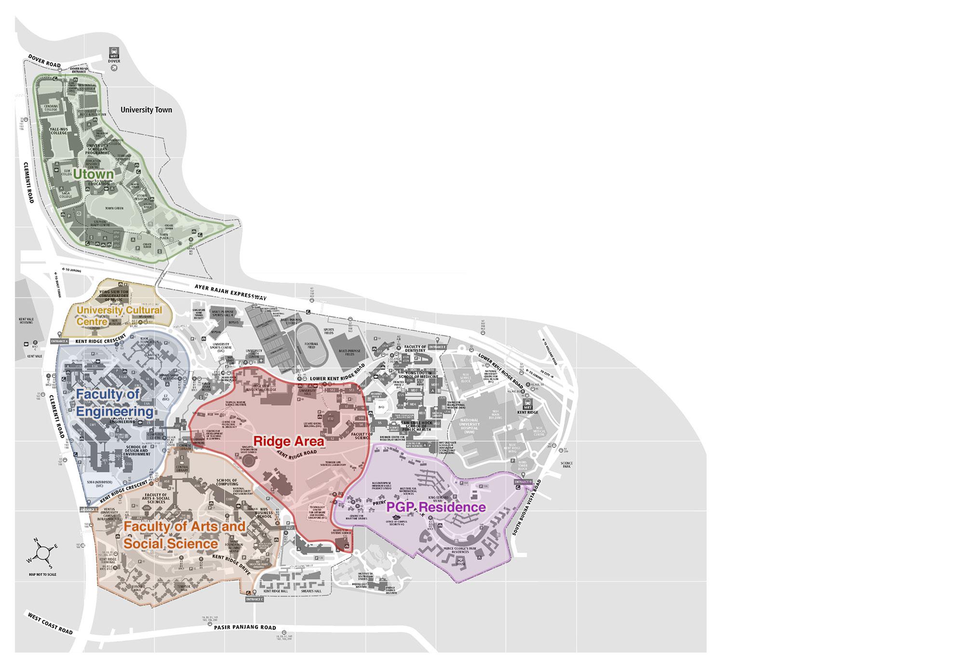

**Faculty**

**of Science**

**Yusof Ishak House**

**Faculty**

**of Science**

**Yusof Ishak House**