Tim Schonberger
Gary Graham
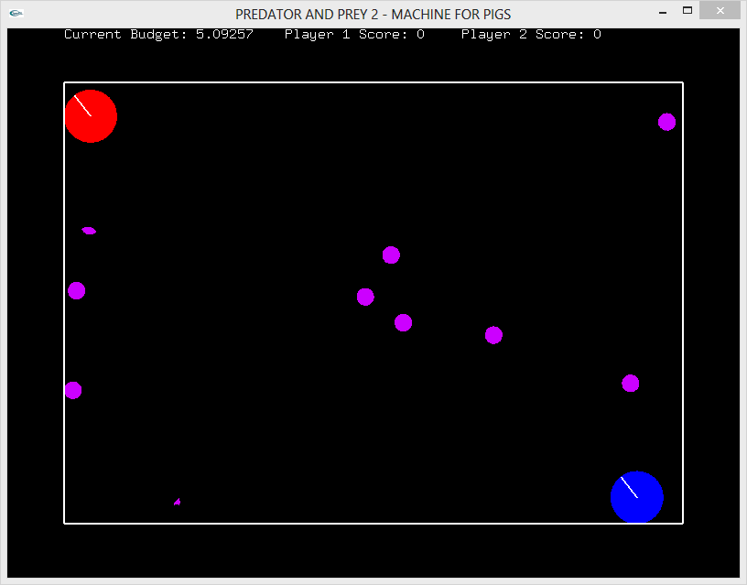

This picture shows the rough starting positions on the players. You can see the radial lines indicating the remaining time, as well as the purpose obstacles. At the top of the screen you can notice the Current remaining budget, as well as the score for both players.
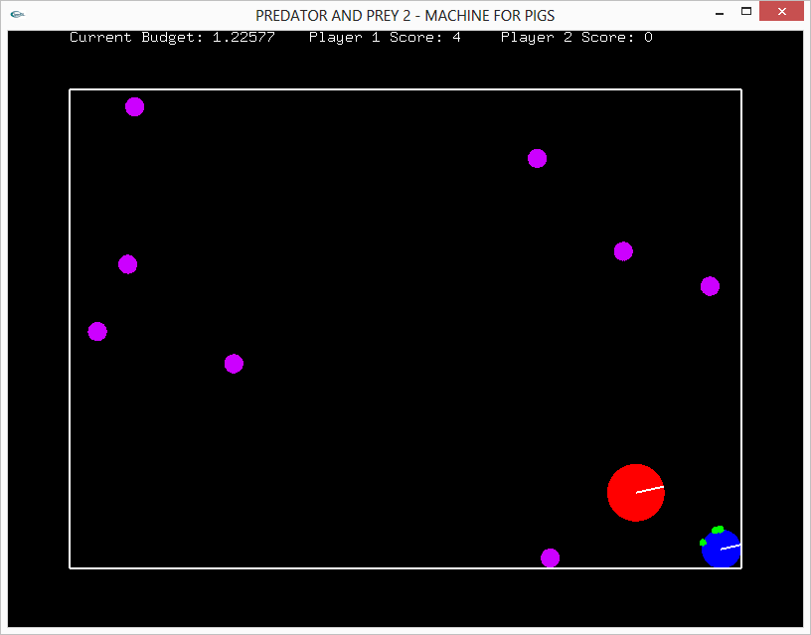

Here we see what happens when the Predator(red player) comes into contact with the prey(blue player). As you can see, the score is 4, the prey has 4 green scars, and has shrunk to a smaller size.
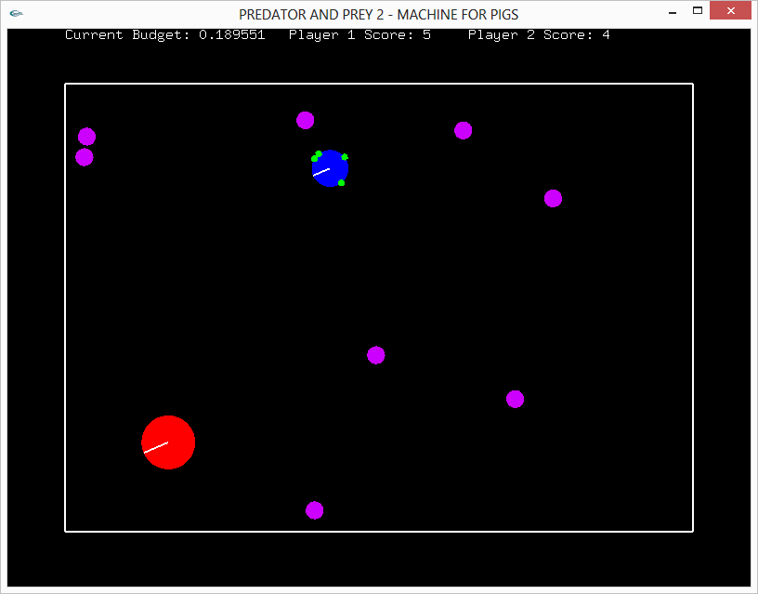

This screens shows what happens after turnover of the roles. Player 2 has become the red disc, and has scored four points.

