**Introduction:**

For creating the image sharing web application, we are using MariaDB and MySQL. We are having 7 different tables in our databases (User, Image, Tag, Tags, Rate, Comment, Categorys). By defining their primary key and foreign key we can easily make connection between these tables and also figure out table’s relationship in order to prevent redundant data. The Rate and Tags table was join table to make many to many relation between two tables. For making user be able to rate only once per same image, we need to make foreign key combination as a primary key. Tags also has a foreign key combination as a primary key so that user will not create same tag name to same image, but they can create many different tags to many images.

**User Story:**

-As a user, I want to share images that I think are important or worth sharing with my classmates.

-As a first visitor, I want to see the pictures/images so that I can exchange information about the classes. (login -private/public)

-As a user, I want to share my hobbies / my favorites so that we can get to know each other more.

-As a user, I want to give a grade (rate) so that

I can I can express my opinion and I can show my interest.

-As a user, I want to create a tag for the images so that my classmate can go through images easily.

-As a visitor/ user, I would like to save images in a gallery (album) so that I can see them and share pictures later.

-As a user, I want to comment on pictures so that I can give them feedbacks and detail information.

-As a user, I would like to see the images organized and categorized into different categories depending on the nature of images so that I can find images easily.

-As a user, I want to delete the files from my gallery (album) so that I can keep some images only which I need.

**ER Model:**

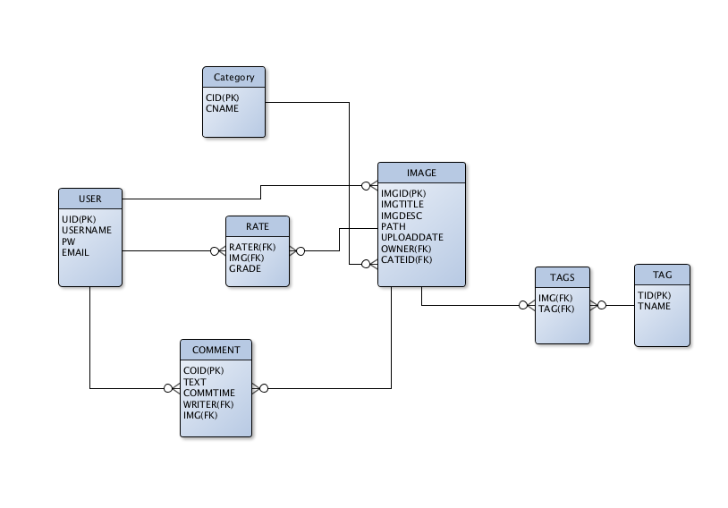

**SQL mapping:**

**User:**

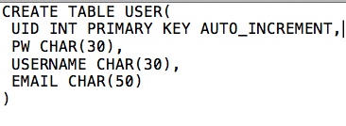

**Category:**

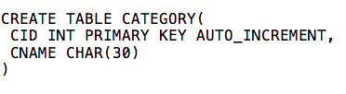

**Image:**

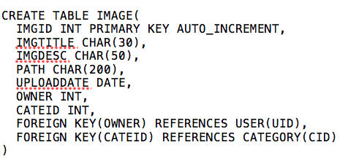

**Rate:**

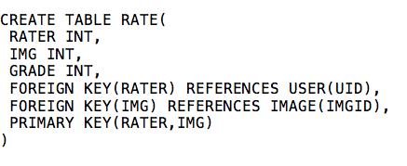

**Tag:**

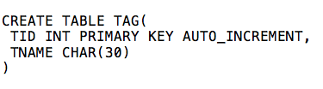

**Tags:**

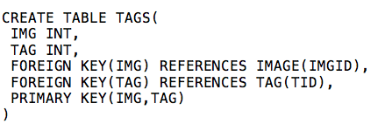

**Comment:**

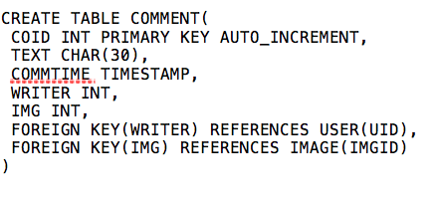

**conclusion:**

Working with databases was a really good experience. Some of the greatest features of it in our project was:

-We can query data in a database.

-We can look up data from a database relatively rapidly.

-We can relate data from two different tables together using JOINs.

-We can create meaningful reports from data in a database.

-Databases can handle very large data sets.