**Instructions for installing the playfield LCD on a Stern SAM system on Tron Legacy Pinball**

A close up of a stage

Description generated with high confidence

Package contents:

* 5” LCD
* SAM or Total Light Show Serial to USB cable with 90-degree adapter
* Raspberry Pi 3
* Raspberry Pi 3d mount
* SD card
* USB stick
* Power adapter
* Video cable
* Instructions

**ISSUES**

1. If you are using a ColorDMD and it is connected to the 12v power molex in the front right of the playfield, you cannot use this connector for the LCD. The ColorDMD causes a Group loop which will show up as a scrolling horizontal line on the mini LCD. You will need to purchase a 5v version of the LCD with harness.

**HARDWARE INSTALL**

1. Disconnect and remove the Tron toy recognizer from the playfield. It will have two screws securing it to the disc cover. Disconnect any led light power and remove the unit from the machine.
2. Install Raspberry PI in backbox below the CPU board. Mounting hardware is included, or you can use an existing screw to secure it.
3. Connect the power molex to the open connector that is in the lower left of the backbox. If there is a mod already connected here, remove it and use the split connector supplied and connect both.
4. Run the power cable through cable management and over to where the Pi is mounted.
5. Install the supplied SD card.
6. Install the USB stick in one of the open USB ports on the Raspberry Pi.
7. Install the Serial to USB interface. Plug in the 9 pin serial adapter to the Stern board or the Total Light Show Serial interface as show in Figure B. You may need to remove the florescent light to install the 90 degree adapter. Make sure the cable is secure and reinstall the lightbulb.
8. Insert the USB cable into an open port on the Raspberry PI.
9. Install the LCD above the Disc. I like to position the LCD mount where it is even with the disc artwork on the top of the plexi. Run the power, and Video adapters through the right hole where the power for the Recognizer once was. This is a bit tricky, but you can push each adapter through the whole in a line, White, Yellow, and power. Once you have the cable through you can remove the 3m tape protection from the LCD and permanently mount it. If you need to remove the LCD for any reason you can push down on the LCD and it will undock from the mount itself.
10. Remove the protective layer on the LCD by pulling the small green tab.

**FIRMWARE INSTALL FOR SAM**

1. You will need to download pinball-browser to patch your TRON Firmware so that it can communicate with the LCD mod.
   1. Download pinball-browser from <http://tiny.cc/pinballbrowser6>
   2. DONATE to pinball-browser. None of this would be possible without his work and this allows for future system integrations with other Stern SAM Systems (Star Trek, Metallica, Spiderman, etc)
   3. Make sure you have the latest version of coms patch as of this writing is v132. Any version after v132 will work with TRON. This file is in the same directory as pinball-browser
   4. Open Pinball-Browser and load the Tron firmware you downloaded from Stern (v1.74)

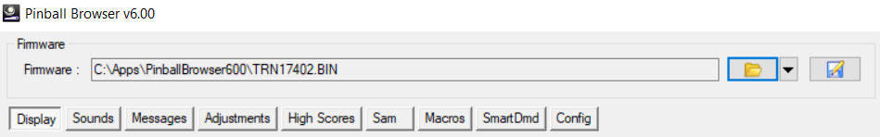

* 1. See next page:
  2. Click the “Sam” tab
  3. 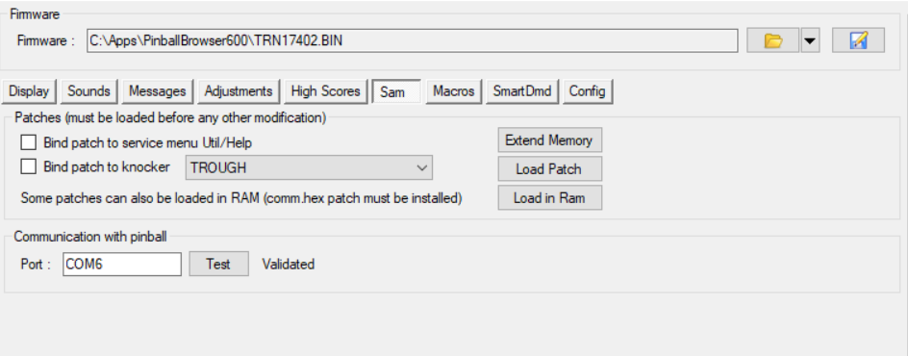
  4. Click “Load Patch” and select the comm131.hex file
  5. Enter you Tron Machine serial number in the dialog box
  6. 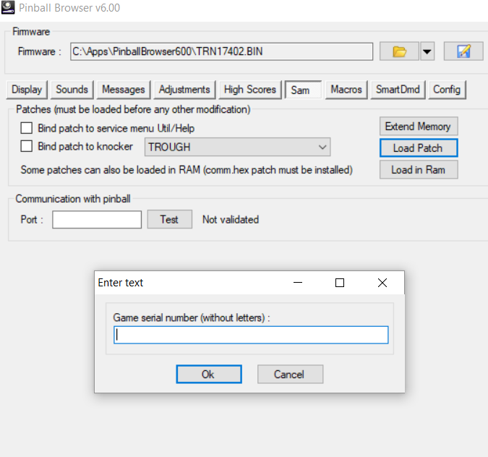
  7. Click the Save icon and Save your firmware to the root of a USB stick.
  8. 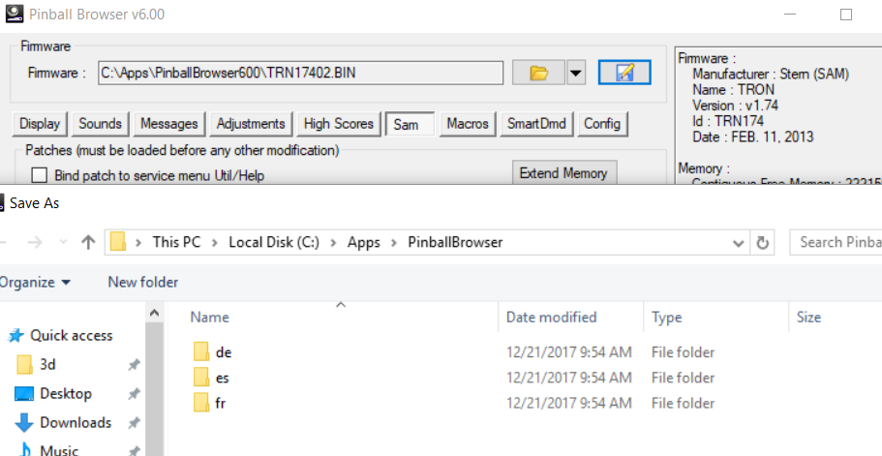
  9. Flash your Tron machine with the newly create firmware file. Follow the Stern website if you need help here: <http://www.sternpinball.com/upload/downloads/sb164.pdf>
  10. Install and boot up your new Tron Playfield LCD.

**LATEST SAM UPDATE FROM INITIAL version 1.1 to 1.4:**

To update to the latest version which contains bug fixes and enhancements:

**Installation Instructions:**

1.  You need to go download the very latest Pinball-Browser v 6.11 which will have a new comms patch of version 1.32.  You have to go re-flash your Tron firmware with this version so that I can get the new states that fix the discmb as well as some other issues.

2.  Once Patched, go here <https://1drv.ms/f/s!AnreFtnjNkJZ9ExpLVzSaawzpkdn> and download everything including the folders and copy them over to the usb stick that is plugged into the Pi.  You can just use a PC.  Make sure the folder structure stays the same and copy all the files to the usb.  The main program file is the pitron.pyc file.  You can rename your other one if you want to keep a backup copy that you can go back to. (I don't see a reason you would)

4.  **Changes to SAM version from 1.1 to 1.4:**

*  Added new DiscMB Restart mode so that detection of the mode state is possible if you don't hit the DISCMB Restart shot.

*Added DiscMB Restart Video

* Added Return to Grid Detection

*Fixed Most Active modes to clear the video list and default to The Grid video when complete

*Added structure for re-setting states on Active Multiball mode completion

* Added wait times in between mode completions to allow for video updates

*Fixed Game over video

*Added placeholder videos for SOS and Portal

*Added Portal mode detection

*updated firmware version detection to 1.32

*Turned off TRON mode for now, TRON was too busy and interrupting modes

*added debug output and log files to usb

*Prelim Ball drain detection

*Prelim Active Score per Player

**TOTAL LIGHT SHOW INTEGRATION**

1. TLS Instructions