1. Put on safety glasses and use earplugs
2. Take the O’ring and place it on a piece of tin foil
3. 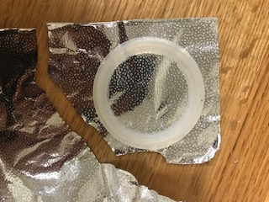Using your fingers, rip the tin foil around the O’ring
4. 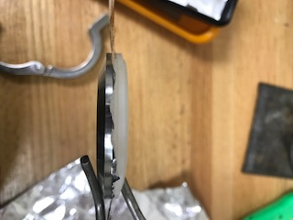Take the piece of tin foil and place it in between the O’ring and the cap
5. 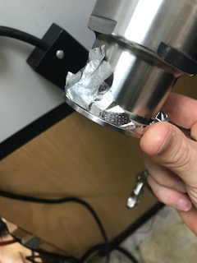Fold the excess tin foil over so that it is not in the way
6. 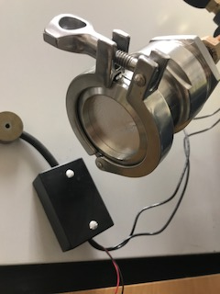Secure the cap on using the clamp
7. Open the air tank by screwing the cap counterclockwise
8. 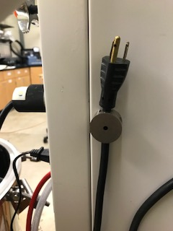Plug in the pressure regulator (you will plug this in and unplug it for each experiment)
9. 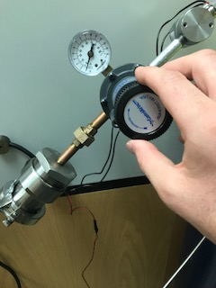Slowly turn the pressure regulator clockwise so and observe the increase in pressure (PSI)
10. Observe at what pressure the tin foil failed
11. Turn the pressure regulator counterclockwise to decrease the pressure
12. Unplug the pressure regulator
13. Close the air Tank by screwing the cap clockwise
14. Record the Pressure at which it failed, whether the shiny or dull side was facing outwards, if the foil was original smooth or crumpled, and where the hole appeared