Web Services for Climate Model Diagnositic Analysis

Lei Pan, Seungwon Lee, Chengxing Zhai, Jonathan Jiang, Benyang Tang, and Joao Teixeira
Jet Propulsion Laboratory, California Institute of Technology
Pasadena, CA 91109, USA
{lei.pan, seungwon.lee, chengxing.zhai, jonathan.h.jiang, benyang.tang, joao.teixeira}@jpl.nasa.gov

Abstract—We present the computer software technologies used in enabling climate model diagnositic anaysis.
Keywords—web services; climate science; numerical model; diagnostic analyses

Introduction
The traditional approach to climate model evaluation compares a single parameter at a time. This identifies symptomatic model biases and errors, but fails to diagnose the model problems.
We have built Parallel Web-Service Climate Model Diagnostic Analyzer (PAWS-CMDA) that provides a streamlined, structured way to prepare the large-volume, multiple heterogeneous datasets and provide a computationally efficient way to simultaneously process the multi-source datasets for model diagnosis.
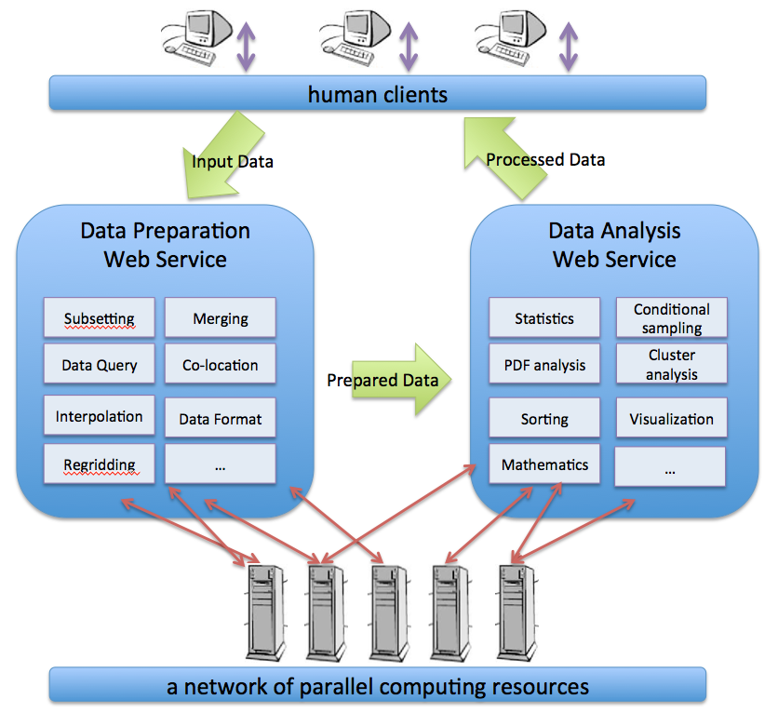
Figure 1. Architecture of PAWS-CMDA.

Objectives
The objective of the proposed project is to enable multi-aspect physics-based and phenomenon-oriented model performance evaluations and diagnoses through the comprehensive and synergistic use of multiple observational data, reanalysis data, and model outputs.

Data preparation of observation data and model outputs for model-data intercomparisons

Data analysis for model performance evaluation and diagnosis
This research is sponsored by the NASA ROSES CMAC (Computational Modeling Algorithms and Cyberinfrastructure) 2011 Program.

Overall Architecture
The overall architecture of PAWS-CMDA consists of two main functional blocks: (1) data preparation system and (2) data analysis system. The functional blocks are composed of several operations, individually wrapped with Web Service interfaces, and powered by python multi-processing for computational performance enhancement from leveraging multi-core symmetric multiprocessing clusters. PAWS-CMDA has the user interfaces using web browsers. Figure 1 illustrates the architecture of PAWS-CMDA.

The capabilities of PAWS-CMDA include:

Data preparation
- Change data format (e.g., change a HDF file to a NetCDF file);
- Subset data conditionally by time, space, and variable (e.g. select tropical summer water vapor data);

Data analysis
- Apply mathematical operations (e.g. apply algebraic, logical, and calculus operations);
- Apply statistical operations (e.g. calculate standard deviation and correlation)
- J

Analysis tools

Single Variable Analysis
Double Variable Analysis
temporal averaging and plotting
time series generation and plotting
zonal mean calculation and plotting
2-D Variable Analysis
3-D Variable Analysis
vertical profile averaging and plotting
pressure-level slicing and plotting
zonal mean calculation and plotting
correlation calculation
scatter plotting
histogram
difference calculation and plotting
conditional sampling

Implementation Details

Flow chart describing our dev process

Develop Analysis Tool
Wrap Analysis Tool with Python Caller
Build Web Browser Interface
Build Web Service
Virtualize web-service system
Integrate web-service system into Cloud

Python as glue
We choose Python as a driving programming language for the proposed system for three reasons. First, Python is a free-license, open-source tool. Second, Python developers are one of the fastest growing programming communities and therefore provide various useful packages for users. Third, Python has strengths in OS-level interactions (e.g., networking, file I/O, process spawning and joining) and string and data/time manipulation.

Web services
We built our PAWS-CMDA system as Web Services because the Web Service technology has a simple and flexible environment with a rich set of open source packages for distributed programming. Another important reason to build web services instead of standalone offline equivalents is the heavy requirement of PAWS-CMDA in terms of the large volume of input datasets which are typically needed for long-term data-model intercomparisons.
The software packages that enable our web services:
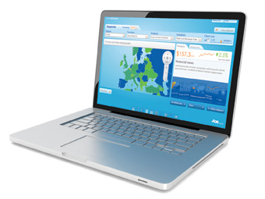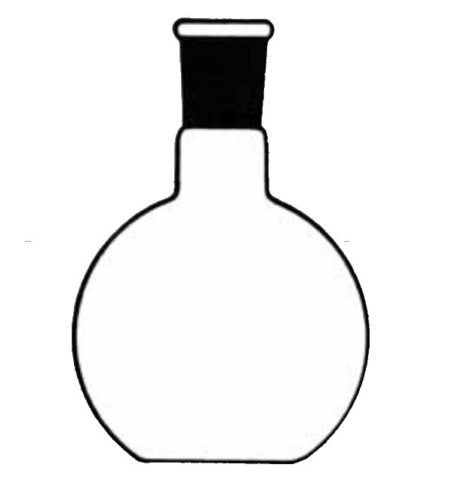
URI
(scoping + method)
Client
(Web Browser, JavaScript)
Octave App.
URI
(results)
JSON

Data management strageties
We have strategies to optimize the data discovery, access and sharing performance of our PAWS-CMDA system. PAWS-CMDA is both a consumer and a producer of data; it reads in pre-processed data as input and produces processed data products as output. Both input and output data can be large in volume, which calls for a strategy for I/O efficiency.

Using the Amazon Cloud
During the summer school, each student was assigned to a VM on Amazon EC2.

Scientific applications of PAWS-CMDA
We applied PAWS-CMDA to process the A-Train datasets, ECMWF/MERRA outputs, and CMIP5 model outputs to evaluate the moist process parameterizations of the general circulation models (GCMs). The fidelity of climate and weather models depends critically on the representation of clouds and precipitation.
CMDA was used as an educational tool for the Summer School organized by JPL’s Center for Climate Science in September 22-26, 2014. The theme of the Summer School in 2014 was “Using Satellite Observations to Advance Climate Models.”

Use cases:

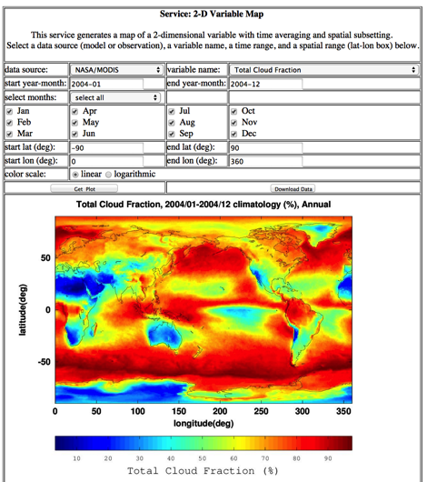
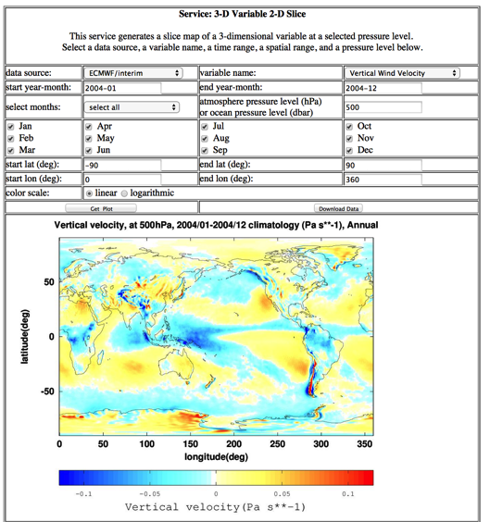
One hour introduction presentation. Five research topics for JPL summer school. Five hours of research time.
- Topic 1: Surface and deep ocean connections

- Topic 2: observed variabilities of clouds and precipitation

- Topic 3

- Topic 4

- Topic 5

Student feedbacks:

Appreciation
“very user-friendly”

improvement
“provide the time ranges over which the variables are available”

Conclusions and future work
We have developed a web-baesd tool to enable multi-aspect physics-based climate data analyses. CMDA supports the comprehensive use of multiple observational data, reanalysis data, and model outputs. The advantages of this tool include: no local installation nor large data storage are required for the users; each user has a dedicated virtual machine in the Amazon Cloud environment. CMDA was used as an educational tool for the JPL/Caltech Climate Summer School in September 2014, and was proven to be easy to use and customizable.
We will continue to develop around this framework to add in new features such as user work flow design and recommendation, execution provenance collection and query. The tool will be open-source in the near future.

Acknowledgment
The authors would like to thank … for ….

References
.

- G. Eason, B. Noble, and I. N. Sneddon, “On certain integrals of Lipschitz-Hankel type involving products of Bessel functions,” Phil. Trans. Roy. Soc. London, vol. A247, pp. 529–551, April 1955. (references)
- J. Clerk Maxwell, A Treatise on Electricity and Magnetism, 3rd ed., vol. 2. Oxford: Clarendon, 1892, pp.68–73.

