**Refactor Udagram App into Microservices and Deploy**

**I. Containers and Microservices:**

- Divide an application into microservices:

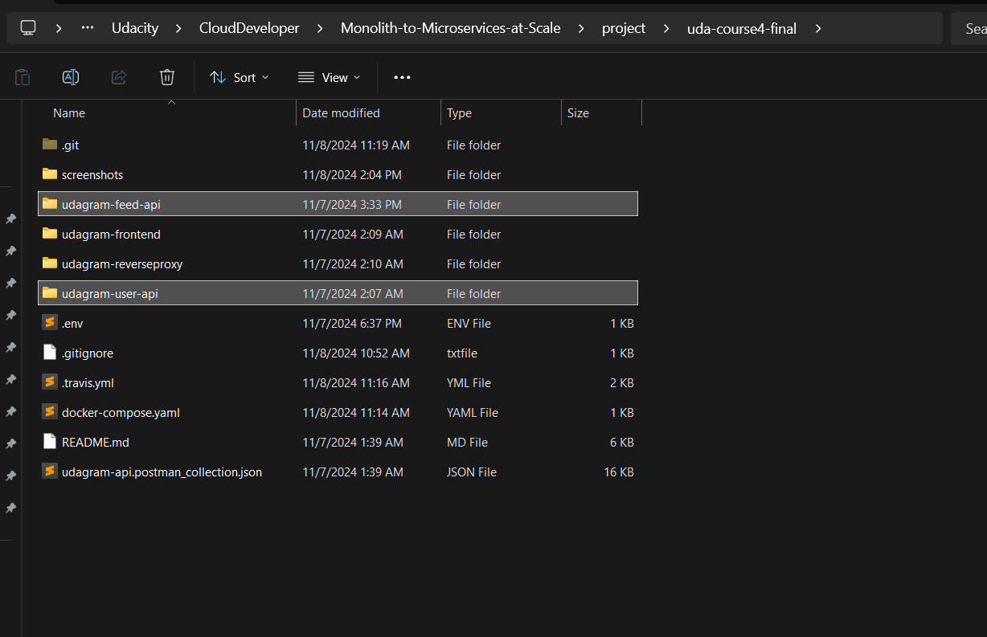

- Build and run a container image using Docker:

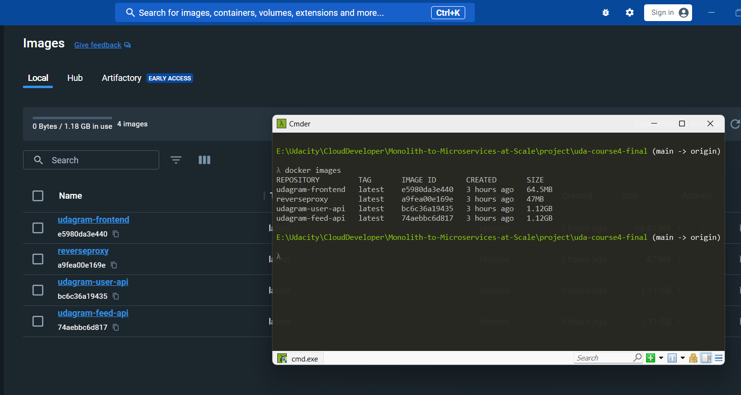

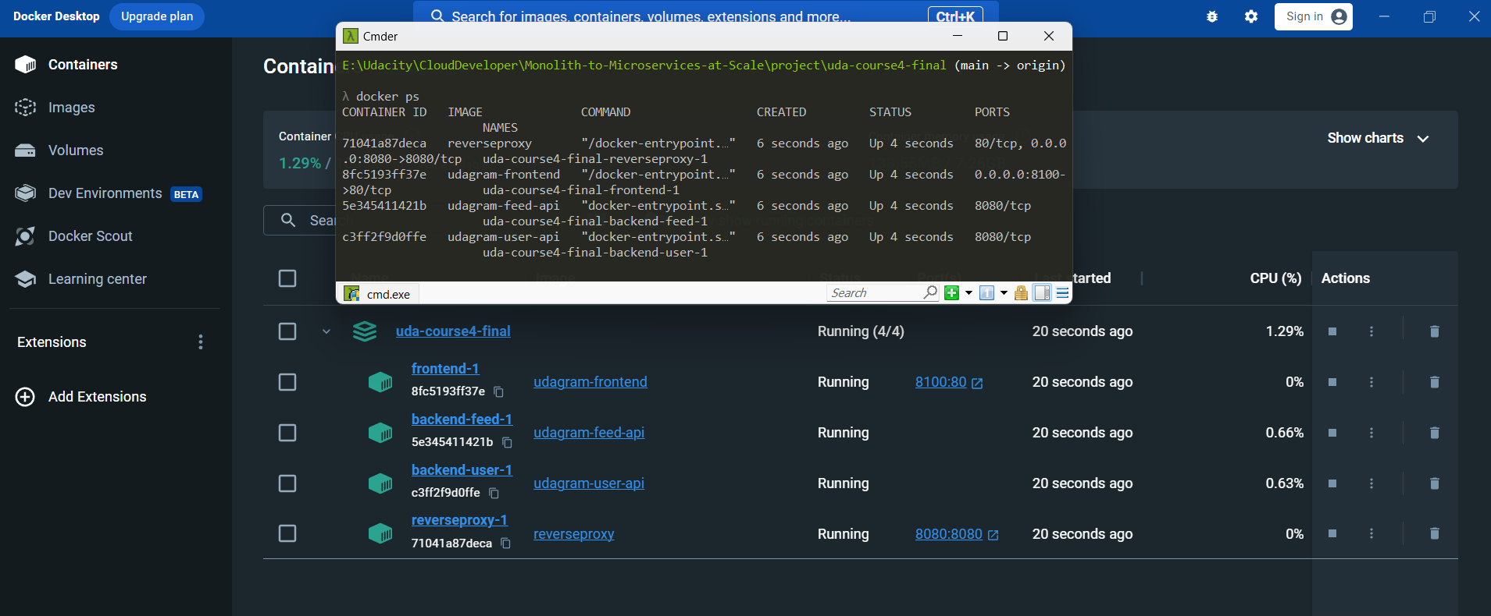

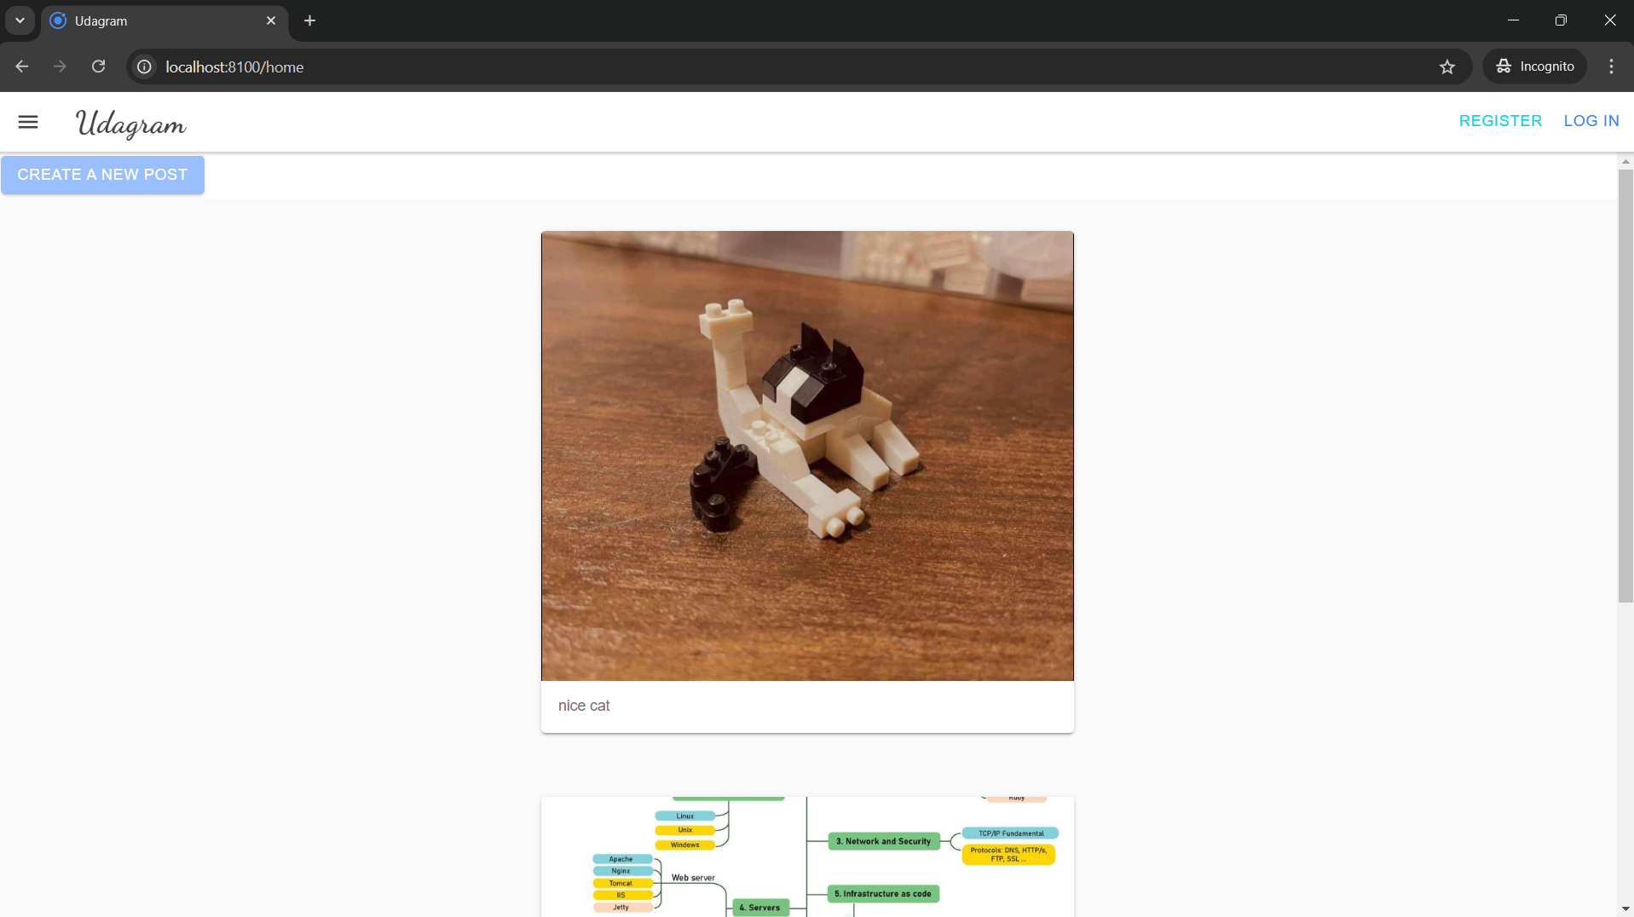

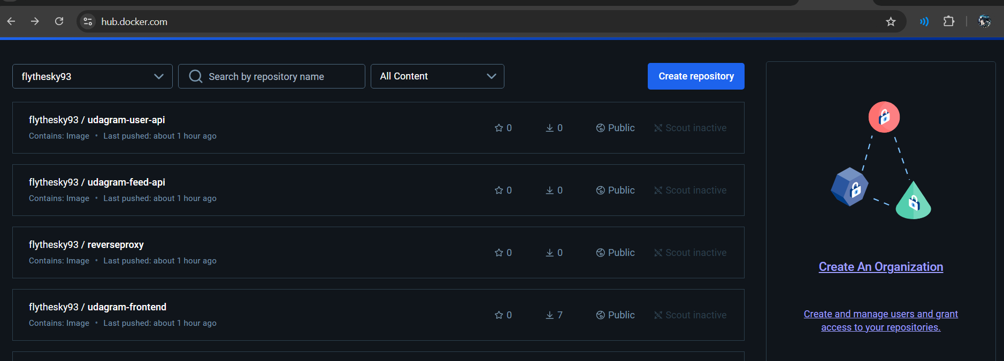

**II. Independent Releases and Deployments:**

**III. Service Orchestration with Kubernetes:**

- Deploy microservices using a Kubernetes cluster on AWS

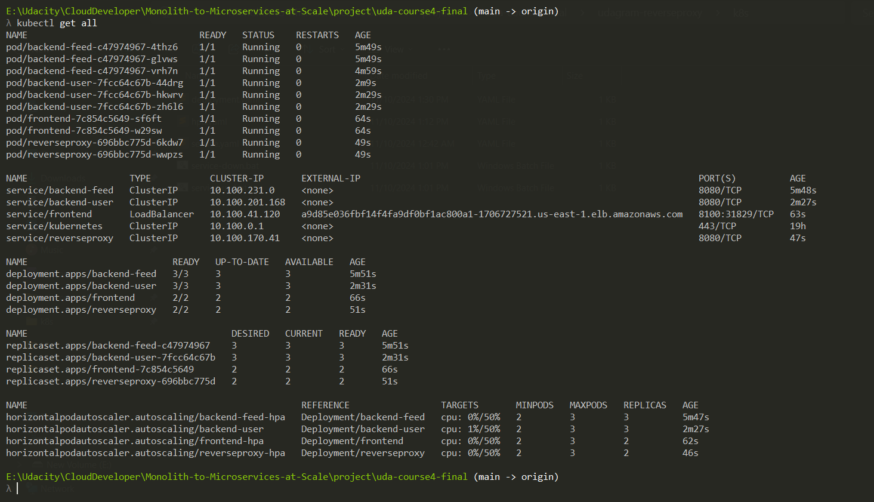

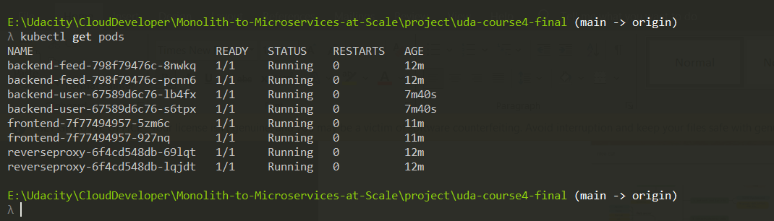

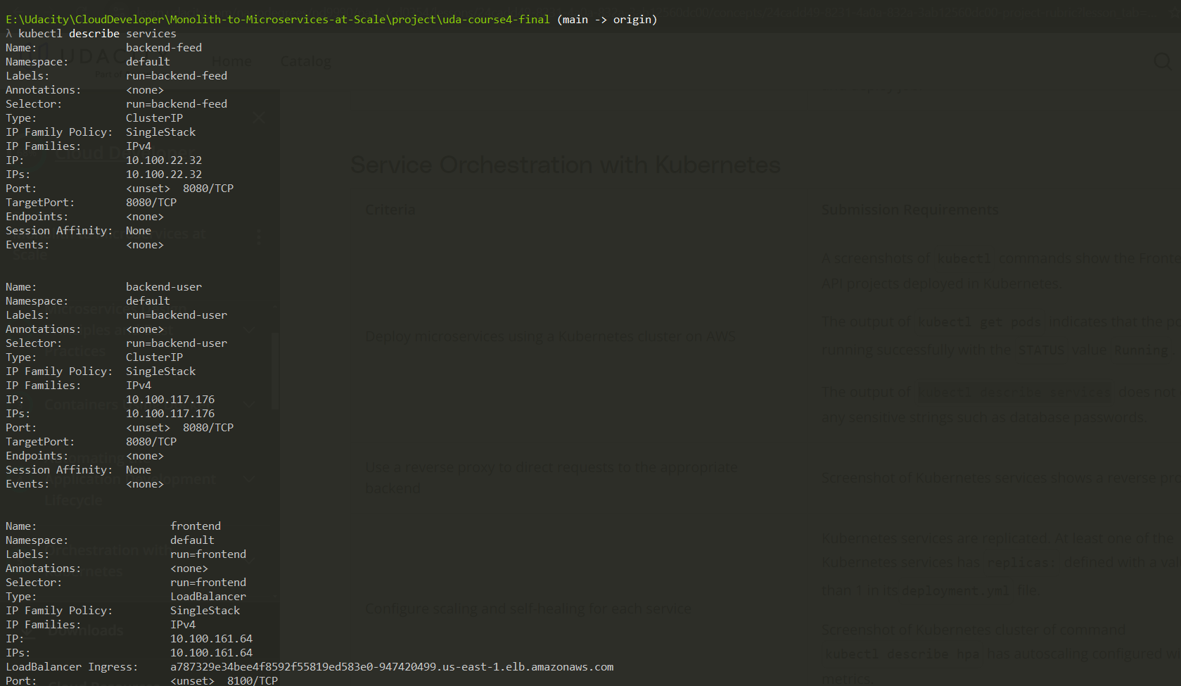

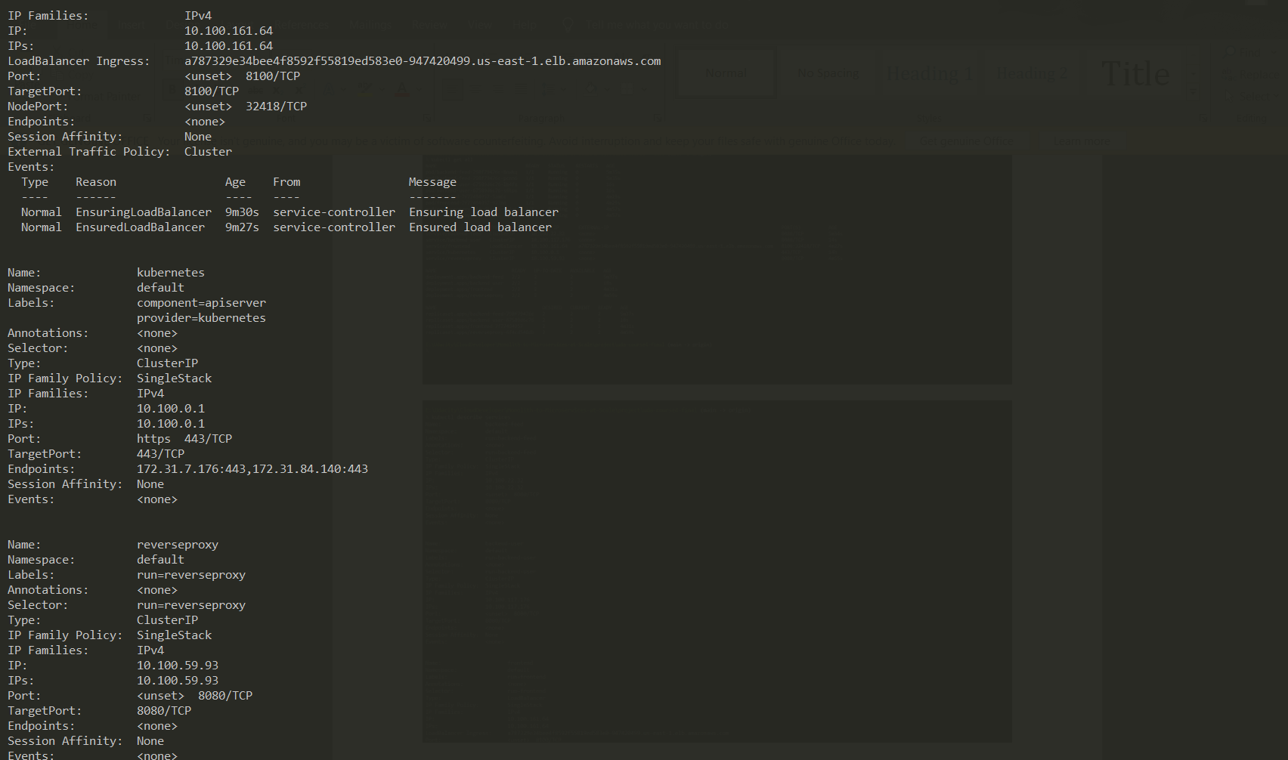

- Use a reverse proxy to direct requests to the appropriate backend:

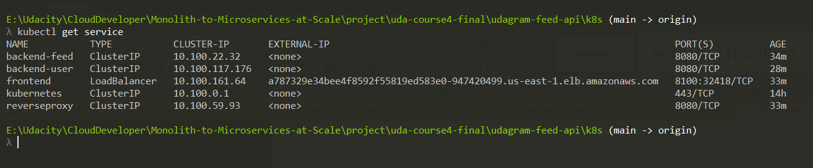

- Configure scaling and self-healing for each service:

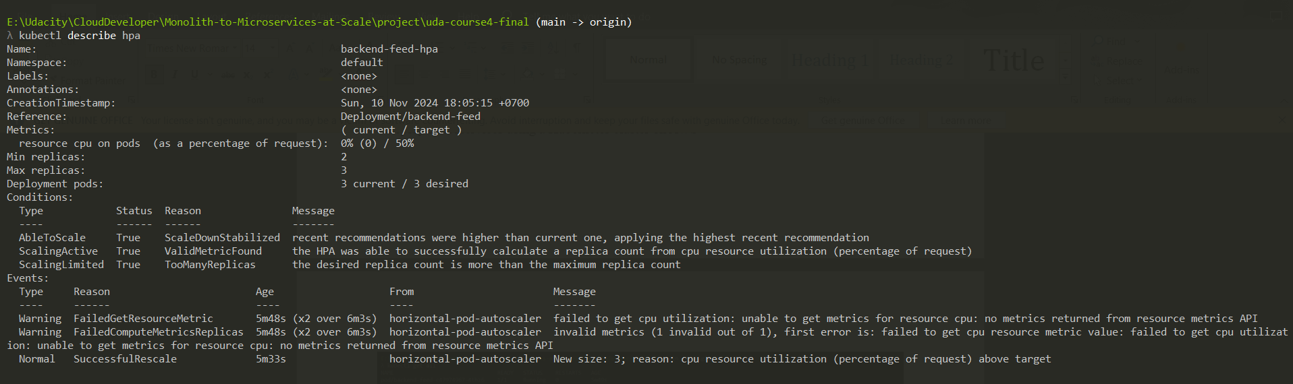

**IV. Debugging, Monitoring, and Logging:**

- Use logs to capture metrics for debugging a microservices deployment