Circuit Analysis (Lab # 6)
Experiment 6: VERIFICATION OF KIRCHHOFFS LAWS

Name: M.FAHAD Registration No: 2025-CE-105

Date: ……………………………. Grade and Signature: ………………………

CLO2  CLO3 | Use with identification the circuit components, breadboards, multimeters, power supplies, signal generators, and oscilloscopes.  Make measurements in their own constructed electric circuits.
Psychomotor/Affective | Level1 (1) | Level2 (2-3) | Level3 (4-5) | Level4 (6-7)
Report Marks (3) |  |  | Total marks  (10)

Objective
To verify Kirchhoff’s current law and Kirchhoff’s voltage law for the given Circuit.
Apparatus Required
Sr. no | Apparatus | Range | Quantity
1 | Regulated Power Supply | Standard | 1
2 | Signal Generator | Standard | 1
3 | Oscilloscope | Standard | 1
4 | Digital Multimeter | Standard | 1
5 | Breadboard & Wires | Standard | As Required
6 | Resistors | 330ohm, 220ohm 1kohm | 3
Description
KCL: The algebraic sum of the currents meeting at a node is equal to zero.
KVL: In any closed path / mesh, the algebraic sum of all the voltages is zero.
Precautions:
- Voltage control knob should be kept at minimum position.
- Current control knob of RPS should be kept at maximum position.

Procedure for KCL:
- Give the connections as per the circuit diagram.
- Set a value in RPS.
- Note down the corresponding readings using multimeter
- Repeat the same for different voltages
Circuit - KCL

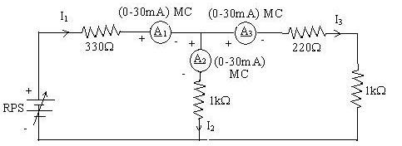

KCL - Practical Values:

Sl. No. | Voltage E |  | Current |  | I1 = I2 + I3
 |  | I1 | I2 | I3
 | Volts | mA | mA | mA | mA
1 | 5 | 5.69 | 3.12 | 2.56 | 5.68
2 | 15 | 17.06 | 9.37 | 7.68 | 17.05
3 | 25 | 28.43 | 15.62 | 12.81 | 28.43

Procedure for KVL:
- Give the connections as per the circuit diagram.
- Set a value in RPS.
- Note all the voltage reading
- Repeat the same for different voltages

Circuit - KVL

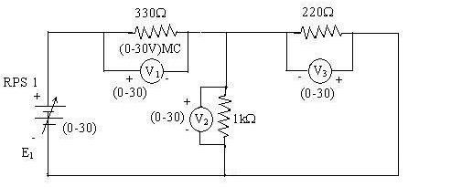

KVL - Practical Values

Sl. No. | RPS |  | Voltage |  | E1 = V1 + V2
 | E1 | V1 | V2 | V3
 | V | V | V | V | V
1 | 5 | 3.23 | 1.77 | 1.77 | 5.00
2 | 10 | 6.46 | 3.54 | 3.54 | 10.00
3 | 15 | 9.69 | 5.31 | 5.31 | 15.00

Result:
Thus, Kirchhoff’s voltage law and Kirchhoff’s current law are verified practically by performing this experiment.

Post Lab Questions

- Define Kirchhoff’s current law.
Kirchhoff’s Current Law (KCL) states that the total current entering a junction is equal to the total current leaving it.
It means no charge is lost or gained at a node in a circuit.
All incoming currents must balance the outgoing currents.
This law is based on the principle of conservation of electric charge.
Mathematically, it is written as: ∑I(in) = ∑I(out).

- Define Kirchhoff’s voltage law.
Kirchhoff’s Voltage Law (KVL):
Kirchhoff’s Voltage Law states that the sum of all voltages around any closed loop in a circuit is equal to zero.
This means the total voltage supplied is equal to the total voltage drop in the loop.
Energy is conserved as electrical energy is neither created nor destroyed in the loop.
All voltage rises and drops must balance each other.
Mathematically, it is written as: ∑V = 0.

- What are the applications of regulated power supply?
Applications of Regulated Power Supply:
Regulated power supplies are used in electronic devices like computers, televisions, and mobile chargers to provide stable voltage.
They are important in laboratory equipment for accurate testing and measurements.
Used in communication systems such as radios and transmitters to ensure consistent performance.
Applied in industrial control systems and automation equipment.
They are also used in battery charging circuits to prevent overcharging and damage.

- What are the limitations of KCL?
Limitations of Kirchhoff’s Current Law (KCL):
KCL assumes that charge is conserved at a node, which may not hold in cases involving charge storage (like capacitors at high frequencies).
It is not accurate for high-frequency circuits where displacement current becomes significant.
KCL does not account for electromagnetic effects such as radiation or inductive coupling.
It assumes instantaneous current flow, ignoring time delays in signal propagation.
It is less effective in distributed systems where circuit elements are not lumped but spread over space.

