Circuit Analysis (Lab 7)

Experiment 7: Analysis of Operational Amplifiers Operations

Name: M.Fahad Registration No: 2025-CE-105

Date: ……………………………. Grade and Signature: …………………

CLO4 | Construct amplifiers with operational amplifiers.
Psychomotor/ Affective | Level1  (1) | Level2 (2-3) | Level3 (4-5) | Level4 (6-7)
Report Marks (3) |  |  | Total marks  (10)

Objective
The objective of this lab is to investigate the input to output relationship for inverting and noninverting amplifiers.

Apparatus Required
Sr. No. | Apparatus | Range | Quantity
1 | Regulated Power Supply | Standard | 1
2 | Signal Generator | Standard | 1
3 | Oscilloscope | Standard | 1
4 | Digital Multimeter | Standard | 1
5 | Breadboard & Wires | Standard | As Required
6 | Resistors | 1k Ω, 2k Ω ,3k Ω | 3

Description
Operational amplifiers can be used in two basic configurations to create amplifier circuits. One is the inverting amplifier where the output is the inverse or 180° out of phase with the input, and the other is the non-inverting amplifier where the output is in the same sense or in phase with the input.
Both operational amplifier circuits are widely used and they find applications in different areas. When an operational amplifier or op-amp is used as a non-inverting amplifier it only requires a few additional components to create a working amplifier circuit.
Pin configuration of IC 741 op amp is shown below
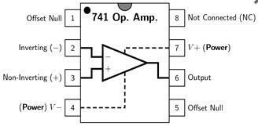
- Pin 1 is offset null.
- Pin 2 is inverting input terminal.
- Pin 3 is a non-inverting input terminal.
- Pin 4 is negative voltage supply (VCC)
- Pin 5 is offset null.
- Pin 6 is the output voltage.
- Pin 7 is positive voltage supply (+VCC)
- Pin 8 has no connection.
Precautions:
- Voltage control knob should be kept at minimum position.
- Current control knob of RPS should be kept at maximum position.
- Carefully utilize the oscilloscope channels and function generator.

Procedure for Inverting Amplifier:
- Wire up the circuit as shown in the figure below on the breadboard.
- Give the input to the inverting terminal of the op-amp and simultaneously display the input and output on the oscilloscope.
- Draw the input & output waveforms at the end of the lab.
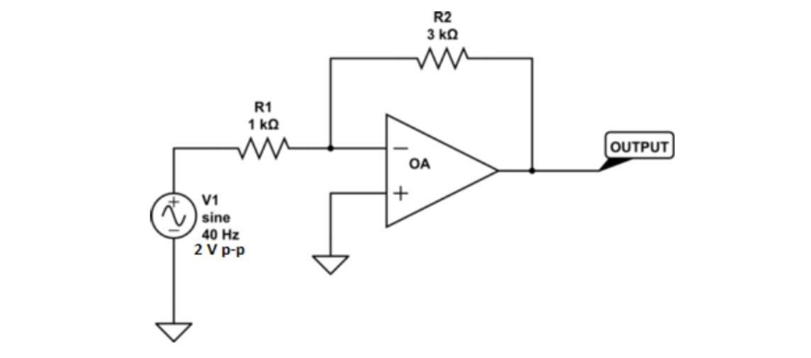
Procedure for Non-Inverting Amplifier:
- Wire up the circuit as shown in the figure below on the breadboard.
- Give the input to the non-inverting terminal of the op-amp and simultaneously display the input and output on the oscilloscope.
- Draw the input & output waveform at the end of the lab.
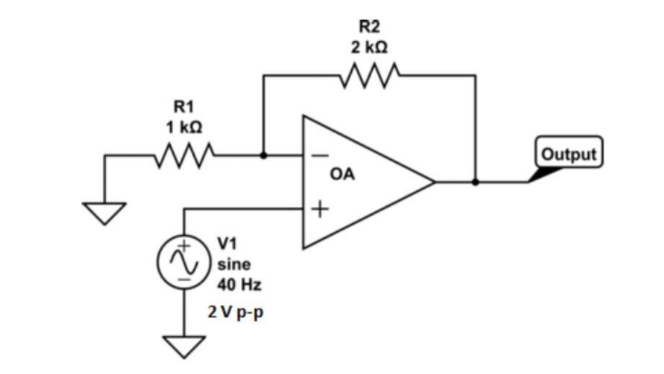
Result:
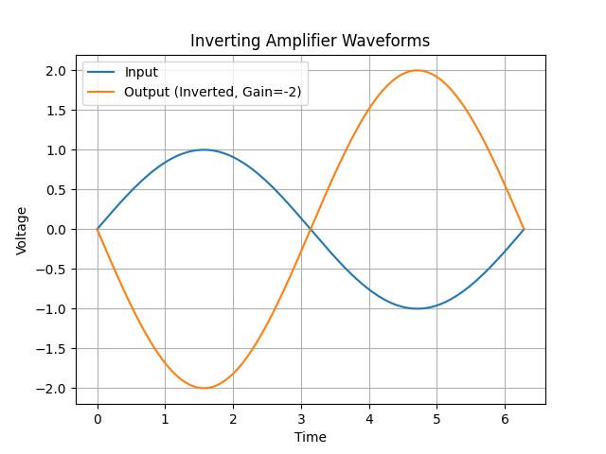
Figure 8: Inverted Output
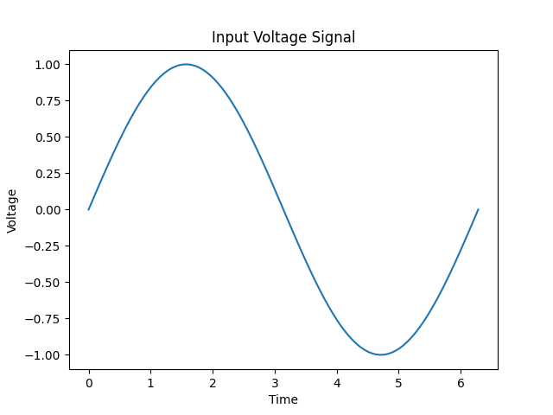

Figure 7: InputVoltageSignal
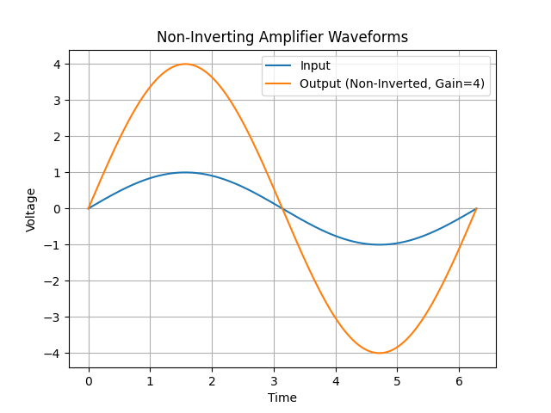
Figure 9: Non-Inverting Output

Post Lab Questions
- Define inverting amplifier.

An inverting amplifier is an electronic circuit in which the input signal is applied to the inverting ]terminal of an operational amplifier (op-amp).
It produces an output that is 180° out of phase (inverted) with the input signal.
The gain of the amplifier depends on the ratio of feedback resistance to input resistance.
It is commonly used in signal processing to amplify and invert voltage signals.
- Define Non-inverting amplifier.

A non-inverting amplifier is an electronic circuit where the input signal is applied to the non-inverting (+) terminal of an operational amplifier (op-amp).
The output signal is in phase with the input, meaning there is no inversion.
Its voltage gain is determined by the ratio of feedback resistance to input resistance.
It is widely used when amplification is required without changing the signal polarity.

- What are the applications of inverting amplifiers?

Inverting amplifiers are widely used in electronic circuits for various purposes, including:
- Signal inversion: To produce an output that is the opposite (180° phase shift) of the input signal.
- Voltage amplification: To amplify weak signals with controlled gain.
- Summing amplifier (adder): Multiple input signals can be combined into a single output (used in audio mixers and analog computers).
- Current-to-voltage conversion: Used in sensors (like photodiodes) to convert current into measurable voltage.
- Waveform shaping: Useful in signal processing applications to modify or condition signals.
- Active filters: Used in designing low-pass, high-pass, and band-pass filter circuits.

- What are the applications of non-inverting amplifiers?

Non-inverting amplifiers are commonly used in many electronic applications, such as:
- Voltage amplification without phase change: Amplifies signals while keeping the output in phase with the input.
- Buffer (voltage follower): Provides high input impedance and low output impedance to isolate stages.
- Signal conditioning: Used with sensors to amplify weak signals without distortion.
- Audio amplification: Maintains signal polarity, which is important in sound systems.
- Active filters: Used in low-pass, high-pass, and band-pass filter circuits.
- Data acquisition systems: Ensures accurate signal transmission from sensors to processing units.

- What is gain of an amplifier?

The gain of an amplifier is the measure of how much the amplifier increases the strength of an input signal.
It is defined as the ratio of output signal to input signal (Voltage, Current, or Power).
For a voltage amplifier, gain is given by: ( \text{Gain} = \frac{V_{\text{out}}}{V_{\text{in}}} ).
Gain can be greater than, less than, or equal to one, depending on the amplifier design.

- How do you calculate the gains for inverting and non-inverting amplifiers?

The gain of inverting and non-inverting amplifiers is calculated using simple formulas based on resistor values:

Inverting Amplifier Gain
The voltage gain is given by:
[
A_v = -\frac{R_f}{R_{in}}
]
- (R_f) = feedback resistor
- (R_{in}) = input resistor
- The negative sign shows the output is inverted (180° phase shift).

Non-Inverting Amplifier Gain
The voltage gain is given by:
[
A_v = 1 + \frac{R_f}{R_1}
]
- (R_f) = feedback resistor
- (R_1) = resistor connected to ground
- Gain is positive, so no phase change occurs.

