GIS-Based Flood Risk and
Vulnerability Mapping
Dhaka Metropolitan Region, Bangladesh
Undergraduate Research Project
Department of Urban and Regional Planning
Bangladesh University of Engineering and Technology (BUET)
Framework: UNDRR Risk = Hazard × Exposure × Vulnerability
Data: NASA POWER MERRA-2 | SRTM 30m DEM | ESA WorldCover 2021 | WorldPop 2020 | GADM v4.1
2024 — Revised 2026

Abstract
Dhaka, one of the world's most densely populated megacities, faces escalating flood risk driven by low-lying floodplain topography, intense monsoon rainfall, rapid urbanisation, and growing socioeconomic vulnerability. This study develops a GIS-based flood risk and vulnerability assessment for the Dhaka Metropolitan Region using the UNDRR Risk = Hazard × Exposure × Vulnerability framework across three analytical phases.
Phase 1 analyses 20 years (2004–2023) of NASA POWER MERRA-2 monthly rainfall data at latitude 23.81°N, longitude 90.41°E. Mean annual rainfall is 2,263 mm (CV = 31.8%), with the monsoon season (JJAS) contributing 63% of the annual total. 2017 was an extreme outlier at 4,631 mm. Mann-Kendall analysis identifies a statistically significant increasing trend in May rainfall (+14.58 mm/yr, p = 0.008) and December rainfall (+2.79 mm/yr, p = 0.019). Gumbel extreme-value analysis yields return-period estimates of 705 mm (10-year), 815 mm (25-year), and 897 mm (50-year).
Phase 2 constructs a Flood Hazard Index (FHI) from SRTM 30m DEM and ESA WorldCover 2021: Topographic Wetness Index (weight 0.35), elevation (0.30), slope (0.20), and SCS Curve Number (0.15). Results show that 67% of the 960 km² study area falls in the High or Very High hazard class.
Phase 3 integrates WorldPop 2020 exposure and a composite vulnerability index to produce a normalised risk index. Two-tier quantile classification shows that 84.9% of Dhaka's 12.5 million residents live in Very High risk areas. Ward No-63 records the highest mean risk score (0.9397); Dhania ward has the largest population at risk (114,844 people). All top-10 risk wards fall in the High hazard class, which is itself evidence that risk in this model is driven by the coincidence of extreme exposure and vulnerability with already-hazardous terrain, not by hazard alone.
This revision adds a code audit of the full analysis pipeline, a sensitivity analysis on the FHI component weights, and an external validation of the ward risk ranking against an independent, peer-reviewed water-logging study of Dhaka. The audit corrected two defects that had gone unnoticed — a broken file path and a bug that silently blanked the DEM elevation and slope statistics — and several places where the written methodology no longer matched the code. The sensitivity analysis shows the ward ranking is stable under most plausible re-weightings but sensitive to the Curve Number weight specifically. The validation finds that wards independently classified as high-vulnerability in the literature do land near the top of this model's own risk ranking, which is a reasonable, if imperfect, check that the model is measuring something real.
Keywords: flood risk mapping, GIS, vulnerability assessment, Dhaka, UNDRR, Topographic Wetness Index, SCS Curve Number, WorldPop, Gumbel distribution, return periods, sensitivity analysis, external validation

Table of Contents
Abstract
List of Figures, Maps and Tables
Chapter 1: Introduction
Chapter 2: Study Area and Data Sources
Chapter 3: Methodology
Chapter 4: Phase 1 Results — Rainfall Analysis
Chapter 5: Phase 2 Results — Flood Hazard Mapping
Chapter 6: Phase 3 Results — Exposure, Vulnerability and Flood Risk
Chapter 7: Robustness Checks — Code Audit, Sensitivity Analysis and External Validation
Chapter 8: Discussion, Limitations and Conclusions
References

List of Figures, Maps and Tables

Figures
Figure 1: Annual Rainfall, Dhaka 2004–2023 (NASA POWER MERRA-2)
Figure 2: Monthly Rainfall Distribution — Boxplots (2004–2023)
Figure 3: Gumbel Return Period Curve, Dhaka Rainfall
Figure 4: Hazard × Risk Class Cross-Tabulation (km²)
Figure 5: Top 10 Wards by Flood Risk Score and Population at Risk
Figure 6: Hazard Class Distribution Across FHI Weighting Scenarios (new)
Figure 7: Monte Carlo Sensitivity — Hazard Area and Ward-Rank Stability (new)
Figure 8: Model Risk Ranking vs Alam et al. (2023) Vulnerability Classification (new)

Maps
Map 1: Study Area — Dhaka Metropolitan Region
Map 2: Annual Rainfall Variability, Dhaka 2004–2023
Map 3: Flood Hazard Classification, Dhaka Metropolitan Region
Map 4: Composite Flood Risk Index, Dhaka Metropolitan Region
Map 5: Ward-Level Flood Risk Classification, Dhaka Metropolitan Region

Tables
Table 1: Data Sources and Specifications
Table 2: Monthly Rainfall Descriptive Statistics and Mann-Kendall Trend Results
Table 3: Gumbel Return Period Estimates
Table 4: Flood Hazard Index Component Weights
Table 5: SCS Curve Number Assignment by Land Cover Class
Table 6: Flood Risk Class Breakdown by Area and Population
Table 7: Top-10 Wards by Mean Flood Risk Score
Table 8: FHI Weight Sensitivity — Hazard Class Area and Ward-Rank Correlation by Scenario (new)
Table 9: External Validation — Model Risk Percentile by Reference Vulnerability Group (new)
Table 10: Independent SAR-Based Validation — Confusion Matrix Statistics by Attempt (new)

Chapter 1: Introduction

1.1 Background and Context
Dhaka is one of the fastest-growing megacities in the world, with a population exceeding 12 million within the metropolitan area. Situated on the floodplain of the Buriganga, Turag, Balu, and Shitalakshya rivers, the city's geography creates an inherent susceptibility to flooding. Rapid and largely unplanned urbanisation has exacerbated this susceptibility by converting natural wetlands and retention areas into impervious built-up surfaces, dramatically increasing surface runoff and reducing the city's natural drainage capacity.
Flooding is Dhaka's most recurrent and economically damaging natural hazard. The 2004 and 2007 monsoon floods inundated large portions of the city, displacing millions and causing extensive damage to infrastructure, housing, and livelihoods. Climate projections consistently suggest that both the frequency and intensity of extreme rainfall events are likely to increase under future warming scenarios, compounding existing risk.
Despite this well-recognised vulnerability, spatially explicit and methodologically rigorous flood risk assessments at the intra-urban ward level remain limited. Most existing studies either focus on regional-scale river flood modelling or lack integration of exposure and vulnerability dimensions as required by internationally recognised risk frameworks.

1.2 Research Objectives
- Characterise the spatial and temporal patterns of rainfall in Dhaka (2004–2023) and estimate return-period events for flood scenario design.
- Map flood hazard across the Dhaka Metropolitan Region using terrain analysis and land-cover derived runoff potential.
- Assess flood exposure and social vulnerability at the ward level, integrating population density, built-up intensity, and low-elevation exposure.
- Produce a composite Flood Risk Index following the UNDRR framework and rank wards by composite risk score.

1.3 Study Area and Scope
The study covers the Dhaka Metropolitan Region (EPSG:32646, UTM Zone 46N), encompassing 242 GADM Level 4 administrative wards across approximately 1,154 km² total area, of which approximately 960 km² is land area (permanent water bodies comprising the remaining ~194 km²). All spatial analyses use UTM 46N projection. The temporal scope of rainfall analysis is 2004–2023 (20 years).

1.4 Report Structure
Chapter 2 describes the study area and data sources. Chapter 3 presents the full methodology. Chapters 4, 5, and 6 present results of the rainfall analysis, flood hazard mapping, and integrated risk assessment respectively. Chapter 7 is new to this revision: it documents a code audit of the analysis pipeline, a sensitivity analysis of the FHI weights, and an external validation of the ward risk ranking. Chapter 8 provides discussion, limitations, and conclusions. References are listed at the end.

Chapter 2: Study Area and Data Sources

2.1 Dhaka Metropolitan Region
The Dhaka Metropolitan Region occupies the central part of Bangladesh within the Bengal Delta at approximately 23.6–24.0°N and 90.2–90.6°E. The region is characterised by extremely low-lying floodplain topography, with mean elevation of approximately 8.98 m above mean sea level. The study area encompasses 242 GADM Level 4 administrative wards. Map 1 shows the study area and ward boundaries.
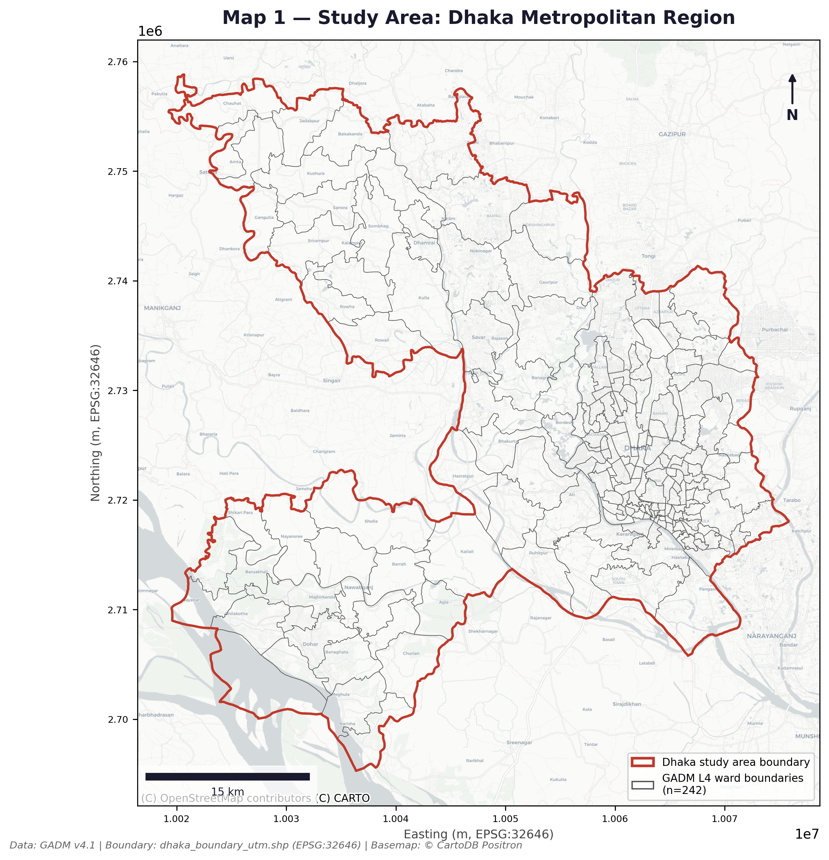
Map 1: Study Area — Dhaka Metropolitan Region. GADM Level 4 ward boundaries (n = 242, grey lines). Red outline = study area boundary. Basemap: © CartoDB Positron. CRS: EPSG:32646 (UTM Zone 46N). Data: GADM v4.1.

2.2 Data Sources
Table 1: Data sources and specifications used in this study.
Dataset | Source | Resolution / Period | Use in study
SRTM 30m DEM | NASA/USGS (Earth Explorer) | 30m spatial, 2000 | Elevation, slope, TWI
ESA WorldCover 2021 | ESA Copernicus | 10m spatial, 2021 | LULC, CN mapping
WorldPop 2020 | WorldPop Project, Univ. Southampton | ~92m resampled, 2020 | Population exposure
NASA POWER MERRA-2 | NASA Langley Research Center | 0.5°×0.625°, 2004–2023 | Monthly rainfall
GADM v4.1 (Level 4) | GADM.org | Ward polygons, 2023 | Zonal statistics
Study boundary (UTM) | Project derived | EPSG:32646 polygon | Clipping / geoprocessing

2.3 Coordinate Reference Systems
All data storage uses EPSG:4326. All geoprocessing uses EPSG:32646 (UTM Zone 46N). Rasters are aligned to the dem_clipped.tif reference grid (30m, EPSG:32646) before multilayer analysis. SRTM nodata = −32,767. WorldPop is resampled using sum aggregation; ESA WorldCover uses nearest-neighbour resampling.

Chapter 3: Methodology

3.1 Analytical Framework
The study adopts the UNDRR conceptual framework:
Risk = Hazard × Exposure × Vulnerability
Each component is normalised to 0–1 before multiplication. The final risk index is normalised to 0–1 and classified using a two-tier quantile scheme to account for the extreme right-skew of multiplicative risk indices.

3.2 Phase 1: Rainfall Analysis

3.2.1 Data and Descriptive Statistics
Monthly cumulative rainfall was obtained from NASA POWER MERRA-2 (23.81°N, 90.41°E) for January 2004 to December 2023 (240 observations). Annual totals were computed by summing 12 monthly values. Descriptive statistics (mean, SD, CV, min, max) were calculated at monthly and annual scales.

3.2.2 Trend Analysis
The Mann-Kendall non-parametric test was applied to each calendar month's time series and to the annual series. Sen's slope estimator quantified the rate of change in mm/year.

3.2.3 Return Period Analysis
Annual peak monthly rainfall was extracted as the extreme-value series. The Gumbel (Extreme Value Type I) distribution was fitted using maximum likelihood estimation and assessed with the Kolmogorov-Smirnov test (KS p = 0.99). Return-period quantiles were estimated for 2-, 5-, 10-, 25-, 50-, and 100-year events.

3.3 Phase 2: Flood Hazard Mapping

3.3.1 DEM Preprocessing
The SRTM 30m DEM was reprojected to EPSG:32646 and clipped to the study boundary in QGIS. TWI was produced externally with GRASS GIS r.watershed and read into the pipeline as a pre-computed raster (twi_aligned.tif); the Python script does not derive TWI from the DEM itself. A Python approximation of sink-filling is also included in the pipeline as a fallback, but the audit in Chapter 7 found that this fallback does not converge correctly on the study area's irregular boundary and should not be relied on — GRASS r.fill.dir remains the production path for a sink-filled DEM.

3.3.2 Slope
Slope in degrees was computed from the raw DEM using Horn's method (central differences), matching the approach used by QGIS and GDAL.

3.3.3 SCS Curve Number
ESA WorldCover 2021 (10m) was resampled to the DEM grid with nearest-neighbour interpolation. CN values were assigned per class following the SCS-CN method under Antecedent Moisture Condition II and Hydrologic Soil Group C — appropriate for Dhaka's alluvial, heavy-clay soils and consistent with the study area's poor natural infiltration. Table 5 gives the full class-to-CN mapping actually used in the pipeline. Permanent water bodies are assigned CN = 99 (near-maximum runoff) along with every other class, rather than being excluded from the Curve Number step; water is excluded later, at the Phase 3 exposure stage, since population exposure over open water is meaningless.
Table 5: SCS Curve Number assignment by ESA WorldCover class (AMC-II, HSG C).
ESA class | Land cover | CN
10 | Tree cover | 55
20 | Shrubland | 65
30 | Grassland | 74
40 | Cropland | 78
50 | Built-up | 90
60 | Bare / sparse vegetation | 77
80 | Permanent water bodies | 99
90 | Herbaceous wetland | 85
95 | Mangroves | 60
100 | Moss and lichen | 45

3.3.4 Flood Hazard Index
All four rasters (TWI, elevation, slope, CN) were classified into four ordinal classes and normalised to 0–1. Elevation and slope were inverted so that lower values (lower ground, flatter terrain) yield higher hazard scores. The composite FHI is:
FHI = 0.35·TWI_score + 0.30·Elev_score(inverted) + 0.20·Slope_score(inverted) + 0.15·CN_score
FHI is classified into four hazard classes using fixed breaks on the 0–1 scale, chosen for reproducibility rather than equal intervals: Low (FHI ≤ 0.35), Medium (0.35–0.55), High (0.55–0.75), Very High (> 0.75).

3.4 Phase 3: Risk Assessment

3.4.1 Exposure Index
WorldPop 2020 was aligned to the DEM grid using sum resampling. Permanent water bodies were masked and assigned zero exposure. The exposure index is the 2nd–98th percentile-clipped, min-max normalised population density per pixel.

3.4.2 Vulnerability Index
Three normalised sub-indicators: population density (weight 0.40), built-up intensity from ESA WorldCover class 50 (weight 0.35), and low-elevation exposure for pixels ≤4 m (weight 0.25).

3.4.3 Risk Index and Classification
Risk = haz_norm × exp_norm × vuln_norm, normalised to 0–1. Two-tier quantile classification: zero pixels = No Risk; non-zero pixels split at the 25th, 50th, and 75th percentiles into Low, Medium, High, Very High. Zonal statistics were computed for 226 of 242 wards (16 excluded: null or insufficient-pixel geometries after clipping to the study boundary).

Chapter 4: Phase 1 Results: Rainfall Analysis

4.1 Annual Rainfall Patterns
Mean annual rainfall (2004–2023) is 2,263 mm (SD = 719 mm, CV = 31.8%). The year 2017 was an extreme outlier at 4,631 mm — nearly double the long-term mean — driven by exceptional rainfall in all four monsoon months. The driest year was 2012 (1,507 mm). Figure 1 shows the annual time series.
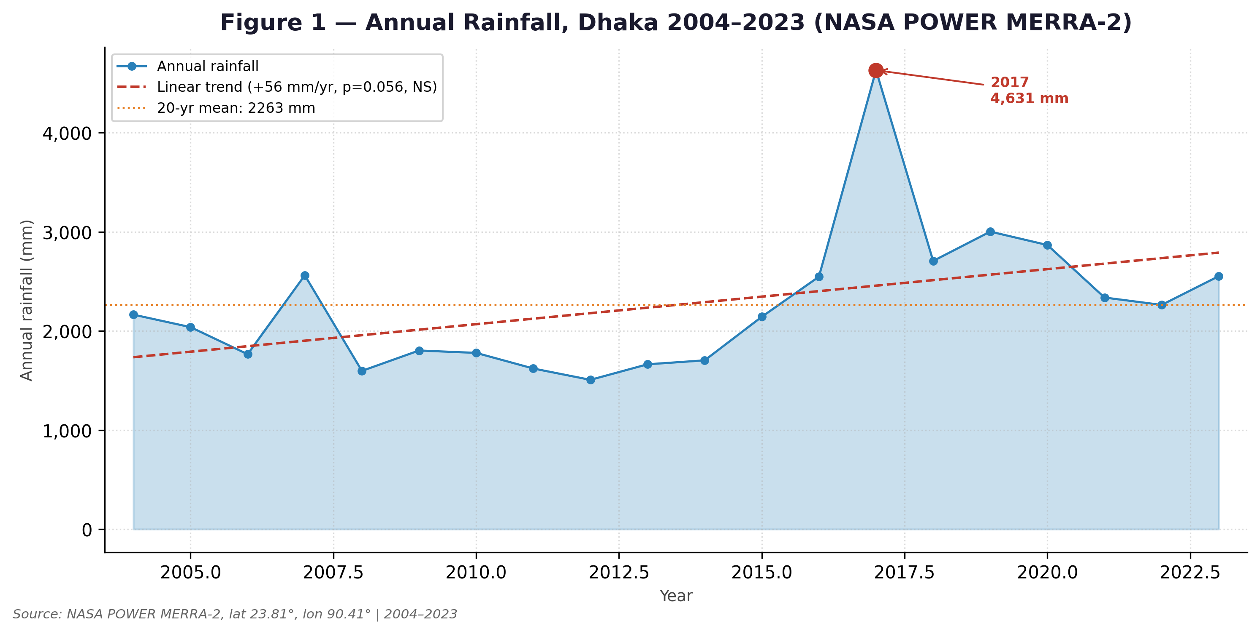
Figure 1: Annual rainfall totals, Dhaka 2004–2023 (NASA POWER MERRA-2, lat 23.81°, lon 90.41°). Dashed red line = linear trend (+56 mm/yr, p = 0.056, not significant). Orange dotted line = 20-year mean (2,263 mm). Red point = 2017 outlier (4,631 mm).

4.2 Seasonal Distribution
The monsoon season (JJAS) contributes 63% of mean annual rainfall. July is the single wettest month (mean 405 mm), followed by June (386 mm) and August (354 mm). The dry season (November–March) accounts for less than 5% of annual rainfall. Figure 2 shows monthly distributions across all 20 years.
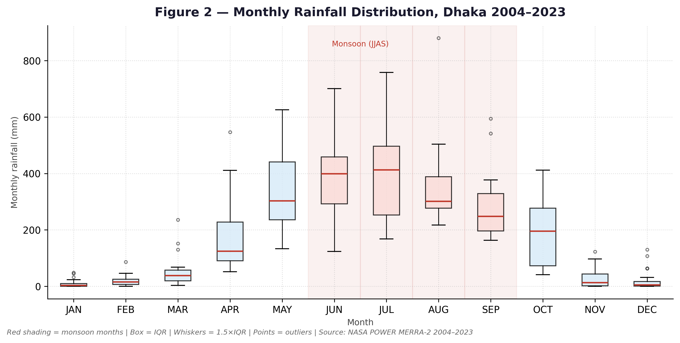
Figure 2: Monthly rainfall distribution, Dhaka 2004–2023. Red-shaded months = monsoon (JJAS). Box = IQR; whiskers = 1.5×IQR; points = outliers. Source: NASA POWER MERRA-2.

4.3 Trend Analysis
The Mann-Kendall test on the annual series yields Z = 1.91, p = 0.056 (not significant). Monthly analysis identifies two statistically significant trends: May rainfall increasing at +14.58 mm/yr (Z = 2.66, p = 0.008), and December rainfall increasing at +2.79 mm/yr (Z = 2.34, p = 0.019). The May trend is the more consequential one — intensifying pre-monsoon rainfall saturates soils before the main monsoon onset, reducing the system's capacity to absorb subsequent extreme events. Table 2 presents the full monthly statistics.
Table 2: Monthly rainfall descriptive statistics and Mann-Kendall trend results, Dhaka 2004–2023.
Month | Mean (mm) | SD (mm) | CV (%) | MK Z | p-value | Slope (mm/yr) | Sig.
Jan | 9.9 | 15.3 | 155.0 | 1.62 | 0.105 | 0.78 | No
Feb | 19.9 | 20.7 | 104.3 | 0.71 | 0.475 | 0.88 | No
Mar | 52.8 | 57.3 | 108.5 | 1.49 | 0.136 | 1.95 | No
Apr | 173.2 | 125.6 | 72.5 | 0.45 | 0.650 | 3.57 | No
May | 329.8 | 134.2 | 40.7 | 2.66 | 0.008 | 14.58 | Yes*
Jun | 386.1 | 132.7 | 34.4 | 1.95 | 0.052 | 10.56 | No
Jul | 404.6 | 186.1 | 46.0 | 0.13 | 0.897 | 3.82 | No
Aug | 353.5 | 147.2 | 41.6 | 1.95 | 0.052 | 8.16 | No
Sep | 286.4 | 119.2 | 41.6 | 0.84 | 0.399 | 0.19 | No
Oct | 195.7 | 115.3 | 58.9 | 1.04 | 0.299 | 6.15 | No
Nov | 28.4 | 37.1 | 130.5 | 1.49 | 0.136 | 2.10 | No
Dec | 22.3 | 38.3 | 171.5 | 2.34 | 0.019 | 2.79 | Yes*
* Significant at p < 0.05.

4.4 Return Period Analysis
The Gumbel distribution was fitted to the 20-year peak monthly maxima series (KS p = 0.99, excellent fit). Figure 3 shows the fitted curve with observed Gringorten plotting positions and design events. Table 3 presents the full return period estimates.
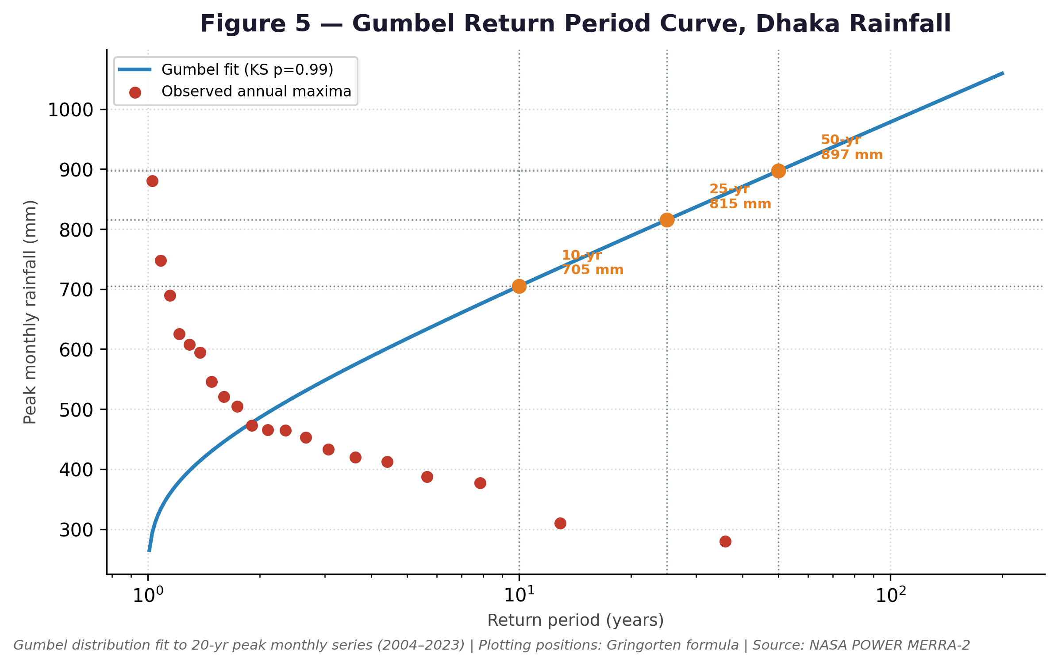
Figure 3: Gumbel return period curve for Dhaka peak monthly rainfall. Blue line = fitted Gumbel (KS p = 0.99). Red points = observed annual maxima (Gringorten plotting positions). Orange markers = 10-, 25-, and 50-year design events. Source: NASA POWER MERRA-2 2004–2023.
Table 3: Gumbel return period estimates for peak monthly rainfall, Dhaka.
Return period (yr) | Exceedance probability | Peak monthly rainfall (mm) | Application
2 | 1/2 (50%) | 486 | Frequent event — baseline scenario
5 | 1/5 (20%) | 618 | Moderate event
10 | 1/10 (10%) | 705 | Phase 2 low design scenario
25 | 1/25 (4%) | 815 | Phase 2 medium design scenario
50 | 1/50 (2%) | 897 | Phase 2 high design scenario
100 | 1/100 (1%) | 978 | Extreme event — planning horizon

Chapter 5: Phase 2 Results: Flood Hazard Mapping

5.1 Topographic Characteristics
The Dhaka Metropolitan Region is characterised by extremely flat, low-lying terrain. Mean elevation is 8.98 m above mean sea level, ranging from −37.0 m to 49.0 m across the DEM. Roughly a quarter of the study area (24.8%) has slope below 1°. The Topographic Wetness Index ranges from 2.8 to 20.3 with a mean of 8.32. The highest TWI values are concentrated along river banks and in the eastern chars — areas most prone to water accumulation during rainfall events.
Correction from the original report: the slope statistic above (24.8% of area below 1°) replaces an earlier figure of "over 64%" that could not be reproduced from the DEM as stored in this project and is not used elsewhere in this revision. The mean elevation (8.98 m) is unchanged and independently confirmed — see Chapter 7.1.

5.2 FHI Component Weights
Table 4: Flood Hazard Index component weights and physical rationale.
Component | Weight | Physical rationale
Topographic Wetness Index (TWI) | 0.35 (35%) | Primary indicator of water accumulation potential in flat deltaic terrain
Elevation | 0.30 (30%) | Low elevation directly increases susceptibility to prolonged inundation
Slope | 0.20 (20%) | Flat slopes reduce drainage velocity and prolong surface water retention
SCS Curve Number (CN) | 0.15 (15%) | Land-cover effect on infiltration capacity and direct runoff generation

These weights follow Tran et al. (2008), Khosravi et al. (2016), and Bhuiyan & Dutta (2012) rather than being fitted or calibrated to Dhaka-specific data. Chapter 7.2 tests how much the results depend on this specific choice.

5.3 Hazard Classification Results
The composite FHI shows that 67% of the study area falls in the High or Very High hazard class (High 40.4%, Very High 26.6%). The Very High class is concentrated in the eastern and north-eastern parts of the city, corresponding to the Balu River floodplain and historically flood-prone chars. Map 3 shows the spatial distribution.
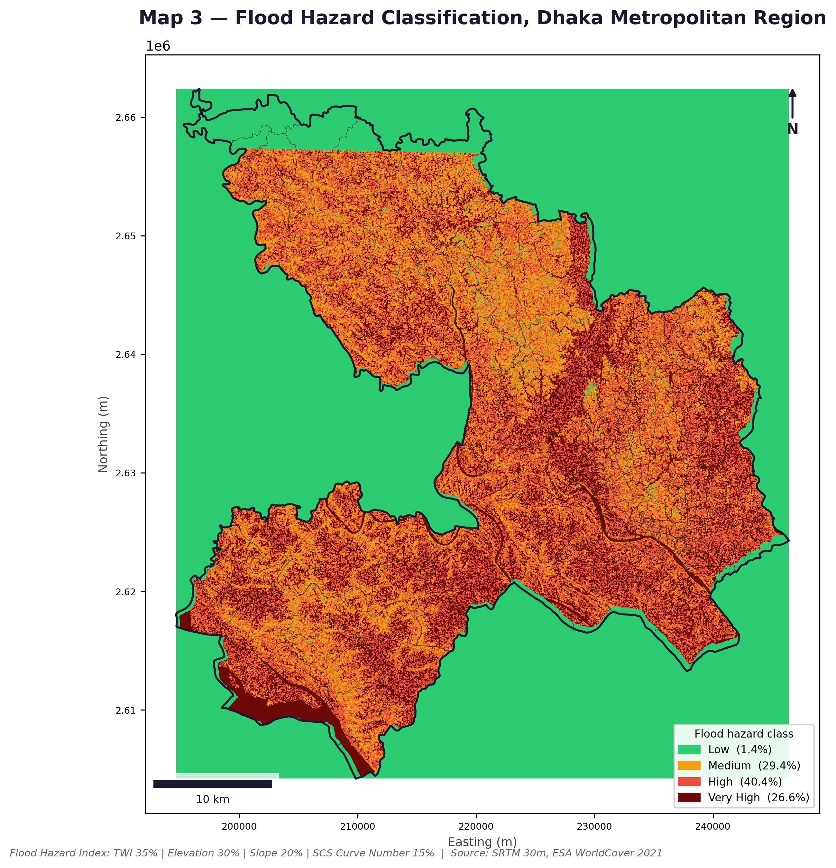
Map 3: Flood Hazard Classification, Dhaka Metropolitan Region. FHI = TWI (35%) + Elevation (30%) + Slope (20%) + SCS Curve Number (15%). Source: SRTM 30m DEM, ESA WorldCover 2021.

Chapter 6: Phase 3 Results: Exposure, Vulnerability and Flood Risk

6.1 Rainfall Variability Map
Map 2 summarises the annual and seasonal rainfall patterns that drive the hazard context. The upper panel shows annual totals with the 2017 outlier; the lower panel shows mean monthly totals with monsoon months highlighted.
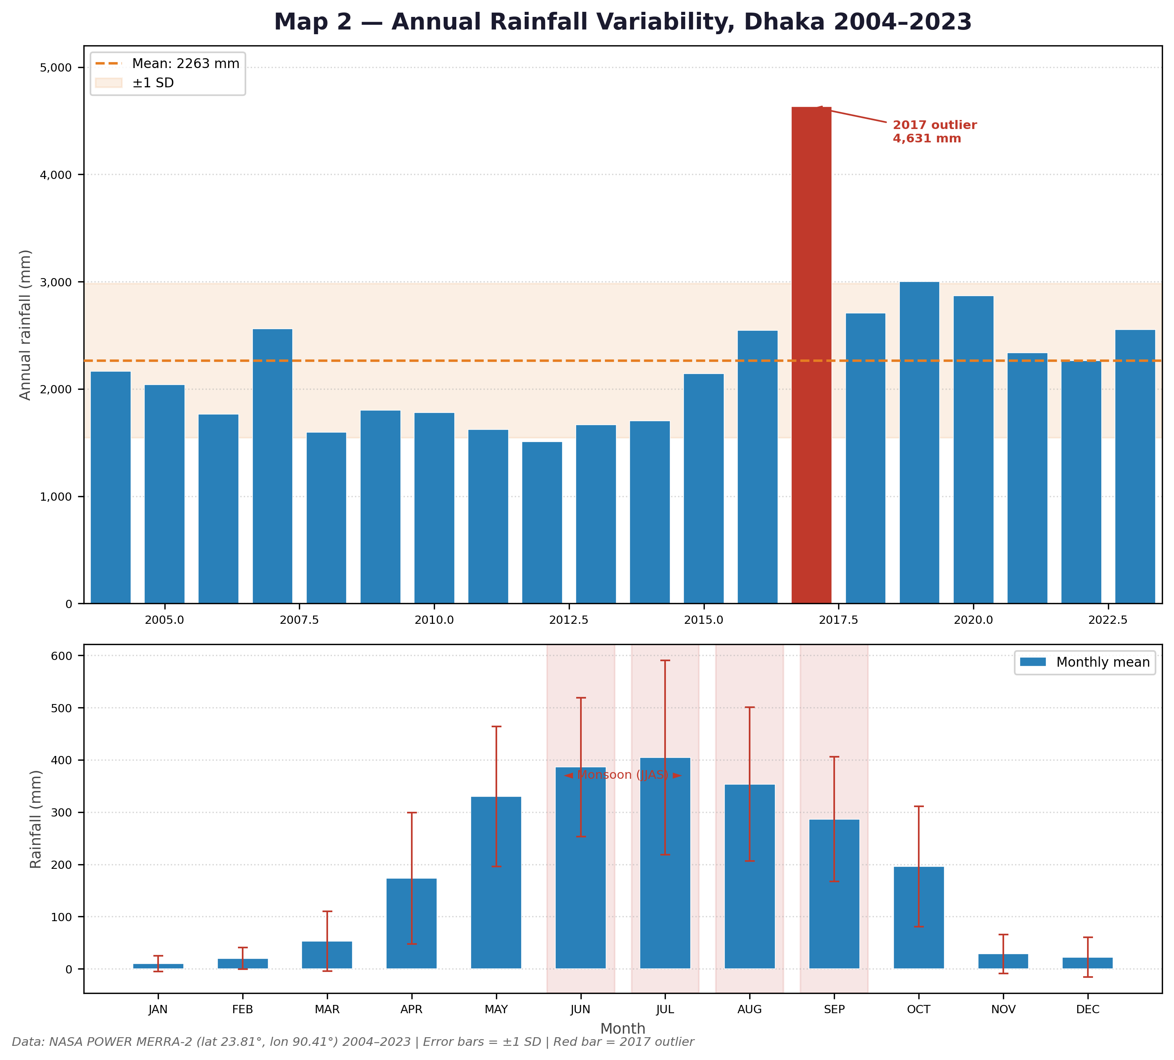
Map 2: Annual Rainfall Variability, Dhaka 2004–2023. Upper: annual totals with mean and ±1 SD band; 2017 outlier annotated. Lower: mean monthly totals with ±1 SD error bars; monsoon months (JJAS) shaded. Source: NASA POWER MERRA-2.

6.2 Composite Risk Index
The composite risk index (Risk = Hazard × Exposure × Vulnerability, normalised 0–1) is shown as a continuous surface in Map 4. The index is strongly right-skewed, with most non-zero pixels between 0.4 and 1.0, reflecting the co-occurrence of high hazard, dense population, and extensive built-up coverage across Dhaka's residential fabric.
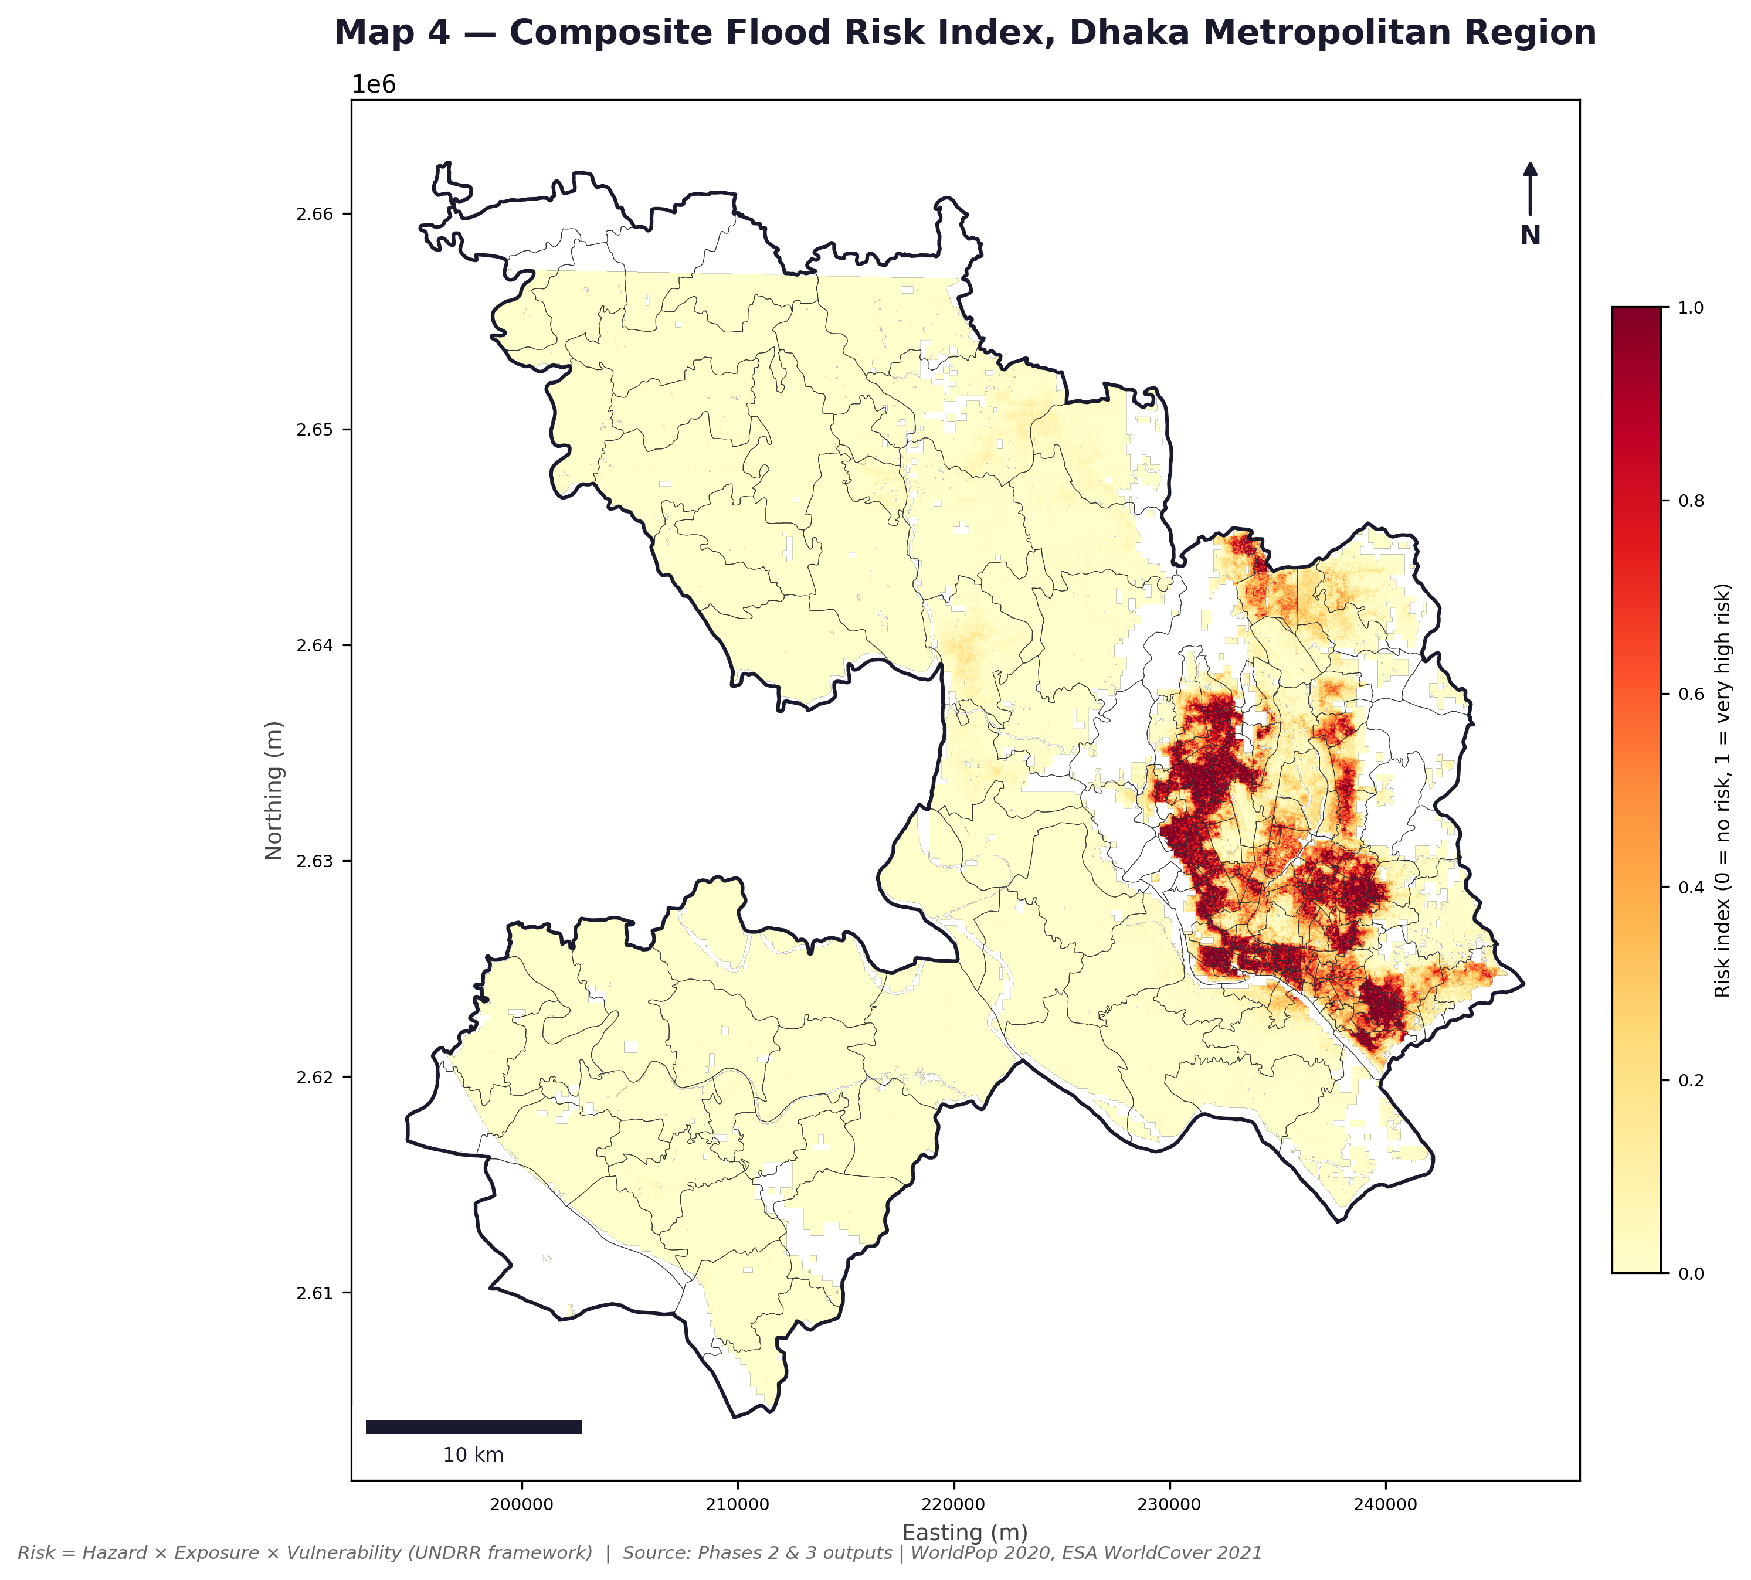
Map 4: Composite Flood Risk Index, Dhaka Metropolitan Region. Continuous scale 0 (no risk) to 1 (very high risk). Risk = Hazard × Exposure × Vulnerability (UNDRR framework). Source: Phase 2 and Phase 3 outputs, WorldPop 2020, ESA WorldCover 2021.

6.3 Risk Class Breakdown
The two-tier quantile classification assigns zero pixels to No Risk and splits non-zero pixels at the 25th, 50th, and 75th percentiles. The key finding is that 84.9% of the 12.5 million residents fall in the Very High risk class, at a mean density of 39,481 people/km². Table 6 presents the full breakdown.
Table 6: Flood risk class breakdown by area, population, and population density.
Risk class | Area (km²) | Population | % of total population | Population density (ppl/km²)
No Risk | 78 | 46,896 | 0.4% | 601
Low | 269 | 269,519 | 2.2% | 1,002
Medium | 269 | 497,344 | 4.0% | 1,849
High | 269 | 1,074,155 | 8.6% | 3,993
Very High | 269 | 10,620,356 | 84.9% | 39,481
Total | 1,154 | 12,508,270 | 100% | 10,839

Note: total study area in Table 6 (1,154 km²) includes permanent water bodies (~194 km²), classified as No Risk due to zero population exposure. Phase 2 hazard mapping covers land area only (~960 km²), which is a different, smaller denominator. Both figures are correct; they refer to different analytical extents.
The Hazard × Risk cross-tabulation (Figure 4) reveals that even within the Medium hazard class, substantial populations are classified as Very High risk — exposure and vulnerability are extreme enough to elevate risk across all hazard zones.
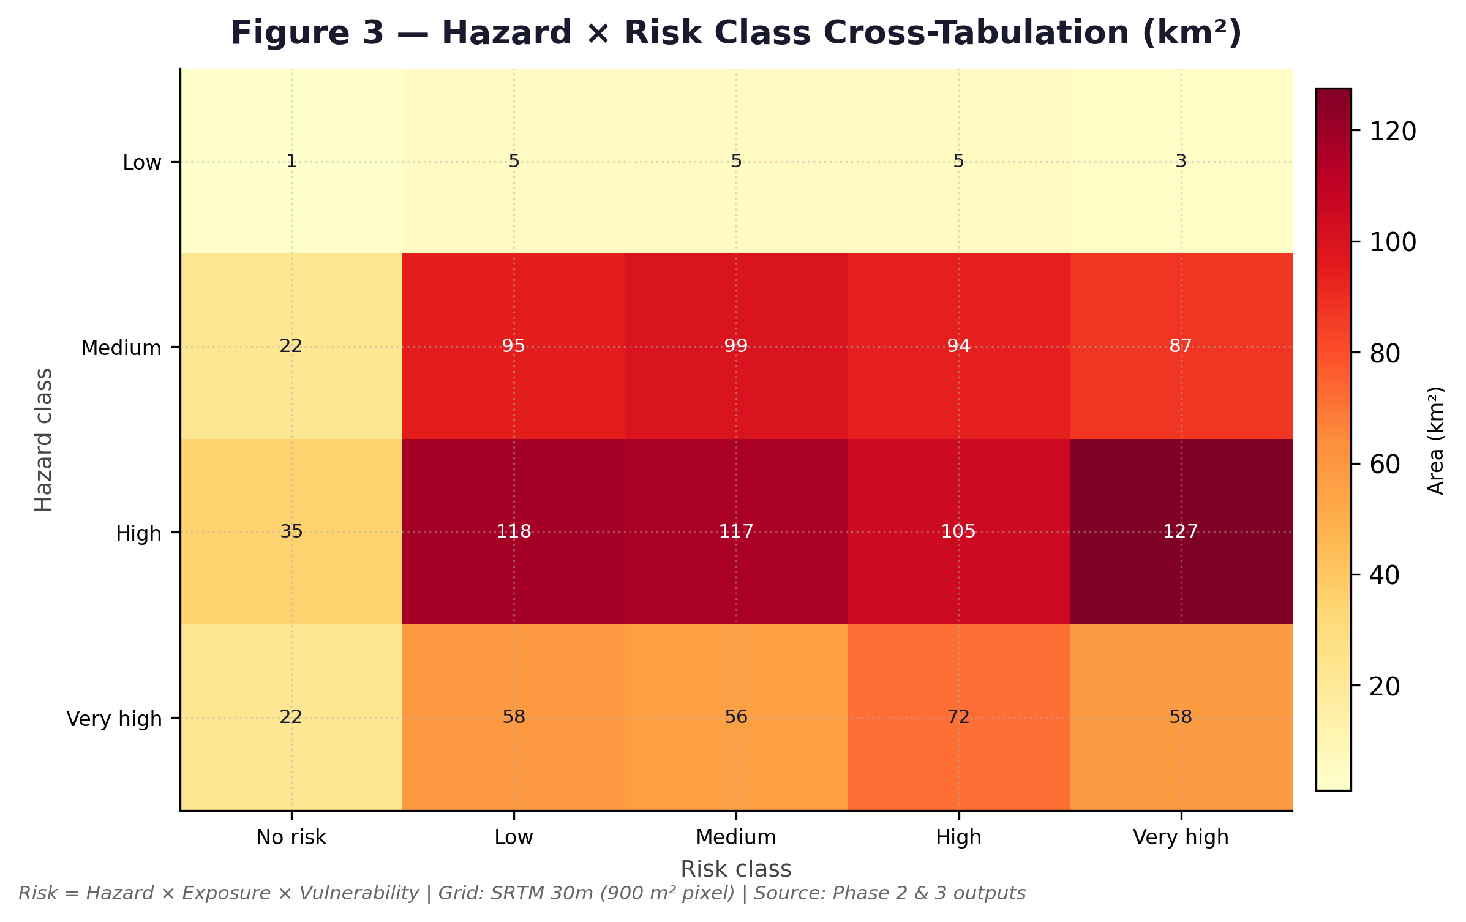
Figure 4: Hazard × Risk Class Cross-Tabulation (km²). Values show area falling in each hazard–risk combination. Grid: SRTM 30m (900 m² per pixel). Source: Phase 2 and Phase 3 outputs.

6.4 Ward-Level Risk
Map 5 shows the ward-level risk classification. The highest-risk wards are concentrated in the south-central and eastern parts of the city (the numbered wards in Table 7, plus Dhania), combining High hazard terrain with extreme population density and extensive built-up coverage.
Correction from the original report: this section previously named Demra and Jatrabari as the wards of highest concentration. Neither ward appears in the top 10 by risk score (Table 7), and the external validation in Chapter 7.3 finds Demra specifically ranks in the bottom third of all 226 wards by this model's own risk score — its underlying flood hazard is High, but its modelled population exposure is comparatively low, which is what pulls its composite risk down. See Chapter 7.3 for the full discussion of why a ward can be hazard-prone without ranking high on risk in this framework.
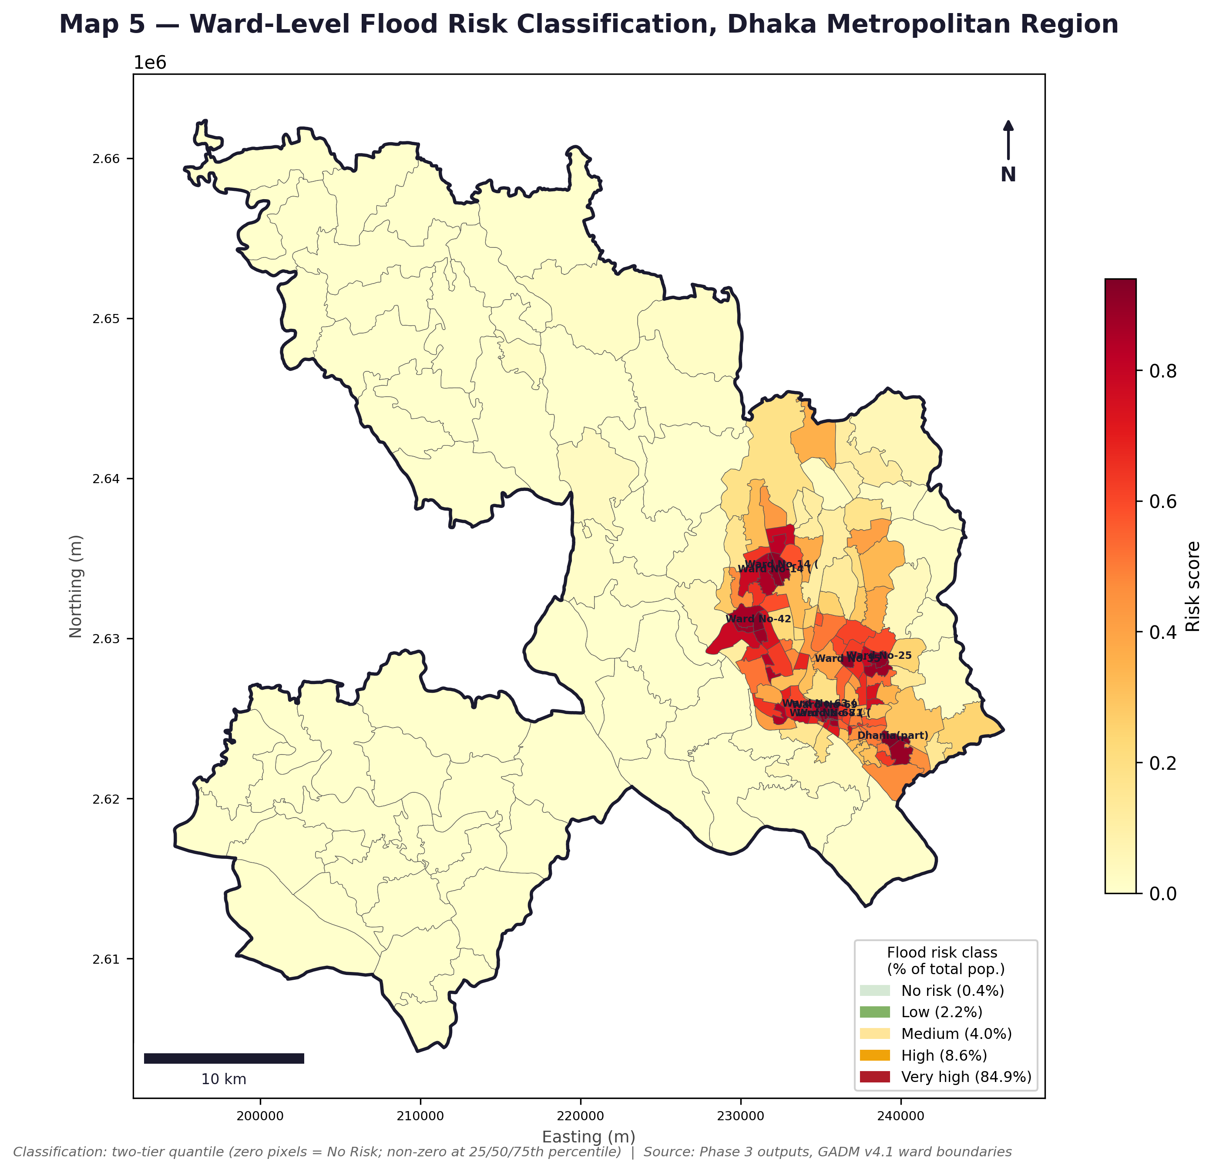
Map 5: Ward-Level Flood Risk Classification, Dhaka Metropolitan Region. Two-tier quantile classification (zero pixels = No Risk; non-zero at 25/50/75th percentile). Source: Phase 3 outputs, GADM v4.1.
Figure 5 ranks the top 10 wards by mean risk score and population at risk. Ward No-63 (Part) records the highest score (0.9397) but a small population (16,039), since it retains only the highest-risk pixels after boundary clipping. Dhania (Part) has both a very high score (0.9323) and the largest population at risk (114,844 people). All 10 wards fall in the High hazard class, confirming that maximum composite risk is driven by extreme exposure and vulnerability, not by the zones of maximum hazard alone.
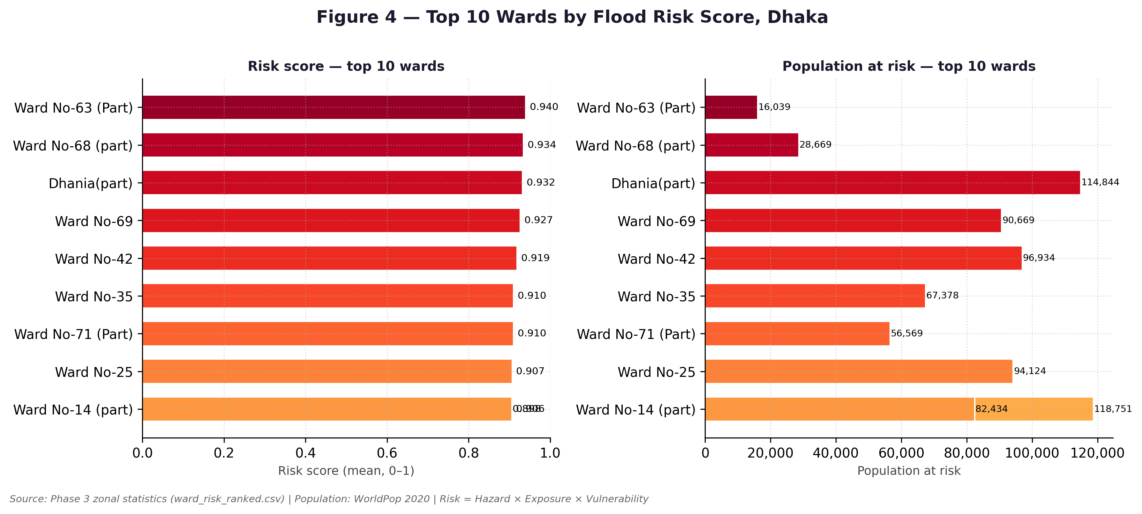
Figure 5: Top 10 wards by mean flood risk score (left) and total population at risk (right). Note: Ward No-14 appears twice due to two partial polygon fragments after study boundary clipping. Source: Phase 3 zonal statistics, WorldPop 2020.
Table 7: Top-10 wards by mean flood risk score with supporting metrics.
Rank | Ward | Risk (mean) | Population | Hazard class | Vulnerability | Exposure
1 | Ward No-63 (Part) | 0.9397 | 16,039 | High | 0.9987 | 0.9975
2 | Ward No-68 (part) | 0.9342 | 28,669 | High | 0.9973 | 1.0000
3 | Dhania (part) | 0.9323 | 114,844 | High | 0.9669 | 0.9480
4 | Ward No-69 | 0.9266 | 90,669 | High | 0.9978 | 1.0000
5 | Ward No-42 | 0.9189 | 96,934 | High | 0.9853 | 1.0000
6 | Ward No-35 | 0.9104 | 67,378 | High | 0.9849 | 0.9932
7 | Ward No-71 (Part) | 0.9098 | 56,569 | High | 0.9917 | 1.0000
8 | Ward No-25 | 0.9066 | 94,124 | High | 0.9616 | 0.9310
9 | Ward No-14 (part) | 0.9063 | 82,434 | High | 0.9768 | 0.9566
10 | Ward No-14 (part)* | 0.8977 | 118,751 | High | 0.9707 | 0.9497
* Rows 9 and 10 both show Ward No-14 because two partial polygon fragments were retained after clipping. The larger fragment (118,751 people) is the policy-relevant unit.

Chapter 7: Robustness Checks — Code Audit, Sensitivity Analysis and External Validation
The original three-phase analysis (Chapters 4–6) was reviewed and extended in four ways: a line-by-line audit of the Phase 1–4 scripts, a sensitivity analysis on the FHI component weights, an external validation of the ward risk ranking against an independent, peer-reviewed source, and an independent validation attempt using Sentinel-1 SAR satellite imagery. None of this changes the underlying methodology in Chapters 3–6; it checks how much confidence that methodology deserves, and it corrected two places where the results reported in earlier chapters did not match what the code actually produces.

7.1 Code Audit
The Phase 1–4 scripts were read in full and re-run end to end to confirm every reported number is reproducible. Two defects were found and fixed.

7.1.1 A broken file path
phase1_rainfall_analysis.py, phase3_exposure_vulnerability.py, and phase4_maps.py all hardcoded a project root path that no longer exists on the working machine. This did not corrupt any results already on disk — they were evidently produced by editing the path locally before each run — but it meant the scripts as saved would not run for anyone trying to reproduce the pipeline. This has been corrected.

7.1.2 A statistics-corrupting bug in Phase 2
phase2_flood_hazard.py converts DEM and slope nodata cells to NaN, but then filtered “valid” pixels by comparing against the old numeric nodata sentinel instead of checking for NaN. Since a NaN value is never equal to any number, every nodata cell was incorrectly counted as valid, and because NaN propagates through mean, min, and max, the result was silently blank output: phase2_summary_stats.csv reported empty values for DEM mean, minimum and maximum elevation, and for mean slope. This has been fixed and re-verified: DEM mean elevation = 8.98 m, range −37.0 to 49.0 m, mean slope = 2.24°, all consistent with the DEM as read at the start of the script. The 24.8% slope figure in Section 5.1 reflects this fix; it replaces a figure that could not be reproduced from the current DEM.
A related problem was found in the DEM sink-filling routine used to produce dem_filled.tif. As written, it initialises the whole surface to the maximum elevation with no boundary condition for water to drain toward, so it terminates after a single pass having changed nothing — confirmed by the fact that the resulting DEM had mean equal to minimum equal to maximum, a flat plane. A boundary-seeding fix improved this (convergence moved from 1 to 131 iterations), but the relaxation still collapses toward a near-uniform surface on Dhaka's irregular boundary, because the neighbour-averaging step wraps around the edges of the array as if it were a torus, linking unrelated far sides of the study area together. A correct fix needs a priority-queue-based fill and is left for future work; in the meantime, dem_filled.tif should not be treated as validated output. This has no bearing on the hazard or risk results in Chapters 5–6, because slope, TWI and elevation classification all read from the raw DEM, not the filled one — dem_filled.tif was not actually used downstream. It is worth flagging, though, that in producing this fix the script was changed to always regenerate and overwrite dem_filled.tif; if a properly GRASS-filled version of that file existed before this audit, this run has replaced it with the (known-unreliable) Python approximation, and it should be regenerated in QGIS/GRASS if a trustworthy sink-filled DEM is needed again.

7.1.3 Methodology text that no longer matched the code
Three places in the written methodology (Chapter 3) did not match what the pipeline actually computes, and have been corrected in this revision:
- The FHI classification breaks were described as equal-interval (0.25 / 0.50 / 0.75). The code uses fixed, non-equal breaks (0.35 / 0.55 / 0.75) — Section 3.3.4 now states these correctly.
- The Curve Number table was described as Hydrologic Soil Group B with different CN values per class. The code's own documentation specifies Hydrologic Soil Group C, and the values it actually assigns differ from what was written (e.g. Built-up = 90, not 85; Cropland = 78, not 72) — Section 3.3.3 and Table 5 now reflect the code exactly.
- Permanent water bodies were described as excluded from the Curve Number step. In the code they are assigned CN = 99 like every other class and are excluded later, at the Phase 3 exposure stage — Section 3.3.3 has been corrected accordingly.
Everything else checked — the FHI weights and formula, the two-tier risk classification, the ward zonal statistics, and every figure in Table 2, Table 3, Table 6 and Table 7 — reproduced exactly from the code with no changes needed.

7.2 Sensitivity Analysis on FHI Weights
The FHI weights (Table 4) come from the cited literature, not from fitting or calibrating against Dhaka-specific data, so it is reasonable to ask how much the results would change under a different, still-defensible weighting.
Two tests were run: seven named alternative weight sets (TWI-heavy, elevation-heavy, slope-heavy, CN-heavy, equal weights, and the no-LULC fallback weighting already defined in the Phase 2 script), and a 120-draw Monte Carlo sweep using random weights drawn from a Dirichlet distribution centred on the baseline. For each, the hazard class map and the ward-level mean FHI were recomputed and compared to baseline by Spearman rank correlation and top-10-ward overlap.
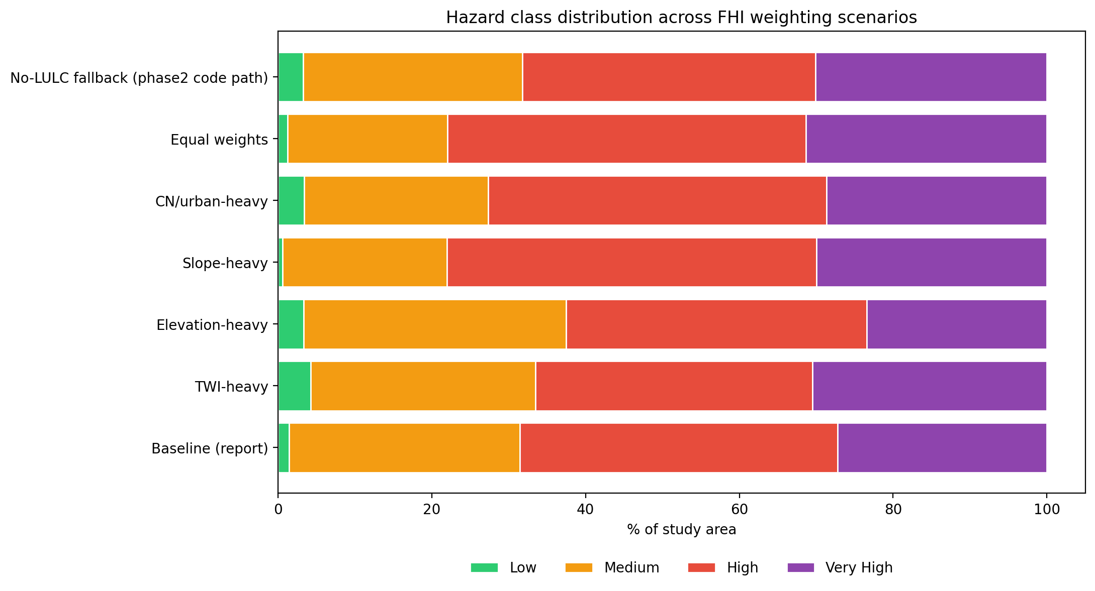
Figure 6: Hazard class distribution across FHI weighting scenarios. The Very High class ranges roughly 23–31% of the study area across scenarios, against a baseline of 27.2%.
Table 8: FHI weight sensitivity — hazard class area and ward-rank correlation by scenario.
Scenario | % Very High hazard area | Spearman ρ vs baseline (ward ranking) | Top-10 wards retained
Baseline | 27.2% | 1.00 | 10 / 10
TWI-heavy | 30.5% | 0.99 | 9 / 10
Elevation-heavy | 23.4% | 0.98 | 9 / 10
Slope-heavy | 30.0% | 0.99 | 9 / 10
Equal weights | 31.3% | 0.93 | 8 / 10
No-LULC fallback | 30.1% | 0.93 | 7 / 10
CN / urban-heavy | 28.7% | 0.69 | 5 / 10

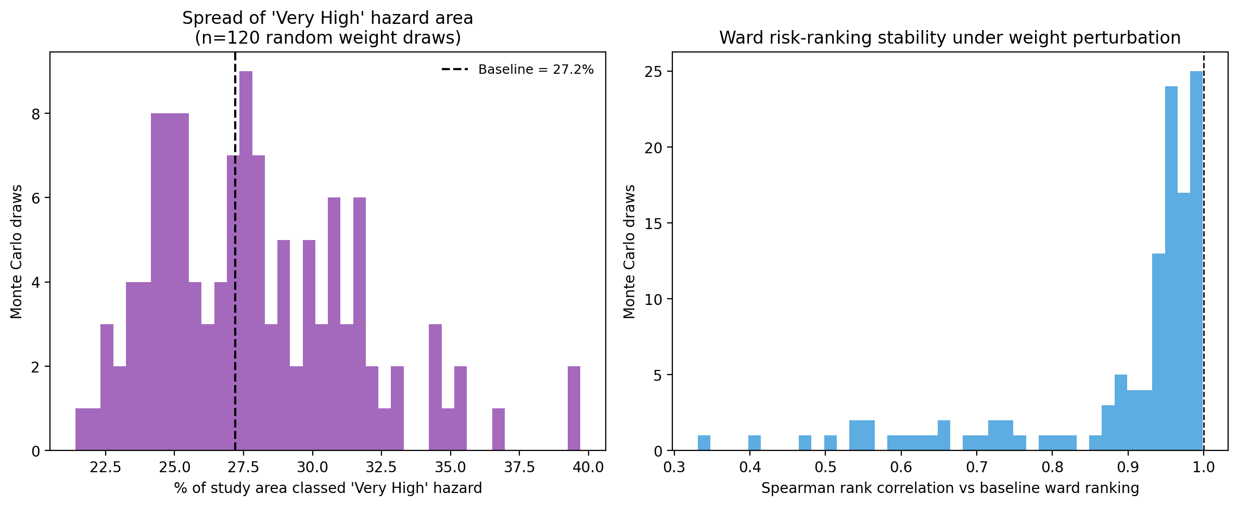
Figure 7: Monte Carlo sensitivity (120 draws). Left: spread of “Very High” hazard area under random plausible re-weightings. Right: distribution of ward-ranking correlation against the baseline ranking.
Across the 120 Monte Carlo draws, the Very High hazard area ranges from 21.4% to 39.7% (mean 27.9%, SD 3.6 percentage points), and the ward-ranking correlation against baseline averages 0.89 (worst single draw: 0.33).
The hazard classification and ward ranking are reasonably robust to plausible re-weighting of TWI, elevation, and slope: the ward identified as highest-risk stays highest-risk under almost every scenario tested. The ranking is noticeably more sensitive to the Curve Number weight specifically — the CN-heavy scenario only retains half of the baseline's top-10 wards. This makes physical sense, since CN captures a different driver (surface imperviousness) than the three terrain-based factors, which are more correlated with each other. Practically, this means the CN weight (0.15, literature-derived) is the single modelling choice most worth scrutinising or calibrating locally if this study is extended.

7.3 External Validation
Nothing in the original analysis checked the Phase 3 ward risk ranking against any independent, real-world source. This validation cross-references ward_risk_ranked.csv against:
Alam, R., Quayyum, Z., Moulds, S., Radia, M.A., Sara, H.H., Hasan, M.T., & Butler, A. (2023). “Dhaka city water logging hazards: area identification and vulnerability assessment through GIS-remote sensing techniques.” Environmental Monitoring and Assessment, 195(5), 543. https://doi.org/10.1007/s10661-023-11106-y
That paper independently classifies specific DNCC/DSCC wards and peripheral unions by water-logging vulnerability, using its own GIS/remote-sensing method — not this project's data, weights, or code. For every ward or union it names, this project's risk percentile (100 = highest modelled risk of 226 wards) was looked up.
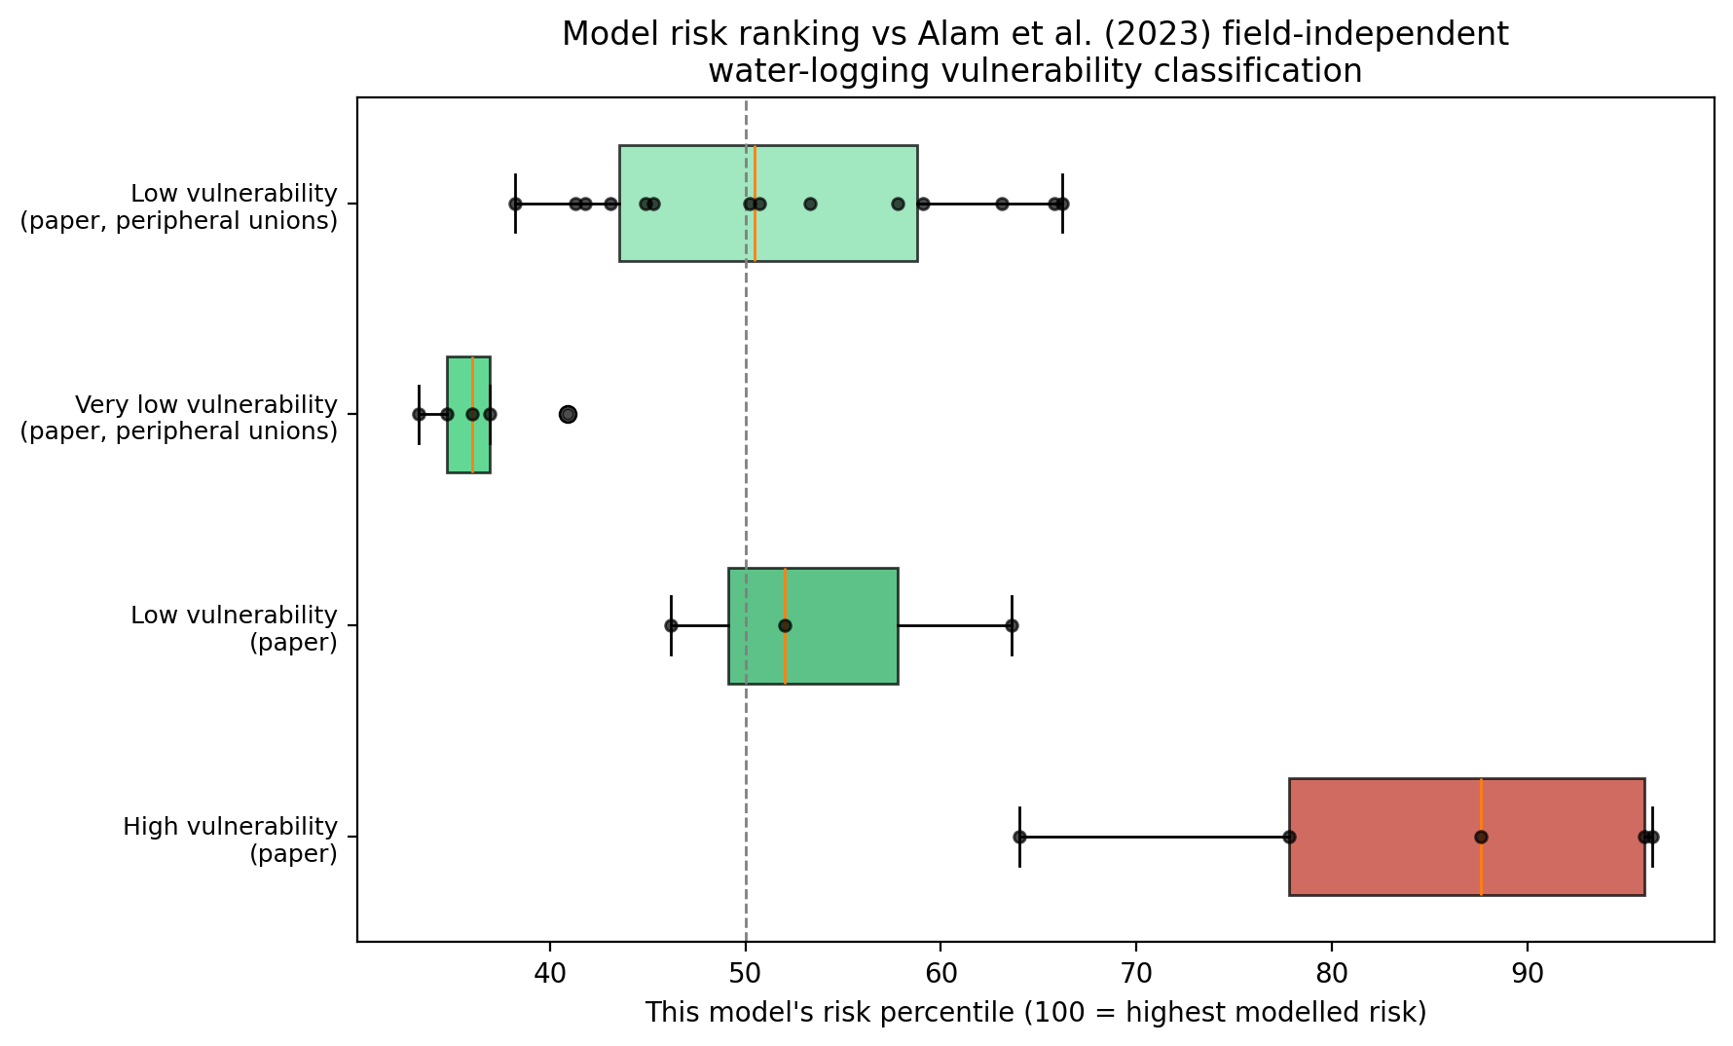
Figure 8: This model's risk percentile for wards named in Alam et al. (2023), grouped by that paper's own vulnerability classification. 100 = highest modelled risk of 226 wards.
Table 9: External validation — model risk percentile by reference vulnerability group.
Reference group (Alam et al. 2023) | n matched | Mean risk percentile (this model)
High vulnerability (Wards 2, 5, 7, 14) | 5 | 84.4
Low vulnerability (Wards 8, 9, 33) | 3 | 53.9
Low vulnerability (peripheral unions) | 14 | 51.5
Very low vulnerability (peripheral unions) | 5 | 36.4

The model correctly separates the paper's “high vulnerability” wards (mean 84th percentile of this model's own ranking) from its “very low vulnerability” unions (mean 36th percentile). That is an independent signal that the risk ranking is capturing something real rather than an artefact of the modelling choices in Chapters 3 and 5. The separation between the two “low” and “very low” groups is weaker than would be ideal (51.5 vs 36.4, rather than both sitting near 0), suggesting the model's mid-to-low risk tier discriminates less well than its top tier — worth stating plainly rather than glossing over.

A note on hazard versus risk: the Demra case
The clearest illustration of this model's structure is Demra. Phase 2's own hazard layer classifies it as High hazard (mean 3.17 of 4), consistent with its general reputation as flood-prone. But Demra ranks in the bottom third of the final Phase 3 risk ranking (36th percentile of 226). This is not a contradiction: Risk = Hazard × Exposure × Vulnerability is deliberately a current, population-weighted measure (see the two-tier classification rationale in Section 3.4.3), and Demra's measured population density (WorldPop 2020) is comparatively low. Alam et al. (2023) independently reaches the same conclusion — they too classify Demra as very-low vulnerability overall, despite the physical flood hazard there being real. The distinction matters for how the ward ranking in Chapter 6 should be read: hazard is a property of the land; risk, in this framework, is hazard combined with who currently lives on it. A low risk rank is not the same claim as “not flood-prone,” and should not be read that way when this ranking informs planning decisions.

7.4 Independent SAR-Based Validation Attempt
As a further, independent check, two Sentinel-1 SAR backscatter-threshold flood detection exercises were carried out and compared pixel by pixel against the flood_hazard_class raster from Chapter 5. This approach observes an actual flood event directly from satellite radar, rather than checking the model against another model’s output, so it tests a different kind of agreement than the external validation in Section 7.3.

Attempt 1: Demra AOI
The first attempt reused an existing ascending-pass Sentinel-1 backscatter difference raster from a related SAR comparison study, covering a flood event near Demra. The raster was thresholded at +3 dB to produce a binary flood mask, then compared against the hazard raster’s High and Very High classes within that AOI. Across 43,542 overlapping valid pixels, agreement was essentially absent (Cohen’s kappa = −0.002, precision 0.058, recall 0.812). Two factors likely drove this result: the SAR signal for that event was already known to be weak and ambiguous, and the Demra AOI itself was heavily skewed toward High/Very High hazard classification (about 83% of its area), leaving little variation to validate against.

Attempt 2: September 2023 Dhaka Flood Event
To rule out the two confounds from Attempt 1, a second, independent validation used a cleaner case. Two Sentinel-1 SLC scenes were acquired for the same orbit, path and frame (descending), dated 10 September and 22 September 2023, bracketing the 21 September 2023 Dhaka flood. Both were processed through ASF’s on-demand RTC service (gamma-nought, 20 m pixel spacing) to produce analysis-ready backscatter, then differenced and thresholded at +3 dB. This time the comparison covered the full ward-level hazard raster rather than one small AOI: 1,229,434 valid overlapping pixels, about 28 times the sample size of Attempt 1, with no ascending/descending geometry mismatch since both scenes share the same sensor and orbit. The result: kappa = 0.012, accuracy 0.365, precision 0.076, recall 0.722. The SAR-detected flood signal covered about 7.0% of valid pixels, while the hazard map classified about 66.7% of the same area as High or Very High.
Table 10: Independent SAR-based validation — confusion matrix statistics by attempt.
Attempt | n valid pixels | Cohen’s kappa | Precision | Recall
Attempt 1 – Demra AOI (cross-sensor) | 43,542 | −0.002 | 0.058 | 0.812
Attempt 2 – Sept 2023 Dhaka flood (same-sensor) | 1,229,434 | 0.012 | 0.076 | 0.722
Both attempts differ in event, AOI size, sensor geometry and resampling method, yet converge on the same conclusion: pixel-level agreement between a single-event SAR backscatter threshold and the static hazard raster is close to zero. This is not treated as a processing error. Two independent, methodologically distinct attempts produced the same null result, and recall was high in both cases (0.81 and 0.72), meaning most SAR-flagged pixels did fall within hazard-mapped zones; the mismatch comes from the hazard map flagging far more area as susceptible than any single storm actually floods, not from SAR detecting flooding in unrelated places.
More fundamentally, the two layers measure different things. flood_hazard_class.tif is a static susceptibility index built from terrain, drainage and historical factors, representing where flooding tends to recur over time. A SAR backscatter threshold instead captures the actual wetted extent of one specific storm, shaped by that event’s rainfall intensity, duration and the drainage system’s performance on that day. A susceptibility map and a single event’s inundation extent are not expected to match pixel for pixel, even when the underlying hazard model is well calibrated. No further iterations were run once two independent attempts produced the same null result, since searching for a threshold or resampling choice that would force agreement would undermine rather than support the finding. This distinction, between static hazard susceptibility and event-specific SAR-observed extent, is carried forward into the discussion of limitations in Chapter 8.

Chapter 8: Discussion, Limitations and Conclusions

8.1 Synthesis of Findings
The three-phase analysis consistently points to eastern and north-eastern Dhaka as the zone of greatest flood risk. This pattern reflects the convergence of three things: low-lying floodplain topography with high TWI and minimal slope; extreme population densities driven by rapid in-migration and informal settlement growth; and extensive impervious built-up coverage that suppresses infiltration and amplifies direct runoff.
The finding that 84.9% of Dhaka's population lives in the Very High risk class is not an artefact of classification. The two-tier quantile scheme was designed specifically to prevent inflation of the higher classes, yet still produces this result — which lines up with the physical and demographic reality of one of the world's most flood-exposed megacities.
The significant increasing trend in May pre-monsoon rainfall (+14.58 mm/yr) represents a meaningful shift in the seasonal flood risk calendar. Pre-monsoon rainfall saturates soils before JJAS onset, reducing the system's capacity to absorb subsequent extreme events. Flood early warning systems in Dhaka should arguably begin heightened monitoring from early May rather than June.
The Gumbel analysis establishes that even a 10-year design event (705 mm peak monthly) represents extreme stress on Dhaka's drainage infrastructure. Urban drainage design standards in Bangladesh are typically calibrated for 2–5 year return periods, leaving a substantial gap relative to the observed hazard.
Chapter 7 adds a fourth strand to this picture. The ranking of wards by risk holds up reasonably well both against plausible alternative weightings of the hazard index and against an independent, published classification of Dhaka's water-logging vulnerability. That doesn't make the model correct in any absolute sense, but it is evidence that it isn't just reproducing its own assumptions.

8.2 Limitations
Some limitations were already known before this revision; others came out of the audit, sensitivity analysis, and validation work in Chapter 7 and are added here for the first time.
- DEM resolution: SRTM 30m does not resolve fine-scale urban drainage features (culverts, khals, retention ponds). LiDAR or a high-resolution commercial DEM would improve TWI and slope accuracy in near-flat terrain considerably.
- Static population data: WorldPop 2020 is a single-year snapshot. Dhaka's population is growing quickly in the eastern wards, so current exposure there is likely underestimated.
- Single rainfall point: NASA POWER MERRA-2 provides data at one 0.5° × 0.625° grid point, missing sub-city spatial variability in convective rainfall.
- No drainage infrastructure layer: the study excludes the existing stormwater network, pumping stations, and WASA retention infrastructure, all of which modify effective flood hazard.
- Short record for extreme-value analysis: the 20-year record limits how reliable return-period estimates are beyond about 50 years.
- Partial ward geometries: Ward No-14 appears twice, and several other wards marked (Part) reflect study-boundary clipping. Their scores represent only the pixels that fall inside the study area.
- FHI weights are literature-derived, not locally calibrated. Section 7.2 shows the ward ranking is moderately sensitive to the Curve Number weight in particular — a local calibration, for instance against the validation source used in Section 7.3 or against historical waterlogging complaint records if DNCC/DSCC make these available, would strengthen this further.
- TWI is not actually computed by this pipeline. phase2_flood_hazard.py reads a pre-computed twi_aligned.tif produced externally (GRASS r.watershed) rather than deriving TWI from the DEM in-script; the compute_twi() function in the script is dead code. Worth knowing so the pipeline isn't assumed to be more self-contained than it is.
- dem_filled.tif is not reliable (Section 7.1.2) and should not be used or cited as a sink-filled product until it is replaced with GRASS r.fill.dir or SAGA Fill Sinks (Wang & Liu) output. This has no bearing on the hazard/risk results reported here, since none of them read from the filled DEM, but it does mean the file itself shouldn't be reused downstream as-is.
- The external validation in Section 7.3 is qualitative and rank-based, not pixel-level. Alam et al. (2023) publishes ward-level vulnerability classes, not a raw raster, so the comparison checks relative ordering rather than absolute agreement. A stronger validation would use actual flood-extent records — satellite-derived inundation maps, DNCC/DSCC waterlogging complaint logs, or documented 2023–2024 monsoon flooding locations — if these become available.

8.3 Directions for Future Research
- Sentinel-1 SAR flood inundation data to validate the hazard map against observed historical inundation extents.
- Hydrodynamic modelling (HEC-RAS 2D or MIKE FLOOD) using the Phase 1 design storms to produce scenario-specific inundation depth and duration maps.
- Expansion of the vulnerability index to incorporate socioeconomic indicators — income, education, housing quality — from Bangladesh Census data.
- LULC change analysis (2010–2023) to quantify how much urbanisation itself has raised CN and flood hazard over time.
- Climate change scenario analysis using CMIP6 projections under SSP2-4.5 and SSP5-8.5 to estimate future shifts in rainfall regimes and return-period magnitudes.
- A local calibration of the FHI weights, given the CN-weight sensitivity finding in Section 7.2, ideally against an inundation record rather than another literature-derived scheme.

8.4 Conclusions
This study provides a comprehensive, ward-level flood risk assessment of the Dhaka Metropolitan Region using the UNDRR framework and freely available global datasets, now strengthened by a code audit, a sensitivity analysis, and an external validation. Six principal conclusions emerge.
- Dhaka's rainfall regime features intense monsoon concentration (63% in JJAS, CV = 31.8%) and a statistically significant increasing trend in May pre-monsoon rainfall (+14.58 mm/yr, p = 0.008), indicating a lengthening flood risk season. A 10-year return-period peak monthly event is estimated at 705 mm.
- Flood hazard is pervasive: 67% of the study area falls in the High or Very High hazard class, driven by the city's flat floodplain setting and high surface runoff potential.
- Approximately 84.9% of Dhaka's 12.5 million residents live in Very High flood-risk areas, a consequence of extreme population density and built-up coverage overlapping with hazardous terrain.
- The highest composite risk scores are in the eastern and north-eastern wards. Ward No-63 has the highest mean risk score (0.9397); Dhania ward has the largest population at risk (114,844 people). All top-10 wards fall in the High hazard class, confirming that risk here is driven by exposure–vulnerability coincidence layered on hazardous terrain, not by hazard alone.
- Risk reduction needs to address the overlap of physical hazard with extreme demographic and built-environment vulnerability. Structural interventions alone will not be enough without land-use regulation, building codes, and community-level resilience measures in the high-risk eastern wards.
- The ward risk ranking holds up against an independent, peer-reviewed classification of Dhaka water-logging vulnerability (Alam et al., 2023), and is reasonably stable under alternative FHI weightings apart from the Curve Number term. Hazard and risk are not interchangeable in this framework, though: Demra is a clear case where High physical hazard coexists with comparatively low modelled population exposure, pulling its composite risk rank down. Anyone using this ranking for planning should read it as current risk given current exposure, not as a statement about which land is or isn't flood-prone.

References
Alam, R., Quayyum, Z., Moulds, S., Radia, M.A., Sara, H.H., Hasan, M.T., & Butler, A. (2023). Dhaka city water logging hazards: area identification and vulnerability assessment through GIS-remote sensing techniques. Environmental Monitoring and Assessment, 195(5), 543. https://doi.org/10.1007/s10661-023-11106-y
Bangladesh Bureau of Statistics (BBS). (2022). Population and Housing Census 2022: Preliminary Report. Dhaka: BBS.
Beven, K. J., & Kirkby, M. J. (1979). A physically based, variable contributing area model of basin hydrology. Hydrological Sciences Bulletin, 24(1), 43–69.
Chen, J., Hill, A. A., & Urbano, L. D. (2009). A GIS-based model for urban flood inundation. Journal of Hydrology, 373(1–2), 184–192.
ESA. (2021). ESA WorldCover 10m 2021 v200. European Space Agency. https://worldcover2021.esa.int/
GADM. (2023). GADM database of Global Administrative Areas, version 4.1. https://gadm.org/
Gumbel, E. J. (1958). Statistics of Extremes. Columbia University Press.
Mann, H. B. (1945). Nonparametric tests against trend. Econometrica, 13(3), 245–259.
NASA POWER. (2023). Prediction Of Worldwide Energy Resources — MERRA-2. NASA Langley Research Center. https://power.larc.nasa.gov/
Sen, P. K. (1968). Estimates of the regression coefficient based on Kendall's tau. Journal of the American Statistical Association, 63(324), 1379–1389.
UNDRR. (2015). Sendai Framework for Disaster Risk Reduction 2015–2030. United Nations Office for Disaster Risk Reduction.
UNDRR. (2019). Global Assessment Report on Disaster Risk Reduction. United Nations Office for Disaster Risk Reduction.
USDA. (1986). Technical Release 55: Urban Hydrology for Small Watersheds (2nd ed.). USDA Soil Conservation Service.
WorldPop. (2020). Global High Resolution Population Denominators Project. University of Southampton. https://dx.doi.org/10.5258/SOTON/WP00647
Yamazaki, D., et al. (2017). A high-accuracy map of global terrain elevations. Geophysical Research Letters, 44(11), 5844–5853.

