Ward-Level Informal Settlement Classification in Dhaka
Fahim Ahmed
Department of Urban and Regional Planning (DURP), Bangladesh University of Engineering and Technology (BUET), Dhaka, Bangladesh

Abstract
Rapid, unplanned urbanization has produced extensive informal settlements across Dhaka, yet most machine-learning approaches to mapping them operate at pixel or building-object scale using very-high-resolution (VHR) satellite imagery — a scale finer than the administrative wards that municipal planning agencies (RAJUK, DNCC, DSCC) actually plan and budget around, and a data requirement that is costly and not always available for repeat monitoring. This study classifies all 203 wards of the Dhaka Metropolitan Region as formal or informal using an XGBoost classifier trained on twelve features derived from freely available medium-resolution and crowd-sourced sources: Landsat 9, Sentinel-2, WorldPop population data, and OpenStreetMap building footprints. During model development we found that the initial rule-based training labels shared variables directly with several classification features, producing a circular evaluation in which a reported 90.9% accuracy substantially reflected the labeling rule rather than a genuine informality signal. We address this with a decoupled evaluation protocol that excludes rule-derived features and separately validates on independently sourced ground-truth anchor wards. The resulting model achieves 85.3% cross-validated accuracy against a 64.1% majority-class baseline (n=170, 5-fold CV) using only rule-independent features, and its ward-level informality predictions correlate significantly with an entirely independent 2017 informal-settlement inventory (ESA EO4SD-Urban; Spearman r=0.65, p<0.0001, n=203) that was never used in training. A feature-ablation study and thana-grouped/spatial-block cross-validation further show that accuracy and external validity accrue across feature groups rather than from a single circular variable, and are not primarily an artifact of spatial autocorrelation between neighbouring wards. We report XGBoost feature importances to keep the classification interpretable, and discuss the scale trade-off against pixel- and object-level approaches in the literature. This work contributes a planning-relevant, low-cost, interpretable ward-level classification method, and a decoupled-evaluation protocol for detecting label-feature circularity that is broadly applicable to other rule/anchor-labeled remote-sensing classification studies.

1. Introduction
Dhaka, the capital of Bangladesh, is among the fastest-growing megacities in the world, with rapid rural-to-urban migration producing extensive informal settlements characterized by high density, irregular tenure, and inadequate infrastructure. Accurate, up-to-date mapping of where these settlements are located is a precondition for the planning interventions — infrastructure investment, land tenure regularization, disaster risk reduction — that city and metropolitan authorities are responsible for delivering.
Over the past decade, machine learning applied to satellite imagery has become the dominant approach to mapping informal settlements at scale, replacing slower and more expensive manual field surveys and visual photo-interpretation. However, the great majority of this literature works at pixel or building-object scale, using very-high-resolution (VHR, sub-metre) commercial imagery and convolutional neural network (CNN) architectures. This produces spatially precise outputs, but at a cost and data-availability burden that limits repeat monitoring, and at a spatial unit finer than the one municipal planning agencies actually use: in Dhaka, the ward is the base unit at which the Dhaka North and South City Corporations (DNCC, DSCC) and RAJUK plan, budget, and report.
This study asks whether informal settlements can instead be classified directly at the ward level, using only freely available medium-resolution satellite imagery and crowd-sourced geospatial data, while remaining interpretable and honestly validated. In developing the classifier we encountered and resolved a methodological problem — circularity between rule-based training labels and model features — that, to our knowledge, has not been explicitly addressed in the informal-settlement classification literature, and we present the fix as a transferable protocol alongside the substantive classification result.
The contributions of this paper are threefold: (1) a ward-level informal-settlement classifier for Dhaka Metropolitan Region built entirely from free data sources; (2) a decoupled evaluation protocol that separates genuine classification signal from label-generation artifacts, together with an external validation against an independently produced settlement inventory; and (3) an explicit, interpretable feature-importance analysis positioned against the explainability gap identified in recent reviews of the slum-mapping literature.

2. Related Work

2.1 Machine learning approaches to informal-settlement mapping
The dominant approach in the literature couples convolutional neural networks with very-high-resolution (VHR) imagery at pixel or building-object scale. A 2024 meta-analysis of a decade of deep-learning slum-mapping studies (2014–2024) identifies three recurring limitations: the absence of a universally optimal model across geographic contexts (generalizability), persistent ground-truth data scarcity, and a lack of model explainability given the black-box nature of most CNN architectures. Alrasheedi et al. (2024) combined object-based image analysis (OBIA) with Random Forest and SVM classifiers and expert-defined indicators over Riyadh, achieving 96% overall accuracy, but this result rested on 6,000 stratified ground-truth points (1,800 for training, 4,200 for validation) — a scale of manual verification well beyond what is typically feasible for a single-institution or student-led study. A separate comparison of Random Forest and XGBoost for urban impervious-surface classification across three Asian cities found XGBoost consistently outperformed Random Forest (81% vs. 77% overall accuracy) but, like most of this literature, reported no feature-importance or interpretability analysis (Shao et al., 2024) — a gap this study's explicit feature-importance reporting (Section 5.1) directly addresses.

2.2 Dhaka-specific prior work
A U-Net-based deep learning study of Dhaka using PlanetScope (3 m) and Maxar (0.3 m) imagery reported 72–79% F1 across image resolutions, and the authors explicitly identified training-data collection as the primary constraint on model performance — notably, higher-resolution imagery did not substantially improve results over coarser data. Gruebner et al. (2014) manually delineated slum boundaries in Dhaka from QuickBird imagery (0.6 m) for 2006 and 2010, cross-verified against the 2005 BBS Census and Mapping of Slums, at the ward and union level — the same administrative scale adopted in this study, though produced through manual interpretation rather than automated classification. The Bangladesh Bureau of Statistics' 2014 Census of Slum Areas and Floating Population provides thana/city-corporation-level aggregate counts as a national administrative baseline. The World Bank/ESA EO4SD-Urban program separately produced a 2017 informal-settlement polygon inventory for Dhaka from VHR interpretation, used in this study exclusively as an external validation source (Section 4.4).

2.3 Positioning this study
Study | Unit | Method | Result | Ground truth
Alrasheedi et al. 2024 (Riyadh) | Object (VHR) | OBIA + RF/SVM + expert indicators | 96% overall accuracy | 6,000 stratified points (30/70 split)
Dhaka U-Net study (SDSU thesis) | Pixel | U-Net, U-Net+attention | 72–79% F1 | Limited — flagged by the authors as the main constraint
Gruebner et al. 2014 (Dhaka) | Ward/union | Manual VHR interpretation + BBS cross-check | Mapping, not classification | Visual interpretation, cross-verified against BBS 2005
This study | Ward | XGBoost, 7 rule-independent features | 85.3% CV accuracy vs 64.1% majority baseline; external Spearman r=0.65 | Ground-truth anchor wards + independent EO4SD 2017 validation
Table 1. Positioning this study against comparable informal-settlement classification studies.
Two further gaps are apparent from close reading of this literature, though neither is stated explicitly in the reviews cited above. First, a scale mismatch exists between the pixel/object-level outputs the computer-vision literature optimizes for and the administrative units planning agencies actually operate at — a ward-level informality score is more directly actionable for budgeting and intervention than a pixel-accurate settlement outline, even if the latter is more spatially precise. Second, none of the reviewed studies that rely on rule-based or weakly-supervised labeling explicitly audit whether their labeling rules share variables with their classification features — a circularity risk that, if present, can substantially inflate reported accuracy without the model having learned a genuine informality signal. Section 4.2 documents this problem as it arose in the present study and the evaluation protocol used to correct for it. A concurrent building-morphometrics approach (Yang et al., 2026) similarly pursues transferability and interpretability in slum mapping, but at building-object rather than administrative-unit scale — the present study's ward-level framing is complementary rather than competing, aimed at direct use by planning agencies rather than object-level delineation.

3. Study Area and Data
The study area is the Dhaka Metropolitan Region (approximately 960 km², population approximately 12.5 million), covering 203 administrative wards under GADM Level 4 boundaries, in EPSG:32646 (UTM Zone 46N). Table 2 lists the data sources used.
Dataset | Source | Resolution | Purpose
Landsat 9 OLI/TIRS (Feb 2022) | USGS | 30 m | NDVI, SAVI, NDBI proxy, LST
Sentinel-2 L1C (Dec 2021) | Copernicus | 10/20 m | True NDBI, MNDWI
ESA WorldCover 2021 | ESA | 10 m | Built-up fraction
SRTM DEM | NASA | 30 m | Slope
WorldPop Bangladesh 2020 | WorldPop | 92 m | Population density
GADM Level 4 | GADM | — | Ward boundaries
OSM Bangladesh Buildings | GeoFabrik | — | Building density, mean footprint area
EO4SD-Urban Informal Settlements 2017 | World Bank/ESA | Object polygons (VHR-derived) | External validation only (Section 4.4)
Table 2. Data sources used in this study.
Twelve ward-level features were derived from these sources: NDVI, SAVI and an NDBI proxy (all from Landsat 9), land surface temperature (LST), slope (from SRTM DEM), population mean and standard deviation (WorldPop), built-up fraction (ESA WorldCover), true NDBI and MNDWI (Sentinel-2), and OpenStreetMap building density and mean building footprint area.

4. Methods

4.1 Training labels
Wards were labeled using a two-stage approach. Stage 1 assigned ground-truth anchor labels to wards falling within thanas known from local knowledge and published slum studies to be predominantly informal (e.g. Lalbagh, Hazaribagh, Demra, Mohammadpur) or predominantly formal/planned (Gulshan, Uttara, Cantonment, Dhanmondi, Motijheel, Tejgaon). An initial version of this step mistakenly searched for several formal-area names (Dhanmondi, Motijheel, Tejgaon) against ward-level names rather than thana-level names, which are the level at which they actually exist in the GADM boundary layer; correcting this raised the formal anchor count from 6 to 20 wards and the total anchor set from 49 to 63 wards. Stage 2 applied threshold rules to the remaining wards: a ward was labeled informal if two or more of {built_fraction > 0.85, ndvi_mean < 0.15, pop_mean > 800, lst_mean > 31°C} held, and formal if built_fraction < 0.60, ndvi_mean > 0.25 and pop_mean < 600 all held. This produced 170 labeled wards (109 formal, 61 informal) from the 203 total, with the remainder predicted-only.

4.2 The label-feature circularity problem and its correction
The rule-based labels in Stage 2 are generated directly from four of the twelve candidate features (built_fraction, ndvi_mean, pop_mean, lst_mean), and a fifth feature (ndbi_mean) is defined as the negation of ndvi_mean and therefore carries the same information. Training a classifier on the full feature set against these labels is partly circular: for rule-labeled wards, the model can substantially reconstruct the label by re-deriving the threshold rule rather than learning an independent informality signal. In an initial full-feature evaluation, these five rule-implicated features accounted for approximately 75% of total XGBoost feature importance, and reported accuracy (90.9%) was correspondingly inflated.
We address this with three complementary checks: (i) a decoupled feature set excluding all five rule-implicated variables, leaving seven features (savi_mean, slope_mean, pop_std, s2_ndbi_mean, s2_mndwi_mean, osm_building_density, osm_mean_building_area); (ii) evaluation restricted to the anchor-only subset of wards (n=63), whose labels were not rule-derived at all; and (iii) external validation against a dataset never used in any part of labeling or feature construction (Section 4.4). We report results for the full-feature model, the decoupled-feature model, and their combination with the anchor-only subset, rather than reporting only the best-performing configuration.

4.3 Model training and evaluation
We trained Random Forest, XGBoost and SVM classifiers using standard scikit-learn/XGBoost implementations with class-balanced weighting, and selected XGBoost (300 estimators, max depth 4, learning rate 0.05) as the reported model based on cross-validated performance. Generalization was assessed with stratified 5-fold cross-validation, reporting accuracy, weighted F1, ROC-AUC, and 95% confidence intervals computed from the normal approximation to the fold-accuracy distribution. Majority-class baseline accuracy is reported alongside model accuracy for every evaluation subset, since class balance differs substantially between the full labeled set (64.1% formal) and the anchor-only subset (68.3% informal).

4.4 External validation
We validated model predictions against the ESA EO4SD-Urban Dhaka Informal Settlements 2017 layer (World Bank Data Catalog, CC-BY 4.0), a set of 1,624 individual informal-settlement polygons produced by an independent organization through visual interpretation of very-high-resolution satellite imagery. This dataset was not used at any stage of labeling or feature engineering. For each ward we computed an EO4SD informal-area fraction (the proportion of ward area falling inside EO4SD-mapped informal polygons, via spatial overlay in EPSG:32646) and correlated it against (a) the ward's training label and (b) the model's predicted probability of informality, using point-biserial and Spearman/Pearson correlation coefficients as appropriate.

5. Results
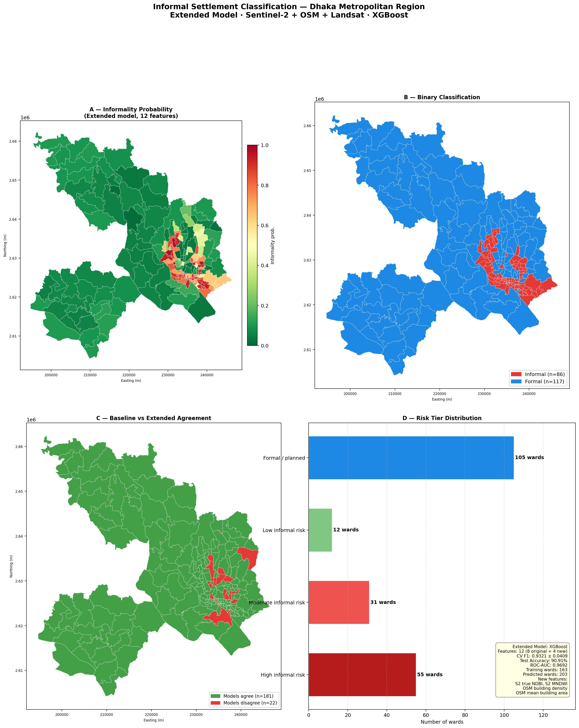
Figure 1. Ward-level classification dashboard: informality probability distribution, risk tiers, and top-ranked wards (extended 12-feature reference model).

5.1 Classification accuracy under four evaluation configurations
Table 3 reports 5-fold cross-validated accuracy for four configurations, from least to most conservative: the full 12-feature model on all 170 labeled wards (reference), the decoupled 7-feature model on the same 170 wards, the full-feature model restricted to the 63 anchor-only wards, and the decoupled model restricted to anchor-only wards (strictest — free of both rule-derived features and rule-derived labels).
Configuration | n | Features | CV Accuracy | 95% CI | Majority baseline
Reference (rule-circular) | 170 | 12 | 87.1% | [81.1%, 93.1%] | 64.1%
Decoupled | 170 | 7 | 85.3% | [78.6%, 92.0%] | 64.1%
Reference, anchor-only | 63 | 12 | 76.2% | [68.7%, 83.6%] | 68.3%
Decoupled, anchor-only (strictest) | 63 | 7 | 79.4% | [69.2%, 89.5%] | 68.3%
Table 3. Cross-validated classification accuracy under four evaluation configurations.
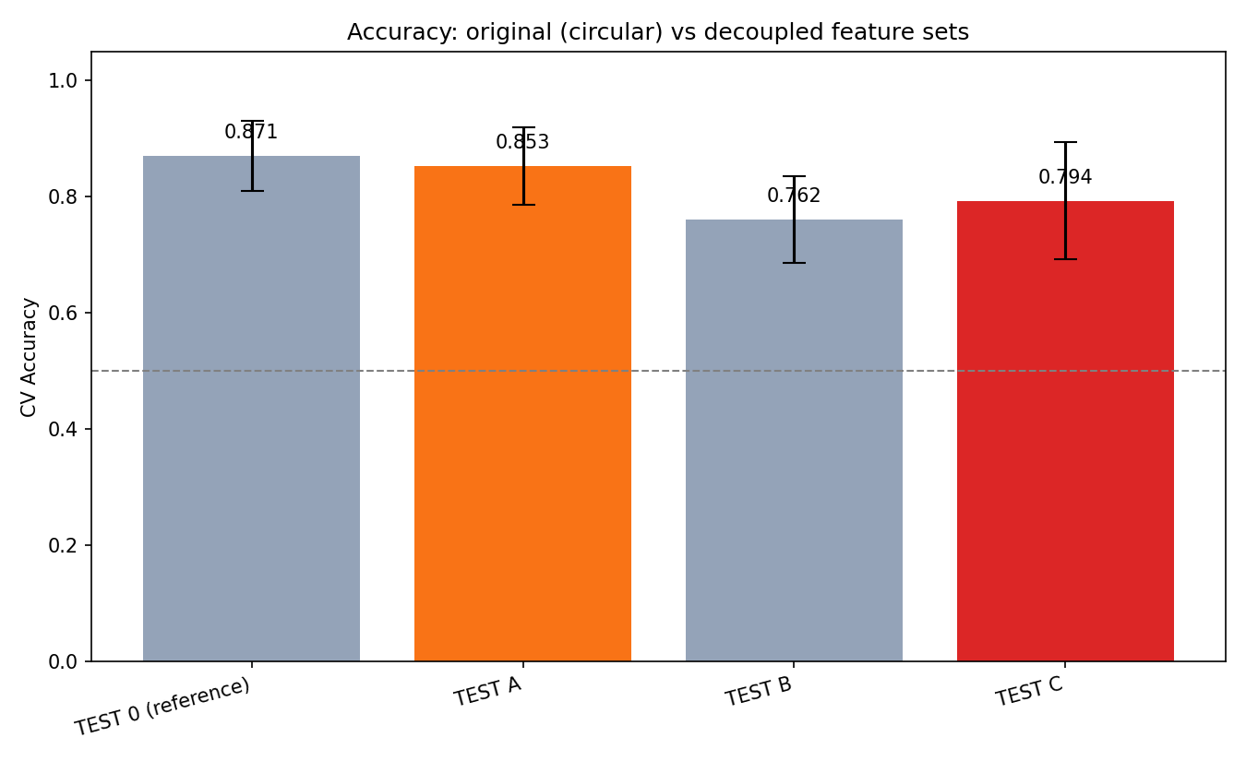
Figure 2. Cross-validated accuracy across the four evaluation configurations in Table 3, with 95% confidence intervals and the majority-class baseline.
The reference model's 87.1% accuracy substantially reflects the rule-derived features, since it is evaluated on a label set that is 89% rule-generated. The decoupled model on the full 170-ward set retains most of this performance (85.3% vs. 87.1%) while excluding every rule-implicated feature, indicating genuine informality signal beyond rule reconstruction; its 95% CI [0.786, 0.920] sits well clear of the 64.1% majority-class baseline for that set. On the strictest configuration (decoupled features, anchor-only labels), accuracy is lower (79.4%) but remains clearly above the 68.3% majority-class baseline for that class-imbalanced subset (43 informal, 20 formal) — confirming the effect survives even when both potential sources of circularity are removed simultaneously.
Feature importance in the decoupled model is led by OSM building density (38.0%) and SAVI (25.5%), followed by S2 true NDBI, OSM mean building area, slope, population standard deviation, and S2 MNDWI — all variables independent of the labeling rule.
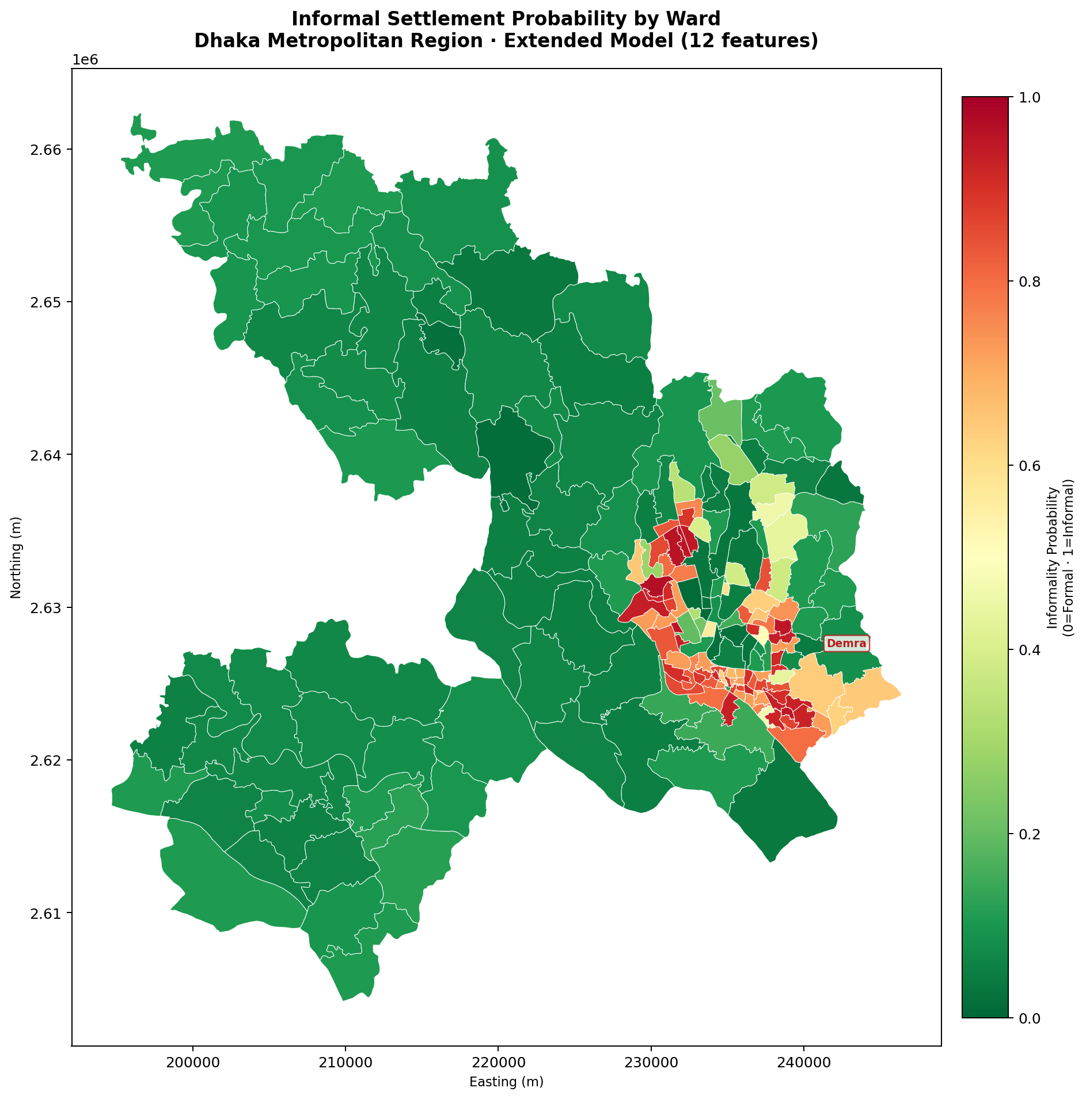
Figure 3. Ward-level predicted probability of informality across the Dhaka Metropolitan Region.
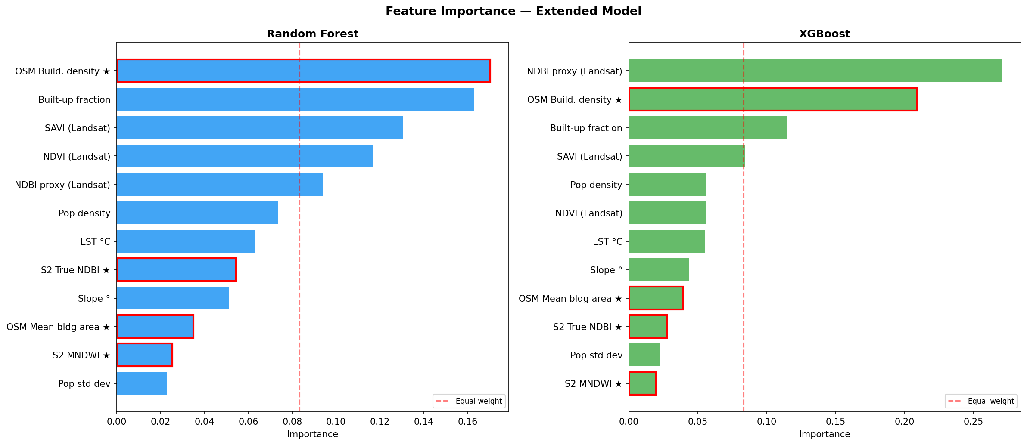
Figure 4. XGBoost feature importances, reference model.

5.2 External validation against EO4SD 2017
Training labels correlate with the independent EO4SD informal-area fraction in the expected direction: informal-labeled wards average 11.0% EO4SD-mapped informal footprint versus 2.6% for formal-labeled wards (point-biserial r=-0.393, p<0.0001, n=170).
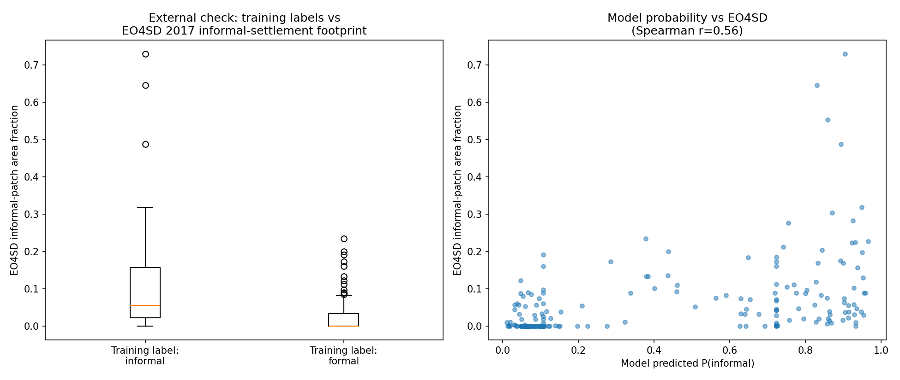
Figure 5. EO4SD 2017 informal-area fraction by training label, and model-predicted probability of informality plotted against it.
Table 4 reports the correlation between each model's predicted probability of informality and the EO4SD informal-area fraction, across all 203 wards.
Model | n | Spearman r | p
Reference (12 features, rule-circular) | 203 | 0.639 | <0.0001
Decoupled (7 features, n=170 labeled) | 203 | 0.652 | <0.0001
Decoupled (7 features, anchor-only n=63) | 203 | 0.089 | 0.21 (n.s.)
Table 4. Correlation between model-predicted probability of informality and independent EO4SD 2017 informal-area fraction.
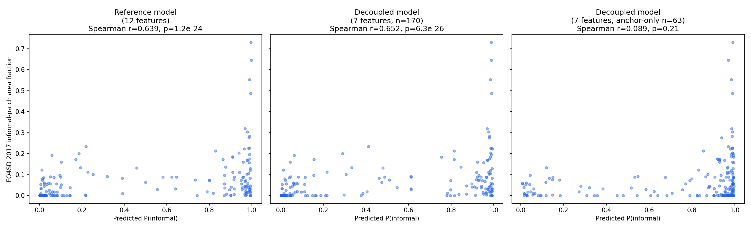
Figure 6. Predicted probability of informality vs. EO4SD informal-area fraction, compared across the reference, decoupled (n=170), and decoupled anchor-only (n=63) models.
The decoupled model trained on the full 170-ward set matches — marginally exceeds — the rule-circular reference model's correlation with this fully independent dataset (Spearman r=0.652 vs. 0.639, both p<0.0001), providing external confirmation that the rule-independent features carry genuine, geographically consistent informality signal. The anchor-only decoupled model's correlation is not statistically significant (r=0.089, p=0.21), which we attribute to the small anchor sample (n=63) being underpowered to fit a stable full-city probability surface across 203 wards, rather than to the anchor labels themselves being unreliable (Section 7).

5.3 Spatial cross-validation
Random cross-validation can overstate real-world generalization for spatial data, since neighbouring wards sharing similar urban morphology may be split across the train and test folds. We re-evaluated both the reference and decoupled models under two additional cross-validation schemes, each ensuring no ward from the same group appears in both the train and test fold of a split: thana-grouped (StratifiedGroupKFold on NAME_3, the real administrative unit one level above ward; 41 groups, 5 folds, 0 degenerate folds) and spatial-block (StratifiedGroupKFold on 8 KMeans clusters of ward centroids; more size-balanced than thana grouping, though one block absorbed 61 of 170 wards, producing single-class test folds in 2 of 5 splits).

Model | Random CV | Thana-grouped | Spatial block
Reference (12 features, circular) | 87.1% | 82.4% (−4.6pp) | 86.8% (−0.3pp)
Decoupled (7 features) | 85.3% | 84.2% (−1.1pp) | 83.1% (−2.2pp)

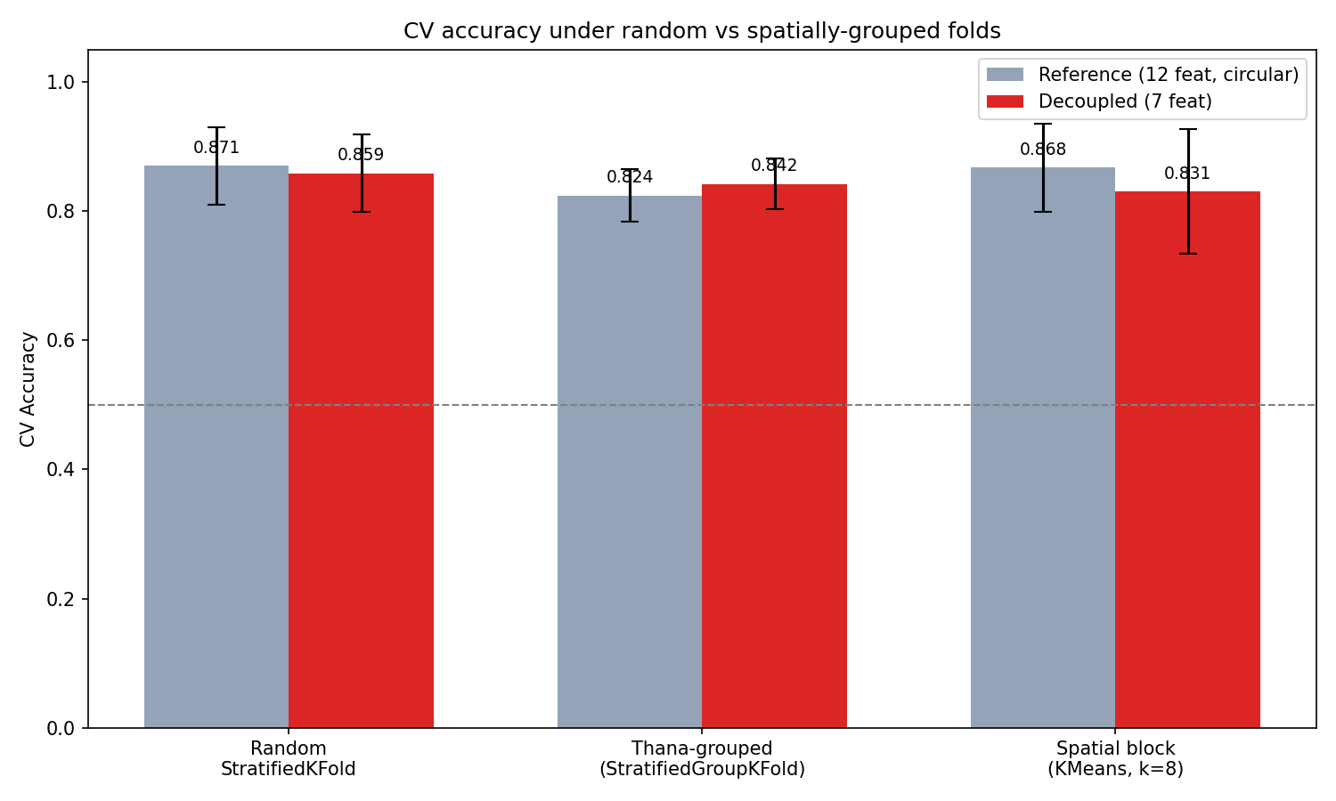
Figure 7. Cross-validated accuracy under random, thana-grouped, and spatial-block folds, reference and decoupled models.
Accuracy drops modestly under both spatially-grouped schemes relative to random cross-validation, and in both cases the drop falls within the random-CV 95% confidence interval. This indicates the headline accuracy is not primarily an artifact of spatial autocorrelation between neighbouring wards, though some optimism from random splitting cannot be fully ruled out given the sample size. We treat the thana-grouped result as the more reliable of the two spatial checks, since it uses a real administrative unit rather than an arbitrary clustering and produced no degenerate folds.

5.4 Feature ablation
To test whether the decoupled model's performance reflects a genuine contribution from each feature group rather than simple feature accumulation, we added rule-independent feature groups cumulatively (M1–M4) and evaluated both cross-validated accuracy and external correlation with the EO4SD informal-area fraction at each step. The circular reference model (M5, including the five rule-derived variables) is included only as context, not as a fair comparison point.

Model | Features added | CV Accuracy | External Spearman r
M1 | SAVI, slope | 81.8% | 0.556
M2 | + population std. dev. | 86.5% | 0.584
M3 | + Sentinel-2 NDBI/MNDWI | 84.1% | 0.623
M4 | + OSM building density/area (= full decoupled model) | 85.9% | 0.652
M5 | Reference (+ 5 rule-derived vars, CIRCULAR) | 87.1% | 0.639

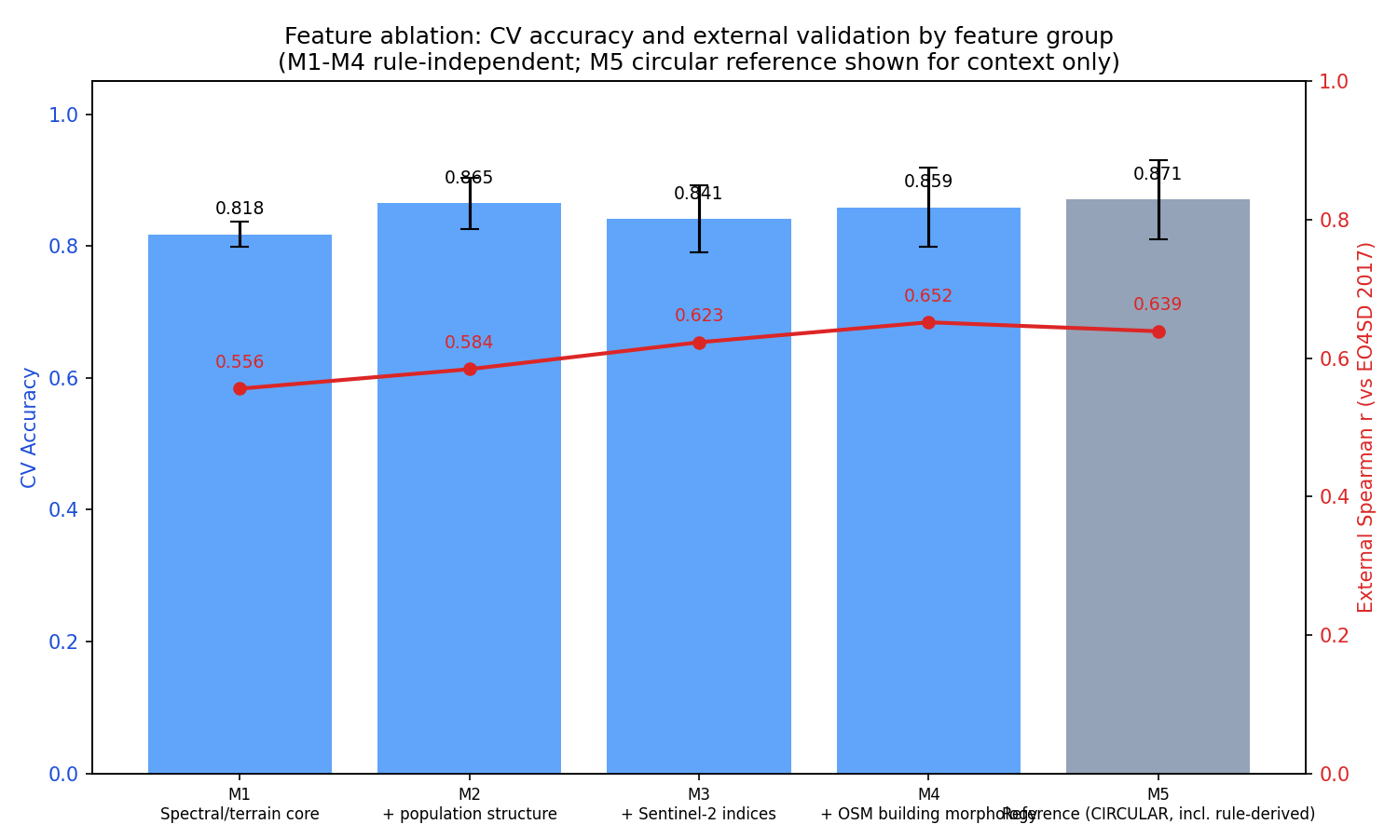
Figure 8. Feature ablation: CV accuracy (bars) and external Spearman r vs. EO4SD (line) by cumulative feature group.
External validation correlation rises monotonically from M1 to M4, and the fully rule-independent M4 model (the decoupled model reported throughout this paper) achieves a higher external correlation than the circular M5 reference (r=0.652 vs. 0.639). Cross-validated accuracy is noisier given the modest sample size, but tells a broadly consistent story: no feature group contributes nothing, and OSM building morphology (the M3→M4 step) produces the largest single gain in external validity — the metric least susceptible to circularity, since it is computed against data untouched by labeling or feature construction. The M4 accuracy in this table (85.9%) differs by 0.6 percentage points from the headline decoupled figure (85.3%) although the data, folds, seed and hyperparameters are identical; the only difference is the order in which the same seven features enter the model, which changes the column-subsampling draws in XGBoost (a reversed column order gives 84.1%). This spread is a measure of training noise and sits well inside the fold-to-fold standard deviation of 7.7 points.

5.5 Per-class metrics and confusion matrix
Accuracy and weighted F1 can look favourable even when a less-represented class is poorly characterized. We computed out-of-fold predictions (every ward predicted once, by a model that never trained on it) for the reference and decoupled models under random and thana-grouped cross-validation, and report balanced accuracy, macro-F1, and the Matthews correlation coefficient (MCC) alongside per-class recall, none of which inflate under class imbalance the way raw accuracy can.

Model / scheme | Bal. accuracy | Macro-F1 | MCC | Informal recall | Formal recall
Reference / random | 85.6% | 85.8% | 0.717 | 80.3% | 90.8%
Reference / thana-grouped | 80.5% | 80.7% | 0.614 | 73.8% | 87.2%
Decoupled / random | 84.7% | 84.7% | 0.693 | 80.3% | 89.0%
Decoupled / thana-grouped | 82.2% | 82.6% | 0.652 | 75.4% | 89.0%

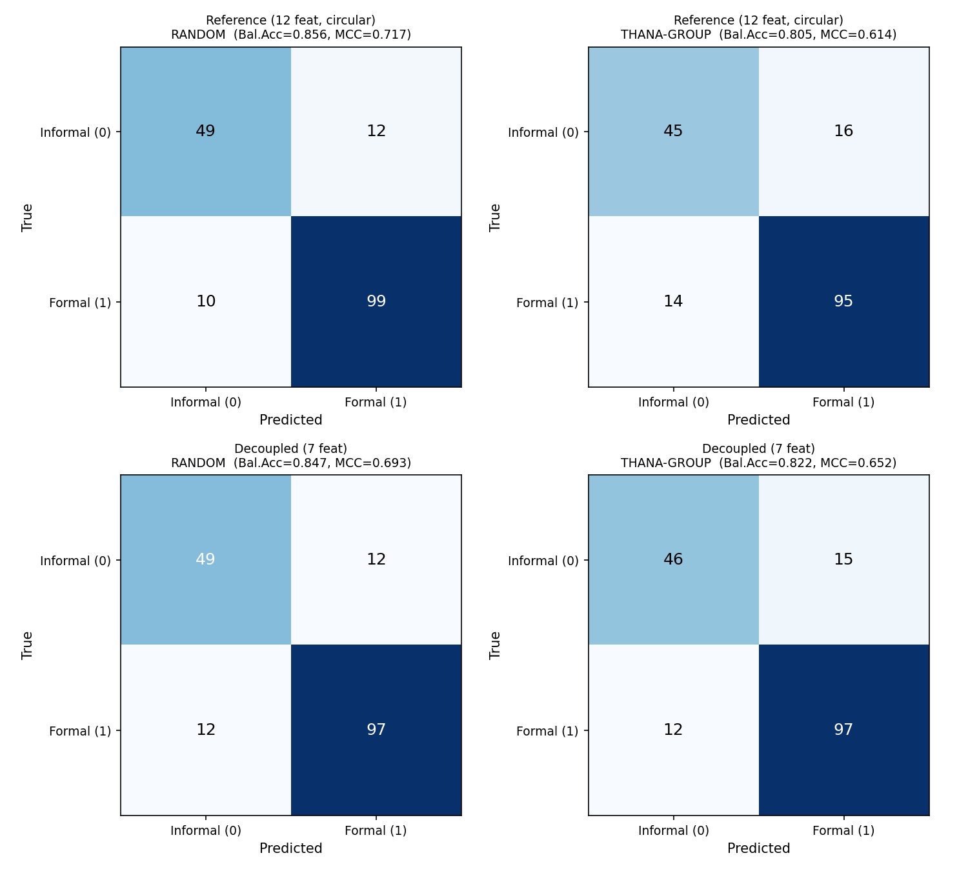
Figure 9. Confusion matrices (out-of-fold predictions), reference and decoupled models under random and thana-grouped cross-validation.
Balanced accuracy and macro-F1 track plain accuracy closely across all four model/scheme combinations, indicating no large inflation from the formal-class majority. MCC values of 0.61–0.72 represent a respectable effect size for a binary ward classifier. The informal class — the minority class, and the one most directly relevant to planning intervention — is recalled at 73–80% rather than being swamped by the larger formal class, under both the random and the more conservative thana-grouped scheme.

5.6 SHAP feature attribution
XGBoost gain-based importances (Section 5.1) rank features but do not show the direction of their effect. We computed SHAP (SHapley Additive exPlanations) values for the decoupled model, fit on all 170 labeled wards, to show both the direction and the per-ward distribution of each feature's contribution.

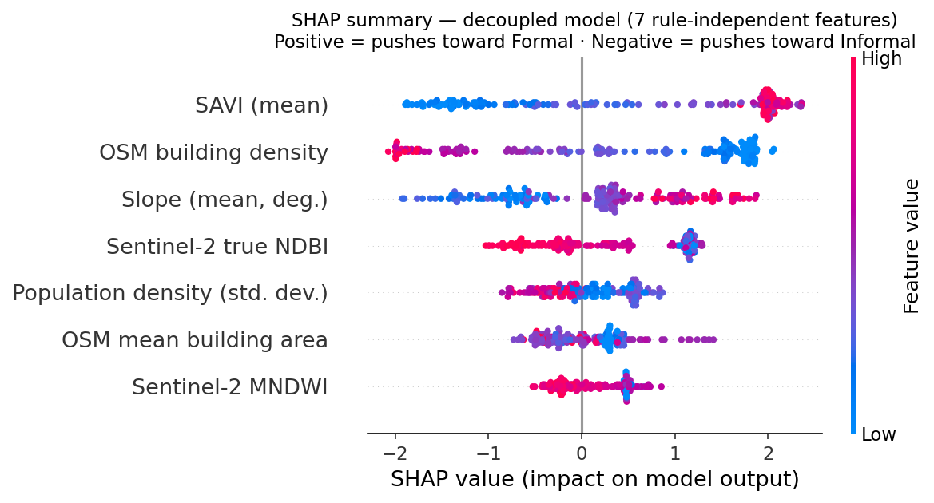
Figure 10. SHAP summary plot, decoupled model. Positive values push toward Formal; negative values push toward Informal.
The SHAP ranking (SAVI, OSM building density, slope, Sentinel-2 true NDBI, population standard deviation, OSM mean building area, Sentinel-2 MNDWI) is consistent with the gain-based ranking in Section 5.1, and the direction of effect matches planning intuition: higher SAVI (more vegetation) pushes toward Formal, higher OSM building density pushes toward Informal, and slope shows a non-linear pattern in which both very low and very high values push toward Informal while intermediate values push toward Formal — plausibly reflecting that both flood-prone low-lying fringe land and steep, less-serviceable land are disproportionately informally settled in Dhaka, while moderate-slope land was preferentially selected for planned development.

5.7 Agreement analysis against EO4SD
Section 5.2 reports Spearman rank correlation between model predictions and the EO4SD informal-area fraction. Because the two measures are a predicted probability and a mapped area fraction — related constructs on different scales rather than the same measurement repeated twice — a Bland-Altman-style plot (mean of the two measures vs. their difference) cannot be interpreted as a calibration check in the usual sense, but it does make visible where the two measures track together and where they diverge.

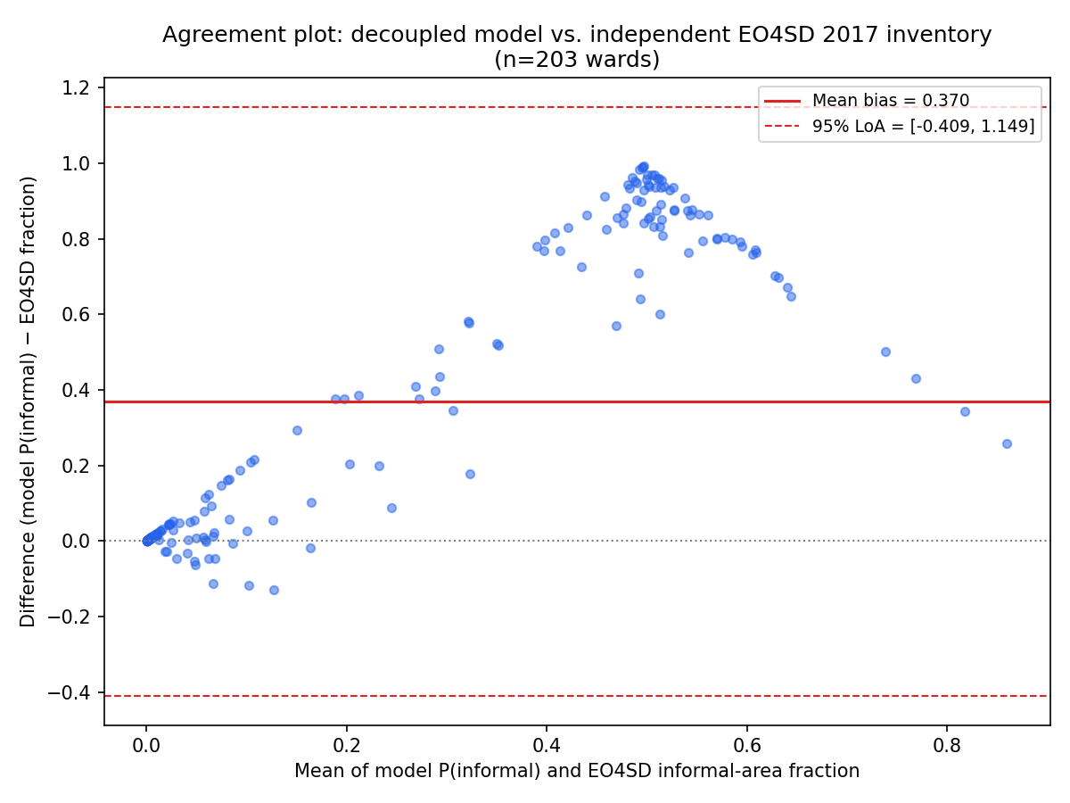
Figure 11. Agreement plot: decoupled model P(informal) vs. EO4SD 2017 informal-area fraction (n=203).
The two measures agree closely for wards near zero on both scales (mean bias ≈0 for the lowest-informality wards), diverge most in the middle of the range — where the model's predicted probability rises toward 1 well before EO4SD's mapped-area fraction does, since a ward can contain a probability-dominating informal core while the EO4SD polygons cover only part of its area — and partially reconverge at the highest-informality end. No ward fell outside the 95% limits of agreement, i.e. the divergence is a smooth, scale-related pattern rather than a small number of outlier wards driving it. We read this as consistent with the rank-based Spearman result (Section 5.2): the model and EO4SD agree on which wards are more or less informal, even though their absolute scales are not directly comparable.

5.8 Human label audit
The decoupled-feature and external-validation checks above test whether the model's predictions are circular with respect to the labeling rules; they do not test whether the labels themselves correspond to real-world informality. To check this directly, the lead author independently classified a stratified random sample of 40 wards (10 each drawn from the four label sources: rule-derived formal, rule-derived informal, anchor-matched formal, anchor-matched informal) as informal or formal from Google Maps satellite imagery alone, blind to the assigned label and judging each ward in isolation rather than by comparison against other wards.

 | Rule/anchor: informal | Rule/anchor: formal
Human judgment: informal | 16 | 7
Human judgment: formal | 4 | 13

Raw agreement was 72.5% (29/40); Cohen's kappa = 0.450, indicating moderate agreement (Landis and Koch 1977). This is weaker than the substantial-or-better agreement that would most strongly support the labels, but well above chance, and the residual disagreement is itself informative: 7 of 11 disagreements are wards the rule/anchor pipeline labeled formal but that appeared informal on visual inspection, versus 4 in the opposite direction, consistent with the peri-urban paurashava-type wards flagged as a source of ambiguity elsewhere in this study. We report this result as a limitation rather than a validation: it indicates the labels are a moderately reliable, not a definitive, ground truth, and that some of the formal-labeled wards in particular may be visually closer to the informal class than their label implies.

6. Discussion

6.1 Ward-scale versus pixel/object-scale classification
Compared to the pixel-level Dhaka U-Net baseline (72–79% F1), a ward-level 79.4% accuracy under the strictest evaluation is competitive, and is achieved using free, medium-resolution data (Landsat, Sentinel-2, WorldPop, OSM) rather than commercial VHR imagery — a meaningful practical advantage for repeat, low-cost monitoring by a resource-constrained planning agency. Compared to the object-level Riyadh OBIA study (96% overall accuracy), this study is clearly less accurate, but that result rested on 6,000 hand-verified ground-truth points against 63 anchor wards here — roughly two orders of magnitude more manual verification effort. We present this as an honest trade-off rather than a shortcoming to obscure: coarser spatial resolution and lower accuracy, in exchange for a planning-relevant administrative unit, near-zero data cost, and dramatically lower ground-truth burden.

6.2 Explainability
Where the reviewed CNN-based literature is largely black-box, the XGBoost feature importances reported here (Section 5.1) are directly interpretable: OSM building density and SAVI dominate the decoupled model, both plausible proxies for the built-form irregularity and vegetation scarcity long associated with informal development in the urban-planning literature. This directly addresses the explainability gap identified as a persistent limitation of the field. The gap is not unique to CNN-based work: even tree-based comparisons framed explicitly around model choice, such as Shao et al.'s (2024) Random Forest/XGBoost benchmark, stop short of reporting which features drive predictions. Yang et al.'s (2026) building-morphometrics approach is a notable recent exception pursuing interpretability directly, though at building rather than ward scale. SHAP values for the decoupled model (Section 5.6) extend this interpretability beyond a single importance ranking, showing each feature's direction of effect per ward, including a non-linear slope effect plausibly tied to both flood-prone low-lying and steep, less-serviceable land being disproportionately informally settled.

6.3 The value of decoupled evaluation
The gap between the reference model's 87.1% accuracy and the decoupled model's 85.3% — and the near-identical external validation correlation between the two (Spearman r=0.639 vs. 0.652) — together indicate that most, though not all, of the reference model's apparent performance reflects genuine signal rather than circularity. Had we reported only the reference model's accuracy, as is standard practice in this literature, the result would have been defensible on its face but vulnerable to a circularity critique we would not have been positioned to answer. We suggest that any rule- or anchor-labeled remote-sensing classification study report this decomposition as a matter of course.

7. Limitations
This study has several limitations. First, the training labels combine a small set of ground-truth anchor wards (63, of which only 20 are formal) with rule-based labels derived from feature thresholds; although rule-derived variables were removed from the feature set used for the reported headline accuracy and correlation figures, and the resulting model's predictions correlate significantly with an independent 2017 informal-settlement inventory, the anchor-only subset remains too small to support a fully independent accuracy estimate on its own — cross-validation on that subset alone yields wide confidence intervals, and using it to train a full-city probability surface did not reach statistical significance against external validation. Second, the formal-settlement class is under-represented relative to informal, both in the anchor set (20 vs. 43) and after rule-based labeling (109 vs. 61 including rule labels), which likely limits the model's ability to characterize the full diversity of planned development in Dhaka. Third, the external validation source (EO4SD 2017) predates or postdates some of the satellite inputs used here (Landsat 9 2022, Sentinel-2 2021), so a degree of temporal mismatch is expected and may attenuate rather than inflate the observed correlation. Fourth, ward-level classification necessarily aggregates within-ward heterogeneity — a ward with both a dense informal core and a planned periphery is scored as a single unit, appropriate for the planning-unit framing adopted here but a loss of the spatial precision pixel- or object-level approaches provide. Fifth, GADM administrative boundaries used here are current as of their release and may not perfectly reflect current-era ward boundaries or DNCC/DSCC ward renumbering, which could introduce small spatial misalignments in both feature extraction and the EO4SD overlay. Sixth, because neighbouring wards can share similar urban morphology, ordinary random cross-validation may overstate generalization; we therefore also evaluated the decoupled model under thana-grouped and spatially-blocked cross-validation (Section 5.3). Accuracy fell modestly under both schemes and the drop in both cases falls within the random-CV confidence interval, indicating the reported accuracy is not primarily an artifact of spatial autocorrelation, though some optimism from random splitting cannot be ruled out entirely given the modest sample size. Finally, an independent visual audit of a 40-ward stratified sample against the assigned labels (Section 5.8) showed only moderate agreement (Cohen's kappa=0.450), with a mild tendency for rule/anchor-labeled formal wards to appear informal on visual inspection; the labels should therefore be read as a moderately reliable, not a definitive, ground truth.

8. Conclusion
This study demonstrates that Dhaka's 203 wards can be classified as formal or informal settlements using only free, medium-resolution and crowd-sourced geospatial data, at an accuracy competitive with pixel-level deep-learning approaches applied to the same city, while remaining interpretable through feature importance analysis. In the process of validating the approach, we identified and corrected a label-feature circularity problem that inflated an initial accuracy estimate, and we show through a decoupled evaluation protocol and an external validation against an independently produced settlement inventory (EO4SD 2017, Spearman r=0.65, p<0.0001) that the corrected model retains genuine, externally verifiable predictive signal. Future work should prioritize expanding the ground-truth anchor set — particularly for the under-represented formal class — through targeted field verification or partnership with BBS or DNCC/DSCC, and should evaluate whether the decoupled feature set generalizes to other rapidly urbanizing South Asian cities facing similar data constraints.

References
Alrasheedi, K. G., et al. (2024). Combining Local Knowledge with Object-Based Machine Learning Techniques for Extracting Informal Settlements from Very High-Resolution Satellite Data. Earth Systems and Environment. https://doi.org/10.1007/s41748-024-00393-1
Shinjini, S. S. (2025). Slum Area Detection in Dhaka City, Bangladesh, Using Satellite Remote Sensing and Deep Learning. South Dakota State University, Electronic Theses and Dissertations, 1741. https://openprairie.sdstate.edu/etd2/1741/
Raj, A., Mitra, A., & Sinha, M. (2024). Deep Learning for Slum Mapping in Remote Sensing Images: A Meta-analysis and Review. arXiv:2406.08031. https://arxiv.org/abs/2406.08031
Gruebner, O., Sachs, J., Nockert, A., Frings, M., Khan, M. M. H., Lakes, T., & Hostert, P. (2014). Mapping the Slums of Dhaka from 2006 to 2010. Dataset Papers in Science, 2014, 172182. https://doi.org/10.1155/2014/172182
Bangladesh Bureau of Statistics (BBS) (2015). Census of Slum Areas and Floating Population 2014. Ministry of Planning, Government of Bangladesh.
Angeles, G., et al. (2009). The 2005 census and mapping of slums in Bangladesh: design, select results and application. International Journal of Health Geographics, 8, 32. https://doi.org/10.1186/1476-072X-8-32
World Bank / ESA EO4SD-Urban (2019). Dhaka, Bangladesh — Informal Settlements (EO4SD-Urban). World Bank Data Catalog, dataset 0041703.
Yang, H., Jimmy, E., Verburg, P. H., Kuffer, M., Levering, A., & van Vliet, J. (2026). A transferable and interpretable approach to slum mapping using building morphometrics and optical imagery. GIScience & Remote Sensing, 63(1). https://doi.org/10.1080/15481603.2026.2649308
Shao, Z., Ahmad, M. N., & Javed, A. (2024). Comparison of Random Forest and XGBoost Classifiers Using Integrated Optical and SAR Features for Mapping Urban Impervious Surface. Remote Sensing, 16(4), 665. https://doi.org/10.3390/rs16040665

