1. Download R studios here -> <https://rstudio.com/products/rstudio/download/>
2. Follow the instructions on the site
3. Place the Arena.R into your preferred working directory
4. Open R studio shortcut on desktop
5. To set your working directory to the R file, use setwd()

* Getwd() returns where the current directory R studio is set to
* Setwd("C:/Users”) is going set the working directory to this path

1. Hit Install, enter Reshape2 in packages line to download the Reshape2 library

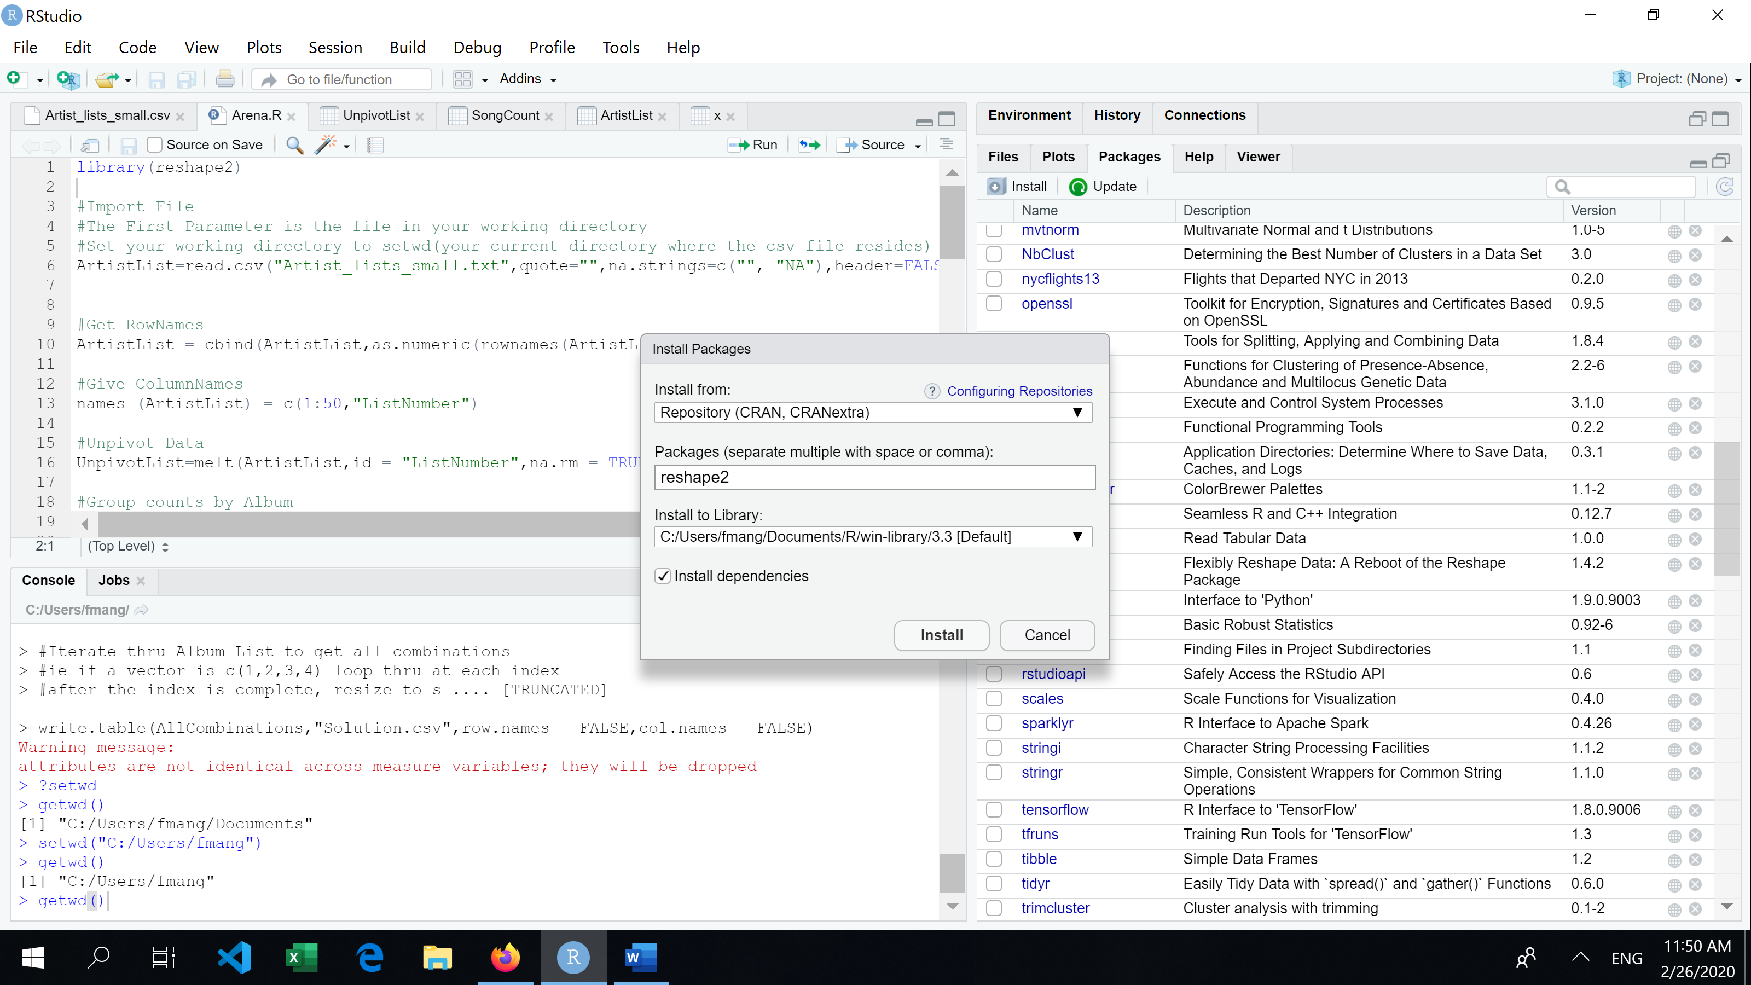

1. 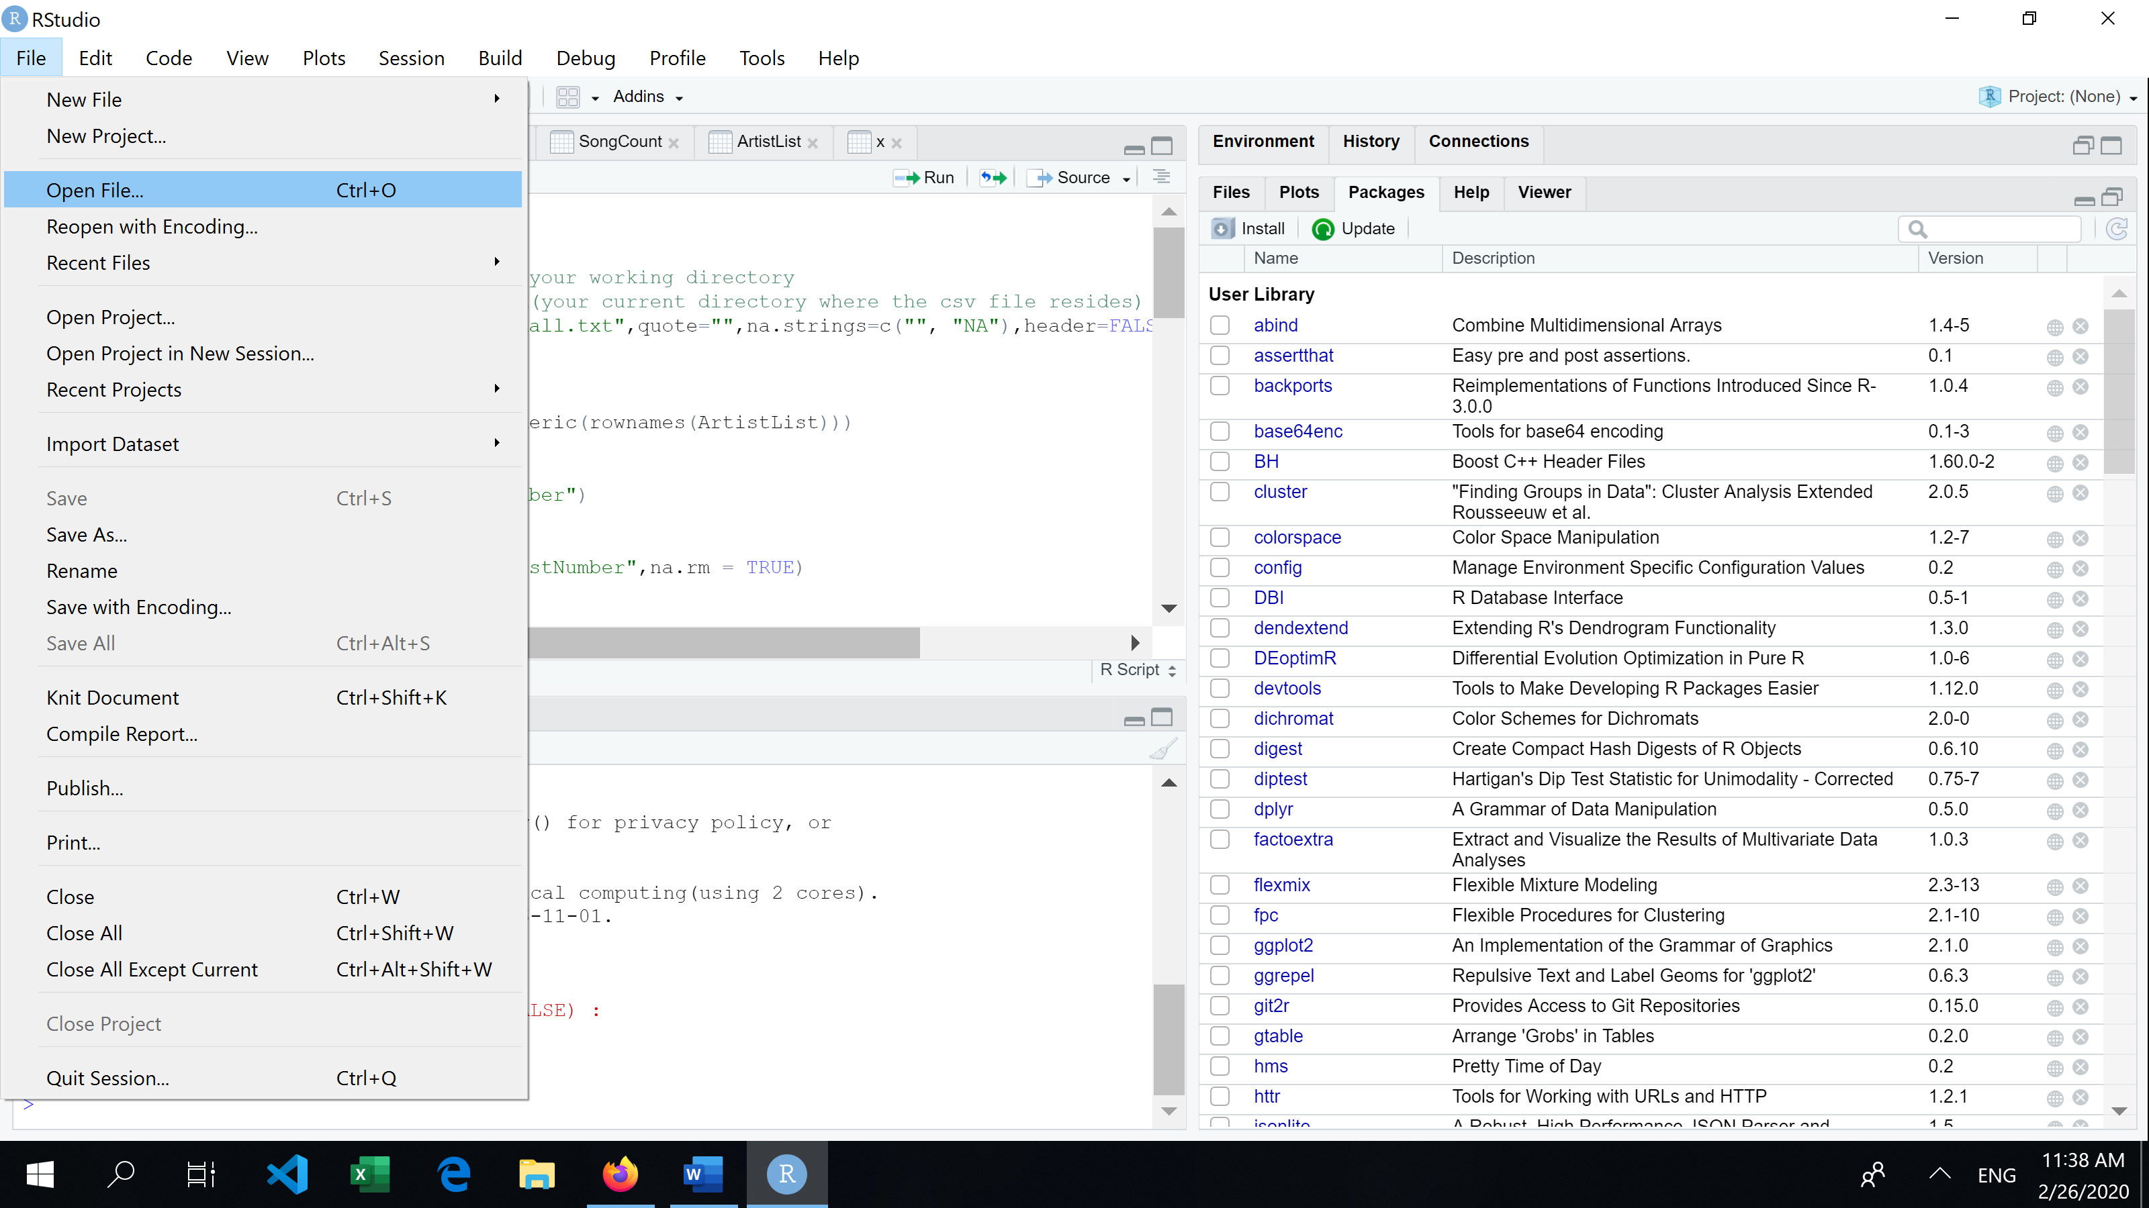
2. Open File -> Search for location where Arena.R script file & open
3. Click on the source to run the script

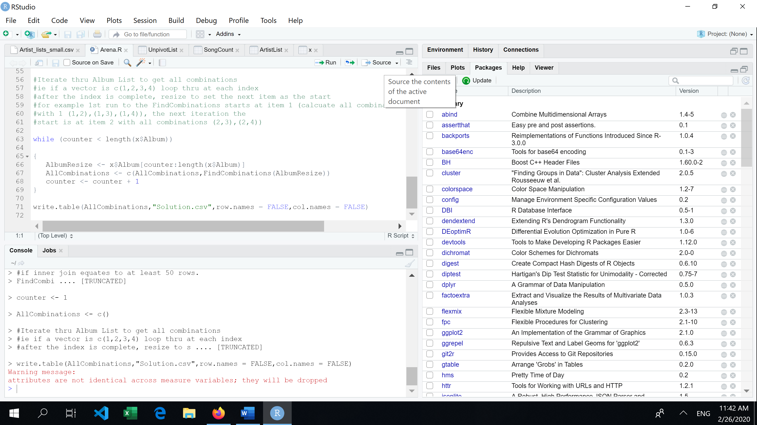

1. The file is created at the current working directory