|  |  |
| --- | --- |
| Capstone  ACME Startup Relocation | Abstract  This Capstone project is a demonstration of key data science concepts applied to the scenario of a company relocation using factors determined by an employee survey.  Manja, Frank  IBM Data Science Professional |

# Introduction/Business Problem

ACME Start is a Machine Learning (ML) startup in New York City that recently received Series A Funding in the amount of $20M USD. ACME currently has 10 employees and is looking to grow to 20 employees by years end. The startup has outgrown its current location and needs to relocate to accommodate current and future employees.

# Data

The Chief Executive Officer (CEO) is concerned that the relocation may result in staff attrition so the CEO asks the Human Resources (HR) Director to perform a survey of employees. The survey asks employees to rank factors that the company will incorporate in the selection of the new location. These factors include proximity to mass restaurants, parks, and gyms. The HR Director will use these results of the survey and Foursquare location data to prepare a report of suitable locations for the relocation.

# Methodology

The Data Science team follows the standard Data Science Methodology illustrated in Figure 1.

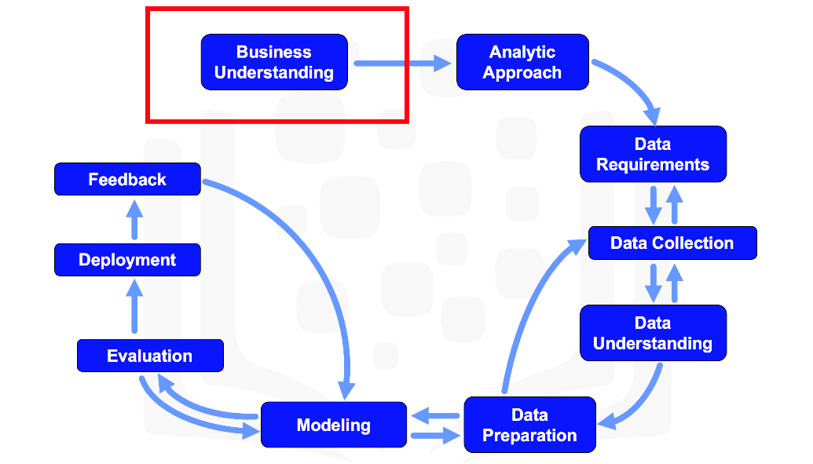

Figure 1. Data Science Methodology

## Business Understanding

The HR Director is the lead for this analysis. She understands that office relocations can be stressful for employees and at time bring about unwanted attrition so she will prioritize employee engagement.

## Analytics Approach

The HR Director has asked the Data Science team to conduct a survey to of employees to gauge employee sentiment and use the information learned in that survey to guide the data analysis.

## Data Requirements

The Data Science team will center their analysis on three data sources:

* Employee Survey
* New York City Maps
* Foursquare Location Data

## Data Collection

The Data Science team has collected the raw survey results from employees using SurveyMonkey. The team downloaded mapping files from the NY city website. The team signed up for a Foursquare account to access data using the Foursquare API.

## Data Understanding

The Data Science team will use standard data exploration techniques on each data source to learn the structure and dimensions of all data.

## Data Preparation

The Data Science team will transform data, making sure there are no missing data values, and incorrect data types. The team will impute missing data from available data. Also, the team will map Foursquare Venue Categories to the ranked features that employees called for in the survey. All data transformation steps will be documented in the Notebook.

## Modeling

The Data Science team will furnish maps of potential sites and segment the sites by their features. The team decided to use clustering and segmentation techniques as they perform well on geographical data where unsupervised learning is needed. The team will use K-means with K=5.

## Evaluation

The Data Science team will evaluate sites for suitability by determining what venues are within 200 meters of potential locations.

## Deployment

The Data Science team will present findings to the HR Director and CEO.

## Feedback

The Data Science team will solicit feedback from the HR Director and CEO, both of whom may ask for additional factors to be included in the analysis.

# Data Analysis

## Survey Data

The raw survey contained ten records. One record for each employee in the startup.

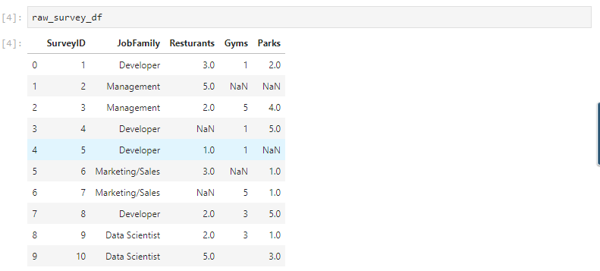

As common in most surveys, the survey takers did not answer every question. The Data Science team worked to identify missing data and incorrect datatypes.

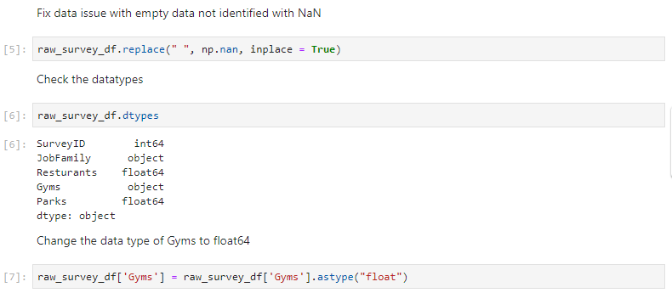

To deal with the missing data the Data Science team replaced missing data with the mean of values of available data.

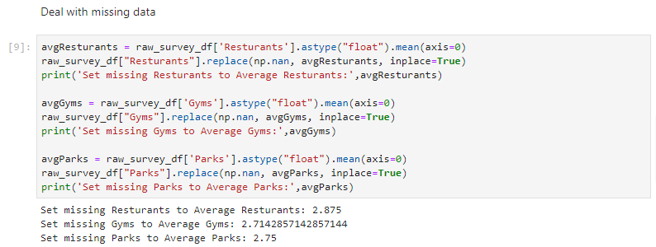

The team performed exploratory data analysis on the survey.

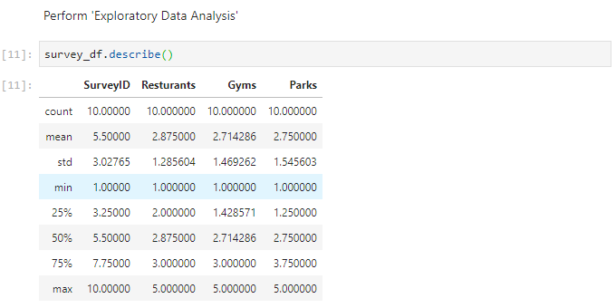

The team visualize the survey data.

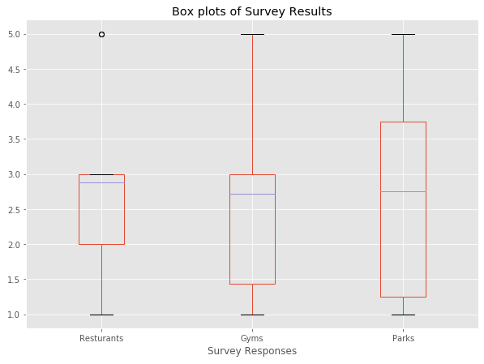

The team calculated the means of survey factors to determine the ranking of location factors that staff want to inform the relocation decision.

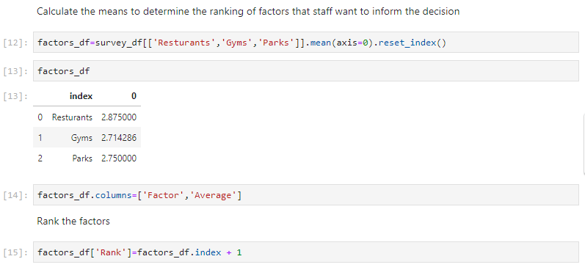

The ranked factors are in order: Restaurants, Gyms, and Parks.

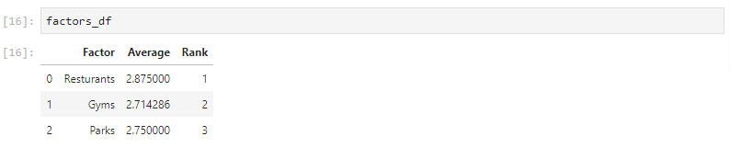

## New York Neighborhood Dataset

The New York Neighborhood dataset has a total of 5 boroughs and 306 neighborhoods. A link to the dataset is at <https://geo.nyu.edu/catalog/nyu_2451_34572>. Sample data from the dataset is shown below.

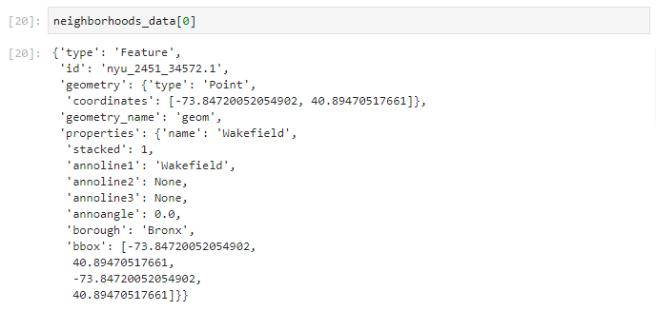

The CEO decided to center the relocation search to neighborhoods in Manhattan.

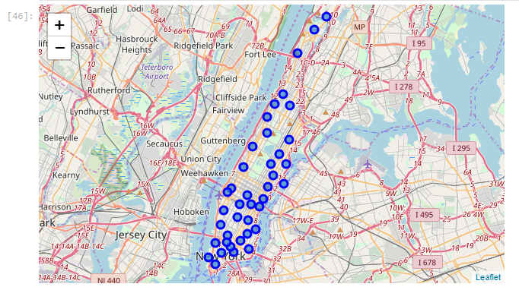

The Data Science team used the Foursquare API to get venue information for each of the Manhattan neighborhoods.

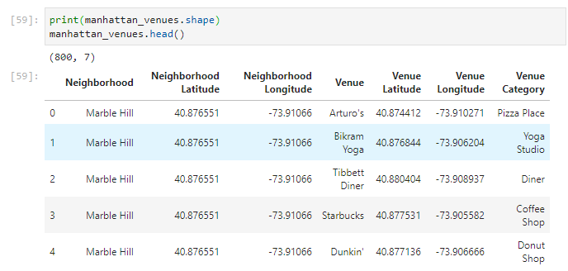

However, the venue categories provided by Foursquare varied significantly from the location factors the employees were surveyed on. The Data Science team wrote a function to map Foursquare venue categories to location factors and in the process consolidated all place to eat into the Restaurants factor, all places of leisure to the Parks factor, and all places for physical activity to the Gyms factor. The function is provided below.

|  |
| --- |
| # Function to map venue categories to employee factors  def Map_Venue_Category(Venue_Category):    #print (Venue_Category)  if re.search('Restaurant', Venue_Category, re.IGNORECASE):    return 'Restaurant'    if re.search('Joint', Venue_Category, re.IGNORECASE):    return 'Restaurant'    if re.search('Tea Room', Venue_Category, re.IGNORECASE):    return 'Restaurant'    if re.search('Pizza Place', Venue_Category, re.IGNORECASE):    return 'Restaurant'    if re.search('Donut Shop', Venue_Category, re.IGNORECASE):    return 'Restaurant'    if re.search('Coffee Shop', Venue_Category, re.IGNORECASE):    return 'Restaurant'    if re.search('Bagel Shop', Venue_Category, re.IGNORECASE):    return 'Restaurant'    if re.search('Bakery', Venue_Category, re.IGNORECASE):    return 'Restaurant'    if re.search('Bar', Venue_Category, re.IGNORECASE):    return 'Restaurant'    if re.search('Bistro', Venue_Category, re.IGNORECASE):    return 'Restaurant'    if re.search('Beer', Venue_Category, re.IGNORECASE):    return 'Restaurant'    if re.search('Burrito', Venue_Category, re.IGNORECASE):    return 'Restaurant'    if re.search('Breakfast', Venue_Category, re.IGNORECASE):    return 'Restaurant'    if re.search('Tea Shop', Venue_Category, re.IGNORECASE):    return 'Restaurant'    if re.search('Candy', Venue_Category, re.IGNORECASE):    return 'Restaurant'    if re.search('Café', Venue_Category, re.IGNORECASE):    return 'Restaurant'    if re.search('Cheese', Venue_Category, re.IGNORECASE):    return 'Restaurant'    if re.search('Chocolate', Venue_Category, re.IGNORECASE):    return 'Restaurant'    if re.search('Bridge', Venue_Category, re.IGNORECASE):    return 'MassTransit'    if re.search('Bus Line', Venue_Category, re.IGNORECASE):    return 'MassTransit'    if re.search('Community Center', Venue_Category, re.IGNORECASE):    return 'Park'    if re.search('Cupcake', Venue_Category, re.IGNORECASE):    return 'Restaurant'    if re.search('Deli', Venue_Category, re.IGNORECASE):    return 'Restaurant'    if re.search('Dessert', Venue_Category, re.IGNORECASE):    return 'Restaurant'    if re.search('Diner', Venue_Category, re.IGNORECASE):    return 'Restaurant'    if re.search('Dog Run', Venue_Category, re.IGNORECASE):    return 'Restaurant'    if re.search('Farmers Market', Venue_Category, re.IGNORECASE):    return 'Restaurant'    if re.search('Food', Venue_Category, re.IGNORECASE):    return 'Restaurant'    if re.search('Fountain', Venue_Category, re.IGNORECASE):    return 'Park'    if re.search('Yogurt', Venue_Category, re.IGNORECASE):    return 'Restaurant'    if re.search('Gourmet', Venue_Category, re.IGNORECASE):    return 'Park'    if re.search('Grocery', Venue_Category, re.IGNORECASE):    return 'Restaurant'    if re.search('Gym', Venue_Category, re.IGNORECASE):    return 'Gym'    if re.search('Harbor', Venue_Category, re.IGNORECASE):    return 'Park'    if re.search('Histor', Venue_Category, re.IGNORECASE): #for historic and history    return 'Park'    if re.search('ice cream', Venue_Category, re.IGNORECASE):    return 'Restaurant'    if re.search('Liquor', Venue_Category, re.IGNORECASE):    return 'Restaurant'    if re.search('Memorial', Venue_Category, re.IGNORECASE):    return 'Park'    if re.search('Pie', Venue_Category, re.IGNORECASE):    return 'Restaurant'    if re.search('Poke Place', Venue_Category, re.IGNORECASE):    return 'Restaurant'    if re.search('Pool', Venue_Category, re.IGNORECASE):    return 'Park'    if re.search('Snack', Venue_Category, re.IGNORECASE):    return 'Restaurant'    if re.search('Steak', Venue_Category, re.IGNORECASE):    return 'Restaurant'    if re.search('Taco', Venue_Category, re.IGNORECASE):    return 'Restaurant'    if re.search('Tennis Stadium', Venue_Category, re.IGNORECASE):    return 'Park'    if re.search('Trail', Venue_Category, re.IGNORECASE):    return 'Park'    if re.search('Field', Venue_Category, re.IGNORECASE):    return 'Park'    if re.search('Spa', Venue_Category, re.IGNORECASE):    return 'Gym'    if re.search('Golf Course', Venue_Category, re.IGNORECASE):    return 'Restaurant'    if re.search('Playground', Venue_Category, re.IGNORECASE):    return 'Restaurant'    if re.search('Plaza', Venue_Category, re.IGNORECASE):    return 'Park'    if re.search('Basketball Court', Venue_Category, re.IGNORECASE):    return 'Park'    if re.search('GastroPub', Venue_Category, re.IGNORECASE):    return 'Restaurant'    if re.search('Momument', Venue_Category, re.IGNORECASE):    return 'Park'    if re.search('Sandwich', Venue_Category, re.IGNORECASE):    return 'Restaurant'    if re.search('Gastro', Venue_Category, re.IGNORECASE):    return 'Restaurant'    if re.search('Tennis', Venue_Category, re.IGNORECASE):    return 'Park'    if re.search('Waterfront', Venue_Category, re.IGNORECASE):    return 'Park'    else:  # if clean up needed return the same name  return Venue_Category |

After the Data Science Team mapped the venue categories to employee categories the resulting data was aligned with the objectives of the location analysis.

|  |
| --- |
| Neighborhood Employee_Venue_Category  Battery Park City Boat or Ferry 1  Cooking School 1  Gym 1  Park 6  Performing Arts Venue 1  Restaurant 8  Shopping Mall 1  Smoke Shop 1  Carnegie Hill Bookstore 1  Dance Studio 1  Gym 5  Park 2  Restaurant 9  Shoe Store 1  Wine Shop 1  Central Harlem Cycle Studio 1  Gym 1  Jazz Club 1  Library 1  Music Venue 1  Restaurant 15  Chelsea Hotel 1  Nightclub 2  Restaurant 14  Speakeasy 1  Theater 2  Chinatown Bike Shop 1  Garden Center 1  Gym 1  Hotel 1  Museum 1  Noodle House 2  Restaurant 13  Civic Center Antique Shop 1  Dance Studio 1  General Entertainment 1  Gym 4  Monument / Landmark 1  Park 1  Restaurant 10  Yoga Studio 1  Clinton Building 1  Comedy Club 1  Gym 3  Hotel 1  Indie Theater 1  Lounge 1  Movie Theater 1  Restaurant 7  Sporting Goods Shop 1  Theater 3  East Harlem Clothing Store 1  Dance Studio 1  Gym 1  Park 1  Pet Store 1  Pharmacy 1  Restaurant 14  East Village Restaurant 19  Wine Shop 1  Financial District Doctor's Office 1  Gym 4  Jewelry Store 2  Monument / Landmark 1  Park 1  Restaurant 10  Salad Place 1  Flatiron Bookstore 1  Cycle Studio 2  Furniture / Home Store 2  Gym 4  Miscellaneous Shop 1  Restaurant 7  Salad Place 1  Sports Club 1  Wine Shop 1  Gramercy Bike Rental / Bike Share 1  Comedy Club 1  Gym 1  Park 1  Restaurant 14  Thrift / Vintage Store 1  Yoga Studio 1  Greenwich Village Clothing Store 1  Cosmetics Shop 1  Jazz Club 1  Optical Shop 1  Park 1  Restaurant 14  Yoga Studio 1  Hamilton Heights Park 1  Pub 1  Restaurant 15  Smoke Shop 1  Yoga Studio 2  Hudson Yards Art Gallery 1  Department Store 1  Furniture / Home Store 1  Gym 1  Hotel 1  Music School 1  Park 1  Pet Store 1  Public Art 1  Residential Building (Apartment / Condo) 1  Restaurant 8  Supermarket 1  Theater 1  Inwood Park 2  Pet Store 1  Restaurant 14  Veterinarian 1  Wine Shop 1  Yoga Studio 1  Lenox Hill College Academic Building 1  Gift Shop 1  Gym 2  Park 1  Restaurant 11  Salad Place 1  Smoke Shop 1  Wine Shop 1  Women's Store 1  Lincoln Square Concert Hall 3  Gift Shop 1  Gym 1  Indie Movie Theater 3  Indie Theater 1  Library 1  Opera House 2  Park 2  Performing Arts Venue 2  School 1  Theater 3  Little Italy Animal Shelter 1  Clothing Store 1  Newsstand 1  Park 2  Restaurant 13  Salad Place 1  Women's Store 1  Lower East Side Art Gallery 2  Clothing Store 1  Park 1  Performing Arts Venue 1  Restaurant 14  Yoga Studio 1  Manhattan Valley Arts & Crafts Store 1  Bike Shop 1  Cosmetics Shop 1  Furniture / Home Store 1  Hostel 1  Park 1  Restaurant 12  Wine Shop 1  Yoga Studio 1  Manhattanville Gym 1  Lounge 1  Other Nightlife 1  Park 2  Restaurant 14  Supermarket 1  Marble Hill Bank 1  Department Store 1  Discount Store 1  Gym 1  Miscellaneous Shop 1  Park 1  Pharmacy 1  Restaurant 10  Supplement Shop 1  Video Game Store 1  Yoga Studio 1  Midtown Clothing Store 1  Gym 2  Hotel 2  Miscellaneous Shop 1  Park 3  Restaurant 8  Salad Place 1  Smoke Shop 1  Sporting Goods Shop 1  Midtown South Boutique 1  Building 1  Clothing Store 1  Cosmetics Shop 2  Hotel 1  Lingerie Store 2  Restaurant 12  Morningside Heights Bookstore 3  Outdoor Sculpture 1  Park 2  Pub 1  Restaurant 12  Salad Place 1  Murray Hill Hotel 2  Jazz Club 1  Lounge 1  Museum 1  Restaurant 14  Speakeasy 1  Noho Boutique 1  Gym 1  Hotel 1  Park 1  Restaurant 13  Rock Club 2  Wine Shop 1  Roosevelt Island Cosmetics Shop 1  Gym 2  MassTransit 1  Outdoors & Recreation 1  Park 3  Residential Building (Apartment / Condo) 1  Restaurant 9  Scenic Lookout 1  School 1  Soho Art Museum 1  Arts & Crafts Store 1  Boutique 1  Clothing Store 2  Cycle Studio 1  Dance Studio 1  Men's Store 2  Miscellaneous Shop 1  Optical Shop 1  Restaurant 5  Women's Store 3  Yoga Studio 1  Stuyvesant Town Boat or Ferry 2  Gas Station 1  Heliport 1  Park 6  Pet Service 1  Restaurant 9  Sutton Place Adult Boutique 1  Gym 4  Restaurant 13  Spiritual Center 1  Yoga Studio 1  Tribeca Cycle Studio 1  Gym 1  Hotel 1  Indie Theater 1  Park 2  Restaurant 10  Salad Place 1  Wine Shop 2  Yoga Studio 1  Tudor City Convenience Store 1  Martial Arts Dojo 1  MassTransit 1  Park 4  Restaurant 12  Yoga Studio 1  Turtle Bay Duty-free Shop 1  Gift Shop 1  Lounge 1  Martial Arts Dojo 1  Museum 1  Park 1  Residential Building (Apartment / Condo) 1  Restaurant 12  Tourist Information Center 1  Upper East Side Art Gallery 1  Bookstore 1  Boutique 1  Gym 2  Hotel 2  Jazz Club 1  Optical Shop 1  Restaurant 11  Upper West Side Bookstore 1  Cosmetics Shop 1  Gift Shop 1  Movie Theater 1  Pub 1  Restaurant 15  Washington Heights Market 1  Park 3  Restaurant 14  Wine Shop 2  West Village Accessories Store 1  Boutique 1  Cosmetics Shop 2  Park 2  Restaurant 13  Speakeasy 1  Yorkville Gym 1  Hobby Shop 1  Monument / Landmark 1  Park 1  Restaurant 13  Video Store 1  Wine Shop 2 |

# Results

The Data Science team used K-means with K=5 to cluster the Manhattan neighborhoods using the employee factors.

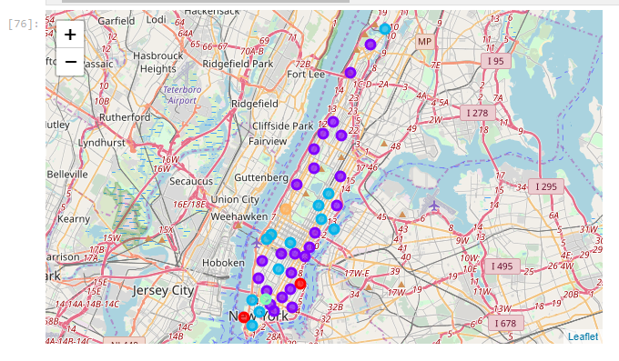

Then the Data Science team found the one location in all of Manhattan that had all the venues in the same rank order as the employees requested in the survey. That location was Carnegie Hill.

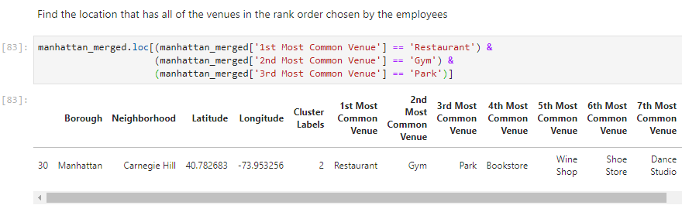

From Wikipedia we learned the following about Carnegie Hill:

Carnegie Hill is a neighborhood within the Upper East Side, in the borough of Manhattan in New York City. Its boundaries are 86th Street on the south, Fifth Avenue (Central Park) on the west, with a northern boundary at 98th Street that continues just past Park Avenue and turns south to 96th Street and proceeds east up to, but not including, Third Avenue.

# Discussion

The key element of this analysis was clearly the ranking of factors by employees. This was by design as the HR Director wanted to ensure employees felt they were heard and respected in this office relocations. As a startup it is critical to maintain key staff members. The analysis that the Data Science team undertook found the one location in Manhattan, NY that met all criteria.

Potentially, the analysis could be tweaked by adding new survey questions for employees or weighting the response of developers and data scientist over others in the company. Also, the search radius around each location could be increased from 200 meters (1 city block) to 500 meters (2.5 city blocks) to get more information on nearby venues. However, that could lead to noise and potentially overlapping locations.

# Conclusion

The analysis met its desired outcome by identifying the single location in Manhattan that clear matched all the ranked desires of the staff.

