WEEK 1 DOCUMENTATION
BIT4107 - Week 1 Report Objectives
- Install Android Studio
- Create first Compose app
- Customize UI elements
Activities Done
- Set up Android Studio + Compose project
- Created Splash Screen
- Built modern Login Screen with gradient
Challenges
- Learning Jetpack Compose syntax
- Managing navigation state
Solutions
- Used LaunchedEffect for splash
- Applied Material 3 design
Screenshots
- Android Studio project open with the mainactivity.kt code
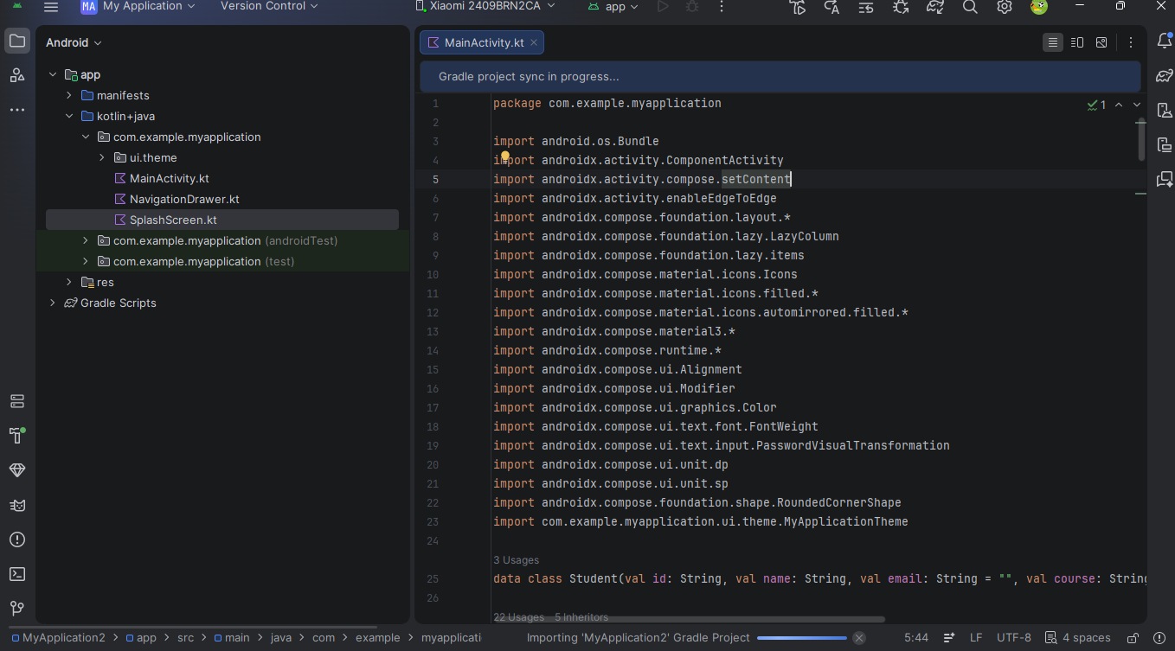
Reflection Successfully completed first mobile app using Jetpack Compose.

WEEK 2 DOCUMENTATION
BIT4107 - Week 2 Report Objectives
- Build Mini Student Management App
- Multiple screens + navigation
- Basic data handling
Activities Done
- Implemented Login, Register, Dashboard
- Added student list
- In-memory data storage
Challenges
- Screen navigation
- State management
Solutions
- Used sealed class for screens
- mutableStateListOf for students
Screenshots
- Login Screen
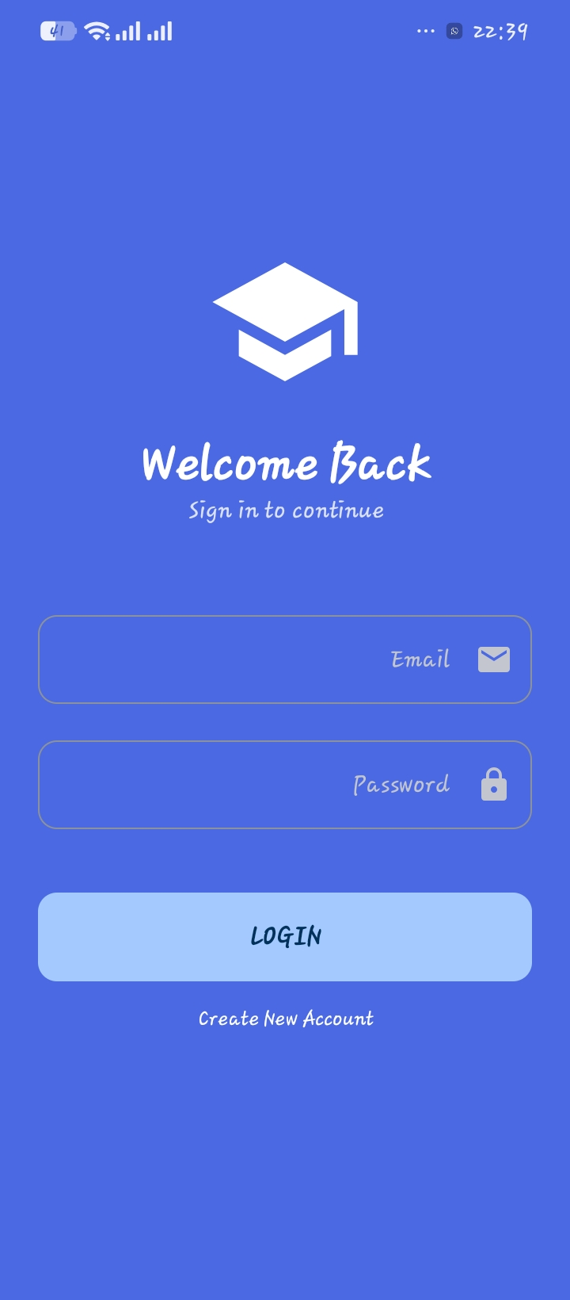

- Registration Screen
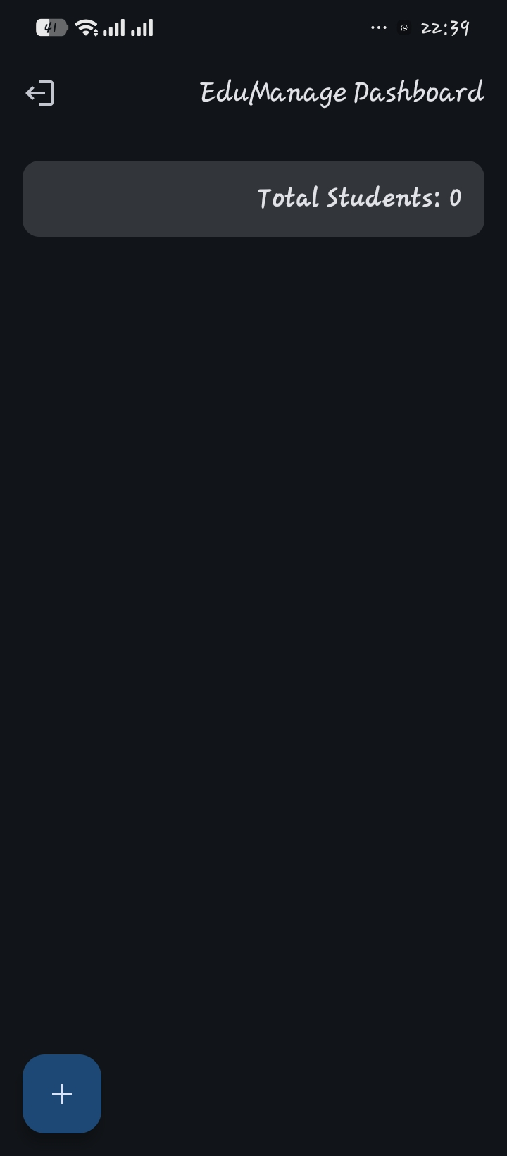
- Dashboard with students
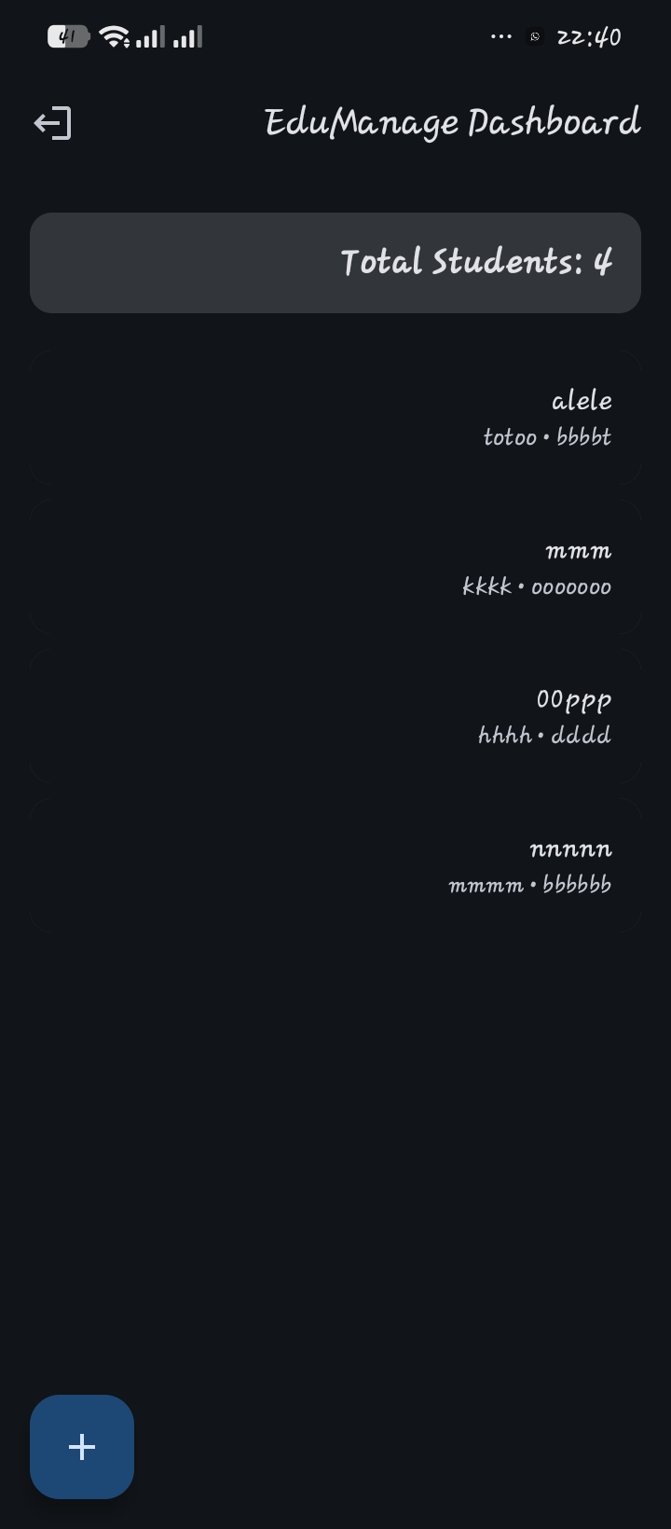
Reflection Learned basic app architecture and state management in Compose.

WEEK 3 DOCUMENTATION
BIT4107 - Week 3 Report Objectives
- Modern UI/UX Design
- At least 5 screens
- Professional look & feel
Activities Done
- Added Splash Screen
- Improved Login with gradient
- Created Dashboard with stats
- Added Profile Screen
- Used AlertDialog for adding students
Challenges
- Making UI beautiful and consistent
- Proper spacing and theming
Solutions
- Applied Material 3 + Rounded shapes
- Used icons and good typography
Screenshots
- Dashboard Screen (with Total Students)

2.login screen

Reflection Improved UI/UX skills significantly. App now looks professional.

